GOSHEN FIRST CHURCH

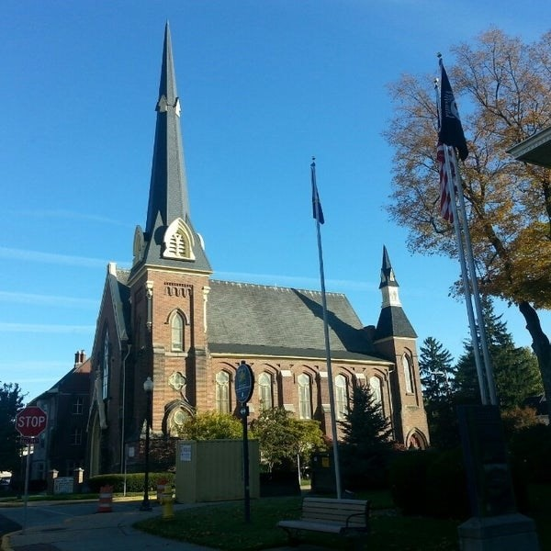 ***July 30, 2025***

***A Global Methodist Church***

***214 S. 5th Street***

***Goshen, IN 46528***

***Phone: 574-533-9518***

***Office Hours: Monday-Friday,***

***8:00 a.m.-12:00 noon***

***Worship: 9:00 a.m.***

***Sunday School: 10:30 a.m.***

***Pastor: Diana Siegel***

***Associate Pastor: Rich Hull***

***OUR CHURCH VISION – “Growing in Faith, Gathering in Community, and Giving in Love”.***

Next Sunday Pauline Yoder will be sharing about the August Mission of the

Month – Heart and Hand International. She is a part of this organization.

“Thank you to the church for my birthday flower, and to Sharon Hull for delivering it. The flower was beautiful, and I appreciated my visit with Sharon.”

-Janelle Rensberger

“Thank you to everyone for your prayers, cards, gifts, and love. Please accept my apology for the delay in writing thank you notes. With my broken hand, it is difficult for me to write. Blessings to you!” -Pastor Diana Siegel

The next Men’s Brown Bag Lunch will be on Thursday, August 7, from

12:00-1:00 p.m. All men are welcome.

VOLUNTEERS – Thank you for your service! Sunday morning, August 3

Greeters: Bob & Donna Shirk VIP: Kelley Leeper

Elevator Hosts: Sharon Hull, Sandy Priem

Ushers: Chuck Rink,Jeff Showalter,George Buckingham,Kent Evans,Mary Ann Eash

Scripture Reader: Dave Parsons

Junior Church: Elementary – Rachel Parsons Tenorio, Kelley Leeper

Junior Church: Jr. High – Loraine Troyer

Coffee Hour: Sharon Hull, Arlene Randolph

Bus Driver: Randy Cripe

Blood Pressure Clinic: Carole Evans

Communion Servers: Patty Krebs, Jim Jaques, J.D. & Linda Russell

It is almost time for students to head back to the classroom. We are able to help Waterford School by providing Kleenex boxes for 25-30 classrooms. Quaker Oat bars for students who miss the meal time, but are hungry are appreciated. You may drop off your contributions in the bins in front of the church office. The lunch for teachers and staff will be Tuesday, August 12. Let Marcia Parsons know if you would like to help.

**CHURCH CALENDAR – AUGUST**

**MONDAYS**

12:00-12:45 p.m. – Exercise class **(begins August 18)**

7:00 p.m. – Choir **(August 11,18,25)**

7:00 p.m. – Boy Scouts/Cub Scouts

**TUESDAYS**

9:00-9:45 a.m. – Exercise class **(begins August 19)**

6:00 p.m. – Prayer Group (first and third Tuesday)

**WEDNESDAYS**

10:00 a.m. – Painting class

3:00 p.m. – Church Council **(August 13)**

7:00 p.m. – Choir practice **(August 6 only)**

**THURSDAYS**

9:00-9:45 a.m. – Exercise class **(begins August 14)**

12:00-1:00 p.m. – Men’s Brown Bag Lunch (once a month) **(August 7)**

1:00-3:00 p.m. – Community Connection here

Primetimers (once a month) **(August 21)**

**SUNDAYS**

9:00 a.m. – Worship

10:30 a.m. – Sunday School

Pastor Jeff Bealmear and Rev. Tommy Hays, both of the Global Methodist Church, assisted in feeding over 200 in the slum area of Witemere in Nyeri, Kenya, on Tuesday. They, along with their mission team, then spent over two hours praying over the slums which carry a population of almost 10,000. They will continue this week in holding a three-day crusade in Nyeri along with a Youth Conference, mission work at an orphanage, and other revival services. Pastor Jeff will begin his appointment on August 1st at Goshen First Church.

