“How Firm A Foundation”

Happy Wednesday Everyone!

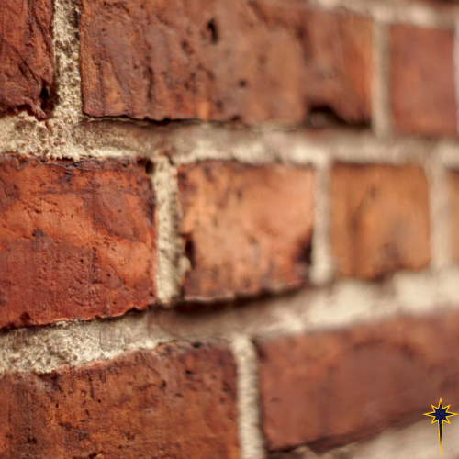 Sometimes things happen in sequence together that make you take a moment to say, “hmm.” Like this week, early in the week my family had a very exciting delivery, the block and brick for our home that we’re building was delivered to the site of our new home. Our property is really starting to look like an active worksite, and once this rain moves on I’m sure things are going to change drastically!

Simultaneously to the foundation of our house being delivered, I was working on the outline of music for worship this week. It was both comical and accurate to life right now when I realized that the first song we are singing is “How Firm a Foundation.” Fitting, isn’t it?

But really this is such a fitting song for what all is taking place at Bethlehem right now as well. In case you missed worship this past Sunday, exciting news was shared that Bethlehem will be partnering with Lutheran Theological Southern Seminary (now housed at LR in Hickory) as a “Contextual Education Site.” This means that we will be welcoming a new seminarian to our congregation in September! Contextual education is meant to be a practicum course, a laboratory if you will, where early year seminarians have the space and opportunity to build a foundation of understanding and experience to build them up and help them in discerning the gifts they have for ministry. Being apart of the formation of future leaders of the church is a huge gift that Bethlehem possesses. I can personally attest, being one of the leaders for the church that this congregation helped form for ministry.

In addition to the exciting news this past week of an incoming seminarian, we look forward this coming Sunday to celebrating “Back 2 Bethlehem Sunday.” We will bless students, teachers, and all education staff as they begin a new school year. Education is both important and a great gift. The character, knowledge, and curiosity instilled in the minds and hearts of students builds them up with a foundation of ability to think creatively and critically. The gift of learning also equips them with tools to be the hands and voices of change for a better tomorrow. We pray that this year will be a year of safety, vitality, and wisdom for students of all ages.

And, beyond welcoming a seminarian, and beyond blessing a new academic year, our Innovation Team will be moving into a new phase in the Ministry Transformation Lab process that we’ve been engaged in since January. So far, this team of ten dedicated individuals have sought to understand the people of Bethlehem on a deeper level, sought to understand the gifts of the community around Bethlehem on a deeper level, and sought to understand the needs of the surrounding community on a deeper level. The team has identified where people of various walks of life and circumstances need support (and need the church to show up) in their daily lives. This has been long, hard work. Yet, the Innovation team has done that work faithfully. Now they move into the “Theological Interpretation Phase.” All of our insights will be looked at through the lens of “What does scripture have to say about all this?” And soon, we will be moving into our own “laboratory phase” as we do some ideating and prototyping for a construct of ministry that will value and intersect with the gifts of Bethlehem Lutheran Church, the gifts of the surrounding community, and the needs of the community. As we journey towards whatever God has in store for Bethlehem, we welcome your prayers.

And lastly (for now), beyond a seminary partnership, a new school year, and a new phase in our ministry transformation journey, exciting ministries are already being resurrected at Bethlehem. The “Tsunamis” group is back and thriving! If you’re scratching your head wondering who are the “Tsunamis,” allow me to explain. Bethlehem has four groups for children, youth, and young adults: *Sprinkles (birth-age 4), Ripples (K-5th grade), Waves (middle & high school), and the Tsunamis (undergrad & graduate students)*. The Tsunamis group has been revamped, and in the past few weeks has already seen great growth. Ten students, from five different college campuses (and more on the way) are making plans to meet with each other throughout the semester both to support each other in life and to serve together as disciples of Jesus. How awesome is that?! As these students pursue intentional courses of study and develop educational and professional foundations for their futures success, they also have an opportunity to gather with other students to network, make new friends, and share the joys and challenges of life together. And you, Bethlehem Lutheran Church, are investing in them: providing space for these young adults to be reminded that they are loved and supported, by God, and by all of you!

I’ll close this week with a few words from that song I mentioned at the beginning of this reflection, because it’s very appropriate for all these foundational building blocks that are being built up through the ministry of Bethlehem Lutheran Church:

*“How firm a foundation, O saints of the Lord, is laid for your faith in Christ Jesus, the Word! What more can he say than to you he has said, who unto the Savior for refuge have fled?*

*Fear no, I am with you, oh, be not dismayed, for I am your God and will still give you aid; I’ll strengthen you, help you, and cause you to stand, upheld by my righteous omnipotent hand.”*

How firm a foundation…and may God bless you and all of us as something glorious gets built upon that foundation!

The peace of Christ be with y’all!

Pastor Vern