**2026 CALENDAR ORDER FORM**

We are pleased to offer the Anglican Church Calendar for 2026.

The 2026 Canadian Anglican Church Calendar, now in its 120th year, The calendar continues the tradition of showcasing beloved Anglican churches from coast to coast.

The funds raised will assist the Anglican Church Women to continue with their many outreach programs. We appreciate your help with these commitments.

Make cheques payable to the Anglican Church Women DoNW, noting your parish name on the cheque.

**Name of Parish______________________________________________**

**Name of Contact Person______________________________________**

**Phone #____________________ email___________________________**

**Delivery address and phone number:**

**___________________________________________________________**

**Number of calendars ordered_______ x Cost $8.00 each = $_________**

**PLEASE have order and payment in before September 16, 2025 to**

**ACW Calendar Secretary, c/o ACW Place, #3, 6678 - 152 Street Surrey B. C. V3S 7J2**

Orders can be mailed with the payment or emailed to the Calendar Secretary: 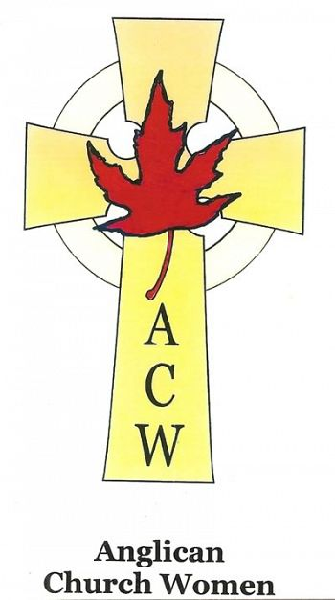Sylvia Enga at sylviaanneenga@gmail.com

Many thanks for your support.

Anglican Church Women

Diocese of New Westminster