CENTER HILL BAPTIST CHURCH

News and Views for August 2025

July was a lot slower than the month of June. It was a great time to do some things that we had never done before (going to see Dennis Swanberg) and doing something that everyone enjoys tremendously (going to Hot Rods for lunch). Everyone who went to these adventures had a wonderful time.

Since it has been so hot, I really think this is the recovery time that we needed to be able to get ready for ‘BACK TO SCHOOL’ and REVIVAL.

Speaking of school, the Back to School party was on Friday, July 25th. I will give updates on that in next month’s newsletter.

Revival is coming up on August 3rd through August 6th. We will have our annual fellowship lunch on Sunday and a Pot Luck supper on Wednesday. We should have a wonderful time, but we all need to be praying that God’s will is being done in all things and that soul’s will be saved. Also, please pray for our evangelist, Scott Smith, and the Worship Team. Our service will start at 10:30 on Sunday morning with no Sunday School.

August 10th, Faith Baptist will be hosting a ‘ReStart Rally’ for the youth. (See Below)

August 18th- American Red Cross Blood Drive

Brother Hood will be meeting on Thursday, September 4th at 6:30 p.m.

We are currently studying the Book of John at Bible Study and Prayer Meetimg each Wednesday evening at 6:30. Everyone is welcome to come. We have some pretty good discussions sometimes. We would love to have you come and join us.

We really need and will continue to encourage people to earnestly pray together for our church and because of this, our **“WAR ROOM”** continues to meet on Sunday mornings. We would love to have more Christians join us in praying for our church, our community, lost souls and each other. It’s not always easy to make it to the meeting, but it is so worth it! We all get blessed just by being there and lifting our needs to our Father as a group. **“. For where two or three are gathered together in My name, I am there in the midst of them.” (Matthew 18:20)**

The **“WAR ROOM”** is located in the basement of the church at the end of the long hallway.

**The following is from our nursery director, Brenda Abney:**

**Nursery/Toddler Schedule August 2025**

Over half the year is behind us! Some of the children will start school the first week in August!

The holiday season will be upon us soon! It seems like we are rushing from one event to the next!

August has five Sundays and so the schedule may be a little "off". As always, if you cannot serve on the date you are scheduled, please let me know as soon as possible.

August 3 Brenda & Tim Abney for Sunday School only

Amy Sims and Jean Griffeth

August 10 Brenda & Tim Abney for Sunday School only

Mary Beth Donaldson and Laura Burford

August 17 Brenda & Tim Abney for Sunday School only

Linda Davis and Pat Hall

August 24 Brenda & Tim Abney for Sunday School only

Mallory Tullis and Tammy Tullis

August 31 Brenda & Tim Abney for Sunday School only

Marie Watson and Debra Camp

Thank you to Pat Hall for asking to serve in the nursery!

Thank you to everyone who serves in the nursery! I appreciate everyone who gives up their

church worship time to further God's glorious Kingdom!

Brenda Abney 770-722-0554

**The Fellowship Hall** is booked for August 6th

**The Life Center** is booked for August 3rd, 9th, 18th, and 31st

As usual, if you have any suggestions or additional information to put in 5the newsletter, please call or email the church office.

May God richly bless you all!!

Email: [chbchurch@comcast.net](mailto:chbchurch@comcast.net); Phone: (770) 267-6311

August 2025

**LOOKING FORWARD:**

August 3 – 6 —Homecoming and Revival

August 6- Family Night Supper

August 10- Youth ReStart Rally at Faith Baptist

August 18- Blood Drive

Sept 2- WOM

Sept 4- BrotherHood

Sept 7- Kids Day on Sunday

Oct 2- BrotherHood

Oct 7- WOM

Oct 25- October Festival

Nov 4 – WOM

Nov 6- BrotherHood

Nov 13- Council meeting

Nov 17- Shoeboxes

Nov 23- Harvest Day and Thanksgiving Meal

Dec 2- WOM Christmas Dinner

Dec 4- BrotherHood and Back Packs

Dec 14- Cantata

Dec 24- Candle Light Service at 5:00

The following is from Pastor Chris Connor and is happening on August 10th for our youth:

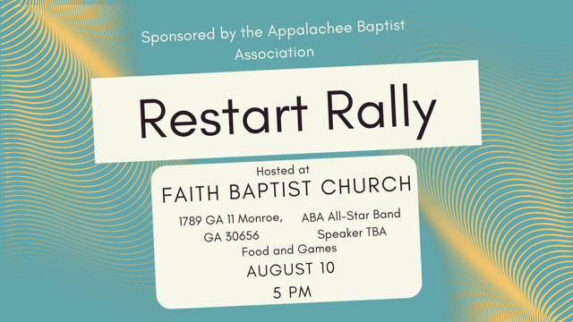

We are excited to announce that we will have Youth Evangelist Hunter Young Preaching. Hunter also has another job. He is a professional wrestler and is known as the Wrestling Saint. It's going to be great! Games and food at 5 with worship at 6. Also the ABA All-Star band and worship team will be leading worship. If you have a teenager or young adult who sings or plays an instrument, they can be part of this great group. Have them email or txt me and I will get them connected up. Be praying for this great event.

Chris Conner

Associational Mission Strategist

Appalachee Baptist Association

770-601-2389