**Diocese of Ottawa • Anglican Church of Canada**





**Ninth Sunday after Pentecost**

August 10th, 2025

Sung Eucharist ~ 10 a.m.

Book of Alternative Services, p. 185

**Welcome to the Church of**

**St. John the Evangelist**

*We acknowledge that we gather at St. John’s on the traditional and unceded territory of the Algonquin Nation. May we dwell on this land with respect and peace.*

**

*This service is video recorded, streamed, and broadcast. By attending this service, you are agreeing to appear on video in our on-line worship offering through St. John’s website and Facebook pages.*

**

*Hymns are from the blue Common Praise hymnbook unless otherwise indicated.*

*Today’s service can be found on page 185 of the green Book of Alternative Services (BAS) located in the pew-back in front of you.*

THE G**ATHERING OF THE COMMUNITY**

## A sheet of music with black lines and dots AI-generated content may be incorrect.Prelude

## Announcements

### Processional (Opening) Hymn

### p 527

#### **Greeting,** p 185

#### **Children’s Talk**

#### Collect for Purity,

#### p 185

#### **The Gloria**

*Sung as printed here.*

## Collect of the Day

Almighty God,

you sent your Holy Spirit

to be the life and light of your Church.

Open our hearts to the riches of your grace,

that we may bring forth the fruit of the Spirit

in love, joy, and peace;

through Jesus Christ our Lord,

who is alive and reigns with you and the Holy Spirit,

one God, now and for ever.

**Amen.**

**THE PROCLAMATION OF THE WORD**

## First Reading Isaiah 1:1,10-20

The vision of Isaiah son of Amoz, which he saw concerning Judah and Jerusalem in the days of Uzziah, Jotham, Ahaz, and Hezekiah, kings of Judah. Hear the word of the Lord, you rulers of Sodom! Listen to the teaching of our God, you people of Gomorrah! What to me is the multitude of your sacrifices? says the Lord; I have had enough of burnt offerings of rams and the fat of fed beasts; I do not delight in the blood of bulls, or of lambs, or of goats. When you come to appear before me, who asked this from your hand? Trample my courts no more; bringing offerings is futile; incense is an abomination to me. New moon and sabbath and calling of convocation - I cannot endure solemn assemblies with iniquity. Your new moons and your appointed festivals my soul hates; they have become a burden to me, I am weary of bearing them. When you stretch out your hands, I will hide my eyes from you; even though you make many prayers, I will not listen; your hands are full of blood. Wash yourselves; make yourselves clean; remove the evil of your doings from before my eyes; cease to do evil, learn to do good; seek justice, rescue the oppressed, defend the orphan, plead for the widow. Come now, let us argue it out, says the Lord: though your sins are like scarlet, they shall be like snow; though they are red like crimson, they shall become like wool. If you are willing and obedient, you shall eat the good of the land; but if you refuse and rebel, you shall be devoured by the sword; for the mouth of the Lord has spoken.

Reader:The Word of the Lord

**People: Thanks be to God**

## Psalm 50 Tune: Old 100th

The Lord has spoken, God of gods,

He calls the earth from east to west;

From Zion, perfect in its grace,

He makes his glory manifest.

Our God will come with raging storm,

Consuming flame, and not be still;

He calls the heavens and earth to see

As now his people hear his will.

“Assemble all my followers

Who sealed the bond with sacrifice;”

For God the Lord himself is judge;

Let heaven declare his cause is right.

## Second Reading Hebrews 11:1-3,8-16

Now faith is the assurance of things hoped for, the conviction of things not seen. Indeed, by faith our ancestors received approval. By faith we understand that the worlds were prepared by the word of God, so that what is seen was made from things that are not visible. By faith Abraham obeyed when he was called to set out for a place that he was to receive as an inheritance; and he set out, not knowing where he was going. By faith he stayed for a time in the land he had been promised, as in a foreign land, living in tents, as did Isaac and Jacob, who were heirs with him of the same promise. For he looked forward to the city that has foundations, whose architect and builder is God. By faith he received power of procreation, even though he was too old and Sarah herself was barren because he considered him faithful who had promised. Therefore from one person, and this one as good as dead, descendants were born, "as many as the stars of heaven and as the innumerable grains of sand by the seashore." All of these died in faith without having received the promises, but from a distance they saw and greeted them. They confessed that they were strangers and foreigners on the earth, for people who speak in this way make it clear that they are seeking a homeland. If they had been thinking of the land that they had left behind, they would have had opportunity to return. But as it is, they desire a better country, that is, a heavenly one. Therefore God is not ashamed to be called their God; indeed, he has prepared a city for them.

Reader:The Word of the Lord

**People: Thanks be to God**

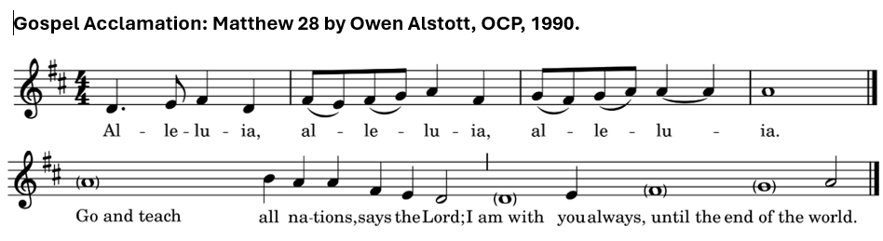**Gospel Acclamation**

## Holy Gospel Luke 10:1-11,16-20

**Holy Gospel Luke 12:32-40**

Gospeller: The Lord be with you

**All: And also with you**

Gospeller: The Holy Gospel of our Lord Jesus Christ according to Luke

**All: Glory to you, Lord Jesus Christ**

Jesus said, "Do not be afraid, little flock, for it is your Father's good pleasure to give you the kingdom. Sell your possessions, and give alms. Make purses for yourselves that do not wear out, an unfailing treasure in heaven, where no thief comes near and no moth destroys. For where your treasure is, there your heart will be also. Be dressed for action and have your lamps lit; be like those who are waiting for their master to return from the wedding banquet, so that they may open the door for him as soon as he comes and knocks. Blessed are those slaves whom the master finds alert when he comes; truly I tell you, he will fasten his belt and have them sit down to eat, and he will come and serve them. If he comes during the middle of the night, or near dawn, and finds them so, blessed are those slaves. But know this: if the owner of the house had known at what hour the thief was coming, he would not have let his house be broken into. You also must be ready, for the Son of Man is coming at an unexpected hour."

Gospeller: The Gospel of Christ

**People:** **Praise to you, Lord Jesus Christ**

## Sermon

## Nicene Creed p. 188

## Prayers of the People

## Confession and Absolution p. 191

## The Peace p. 192

*People may greet one another with the peace of Christ.*

## Offertory Hymn p. 601

THE CELEBRATION **OF THE EUCHARIST**

## Prayer over the Gifts

Father,

receive all we offer you this day,

and grant that in this eucharist

we may be enriched by the gifts of the Spirit.

We ask this in the name of Jesus Christ our Lord.

**Amen.**

## Eucharistic Prayer 2 p. 196

## Sanctus *(sung)*

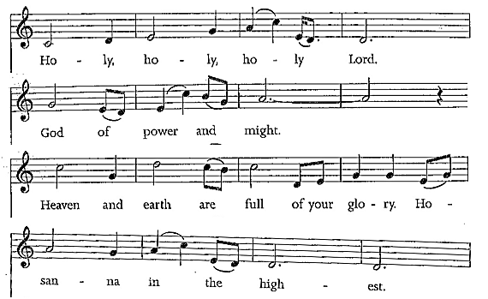

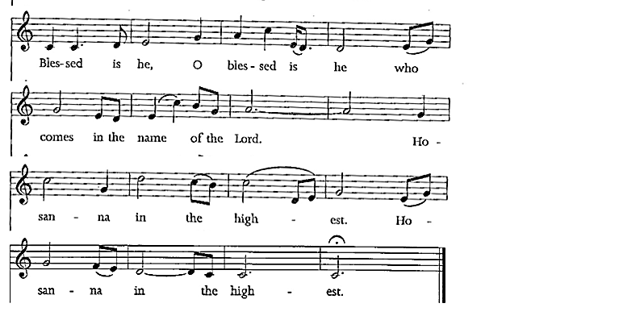

#### The Lord’s Prayer *(sung)*

Our Father in heaven, hallowed be your name;

Your kingdom come;

Your will be done

On earth, as in heav’n.

Give us today our daily bread.

Forgive us our sins

as we forgive those who sin against us.

Save us from the time of trial,

and deliver us from evil.

For the kingdom, and the power, and the glory are yours;

Now and forever.

Amen.

#### Breaking of the Bread 2 p. 212

Celebrant: We break this bread to share in the body of Christ.

**All:** **We being many are one body for we all share in the one bread.**

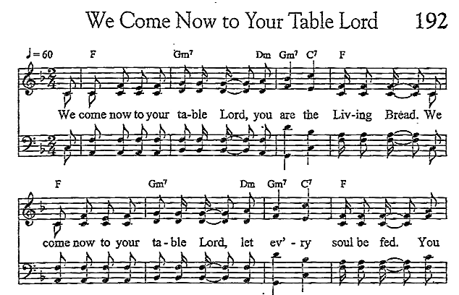 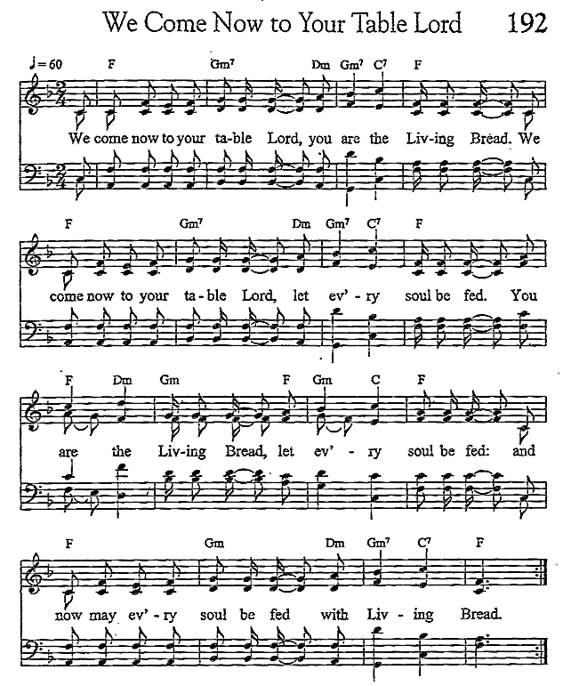

## Communion

*All who are baptized are welcome to receive the bread and/or the wine of Holy Communion. At the Greeter’s direction, please make your way to receive the elements if you wish to. All are welcome to come forward for a blessing.*

## Hymns during Communion p. 149, 161

## Hymn after Communion p. 74

## Prayer after Communion

Eternal God,

grant to your Church the unity and peace

that we have tasted in this eucharist,

the fruit of your life-giving Spirit.

We ask this in the name of Jesus Christ the Lord.

**Amen.**

## Doxology p. 214

## The Blessing

## Recessional Hymn p. 467

## Dismissal

## Postlude

**ANNOUNCEMENTS**

**NEW ORGANIST & MUSIC DIRECTOR**

St John's is excited to announce that Wendy Stokes-Earl will be joining us as our new Organist & Music Director! We are blessed to welcome Wendy to our church family. Wendy will be stepping into her new role as of September 1st. Look for more on Wendy's adventures and accomplishments in upcoming news editions.

**LOOKING FOR THE DONOR(S)/FORMER OWNER(S)**

We have discovered a bar fridge and a Pepsi cooler in the cold storage area (anteroom off the front entrance – George St) of the Lower Hall. If you are the donor of either of these items and would like to reclaim then, please let the office know **by August 15th**. We are hoping to rehome them. Thank you.

**APPOINTMENTS WITH THOMAS**

Looking for a good time to catch Thomas in his office? Starting August 21st, Thomas is going to be available on Thursday afternoons from 1 PM to 4 PM for appointments or drop-in visits (other times by chance or appointment). Appointments can be booked Thursday afternoons, through the church office, or you can drop in and, if he is available, have a chat. Emergencies do arise, so it is best to call before an impromptu visit, just to be sure he is in.

**PRAYER TEAM**

**Philippians 4:6 -** Do not be anxious about anything, but in everything by prayer and supplication with thanksgiving let your requests be made known to God.

This is a follow-up to the insert in our bulletin regarding our prayer lists. We would like to start a team of people praying for a list of those with ongoing needs. Anyone with any level of prayer experience could comfortably pray in their own home.

If you wish to join this integral and powerful ministry, please call the Church office to leave your name and contact information.

**ANNOUNCEMENTS – Cont’d**

**PRAY K7A**

As the summer continues, we’re hoping for good weather on the last Sunday of July. As you know, Christians from across the Smiths Falls area gather to pray for the town, townships, and villages, to sing praise to God, and to encourage each other each month. This month, **August 31st, at 7:00 pm,** **St. John’s Anglican Church**, 2 George Street North. The plan is to meet at the church, and then share in a prayer walk through the town as we pray God’s blessing, healing, forgiveness, and the joy of the Gospel on Smiths Falls.

**FALL BAZAAR**

If you have donations for the upcoming Bazaar in the fall, which will be held on **Saturday, October 18, 2025**, between 11am to 2pm, we would appreciate it if you would hold on to them for a while. We cannot store donations in the hall basement due to mold. We are presently looking for storage places and will announce when we are able to accept your donations. Thank you.

**SMITHS FALLS FOOD BANK**

Collection baskets are at the North and South doors of the Church. They will be collected after the third Sunday of each month, and delivered to the Food Bank. Any questions, contact Debbie Lewis at 613. 284.6111.

**VOLUNTEERS NEEDED**

Greeters, Readers and Intercessors needed for both the 8 AM and 10 AM services. If you are able to help out with this vital and rewarding ministry, please let the office know, and Rev. Thomas will schedule a training day in early September 2025.

**ANNOUNCEMENTS – Cont’d**

**“ST. JOHN’S TODAY” – NEWSLETTER**

We will be providing print and electronic copies of the newsletter. If you wish to receive an electronic copy, please provide your e-mail address on the sheets located in the Canterbury Room and at the North Entrance. You may also call the Church Office 613.283.1261 or e-mail, stjohns.smithsfalls@gmail.com to be placed on the e-mail list.

**ALTAR GUILD FLOWER FUND**

If you wish to donate to the flower fund, please either call the office or place the money on the collection plate in an envelope marked 'Flower Fund’. Any questions, please contact Debbie Lewis at 613.284.6111.

Presiding Celebrant: Rev. Canon Jim Roberts

Preacher: Rev. Canon Jim Roberts

Communion Assistants: Terry Dillabough/Donna Howard

Reader: Pat Lee

Intercessor:Karen Bryan

Greeters: Gail Brennan & Linda Coleman

Altar Guild: Kathy Porter & Lois Arkell

Organist: Sterling Bennett

Readings for next Sunday, August 17, 2025 ~

ISAIAH 5:1-7; PSALM 80:1-2,8-18; HEB 11:29—12:2; LUKE 12:49-56

**ST. JOHN THE EVANGELIST ANGLICAN CHURCH**

2 George Street South, Smiths Falls, Ontario K7A 1X4

613.283.1261 | stjohns.smithsfalls@gmail.com

www.stjohn-smithsfalls.com

*Follow us on Facebook at:*

St-John-the-Evangelist-Anglican-Church-Smiths-Falls

Laura Savage – Parish Administrator

Office Hours: Monday – Wednesday 9 a.m. – 12 noon

Thursday 1 – 4 p.m.

Friday 9 a.m. – 12 noon

**Weekly Liturgies**

Holy Eucharist – Sundays 8 a.m. & 10 a.m.* – Wednesdays 10 a.m.

*Sunday School offered at 10 a.m. from September – June

The Most Reverend Shane A. D. Parker – Bishop & Primate

The Reverend Dr. Thomas Brauer, Presiding Celebrant & Preacher

The Reverend Canon Brian Burrows – Honorary Assistant

The Reverend Canon Jim Roberts – Honorary Assistant

Sterling Bennett – Interim Organist

Emily Duberville – Sunday School Coordinator emduberville@hotmail.com

Dan Willis – Rector’s Warden 613.884.5095

Lois Arkell – People’s Warden 613.485.9181

Tammy Mulrooney – Deputy Warden 613.485.3128

Pat Lee – Deputy Warden 613.485.3368

Tammy Mulrooney – Envelope Secretary

sjsfenvelopesecretary@gmail.com