This Week at PPBC


Thursday, July 3rd


Friday, August 15th, 2025
All youth in grades 7-12 are welcome at the church from 7:30 pm - 9:30 pm for a time of Bible study and games!

Ministry Opportunities 2025-2026 Survey
Paper Copies available in the Office
We believe that God gives spiritual gifts to every believer so that each one can contribute to the spiritual health and growth of the local church (Ephesians 4:11-16).
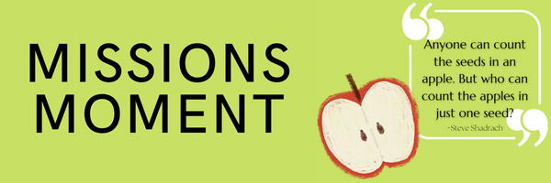
A Prayer Request from AOJ: What a difference a home can make — not just in bricks and paint, but in dignity, safety, and joy. Thanks to the generous donation of a faithful supporter, a family in Haiti has gone from living in a fragile, unsafe structure to having a sturdy, vibrant home of their own. No longer are they exposed to the wind and rain. The children now have their own room. The parents have peace. This is more than a building — it’s a testimony to God’s love, expressed through His people.

Notes

Sunday Ministry Schedules
Below are ministry schedules for Nursery, Jr. Church, Greeters, Ushers, and Sound & Video:
Nursery
Aug 10: Jen Werner, Hannah Colwell
Aug 17: Laura Saunders, Amber Saunders
Jr. Church; ages 3 to grade 6 (Classes combined for the summer)
Aug 10: Deb Brown, Kim St-Onge
Aug 17: Justine McKenzie, Abby Saunders
Greeters
Aug 10: Roy & Elizabeth Werner
Aug 17: Tracy & Karen Ballanger
Ushers
Aug 10: Joe Colwell, Nick Woytowich
Aug 17: Gregg Anderson, Graeme Foster
Sound & Video
Aug 10: Sound: Wyatt Werner | Video: Jordan Anderson
Aug 17: Sound: Caleb Bolsonello | Video: Josh Myers

Morning Service
Song- All My Ways
Welcome
Song- Are You Washed in the Blood
Song – Lamb of God
Scripture
Prayer
Song – I Am Not My Own
Message – Elder Steve Angrove
Song – In Christ Alone
¹⁷ Carrying his own cross, he went out to the place of the Skull (which in Aramaic is called Golgotha). ¹⁸ There they crucified him, and with him two others—one on each side and Jesus in the middle. ¹⁹ Pilate had a notice prepared and fastened to the cross. It read: jesus of nazareth, the king of the jews. ²⁰ Many of the Jews read this sign, for the place where Jesus was crucified was near the city, and the sign was written in Aramaic, Latin and Greek. ²¹ The chief priests of the Jews protested to Pilate, “Do not write ‘The King of the Jews,’ but that this man claimed to be king of the Jews.” ²² Pilate answered, “What I have written, I have written.” ~ John 19:17-22

Praise & Prayer Highlights
PRAY for Denis Tomcheski and his ongoing health concerns and testing for those concerns. PRAY for his health and that he would receive the care he needs.
PRAISE for the safe arrival of Zoey Luc Myers.
PRAISE that Chelsea & Josh have a healthy baby girl. Please continue to PRAY for them as they adjust to being parents.
PRAY for Joan Mabley and the family as they make plans for her to return home next week. PRAY for Joan's ongoing health & recovery.
PRAY for Mike Smith and the Smith family as they mourn the passing of Mike's Nana. PRAY for God's comfort, peace and guidance for the family. While we mourn we also PRAISE with them and are thankful for her faith in Christ.
PRAY for the Persis Family as they continue to look for housing. PRAY that the Lord will provide for them. Please remember to PRAY for Amin who is in school.
PRAY for Bert & Ada Faber and their ongoing health concerns.
PRAY for the Malawi Missions Team; Lino, Les, Lisa, Thea, Sara, Kathryn, Adam, Lucas, Paul and Helen. PRAISE God for the funds coming in. PRAY for safety throughout, that their bags will all get there, that God is already preparing the hearts of the children, the men and the women that He will be putting in their path, for the hearts of the team to be wide open to His leading.
PRAY for Les & April Saunders and the family as they mourn the loss of Les' mother. PRAY for God's comfort, peace and guidance for the family.
Giving
Just as a reminder, there are several ways you can give:
In Person using the offering box located on the back wall of the sanctuary. Donation envelopes are available at the Welcome Centre. Please contact the church office if you would like a box of donation envelopes (office@portperrybaptist.ca)
Through your online banking, you may send electronic transfers to ppbcdonations@gmail.com.
You can also give through Canada Helps. Donation receipts will be provided by Canada Helps, and transaction fees apply.
***********************************************************************
Weekly Newsletter
The PPBC Newsletter is emailed to the church family every Friday. If you would like to be added to the weekly email list, please contact the office by phone: 905-985-8681 or by email: office@portperrybaptist.ca.
*****************************************************************
Church Information:
Location:
2210 Hwy 7A
Port Perry, ON
L9L 1B4
Office Hours:
Monday: 8:30am – 4:00pm
Tuesday: 8:30am – 4:00pm
Wednesday: Closed
Thursday: 8:30am – 4:00pm
Friday: 8:30 am - 3:00 pm
Contact:
Phone: 905.985.8681
Email: office@portperrybaptist.ca
Website: www.portperrybaptist.ca
Staff:
Sr. Pastor – Rev. Jim Clemens
Administrative Assistant – Madeline Werner
Family Ministries Director – Josh Anderson

PPBC Newsletter
Sunday, August 10th, 2025



Sunday Starting Point
Sunday, August 10th, 2025 - 9:30 am
“Beginning the day with the Word and prayer”

Adults & Youth:
Adults and Youth will meet in the sanctuary for a time of study and prayer.
(Please note childcare is unavailable during Starting Point)

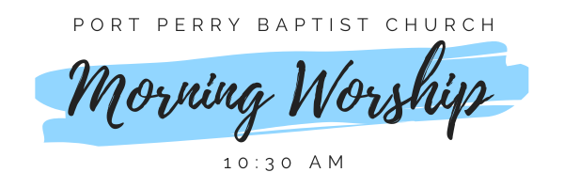Sunday Morning Worship
Sunday, August 10th, 2025 - 10:30 am
We are meeting in the sanctuary and will continue to live-stream for those who are unable to attend.

Message: A Proclamation on the Cross
Scripture: John 19
Steve Angrove

