St. Mark’s Episcopal Church
75 Cold Spring Road
Westford, Massachusetts, 01886

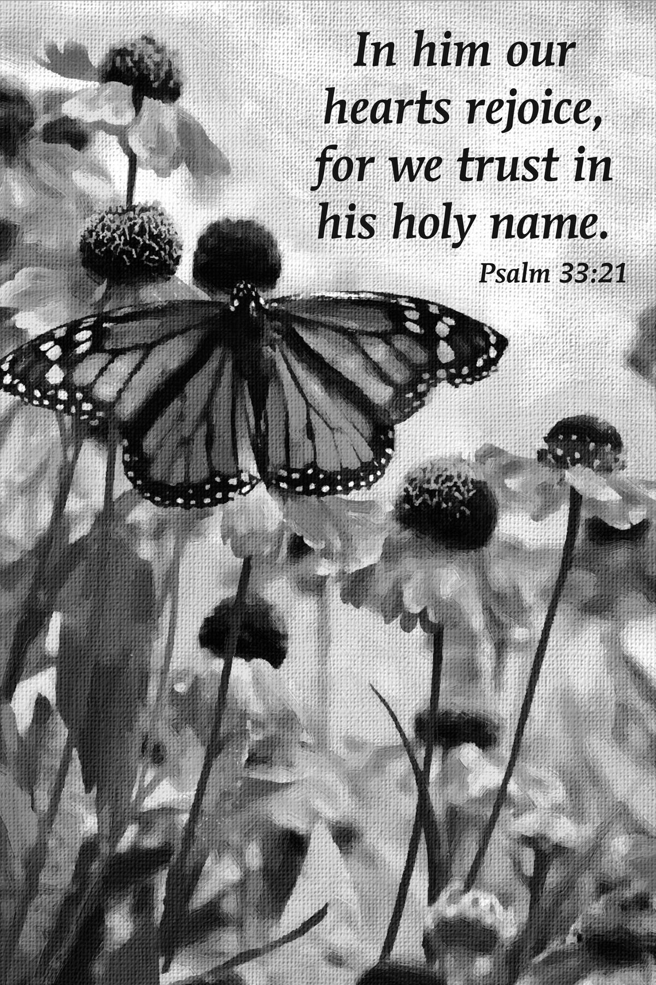

August 10, 2025
Rev. William Bergmann, Officiant
Meredith Marcinkiewicz, Minister of Music
Usher/ Reader: Jenny Meanwell
Chalice Bearer: Elaina Carroll
ENTRANCE HYMN:

The people standing, the Celebrant says
Celebrant | Blessed be God: Father, Son, and Holy Spirit
People | And blessed be his kingdom, now and for ever. Amen.
COLLECT FOR PURITY ( BCP 355)

GLORIA: S 277 Glory to God (Hurd) (BCP p. 356)

THE COLLECT OF THE DAY (BCP p. 357)
Celebrant | The Lord be with you.
People | And also with you.
Celebrant | Let us pray.

Grant to us, Lord, we pray, the spirit to think and do always those things that are right, that we, who cannot exist without you, may by you be enabled to live according to your will; through Jesus Christ our Lord, who lives and reigns with you and the Holy Spirit, one God, for ever and ever. Amen.

The Lessons

FIRST READING: Genesis 15:1-6
The people sit.
A Reading from the book of Genesis.
¹The word of the Lord came to Abram in a vision, “Do not be afraid, Abram, I am your shield; your reward shall be very great.” ²But Abram said, “O Lord God, what will you give me, for I continue childless, and the heir of my house is Eliezer of Damascus?” ³And Abram said, “You have given me no offspring, and so a slave born in my house is to be my heir.” ⁴But the word of the Lord came to him, “This man shall not be your heir; no one but your very own issue shall be your heir.” ⁵He brought him outside and said, “Look toward heaven and count the stars, if you are able to count them.” Then he said to him, “So shall your descendants be.” ⁶And he believed the Lord; and the Lord reckoned it to him as righteousness.

Reader | The Word of the Lord.
People | Thanks be to God.

Silence may follow.
PSALM: Psalm 33:12-22
Remain seated.
¹²Happy is the nation whose God is the Lord! *
happy the people he has chosen to be his own!
¹³The Lord looks down from heaven, *
and beholds all the people in the world.
¹⁴From where he sits enthroned he turns his gaze *
on all who dwell on the earth.
¹⁵He fashions all the hearts of them *
and understands all their works.
¹⁶There is no king that can be saved by a mighty army; *
a strong man is not delivered by his great strength.
¹⁷The horse is a vain hope for deliverance; *
for all its strength it cannot save.
¹⁸Behold, the eye of the Lord is upon those who fear him, *
on those who wait upon his love,
¹⁹To pluck their lives from death, *
and to feed them in time of famine.
²⁰Our soul waits for the Lord; *
he is our help and our shield.
²¹Indeed, our heart rejoices in him, *
for in his holy Name we put our trust.
²²Let your loving-kindness, O Lord, be upon us, *
as we have put our trust in you.

Second Reading: Hebrews 11:1-3, 8-16

The people sit.

A Reading from the letter to the Hebrews.
¹Now faith is the assurance of things hoped for, the conviction of things not seen. ²Indeed, by faith our ancestors received approval. ³By faith we understand that the worlds were prepared by the word of God, so that what is seen was made from things that are not visible.
⁸By faith Abraham obeyed when he was called to set out for a place that he was to receive as an inheritance; and he set out, not knowing where he was going. ⁹By faith he stayed for a time in the land he had been promised, as in a foreign land, living in tents, as did Isaac and Jacob, who were heirs with him of the same promise. ¹⁰For he looked forward to the city that has foundations, whose architect and builder is God. ¹¹By faith he received power of procreation, even though he was too old—and Sarah herself was barren—because he considered him faithful who had promised. ¹²Therefore from one person, and this one as good as dead, descendants were born, “as many as the stars of heaven and as the innumerable grains of sand by the seashore.”
¹³All of these died in faith without having received the promises, but from a distance they saw and greeted them. They confessed that they were strangers and foreigners on the earth, ¹⁴for people who speak in this way make it clear that they are seeking a homeland. ¹⁵If they had been thinking of the land that they had left behind, they would have had opportunity to return. ¹⁶But as it is, they desire a better country, that is, a heavenly one. Therefore God is not ashamed to be called their God; indeed, he has prepared a city for them.

Reader | The Word of the Lord.
People | Thanks be to God.
Silence may follow.

SEQUENCE HYMN:

All stand.

GOSPEL: Luke 12:32-40

All stand.

Celebrant | The Holy Gospel of our Lord Jesus Christ according to John.
People | Glory to you, Lord Christ.

[Jesus said to his disciples,] ³²“Do not be afraid, little flock, for it is your Father’s good pleasure to give you the kingdom. ³³Sell your possessions, and give alms. Make purses for yourselves that do not wear out, an unfailing treasure in heaven, where no thief comes near and no moth destroys. ³⁴For where your treasure is, there your heart will be also.
³⁵“Be dressed for action and have your lamps lit; ³⁶be like those who are waiting for their master to return from the wedding banquet, so that they may open the door for him as soon as he comes and knocks. ³⁷Blessed are those slaves whom the master finds alert when he comes; truly I tell you, he will fasten his belt and have them sit down to eat, and he will come and serve them. ³⁸If he comes during the middle of the night, or near dawn, and finds them so, blessed are those slaves.
³⁹“But know this: if the owner of the house had known at what hour the thief was coming, he would not have let his house be broken into. ⁴⁰You also must be ready, for the Son of Man is coming at an unexpected hour.”

Celebrant | The Gospel of the Lord.
People | Praise to you, Lord Christ.

THE SERMON – REV. WILLIAM BERGMANN

THE CREED (BCP p. 358)

All stand.

We believe in one God,
the Father, the Almighty,
maker of heaven and earth,
of all that is, seen and unseen.
We believe in one Lord, Jesus Christ,
the only Son of God,
eternally begotten of the Father,
God from God, Light from Light,
true God from true God,
begotten, not made,
of one Being with the Father.
Through him all things were made.
For us and for our salvation
he came down from heaven:
by the power of the Holy Spirit
he became incarnate from the Virgin Mary,
and was made man.
For our sake he was crucified under Pontius Pilate;
he suffered death and was buried.
On the third day he rose again
in accordance with the Scriptures;
he ascended into heaven
and is seated at the right hand of the Father.
He will come again in glory to judge the living and the dead,
and his kingdom will have no end.
We believe in the Holy Spirit, the Lord, the giver of life,
who proceeds from the Father and the Son.
With the Father and the Son he is worshiped and glorified.
He has spoken through the Prophets.
We believe in one holy catholic and apostolic Church.
We acknowledge one baptism for the forgiveness of sins.
We look for the resurrection of the dead,
and the life of the world to come. Amen.

THE PRAYERS OF THE PEOPLE (BCP p. 359)

All remain standing.

Father, we pray for your holy Catholic Church;
That we all may be one.
Grant that every member of the Church may truly and
humbly serve you;
That your Name may be glorified by all people.
We pray for Presiding Bishop Sean Rowe, Bishop Julia Whitworth, Rev. Will Bergmann, Rev. Melissa Buono, and for all bishops, priests, and deacons;
That they may be faithful ministers of your Word and Sacraments.
We pray for all who govern and hold authority in the nations
of the world;
That there may be justice and peace on the earth.
Give us grace to do your will in all that we undertake;
That our works may find favor in your sight.
Have compassion on those who suffer from any grief or trouble; That they may be delivered from their distress.
We pray in a special way for those on the St. Mark’s Prayer List, namely:

Ann Oliverson, Susan and Kate, Kate and family, Jack Winter, Deanna Teal, Ben, Bob, Orvil, Margaret Bateman, Derek, Evie and family Beth, Brendan and Corine, Jennifer and Kate, Elizabeth, Jane, Lisa, Pamela, Brooke, David Andrew, Sandra, Charlotte and Bob, Ross, Lorenz, Michele Eberle, Lindy, Ted and Kathy, Andrew Ward, Christine, Pam Mark, John Gallacher, Beth, Janet Andrews, Jim and Cheryl, Marmi Sheehan, Marcia and Ralph, Shelly Wadsworth, Sabrina and family, Marion Perault, Sue Sweeney,, Abbey & Sean Meaden, Albert Caproni and his family, Patricia Hughes and the Kintner family, and those we name aloud or in the silence of our hearts….(pause)

We pray for those who have died, especially:

Betty MacNamara, Daniel Corcoran, Andy Lynch, Kathryn Joseph Gesualdo, Brian, Peter, Timmy Howard, Bob Shaw, Doug, Ian Corker, John Murphy.

Give to the departed eternal rest.

Let light perpetual shine upon them.
We praise you for your saints who have entered into joy;
May we also come to share in your heavenly kingdom.
Let us pray together the Prayer of the Parish:
Almighty & Everliving God, Ruler of all things in heaven and earth, hear our prayers for this Parish family. Strengthen the faithful, arouse the careless, and restore the penitent. Grant us all things necessary for our common life, and bring us all to be of one heart and mind within your holy Church, through Jesus Christ, our Lord. Amen.
Let us pray for our own needs and those of others.
Silence
CONFESSION OF SIN (BCP p. 359)

The Celebrant says
Let us confess our sins against God and our neighbor.

Silence may be kept.

Minister and People

Most merciful God,
we confess that we have sinned against you
in thought, word, and deed,
by what we have done,
and by what we have left undone.
We have not loved you with our whole heart;
we have not loved our neighbors as ourselves.
We are truly sorry and we humbly repent.
For the sake of your Son Jesus Christ,
have mercy on us and forgive us;
that we may delight in your will,
and walk in your ways,
to the glory of your Name. Amen.

The Priest stands and says
Almighty God have mercy on you, forgive you all your sins through our Lord Jesus Christ, strengthen you in all goodness, and by the power of the Holy Spirit keep you in eternal life. Amen.

THE PEACE (BCP p. 360)

All stand.
Celebrant | The peace of the Lord be always with you.
People | And also with you.

Then the Ministers and the People may greet one another in the name of the Lord.

ANNOUNCEMENTS

The Holy Communion

OFFERTORY SENTENCE

The Celebrant says

Offer to God a sacrifice of thanksgiving, and make good your vows to the Most High. Psalm 50:14

OFFERTORY ANTHEM (BCP p. 361)

THE DOXOLOGY V. 3 From all that dwell below the skies (Old 100th) (H 380)

The Great Thanksgiving

The People remain standing.

Celebrant | The Lord be with you.
People | And also with you.
Celebrant | Lift up your hearts.
People | We lift them to the Lord.
Celebrant | Let us give thanks to the Lord our God.
People | It is right to give him thanks and praise.

Facing the Holy Table, the Celebrant proceeds
It is right, and a good and joyful thing, always and everywhere to give thanks to you, Father Almighty, Creator of heaven and earth.
For with your co-eternal Son and Holy Spirit, you are one God, one Lord, in Trinity of Persons and in Unity of Being: and we celebrate the one and equal glory of you, O Father, and of the Son, and of the Holy Spirit.

Therefore we praise you, joining our voices with Angels and Archangels and with all the company of heaven, who for ever sing this hymn to proclaim the glory of your Name:

SANCTUS: S-129 Holy, Holy, Holy

Celebrant and People
Holy, holy, holy Lord, God of power and might,
heaven and earth are full of your glory.
Hosanna in the highest.
Blessed is he who comes in the name of the Lord.
Hosanna in the highest.

The People stand or kneel.

The Celebrant continues

We give thanks to you, O God, for the goodness and love which you have made known to us in creation; in the calling of Israel to be your people; in your Word spoken through the prophets; and above all in the Word made flesh, Jesus, your Son. For in these last days you sent him to be incarnate from the Virgin Mary, to be the Savior and Redeemer of the world. In him, you have delivered us from evil, and made us worthy to stand before you. In him, you have brought us out of error into truth, out of sin into righteousness, out of death into life.
On the night before he died for us, our Lord Jesus Christ took bread; and when he had given thanks to you, he broke it, and gave it to his disciples, and said, “Take, eat: This is my Body, which is given for you. Do this for the remembrance of me.”
After supper he took the cup of wine; and when he had given thanks, he gave it to them, and said, “Drink this, all of you: This is my Blood of the new Covenant, which is shed for you and for many for the forgiveness of sins. Whenever you drink it, do this for the remembrance of me.” Therefore, according to his command, O Father,

Celebrant and People
We remember his death, We proclaim his resurrection, We await his coming in glory;
The Celebrant continues
And we offer our sacrifice of praise and thanksgiving to you,
O Lord of all; presenting to you, from your creation, this
bread and this wine.
We pray you, gracious God, to send your Holy Spirit upon
these gifts that they may be the Sacrament of the Body of
Christ and his Blood of the new Covenant. Unite us to your
Son in his sacrifice, that we may be acceptable through him,
being sanctified by the Holy Spirit. In the fullness of time,
put all things in subjection under your Christ, and bring us to
that heavenly country where, with [ and] all your
saints, we may enter the everlasting heritage of your sons and
daughters; through Jesus Christ our Lord, the firstborn of all
creation, the head of the Church, and the author of our
salvation.
By him, and with him, and in him, in the unity of the Holy
Spirit all honor and glory is yours, Almighty Father, now and
for ever. AMEN.

THE LORD’S PRAYER (BCP p. 363)
As our Savior Christ has taught us, we now pray,
People and Celebrant
Our Father in heaven,
hallowed be your Name,
your kingdom come,
your will be done, on earth as in heaven.
Give us today our daily bread.
Forgive us our sins
as we forgive those who sin against us.
Save us from the time of trial
and deliver us from evil.
For the kingdom, the power,
and the glory are yours,
now and forever. Amen.

The Breaking of the Bread
FRACTION ANTHEM: ALLELUIA S - 154

INVITATION (BCP p. 364)
The Celebrant says
The Gifts of God for the People of God.

DISTRIBUTION (BCP p. 365)
The ministers receive the Sacrament in both kinds, and then immediately deliver it to the people.
The Bread and the Cup are given to the communicants with these words
The Body (Blood) of our Lord Jesus Christ keep you in everlasting life. [Amen.]

COMMUNION HYMN:

POST-COMMUNION PRAYER (BCP p. 365)

After Communion, the Celebrant says
Let us pray.
Celebrant and People
Eternal God, heavenly Father,
you have graciously accepted us as living members
of your Son our Savior Jesus Christ,
and you have fed us with spiritual food
in the Sacrament of his Body and Blood.
Send us now into the world in peace,
and grant us strength and courage
to love and serve you
with gladness and singleness of heart;
through Christ our Lord. Amen.

BLESSING (BCP p. 366)
The Priest blesses the people, saying
The blessing of God Almighty, the Father, the Son, and the Holy Spirit, be upon you and remain with you for ever. Amen.

POST-COMMUNION HYMN:

DISMISSAL (BCP p. 366)
 | Let us go forth in the name of Christ.
People | Thanks be to God.



PRIEST - IN – CHARGE
The Rev. Dr. Will Bergmann, wcbrgm2n@gmail.com, 978-501-3393
SENIOR WARDEN
Scott Hilton, wscotthilton@gmail.com, Cell #: (978) 302-1088
MINISTER OF MUSIC
Lee Yezek: lyezek@gmail.com
VESTRY MEMBERS
Michael O'Hare (Jr. Warden), Joan O’Hare (Treasurer), Ellen Tremblay (Clerk), Paul Ackroyd (At-Large), Chrissy Hemingway (Rental program and Pre-School Representative), Melissa Dewing, Brenda Martin, Mahiro Jilesen.
St. Mark’s Website: www.st-mark.org
Email: secretary@st-mark.org
Phone: (978) 692-7849 Facebook Page: www.facebook.com/stmarkwestford
YouTube Channel: https://www.youtube.com/channel/UCEcL-R4RICNJs0MsDmsJppQ

