## THE DESCRIPTION OF LVIV THEOLOGICAL SEMINARY CHARITY DEPARTMENT MINISTRY TO ORPHANS IN ORPHANAGES OF LVIV REGION UKRAINE

**General Information about Orphanages Visited by LTS**

There are 26 orphanages in Lviv and Lviv region. The problem of orphanhood in Ukraine stirred administration and students of Lviv Theological Seminary to launch the work in orphanages of Lviv region in 2004. Today, the seminary takes care of six orphanages in our area.

Dobromyl orphanage – 93 children

Bukovo orphanage – 110 children

Lopatyn orphanage – 89 children

Demna (Scole) orphanage – 139 children

Lviv government orphanage “Prosvita” - 24 children

Rava-Ruska orphanage – 398 children (over 200 social orphans and orphans)

Also we regularly visit two more orphanages: in Khyriv (315 children – 180 social orphans, 15 orphans - refugees)

**LTS, Description, Purposes. Work in Orphanages**

Every Saturday during the entire studying year, all students who have a desire, can go to the orphanage with the “Rosynka” team, prepare a program and spend time with children there. Partially we have our program inside and partially outside. Our purpose is to touch as many little hearts as possible and tell them about great and almighty God.

**Dobromyl orphanage**

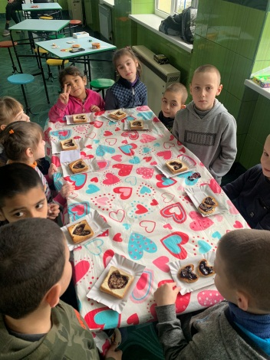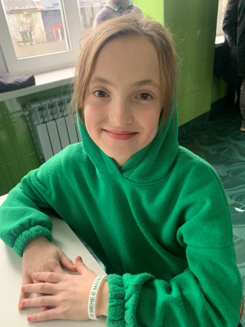The very first mission field for our charity department was Dobromyl orphanage. Now there are 93 children in this institution. The students and workers of LTS teach Bible lessons and do other activities

. We started a program that helps reveal, develop, and improve children’s talents that would help them to believe in themselves and their abilities and enhance their self-esteem. During the time that LTS has worked in Dobromyl, over 20 children came to Christ and visit evangelic churches now.

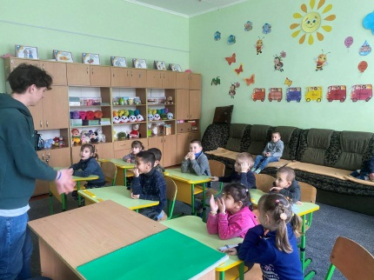

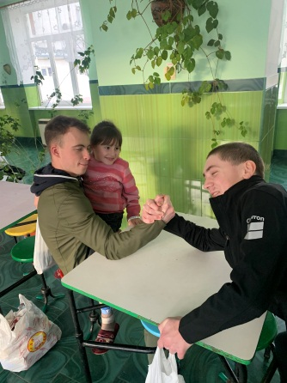 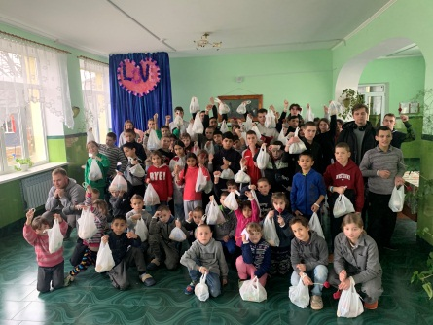

**Bukovo orphanage**

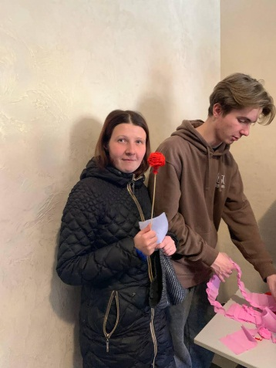Since 2004, the seminary has worked in Bukovo orphanage for girls. There are 110 children in this institution, 14 of them are bed-fast. 96 girls have from mild to intense forms of physical and mental disorders. Students have topic meetings, services, picnics, and leisure with older children. Bed-fast kids need a special care; we feed them with yogurt, take them outside, and pray for them. Students sing songs with movements, give bananas, and communicate Gods love by means of positive gestures to children that suffer from intense disorders. Girls love picnics, so the students often organize them, preparing popcorn, cotton candy, sausages, burgers, and playing games and having fun.

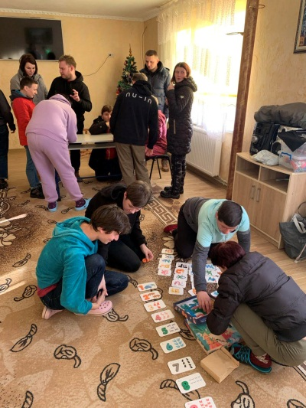 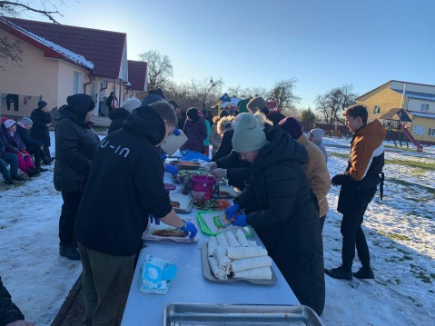 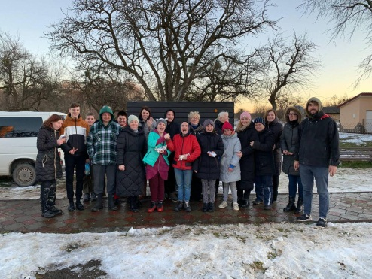

**Lopatyn orphanage**

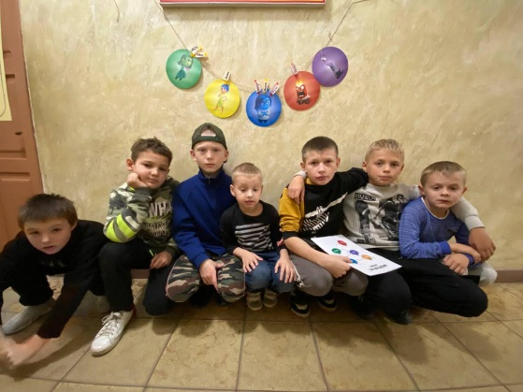In 2006, students started ministry in this orphanage. During regular trips there, we help children in different ways, teach them Bible lessons, and do crafts. Students organize celebrations, plays with decorations, and give children presents and sweets. We apply individual approaches to every child in our work.

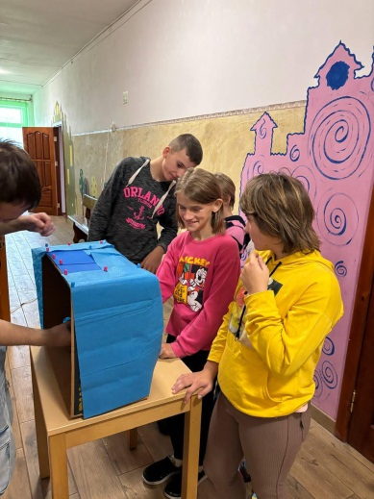 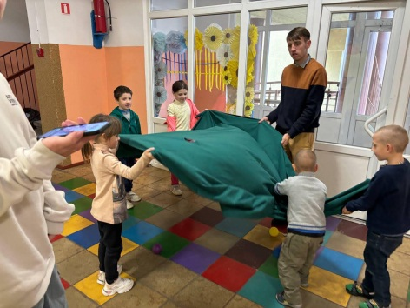 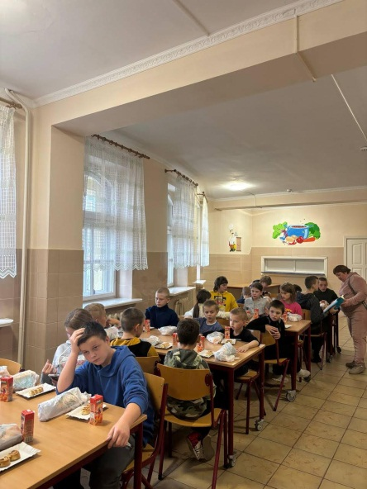

**Rava-Ruska orphanage**

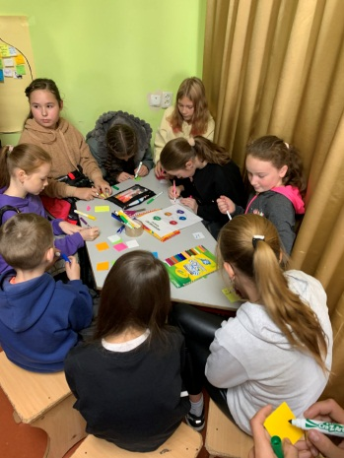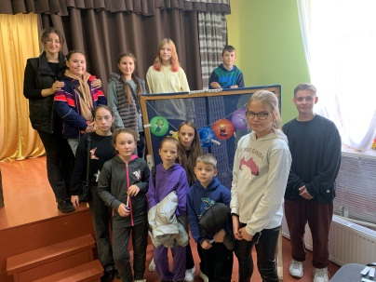In 2021, we started visiting this orphanage more often. Usually, we would bring presents and show a play once per semester, but children always invited us to come over and over again. We decided to try, and seeing that many children come to spend time with us, we started visiting Rava-Ruska on regular basis once a month. Every time we visit, around 70 children participate in our program. Most of our time there we spend outdoors. We take tables out, make cotton candy, have Bible lessons, play active games and do sports. We made friends with many children, who always stay in touch with us. We thank God that He opens us the door to work in this orphanage.

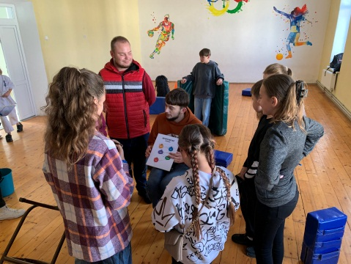 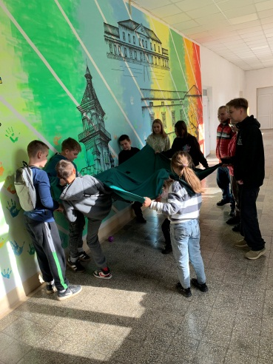 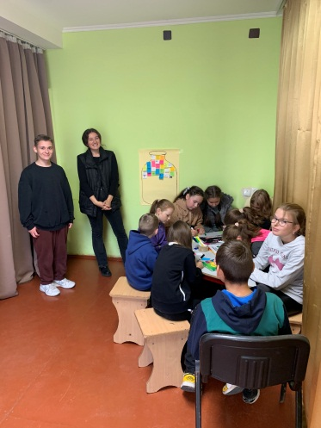

**Demna (Scole) orphanage**

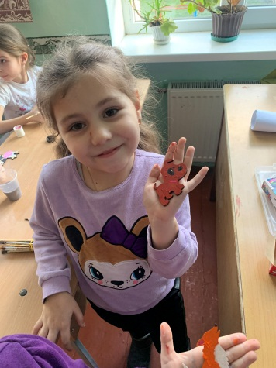

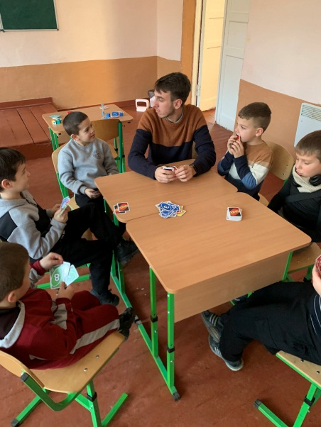All our work in orphanages has this pattern: students divide into groups of 3-4 and prepare a Bible lesson for children of certain age. They also prepare songs, drama, and games for all kids. After lunch, children can choose which group to join: crafts, arts, sports, and snacks making. If they want, kids may also get a haircut.

When the war started, this orphanage received many refugees, who still live there. These are families with children. These children also participate in our program, when visit. Altogether we have 70 children participating.

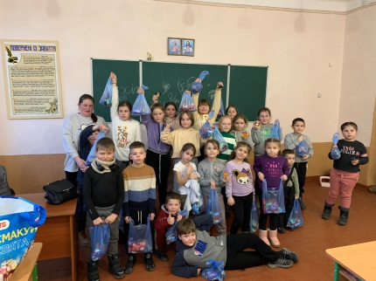 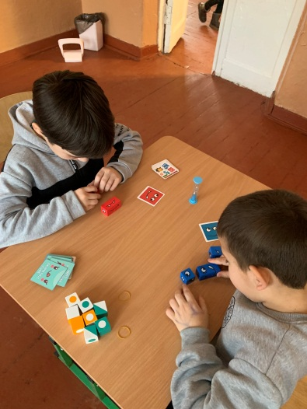 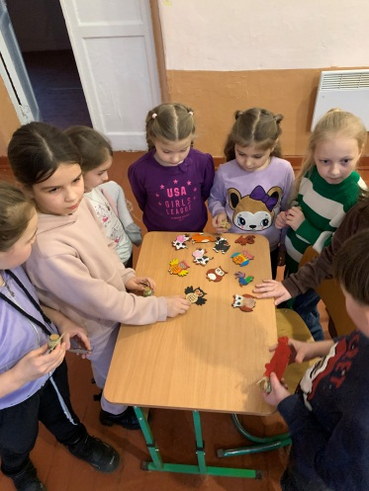

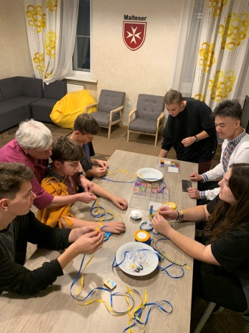**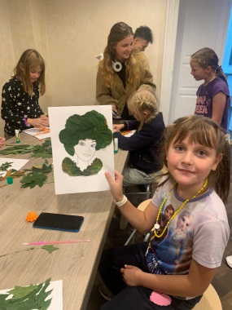Lviv government orphanage “Prosvita”**

From the beginning of September 2022, we started visiting this orphanage on regular basis, where 14 children-orphans live. Our first visits were not easy. Children were closed and didn’t want to communicate with us. At the moment, we became friends and they always wait for our visit and our program. They already have their favorites among the students.

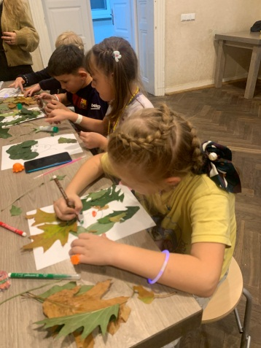 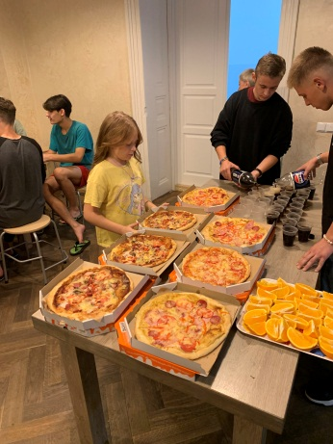 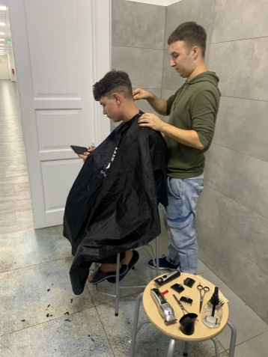

**Description of LTS activity in orphanages**

Students begin their program with a Bible lesson. Students are divided into groups of two or three. They teach a lesson at different classes. We use two programs: lessons developed by the Agape mission and courses prepared by the Samaritan’s Purse. The textbook consists of three parts, each part has 4 lessons.

Part 1: Amazing God's Gift (God Loves Us)

Part 2: Living with God (We can love God)

Part 3: Sharing God's Gift (We Can Love Others)

An important aspect is the production of visibility and demonstration in the class. The Bible lesson lasts about an hour. Then, there is a time to communicate with children, drinking tea or juice with cookies. This is a good opportunity to get acquainted and make friends with children.

Sports is an extremely fun and interesting event for children. In most cases, Rosynka uses the developed manual for games of the "Avana" club. The principle of the game is simple: everything happens in a square, which consists of 4 teams and is closed. Each team has the same number of participants. Due to the fact that each team has both adult participants and small ones, this enables the development of teamwork, as well as forms mutual understanding and compassion. At the end of the games, all teams are rewarded. Unfortunately, this program is way too difficult for Bukovo. To replace the games of the club "Avana", students prepare various simple sports relays, as well as regular games in the circle of friends.

The time for creativity: children are divided into teams and develop their skills and talents.

Rosynka team gives children the choice of several departments:

***Crafts.*** Children use their imagination and show their creativity by making vases of threads and tubes, key chains, various things from paper, cards.

***Cooking***. It gives every child the opportunity to try himself in cooking, since most children choose the profession of cook and confectioner at the end of their education. Children prepare potato pancakes, caramelized apples, decorative pears - hedgehogs, waffles in various forms, pizza.

***Music.*** Children study different motion songs, tongue-twisters, and they quickly master musical notes. Most beloved children's songs are: Airplanes fly every day; I will follow Jesus; Peace like a river; One builds his house on a rock.

***Hairdressing.*** Children have the opportunity to get any haircut. Several students make everything possible to do a haircut and hairdo.

**Testimonies of Children from Orphanages**

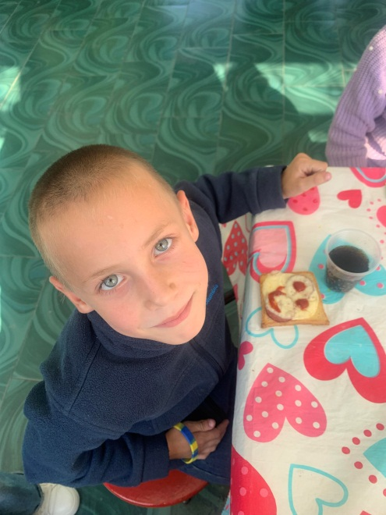I want to share a special story about a little boy with beautiful blue eyes. Currently, three children from the same family study at Dobromyl orphanage, and today, I want to tell you about **Dmytro Hrom**. He is only 7 years old and studies in the 2nd grade.

Our friendship began when I was leading the "Sweet Treats" activity. Dmytro always wanted to help me and never wanted to attend other activities—he just wanted to stay by my side. I let him be my special little helper, and that’s how our bond was formed.

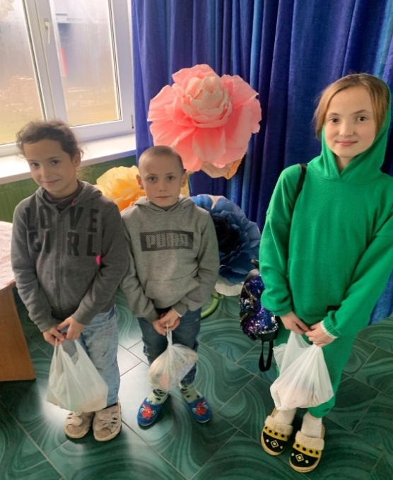Dmytro comes from a family of six children in Boryslav. Their mother is raising them alone. Their father passed away. She works a difficult job as a waitress, and due to financial struggles, she had no choice but to send three of her older children to the orphanage, while two younger ones remain with her. The eldest brother lives separately.

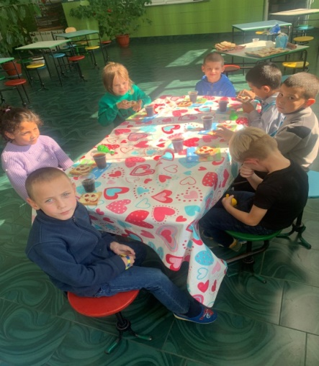Dmytro is the middle child, the youngest of the three siblings in school. His two older sisters take great care of him, making sure he behaves, studies well, and listens to his teachers. In many ways, they have taken on the role of a mother for him at school. When Dmytro was in 1st grade, he always wanted to go home, and his eyes were often filled with tears.

His favorite subject is math. He enjoys solving problems and simple equations and has already learned how to count money and calculate change in a store. He loves going shopping and picking out small things for himself. He also enjoys writing and can already spell out "Mommy" and "Daddy".

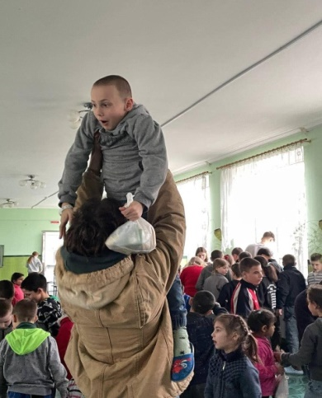Dmytro dreams of becoming a firefighter. He watches the news and sees how bravely firefighters work after missile strikes. He wants to be just like them—to rescue people and do good for others.

He still doesn't fully understand who God is, but we continue planting seeds of faith in his heart—telling him about Jesus, the Almighty God who hears prayers, changes history, and helps firefighters in their dangerous work. We pray that one day, his family will be reunited, and their mother will have the financial stability to take care of her children, giving them love, warmth, and attention that only a mother can provide. May God work a miracle in their lives.

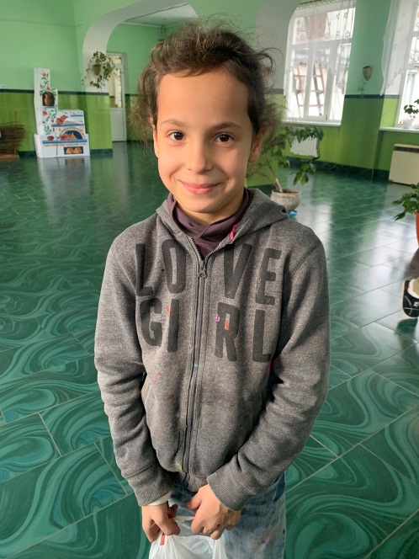**Halynka Hrom** is the younger sister of Dmytro and also studies at the Dobromyl orphanage. Her family is from Boryslav, and she comes from a household of six children. Their mother is the sole provider, as their father has passed away. Due to severe financial difficulties, their mother had to send three of her children to the orphanage in Dobromyl, while the two youngest ones remain with her. Their eldest brother lives separately. The mother works tirelessly as a waitress, but her earnings barely cover the needs of the younger children.

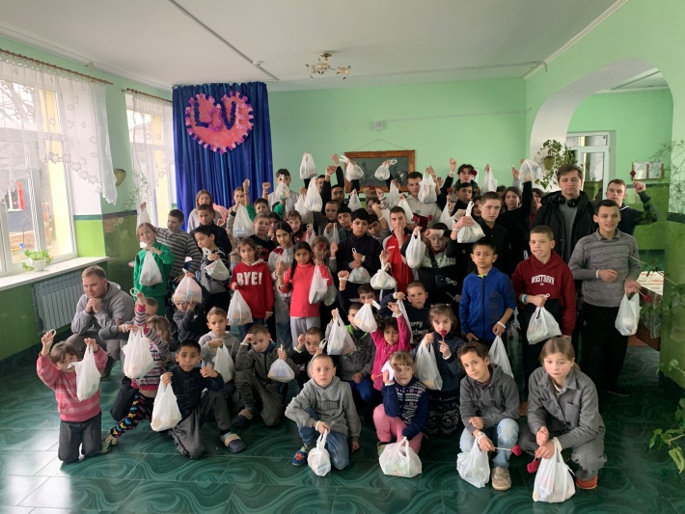Halynka is 9 years old and is currently in the 3rd grade. She was born on September 7, 2016. She is the quietest and most gentle girl in her class. She is hardly ever heard, yet other children are drawn to her, eager to be her friend and spend time with her. At first, she struggled to adjust to school and to life without her mother. However, as time passed, her wounds began to heal, and she now smiles more often than she used to. Today, she has many friends at school. Yet, her favorite time of all remains the school holidays, when her mother takes them all home.

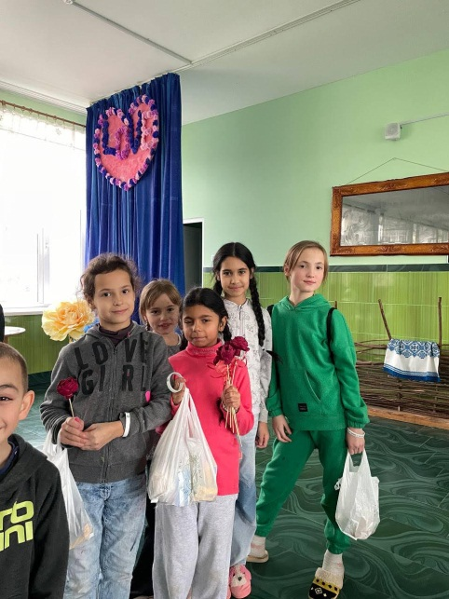Being in elementary school, Halynka adores her teacher, Oksana Volodymyrivna,

who is her favorite person at school. She listens to every lesson with admiration and loves simply sitting on her teacher’s lap, chatting about anything and everything. Her favorite subject is Ukrainian language. She dreams of becoming a doctor one day, so she could help sick children and heal those in need.

Halynka is an excellent student, as learning comes easily to her. She enjoys everything related to education, but above all, she loves drawing. Whenever she gets a paint-by-numbers set, she completely loses herself in the world of colors and creativity. She doesn’t even realize that this is the best therapy for her soul. Her favorite season is autumn, most likely because it is filled with an endless variety of colors and shades.

Halynka loves listening to stories about God. She eagerly participates in all activities and workshops, joyfully running to greet visitors. She prays sincerely for her mother, asking God to help her at work and to make her happy. May God hear the heartfelt prayers of this little girl and grant her and her siblings more time with their mother.

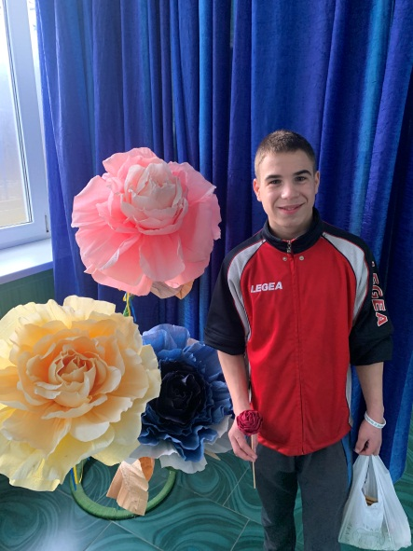**Vasyl Koblyk** has been studying at Dobromyl orphanage since first grade. For several years, the school also had a kindergarten, and even before starting school, Vasyl attended Dobromyl kindergarten. He is currently in the 7th grade.

I first met Vasyl when he was in the 1st grade. I often taught Bible lessons in his class, and he was always eager to listen with wide eyes and enthusiasm. He actively participated in quizzes and Bible competitions. Every evening, he would read the Bible as best as he could. Reading has been more challenging for him compared to other subjects—he reads slowly, saying the words syllable by syllable. Vasyl is an incredibly calm and obedient boy. He eagerly waits for students to visit, excited to take part in all the activities they prepare and lead.

He was born on December 15, 2010, and is now 15 years old. His hometown is Holovske, Sambir district. 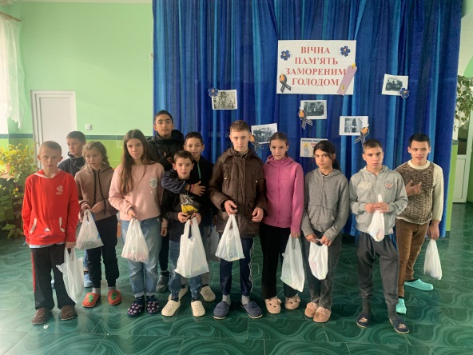

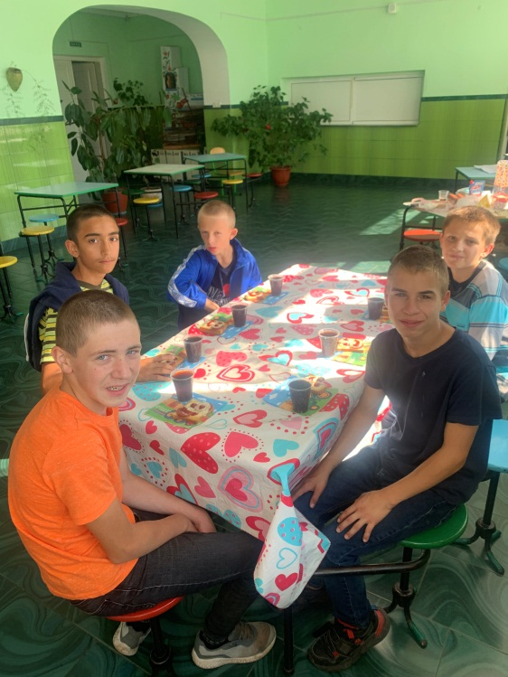A few years ago, Vasyl’s parents passed away. There were three children in the family—two brothers and one sister. His older brother was adopted by a family in the United States and no longer lives in Ukraine. His sister became his legal guardian and takes him home from time to time, especially during school holidays. She also frequently sends him money and treats.

Vasyl is a hardworking boy who loves helping teachers and caregivers. He is always looking for ways to be useful. He has a deep passion for soccer) and enjoys Ukrainian language and crafts. His dream is to become a policeman to protect and help people.

Vasyl is very open to conversations about God and listens attentively to all the stories he hears from the students. With a prayerful heart for this boy, I believe that God will take care of his life, guide his future, and surround him with good and faithful people

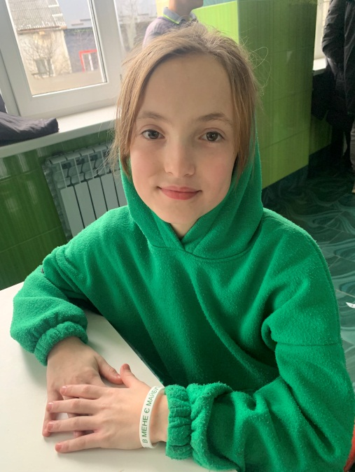**Vasylyna Hrom** is a 12-year-old girl studying at Dobromyl orphanage. She was born on 30 December 2013, and is currently in the 5th grade.

She has a deep admiration for her class teacher, Olha Yevstakhivna, who also teaches mathematics—one of Vasylyna’s favorite subjects. She enjoys solving math problems and equations and finds joy in tackling different challenges.

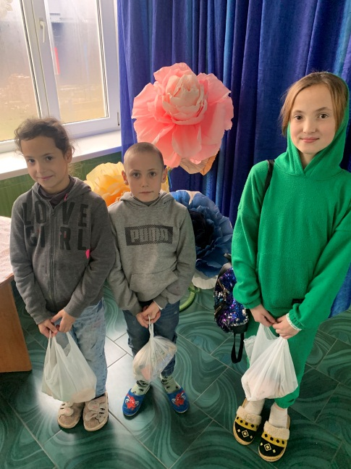Vasylyna’s father passed away five years ago. Their family consists of six children—three of them study in Dobromyl, while the eldest brother lives separately and supports himself. Their mother works tirelessly, and as the oldest daughter, Vasylyna always helps her during school breaks, going with her to work and assisting however she can. The two youngest children live at home with their mother.

One of Vasylyna’s favorite school subjects is vocational training, especially the hairdressing classes held at the school’s salon. She dreams of becoming a professional hairdresser when she grows up so she can support her mother financially and help provide for the family.

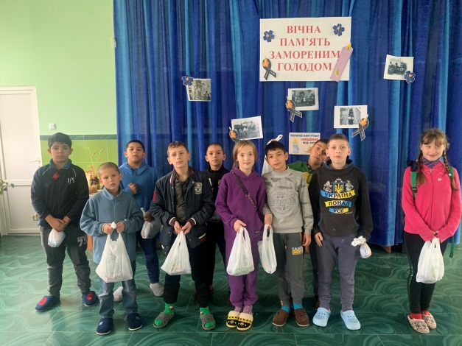In her free time, Vasylyna enjoys spending time in nature, taking quiet walks, and watching how everything around her comes to life. When she looks at the world around her, she sees God’s beauty in creation and marvels at His wisdom. She often prays for God to protect her family and her mother and eagerly waits for weekends and school breaks when they can all be together at home.

Vasylyna is a beautiful and kind-hearted girl. She loves listening to stories about God, cherishing every moment spent with visiting students. She always asks, "When will you come back?" Her excitement and eagerness remind us of how valuable each visit is—how much these children treasure the time, stories, and simple presence of those who come to see them. May God bless Vasylyna’s journey and fulfill her dreams of helping her family and bringing joy to others.

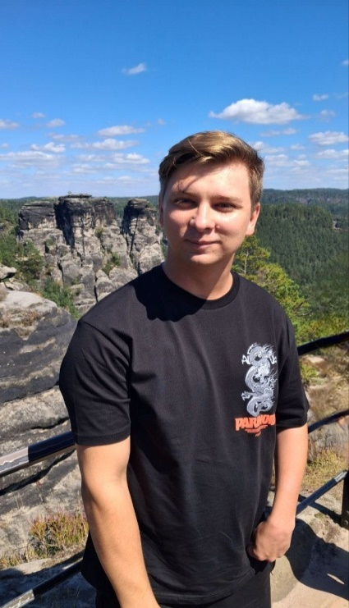 **LTS Students testimonies**

My name is Artem, I am 24, and I am a second-year seminary student. I am refugee. My home town Hirnyak in Donbas is occupied and destroyed. But I do not felt in depression. I have cerebral palsy illness but I am ok. I am grateful for the honor of visiting children's orphanages and serving these wonderful kids. I want to share a little about myself, the “Rosynka” ministry, my impressions, why this ministry is valuable to me, and what I have learned from the children.

I come from a small town in the Donetsk region. Throughout my teenage years, I felt like I lived in a town “forgotten by God,” and I saw the same sentiment in the eyes and attitudes of my family and friends. So, as soon as I came to know the Living God, I wanted to help others and contribute to improving people's lives—especially the lives of teenagers and children who gravitated toward me. Volunteering in “Rosynka” has become my primary opportunity to bring my dream, vision, and desire to life while studying in Lviv.

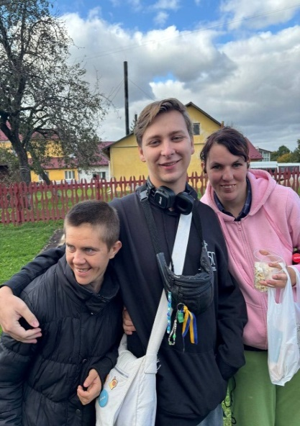

“Rosynka” is a special ministry that brings support, love, and joy to children who are longing for it and truly need it. We organize various events and meetings, traveling to places where there seem to be no roads, where even GPS navigation gets confused—but for God, there is no place that is forgotten. During these visits, the children can witness the sincere desire of volunteers to invest their strength and emotions into building friendship with them. They also hear biblical truths—not only in lessons but through personal interactions with us.

What amazes me most is the children's openness and curiosity. Especially when they share their hearts. Once, while talking to a teenage girl who struggled with smoking, we came to the conclusion that she needed to quit. As she handed me her pack of cigarettes, saying: “You know, you remind me of my father—he is also strongly against it. It’s a pity I rarely get to see him because he is in the military”. In moments like these, I feel more than ever that I am exactly where I need to be, showing that God has not forgotten anyone. I rejoice in being part of God's plan for these children.

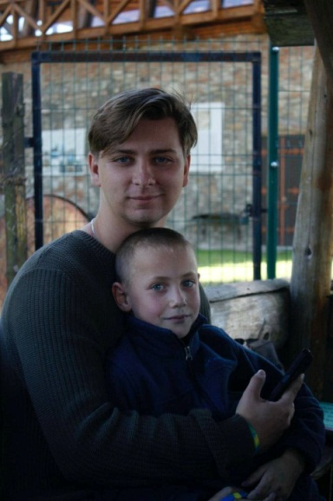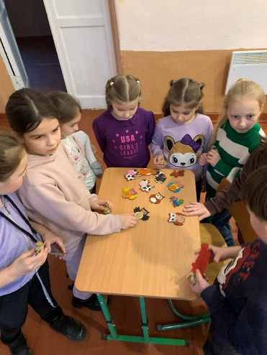 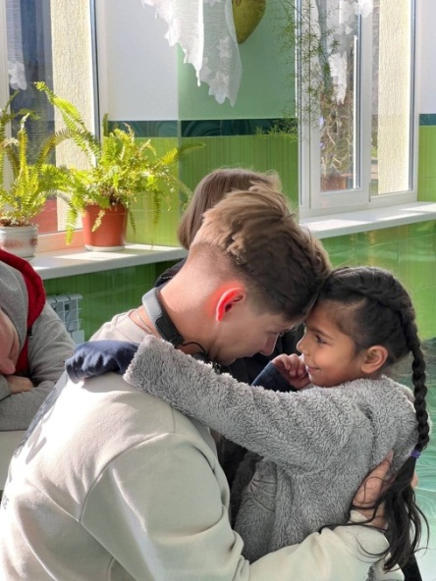

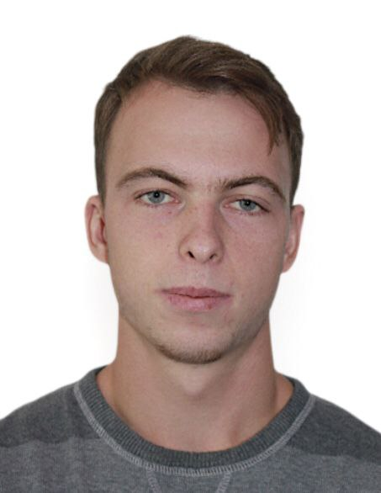My name is **Bohdan Smityukh** I was born in very big family. It is 14 children in our family. It is not easy to leave in so big family. I am from North-West of Ukraine, not far from Belarus boarder. During last 3 year it is always danger to be very close from boarder when Russian army send missiles and drones. But we survive. We prey often because nuclear reactor are very close from our village.

At the moment, I am a first-year student at LTS. I can confidently say that this is a new chapter in my life that has significantly changed my perspectives, goals, and actions and has brought wonderful new connections. LTS is about growt, not only theoretical but also practical. One of the seminary’s practical ministries is the ministry for orphans called Rosynka.

Rosynka is a unique ministry where I can be a blessing in the lives of children while gaining valuable lessons myself. When serving children, it is impossible to remain indifferent. Unforgettable for me are the children's smiles and their sincere love, which they give us at every meeting. Sometimes, in this ministry, I feel joy simply from being able to do something kind for them—fulfilling a small dream or giving a little gift. But most often, they just need attention and conversation.

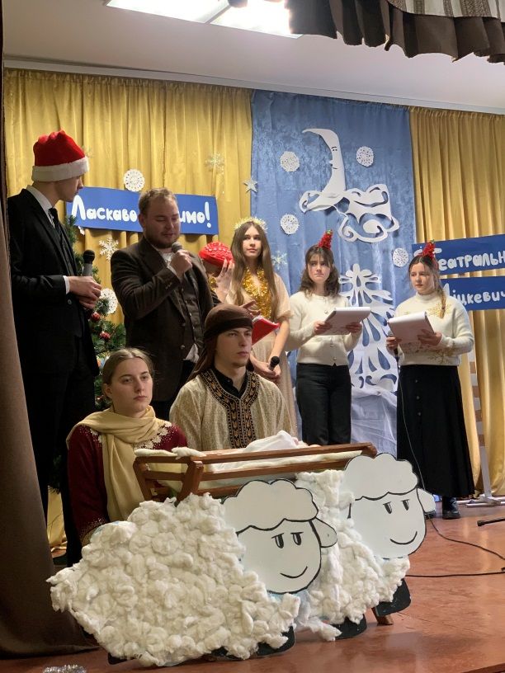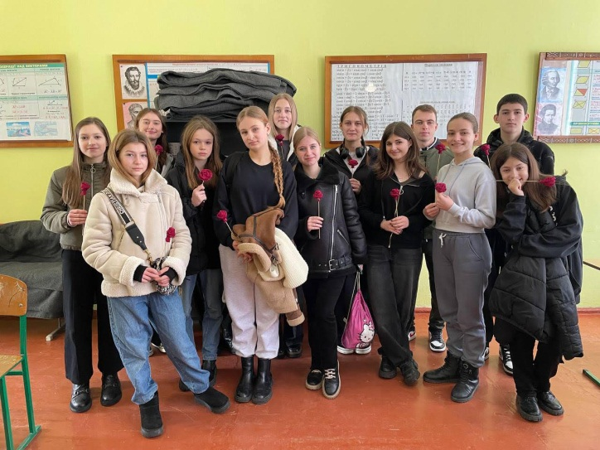At times, I feel like their mentor, but in most cases, it’s actually the other way around because children sometimes ask deep and difficult questions that I don’t always have answers to. That’s how I once realized that I needed to study history. Visiting schools and orphanages, I came to understand that children’s hearts have much to teach me. They sometimes teach lessons that no one else can.

In a way, children are teachers. They show me the character features that I often lack in my Christian life. They are examples of trust, sincerity, and joy—even in moments when there seems to be no reason for it. Children teach us to live and dream despite difficult circumstances.

Rosynka is a moment when I can show children God’s love and care in the way they need it. At the same time, it is also a moment when they reveal to me God’s love for me, helping me understand His care more deeply. Rosynka is one of those ministries that keeps me grounded in reality and helps me see the world more through Christ’s eyes, recognizing the needs of others. This ministry reminds me that Christianity must be practical!

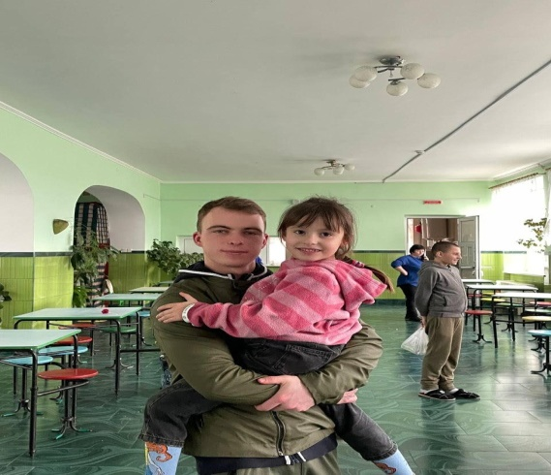 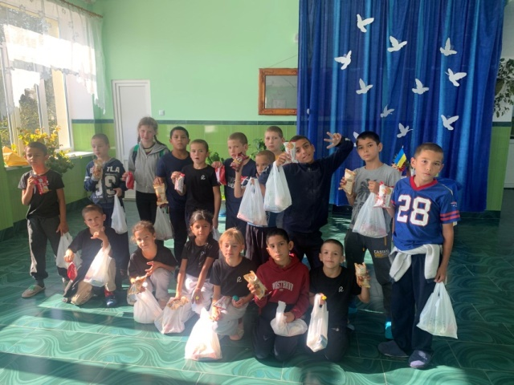

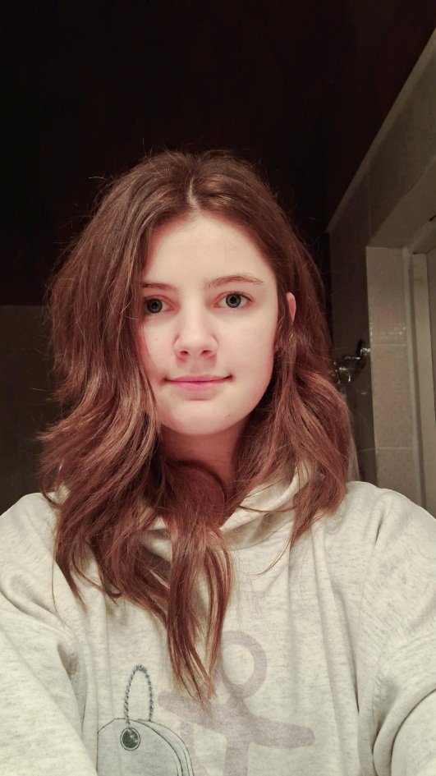

I am **Victoria Korzh**. I was born in Volynia in big family. It is 6 children in our family. But we all are very happy and thanks God for all. We live not far from Belarus boarder and it is a challenge to live not far from enemies from where Russians send missuls and drones. All forest and roads near boarder are im mines. But I like to serve the Lord.

My first trip with *Rosynka* was to the village of Bukovo, where girls live who, although they are adults, behave like children. To be honest, I didn’t know what to expect. I thought it would be an ordinary place with ordinary people who might not fully understand difficult concepts.

When I arrived, it was hard to look at them. I had never seen people who looked so unusual before; some had very short, boyish haircuts, some had scars, and there was an unpleasant smell. I felt so sorry for them. I kept thinking, *How do they live like this? It must be so difficult for them.*

But to my surprise, they were incredibly happy. When I arrived, the first thing they did was hug me—it was so sweet. I noticed that they don’t live with worries or anxieties; they are happy in the present moment. They accept everyone. And because they are so open to communication and physical affection, I forget that they are different from me. I feel very comfortable around them.

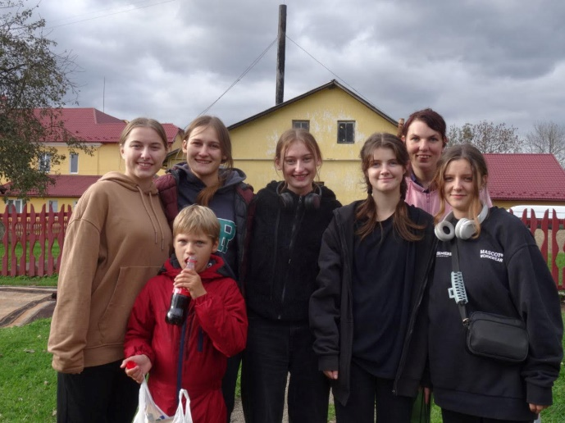The next time, we went on a Christmas outreach, visiting orphanages. The impressions were mixed. I kept wondering, *Why were these beautiful, little creations of God abandoned?* When we held our program, they listened so attentively. Their reactions touched me to the core—you really have to see them in person. They were so sweet.

I thank God and the people who organize these trips because they have taught me to be grateful for everything I have. These trips are necessary—they show a different reality, one that is not seen through rose-colored glasses. I really want to give back the same things that were given to me: love, care, warmth, and friendship.

**What Have Children Taught Me?**

To live in the present. Children don’t dwell on the past or worry about the future; they enjoy every moment.

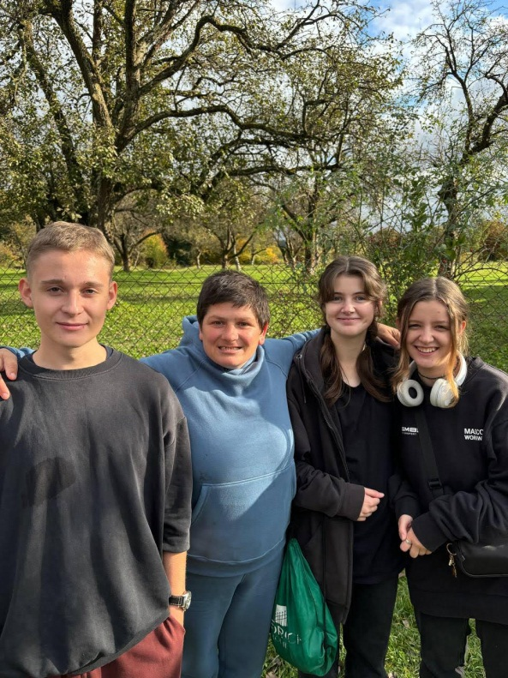To accept others as they are, without judging people by their appearance or past.

To be open to communication. The girls from Bukovo are always ready to talk and make new friends.

To appreciate simple things. They find joy in little things like playing games, spending time with friends, and being with family.

To be grateful for what I have. They have also taught me to value what I have and to be thankful for it.

This experience has changed my life. I have become more sensitive, empathetic, and grateful. I realized that happiness does not depend on material wealth or external circumstances. It is found within us. And the children helped me understand that.