This Week at PPBC



**Thursday, July 3rd**

**Friday, August 8th, 2025**

All youth in grades 7-12 are welcome at the church from 7:30 pm - 9:30 pm for a time of Bible study and games!

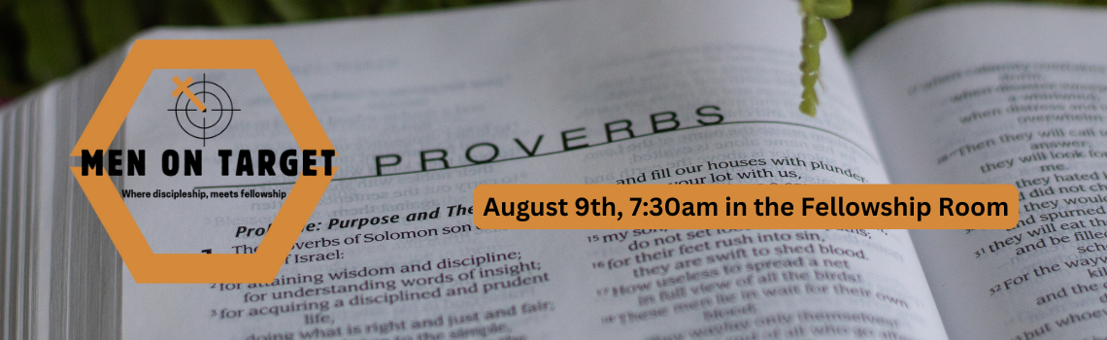

Men's Breakfast and Bible Study 7:30 am at the church

[Ministry Opportunities 2025-2026 Survey](https://forms.gle/gux2TLdFm4goxJM86)

Paper Copies available in the Office

We believe that God gives spiritual gifts to every believer so that each one can contribute to the spiritual health and growth of the local church (Ephesians 4:11-16).

To our Heavenly Father and to our church family, Thank you from your Malawi Team 2025.  We have been hugely encouraged by your support for this trip both by way of prayer and generous giving.  To date we have raised $55,440. Once again, our Heavenly Father has provided above and beyond what we dared imagine! That the funds for the school block are in and exceeded our goal will allow us to complete the structure and help furnish the space. What is an incredible gift from our Heavenly Father!  We thank God for you all and for your generous response to this need and we look forward to sharing reports on the progress of the building.  And we trust and pray that it will be used always and only for God's glory.

The Team leaves Port Perry at 6 AM on Thursday, August 7.  We thank God for the Team that He has brought together.  Each member of the Team has been working over the past 7 months to put together all that will be needed for our time in Malawi.  A special thanks to the Saunders family for printing up booklets for the children we will be working with.  As well, the owner of White Feather has generously provided pencil cases full of pens, colored pencils and much more for the children.

Please don't stop praying.  For safety throughout, that our bags will all get there, that God is already preparing the hearts of the children, the men and the women that He will be putting in our path, for our own hearts to be wide open to His leading.  May we speak the love of Jesus into each heart.

**A Prayer Request from the PPBC Malawi Team:**Pray for the team as they gather early in the morning on August 7 to start their journey to Malawi.  Your prayers through August 7- 21 are so much appreciated.  For safety, for peaceful hearts and for God’s glory.

Notes

Sunday Ministry Schedules

Below are ministry schedules for Nursery, Jr. Church, Greeters, Ushers, and Sound & Video:

**Nursery**  
**Aug 3:**Kathryn denOuden, Audrianna Angrove  
**Aug 10:**Brenda Clemens, Hannah Colwell

**Jr. Church; ages 3 to grade 6 (Classes combined for the summer)**  
**Aug 3:**Gregg & Karen Anderson, Grace Brown  
**Aug 10:**Deb Brown, Kim St-Onge

**Greeters**  
**Aug 3:**Mark & Christine McLaren  
**Aug 10:**TBA

**Ushers**  
**Aug 3: Paul Sammut,** Graeme Foster  
**Aug 10: Joe Colwell,** Nick Woytowich

**Sound & Video**  
**Aug 3:**Sound: Caleb Bolsonello | Video: Joshua Bolsonello  
**Aug 10:**Sound:  Wyatt Werner | Video: Jordan Anderson

Morning Service

Song- *Come Thou Fount of Every Blessing*

Welcome

Prayer - Malawi Missions Trip

Song – *Facing a Task Unfinished*

Scripture

Song – *His Mercy is More*

Message – *Pastor Jim Clemens*

Song – *Hallelujah What a Savior*

Communion

Song – *There is a Fountain*

Praise & Prayer Highlights

**PRAY**for Denis Tomcheski and his ongoing health concerns and testing for those concerns.**PRAY** for his health and that he would receive the care he needs.

**PRAISE** for the safe arrival of Zoey Luc Myers.  **PRAISE** that Chelsea & Josh have a healthy baby girl. Please continue to **PRAY** for them and also Dave & Mandy Myers who are now officially grandparents.

**PRAY**for Joan Mabley and the family as they make plans for her to return home next week. **PRAY** for Joan's ongoing health & recovery.

**PRAY**for Mike Smith and the Smith family as they mourn the passing of Mike's Nana. **PRAY** for God's comfort, peace and guidance for the family. While we mourn we also **PRAISE** with them and are thankful for her faith in Christ. Please **PRAY** for wisdom for them as they make plans for a service.

**PRAY** for the Persis Family as they continue to look for housing.**PRAY** that the Lord will provide for them. Please remember to **PRAY** for Amin who is in school.

**PRAY**for Bert & Ada Faber and their ongoing health concerns.

**PRAY** for the Malawi Missions Team; Lino, Les, Lisa, Thea, Sara, Kathryn, Adam, Lucas, Paul and Helen.  **PRAY** For safety throughout, that our bags will all get there, that God is already preparing the hearts of the children, the men and the women that He will be putting in our path, for our own hearts to be wide open to His leading.

**PRAY** for Les & April Saunders and the family as they mourn the loss of Les' mother. **PRAY**for God's comfort, peace and guidance for the family.

**PRAISE** for the safe arrival of Artemis Grace Bowman. **PRAISE** that Cheryl and James Bowman have a healthy baby girl. Please continue to **PRAY** for them and also Brian and Janine Kovack who are now officially grandparents.

**Giving**

Just as a reminder, there are several ways you can give:

**In Person** using the offering box located on the back wall of the sanctuary. Donation envelopes are available at the Welcome Centre. Please contact the church office if you would like a box of donation envelopes (office@portperrybaptist.ca)

**Through your online banking**, you may send electronic transfers to ppbcdonations@gmail.com.

**You can also give through Canada Helps**. Donation receipts will be provided by Canada Helps, and transaction fees apply.

***********************************************************************

**Weekly Newsletter**

The PPBC Newsletter is emailed to the church family every Friday. If you would like to be added to the weekly email list, please contact the office by phone: 905-985-8681 or by email: [office@portperrybaptist.ca](mailto:office@portperrybaptist.ca).

*****************************************************************

**Church Information:**

**Location:**

2210 Hwy 7A

Port Perry, ON

L9L 1B4

**Office Hours:**

Monday: 8:30am – 4:00pm

Tuesday: 8:30am – 4:00pm

Wednesday: Closed

Thursday: 8:30am – 4:00pm

Friday: 8:30 am - 3:00 pm

**Contact:**

Phone: 905.985.8681

Email: office@portperrybaptist.ca

Website: www.portperrybaptist.ca

**Staff:**

Sr. Pastor – Rev. Jim Clemens

Administrative Assistant – Madeline Werner

Family Ministries Director – Josh Anderson

**PPBC Newsletter**

**Sunday, August 3rd, 2025**



**Sunday Starting Point**

**Sunday, August 3rd, 2025 - 9:30 am**

*“Beginning the day with the Word and prayer”*

**Adults & Youth:**Adults and Youth will meet in the sanctuary for a time of study and prayer.

(Please note childcare is unavailable during Starting Point)

**Sunday Morning Worship**

**Sunday, August 3rd, 2025 - 10:30 am**

We are meeting in the sanctuary and will continue to live-stream for those who are unable to attend.

***Message:****The Hope of a New Exodus*

***Scripture:****Isaiah 52-55*

*Pastor Jim Clemens*