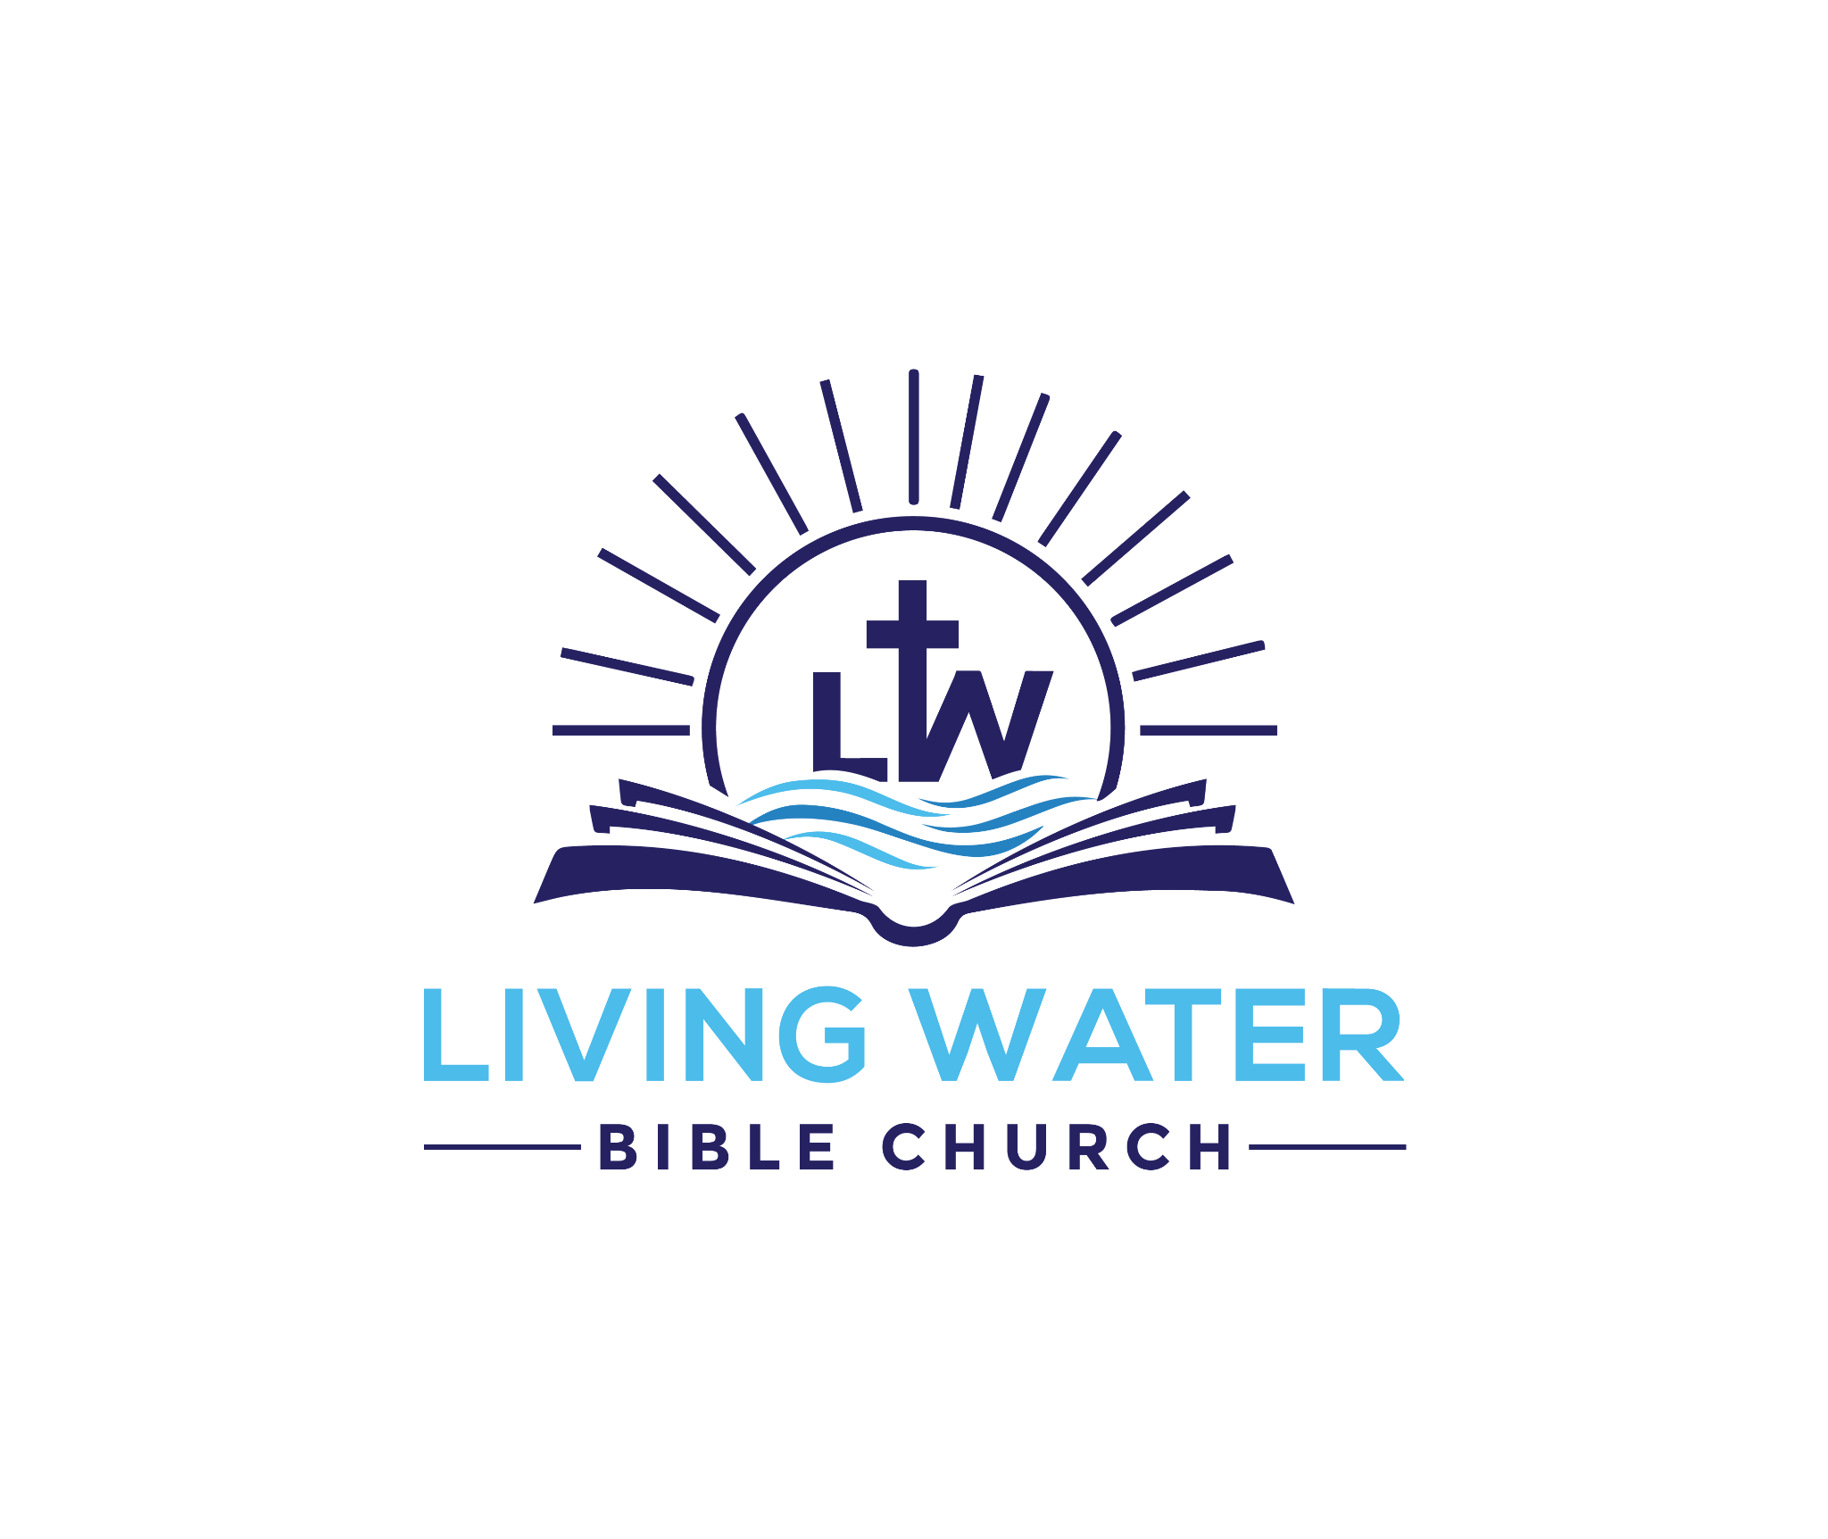
John 6:30–40 – “According to the Scriptures”
Jesus, the Bread of Life, gives eternal life to everyone who believes in Him—and promises to never cast them out. Assurance isn’t about performance, but confidence in His unchanging word.
The Biblical World – Understanding the Context:
After feeding the 5,000, Jesus engaged with a crowd demanding more signs. They referenced the manna in the wilderness, pointing to Moses as their example. But Jesus corrected them—God, not Moses, had given the manna. And now, God was giving something far greater: the true Bread from heaven. Jesus was not offering temporary satisfaction, but eternal life. This section, part of the longer Bread of Life Discourse, is where Jesus clarifies the one requirement for eternal life—believe—and offers powerful promises that guarantee security forever, all grounded in the will of the Father.

Passage Outline
- I. The Bread of Life has given us His life. (vv. 30–33)
- II. We will never hunger, thirst, or be cast out. (vv. 34–37)
- III. Our assurance is based on Jesus’ promise, not our performance. (vv. 38–40)

Passage Notes
I. The Bread of Life has given us His life. (vv. 30–33)
The crowd demanded a sign like manna, but Jesus reminded them it wasn’t Moses—it was God who gave bread. Now, God was giving the “true bread from heaven” that gives life to the world. That bread is Jesus Himself. He came down from heaven to give eternal life to a world dying in sin.
II. We will never hunger, thirst, or be cast out. (vv. 34–37)
Jesus declares: “I am the bread of life.” Those who come to Him will never hunger or thirst. And He adds a promise—“the one who comes to Me I will by no means cast out.” Eternal life is permanent. Those who believe are safe forever. It’s not about effort—it’s about receiving Him.
III. Our assurance is based on Jesus’ promise, not our performance. (vv. 38–40)
Jesus came to do the will of the Father: that none would be lost, and that all who believe in Him would be raised up on the last day. If you’ve believed in Jesus, you’ve done the will of the Father. That’s why you can be absolutely sure.

The Modern World – Relevance Today:
Our world denies absolute truth and makes salvation conditional on behavior. Even in churches, people are told to examine their works to prove they’re saved. But Jesus makes it clear—eternal life is given by believing in Him. Period. Assurance rests on His Word, not our effort.
The World of the Congregation – Applying This Passage Today:
So many believers wrestle with doubt, trying to “feel” saved or earn it. But Jesus says, “I will lose nothing.” If you’ve believed, you’re safe forever. That kind of security frees us to live boldly and serve joyfully—not to earn salvation, but because it’s already ours.

What This Means for Us
- Assurance is based on the Giver, not the receiver.
  - Are you looking to your life or to His promise for confidence?
    - → Anchor your assurance in the Bread of Life who came to give—not take away.
- Jesus will never cast you out—no matter what.
  - Have you been afraid that failure will make Him reject you?
    - → Believe His promise: “I will by no means cast out.” That’s final.
- If you’ve believed, you’re secure—so live boldly.
  - Are you holding back out of fear of not being good enough?
    - → Step out in freedom. He’s holding on to you. You’re His forever.

