Holy Trinity Evangelical Lutheran Church

August 3, 2025, at 10:30 am

Pastor Tina Crog

* welcome and Announcements worship assistant

* Call to Worship Pastor Tina
Creator God, we bring you the joyful parts of ourselves.
Weave us together in hope and praise.
God of new life, we bring you doubt and faith knotted up in our hearts.
Unravel our doubt. Weave faith into our hearts.
Draw us together and point us toward you.
In hope and faith we pray. In hope and faith we worship.

*Opening Hymn “In Christ Called to Baptize” ELW 575
One License A-700000

* Confession and Forgiveness Pastor Tina
Blessed be the triune God ✠ who created all things, who renews and sustains us, who pours out upon us the fullness of peace. Amen.

In the strong assurance of pardon, let us confess our sin.

Merciful God, we confess that like Elijah, we grow weary and afraid. We run from what you’ve called us to do. We doubt that your presence is with us. In our loneliness and despair, we forget your faithfulness. Forgive us, O Lord. Speak to us not in thunder but in silence—in stillness remind us that we are not alone, and renew us for the journey ahead. In Jesus’ name we pray, Amen.

Beloveds, God’s mercy is greater than any of our shortcomings. As a called and ordained minister of the church of Christ, and by his authority, I therefore declare to you the entire forgiveness of all of your sins. In the name of the Father, ✠ and of the Son, and of the Holy Spirit. Thanks be to God!

* Canticle of Praise “Lord Let My Heart Be Good Soil” ELW 512
One License A=700000

*Greeting Pastor Tina

*Prayer of the Day worship assistant
God of quiet strength, when we are overwhelmed by fear, when we feel alone and unsure, you come to us not in the storm, but in the stillness. Speak to us with your gentle voice, renew our weary hearts, and remind us that we are never forsaken. Strengthen us to rise and follow you again. Through Jesus Christ, our refuge and our hope, who lives and reigns with you and the Holy Spirit, one God, now and forever. Amen.

* Passing of the Peace worship assistant
May the peace of christ be with you always. and also with you.
Let’s share the sign of peace with one another.

*Children’s Moment Pastor Tina

*First Lesson: 1 Kings 18:20-39 Reader
²⁰ [King] Ahab sent to all the Israelites and assembled the prophets at Mount Carmel. ²¹ Elijah then came near to all the people and said, “How long will you go limping with two different opinions? If the Lord is God, follow him, but if Baal, then follow him.” The people did not answer him a word. ²² Then Elijah said to the people, “I, even I only, am left a prophet of the Lord, but Baal’s prophets number four hundred fifty. ²³ Let two bulls be given to us; let them choose one bull for themselves, cut it in pieces, and lay it on the wood but put no fire to it; I will prepare the other bull and lay it on the wood but put no fire to it. ²⁴ Then you call on the name of your god, and I will call on the name of the Lord; the god who answers by fire is indeed God.” All the people answered, “Well spoken!” ²⁵ Then Elijah said to the prophets of Baal, “Choose for yourselves one bull and prepare it first, for you are many; then call on the name of your god, but put no fire to it.” ²⁶ So they took the bull that was given them, prepared it, and called on the name of Baal from morning until noon, crying, “O Baal, answer us!” But there was no voice and no answer. They limped about the altar that they had made. ²⁷ At noon Elijah mocked them, saying, “Cry aloud! Surely he is a god; either he is meditating, or he has wandered away, or he is on a journey, or perhaps he is asleep and must be awakened.” ²⁸ Then they cried aloud, and, as was their custom, they cut themselves with swords and lances until the blood gushed out over them. ²⁹ As midday passed, they raved on until the time of the offering of the oblation, but there was no voice, no answer, and no response.
³⁰ Then Elijah said to all the people, “Come closer to me,” and all the people came closer to him. First he repaired the altar of the Lord that had been thrown down; ³¹ Elijah took twelve stones, according to the number of the tribes of the sons of Jacob, to whom the word of the Lord came, saying, “Israel shall be your name”; ³² with the stones he built an altar in the name of the Lord. Then he made a trench around the altar, large enough to contain two measures of seed. ³³ Next he put the wood in order, cut the bull in pieces, and laid it on the wood. He said, “Fill four jars with water and pour it on the burnt offering and on the wood.” ³⁴ Then he said, “Do it a second time,” and they did it a second time. Again he said, “Do it a third time,” and they did it a third time, ³⁵ so that the water ran all around the altar and filled the trench also with water.
³⁶ At the time of the offering of the oblation, the prophet Elijah came near and said, “O Lord, God of Abraham, Isaac, and Israel, let it be known this day that you are God in Israel, that I am your servant, and that I have done all these things at your bidding. ³⁷ Answer me, O Lord, answer me, so that this people may know that you, O Lord, are God and that you have turned their hearts back.” ³⁸ Then the fire of the Lord fell and consumed the burnt offering, the wood, the stones, and the dust and even licked up the water that was in the trench. 39 When all the people saw it, they fell on their faces and said, “The Lord indeed is God; the Lord indeed is God.”

The Word of the Lord. Thanks be to God.

*Psalm 96:1-9 Reader
¹ O sing to the Lord a new song;
sing to the Lord, all the earth.
² Sing to the Lord; bless his name;
tell of his salvation from day to day.
³ Declare his glory among the nations,
his marvelous works among all the peoples.
⁴ For great is the Lord and greatly to be praised;
he is to be revered above all gods.
⁵ For all the gods of the peoples are idols,
but the Lord made the heavens.
⁶ Honor and majesty are before him;
strength and beauty are in his sanctuary.
⁷ Ascribe to the Lord, O families of the peoples,
ascribe to the Lord glory and strength.
⁸ Ascribe to the Lord the glory due his name;
bring an offering, and come into his courts.
⁹ Worship the Lord in holy splendor;
tremble before him, all the earth.

* Acclamation “Alleluia” ELW pg. 205
Al-le-lu-ia! Lord and Sav-ior: o-pen now your sav-ing word.
Let it burn like fire with-in us: speak un-til our hearts are stirred.
Al-le-lu-ia! Lord, we sing for the good news that you bring.

*Second Lesson: 1 Kings 19:1-18 Pastor Tina
¹ Ahab told Jezebel all that Elijah had done and how he had killed all the prophets with the sword. ² Then Jezebel sent a messenger to Elijah, saying, “So may the gods do to me and more also, if I do not make your life like the life of one of them by this time tomorrow.” ³ Then he was afraid; he got up and fled for his life and came to Beer-sheba, which belongs to Judah; he left his servant there.
⁴ But he himself went a day’s journey into the wilderness and came and sat down under a solitary broom tree. He asked that he might die, “It is enough; now, O Lord, take away my life, for I am no better than my ancestors.” ⁵ Then he lay down under the broom tree and fell asleep. Suddenly an angel touched him and said to him, “Get up and eat.” ⁶ He looked, and there at his head was a cake baked on hot stones and a jar of water. He ate and drank and lay down again. ⁷ The angel of the Lord came a second time, touched him, and said, “Get up and eat, or the journey will be too much for you.” ⁸ He got up and ate and drank; then he went in the strength of that food forty days and forty nights to Horeb the mount of God. ⁹ At that place he came to a cave and spent the night there.
Then the word of the Lord came to him, saying, “What are you doing here, Elijah?” ¹⁰ He answered, “I have been very zealous for the Lord, the God of hosts, for the Israelites have forsaken your covenant, thrown down your altars, and killed your prophets with the sword. I alone am left, and they are seeking my life, to take it away.”
¹¹ He said, “Go out and stand on the mountain before the Lord, for the Lord is about to pass by.” Now there was a great wind, so strong that it was splitting mountains and breaking rocks in pieces before the Lord, but the Lord was not in the wind, and after the wind an earthquake, but the Lord was not in the earthquake, ¹² and after the earthquake a fire, but the Lord was not in the fire, and after the fire a sound of sheer silence. ¹³ When Elijah heard it, he wrapped his face in his mantle and went out and stood at the entrance of the cave. Then there came a voice to him that said, “What are you doing here, Elijah?” ¹⁴ He answered, “I have been very zealous for the Lord, the God of hosts, for the Israelites have forsaken your covenant, thrown down your altars, and killed your prophets with the sword. I alone am left, and they are seeking my life, to take it away.” ¹⁵ Then the Lord said to him, “Go, return on your way to the wilderness of Damascus; when you arrive, you shall anoint Hazael as king over Aram. ¹⁶ Also you shall anoint Jehu son of Nimshi as king over Israel, and you shall anoint Elisha son of Shaphat of Abel-meholah as prophet in your place. ¹⁷ Whoever escapes from the sword of Hazael, Jehu shall kill, and whoever escapes from the sword of Jehu, Elisha shall kill. ¹⁸ Yet I will leave seven thousand in Israel, all the knees that have not bowed to Baal, and every mouth that has not kissed him.”

The Word of the Lord. Thanks be to God.

*Sermon Pastor Tina

* Hymn of the Day "He Comes to Us as One Unknown" ELW 737 vs. 1-4
one license A-700000

* Apostle’s Creed
I believe in God, the Father almighty,
creator of heaven and earth.
I believe in Jesus Christ, God's only Son, our Lord,
who was conceived by the power of the Holy Spirit,
born of the Virgin Mary,
suffered under Pontius Pilate,
was crucified, died, and was buried;
he descended to the dead.
On the third day he rose again;
he ascended into heaven,
he is seated at the right hand of the Father,
and he will come to judge the living and the dead.
I believe in the Holy Spirit,
the holy catholic Church,
the communion of saints,
the forgiveness of sins,
the resurrection of the body,
and the life everlasting. Amen.

* Prayers of Intercession Pastor Tina
please be seated
any prayer concerns or joys to share
In solidarity with all creation, we join our voice to the voice of the whole church and pray for the needs of the world.
A brief silence.
Renew in your church a perspective of life beyond worldly pursuits. Build an enthusiasm to embrace life in Christ, so that Christ, the life of the world, is revealed to everyone. God of grace, hear our prayer.
Revitalize and protect the treasures of wild places. Teach all people to value the earth, winds, waters, trees, and animals, the gifts that make life possible on this planet. God of grace, hear our prayer.
Speak wisdom to any in positions of power, that they cease practices of divisiveness, insult, and oppression. Clothe all people in your image, and establish equity and peace. God of grace, hear our prayer.
Reveal your loving presence in the lives of people suffering hunger and need, illness and grief, pain and fear (especially). Give strength to those who give care, and equip them with compassion as they make your love known. God of grace, hear our prayer.
Store up in this congregation a full measure of gratitude and generosity. Guide the work of treasurers and all who attend to financial matters. Support those whose work in our community is difficult and demanding; make us mindful of the toil that goes unnoticed. God of grace, hear our prayer.

Receive our thanks for the lives of your saints who now rest from their labors. Give us wisdom through their witness and encourage us in love as we continue our lives in the world. God of grace, hear our prayer.

Trusting in your lovingkindness, we place our prayer and hope in you, in the name of Jesus Christ. Amen.

*Offering worship assistant
The monthly mission for August is for the Prayer Shawl Ministry. Let us give to god what was first given to us.

*offering music by jared
*Offering Hymn “This is Christ’s Body” ACS 967
Pastor sings first time through. All sing second time through
To be sung while the offering is being returned to the altar.

* Offering Prayer worship assistant and congregation
God of all threads, we bring these gifts—offered from tangled lives and unraveling plans— trusting that You weave wholeness from what feels undone. Use these offerings to mend what is broken, to wrap others in care, and to remind us that Your love never comes apart. Amen.

*The Great Thanksgiving ELW page 206
The Lord be with you.
And also with you.
Lift up your hearts.
We lift them to the Lord.
Let us give thanks to the Lord our God.
It is right to give God our thanks and praise.

It is indeed right our duty and our joy….we praise your name and join their unending hymn:

* Holy, Holy, Holy
* Liturgy of Holy Communion Pastor Tina

* Lord’s Prayer Pastor Tina
let us pray the prayer jesus taught us to pray.
our father, who art in heaven, hallowed be thy name, thy kingdom come, thy will be done, on earth as it is in heaven. give us this day our daily bread; and forgive us our trespasses, as we forgive those who trespass against us; and lead us not into temptation, but deliver us from evil. for thine is the kingdom, and the power, and the glory, forever and ever. amen.

* Lamb of God

*Special Music during Holy Communion by Jared
*Post Communion Blessing

* Post Communion Hymn "Glory to God, Whose Goodness Shines" ACS 1087
Pastor sings first time through. All sing second time through

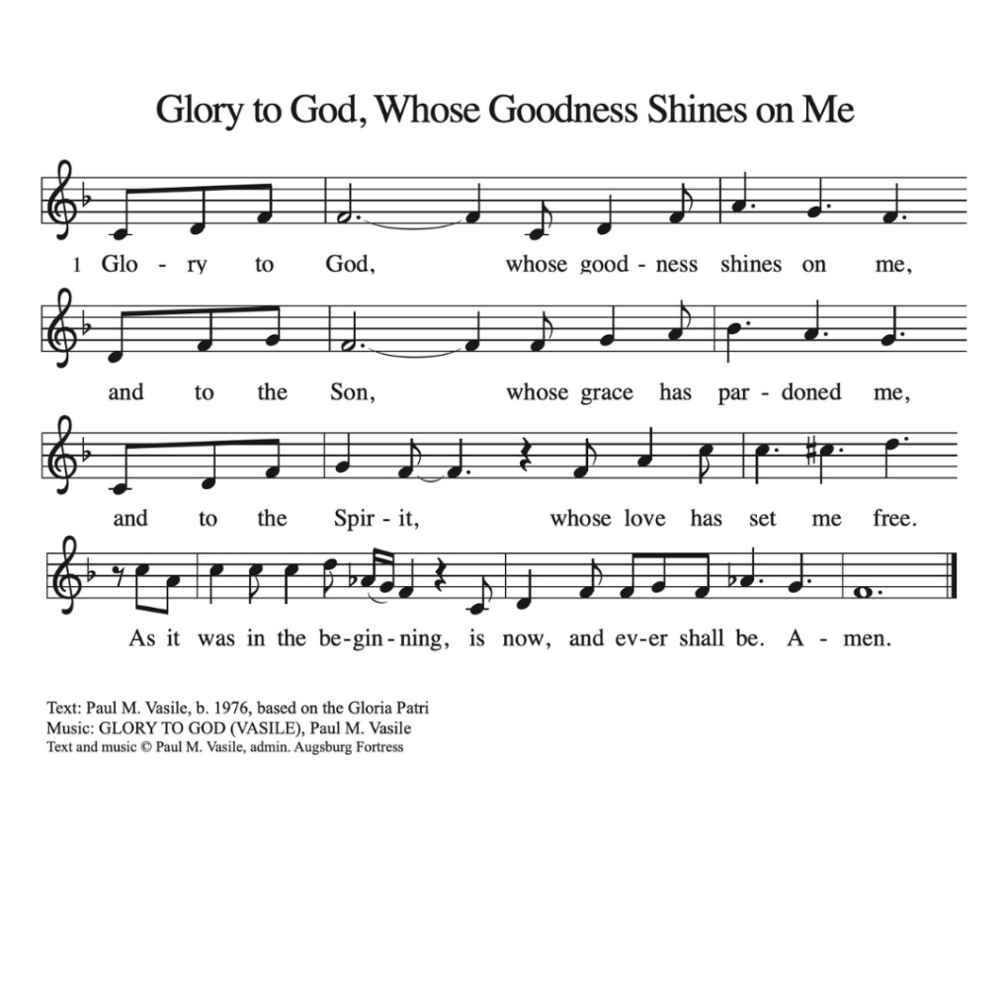

* Prayer After Communion pastor tina and congregation
Gracious God, in this meal you meet us in the breaking and the blessing. When our lives come apart, your love holds us together. Send us out nourished by grace, to mend, to serve, and to trust the threads you are still weaving. Amen.

* Blessing pastor tina

* Closing Hymn "How Great Thou Art" ELW 856
one license A-700000

* Dismissal worship assistant
Go in peace, sharing the gifts of Christ! Thanks be to God!

*Postlude

Call to Worship and the Confession and Forgiveness are by Sarah Are | A Sanctified Art LLC| sanctifiedart.org

