Name of Assembly: United Apostolic Church
Type of service: Bible Study
Date: July 29th, 2025
Series Topic: The Works of the Flesh
Lesson 5: Sins of Hostility – Part 4
Scripture Text: Galatians 5:19-21
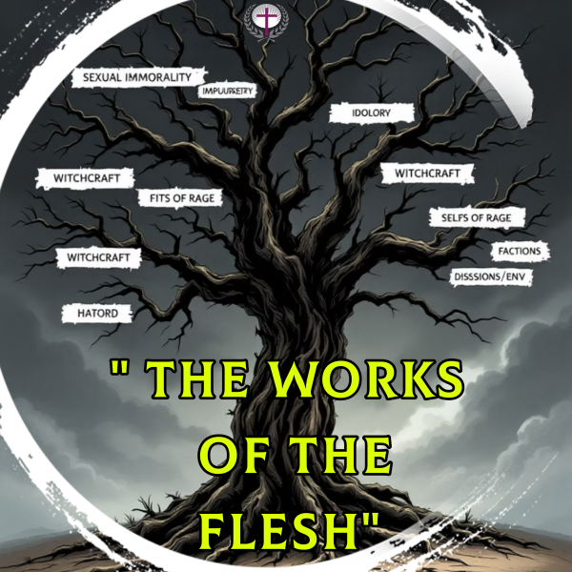

“¹⁹ Now the works of the flesh are manifest, which are these; Adultery, fornication, uncleanness, lasciviousness, ²⁰ Idolatry, witchcraft, hatred, variance, emulations, wrath, strife, seditions, heresies, ²¹ Envyings, murders, drunkenness, revellings, and such like: of the which I tell you before, as I have also told you in time past, that they which do such things shall not inherit the kingdom of God” - Galatians 5:19-21

SINS OF HOSTILITY - Hatred, Variance, Emulations, Wrath, Strife, Seditions, Heresies, Envyings, and Murder

WORK # 12: SEDITIONS

Biblical Definition: The Greek term “dichostasiai,” translated as “seditions” or “dissensions,” denotes sharp divisions, factions, or standing apart. It highlights a deliberate fracturing of unity within the Church community. In Galatians 5:20, Paul places this grievous sin squarely among the “works of the flesh,” contrasting it sharply with the “fruit of the Spirit” and emphasizing its spiritual danger to believers.

Spiritual Consequence

The devastating spiritual consequence of sedition is the fracturing of Christ's body, the Church. This directly grieves the heart of Jesus, who prayed in John 17:21, “That they all may be one; as thou, Father, art in me, and I in thee, that they also may be one in us: that the world may believe that thou hast sent me.” When the body is divided, our collective witness to the world is severely damaged, hindering the spread of the Gospel.

Roots of Division

Sedition often stems from selfish ambition, pride, and a lack of love. It can be fueled by false teaching, personal grievances, or a desire for power rather than a humble submission to Christ's headship. These internal conflicts sow discord and disrupt the peace and order of the congregation, undermining its very foundation.

Scripture consistently warns against divisive behavior, with Paul emphasizing in 1 Corinthians 1:10 that believers should “¹⁰ … speak the same thing, and that there be no divisions among you; but that ye be perfectly joined together in the same mind and in the same judgment."

The Anatomy of Church Division: Root Causes of Seditions

- Personality conflicts between members
- Pride and unwillingness to yield to God's will and others
- Doctrinal disagreements are handled poorly, leading to factionalism.
- Power struggles within leadership, seeking personal gain over corporate good.
- Unresolved offenses festering over time, leading to bitterness and resentment.
- Unbiblical or authoritarian leadership practices that stifle healthy dissent.
- The insidious spread of gossip, slander, and backbiting.
- Worldly ideologies and cultural trends subtly infiltrating biblical truth.
- Failure to practice biblical conflict resolution and reconciliation.
- Lack of transparent, open, and consistent communication.

Manifestations and Warning Signs of Division

- Disengagement and Apathy - Members begin to withdraw from fellowship, ministry, and corporate worship, feeling disconnected or disheartened by internal strife.
- Formation of Cliques - Exclusive groups and factions emerge, often based on shared grievances, specific interests, or loyalty to particular individuals rather than the body as a whole.
- Increased Criticism - A prevalent spirit of negativity, fault-finding, and public criticism towards leadership, other members, or church decisions begins to dominate conversations.
- Decline in Corporate Practices - A noticeable decrease in participation in collective worship, prayer meetings, and other unifying church activities, indicating a breakdown in shared purpose.
- Prioritizing Preferences - Individual or group preferences and desires begin to outweigh the pursuit of unity, peace, and the glory of God in the community.

Practical Steps for Preventing Division

- Study Scripture Together - Regular, deep Bible study helps align the congregation around God's truth rather than personal opinions.
- Pray for Unity - Make church unity a regular focus of prayer, both privately and in corporate gatherings.
- Address Conflicts Early - Follow Matthew 18 principles for conflict resolution to prevent minor disagreements from growing into major divisions.
- Practice Forbearance - Cultivate patience with differences and focus on the essential doctrines that unite rather than minor issues that divide.

WORK # 13: HERESIES

Biblical Definition: The Greek word for “heresies” is “hairesis” and refers to divisions within the church caused by the adoption of dissenting or divisive doctrines or practices. Unlike mere theological differences, heresies represent willful departures from apostolic teaching that threaten the very essence of the gospel message.

Despite being written nearly two millennia ago, Paul's warning remains profoundly relevant today. As new theological perspectives continually emerge, believers must vigilantly discern between genuine biblical teaching and dangerous innovations that undermine foundational truths of the faith.
Paul's placement of heresies among the “works of the flesh” in Galatians 5 reveals their serious spiritual nature. These aren't simply intellectual disagreements but manifestations of human rebellion against divine revelation.

Danger of Heresies
- Doctrinal Corruption - Distorts core gospel truths about Christ, salvation, and God's nature.

- Church Division - Creates factions and breaks fellowship between believers.
- Spiritual Harm - Leads people away from authentic faith into deception.

Throughout church history, heretical teachings have typically appeared attractive and innovative while subtly undermining foundational biblical truths. Their danger lies in how they can seem reasonable while leading believers away from saving faith.

The Berean Model: Scriptural Discernment
Acts 17:11 highlights the Bereans, who “… received the word with all readiness of mind, and searched the scriptures daily, whether those things were so.” This exemplary approach to evaluating teaching serves as a model for all believers.
- Receive Teaching - Listen with openness but not blind acceptance
- Search Scripture - Examine the Bible to verify claims
- Test Alignment - Determine if teaching conforms to biblical truth
- Accept or Reject - Embrace truth, discard error.
The Berean example demonstrates that scriptural discernment isn't optional—it's essential for protecting oneself and others from deception. When Christians fail to exercise this vigilance, they become vulnerable to attractive but dangerous theological innovations.

Conclusion
To effectively identify heretical teachings, believers must first be thoroughly grounded in the apostolic doctrines. This requires a dedicated study of Scripture and familiarity with the core beliefs that have defined our Church from its very beginning.
Paul's instruction to “walk in the Spirit” (Galatians 5:16) provides the ultimate safeguard against works of the flesh, including heresy. The Holy Spirit guides believers into truth and enables them to discern between genuine biblical teaching and dangerous counterfeits.
Standing firm requires lifelong vigilance. False teaching rarely announces itself as heresy but typically comes packaged as enlightened or progressive thinking. By committing to Scripture as the ultimate authority, believers protect both themselves and the church from the divisive influence of heretical ideas.

PERSONAL NOTES
……………………………...………………………………………………
…………………………………...…………………………………………………………………………………………………………………...........…………………………………...…………………………………………………………………………………………………………………...……

