Live God’s law (6:8–9)

^{ESV}Deut. 6:8 You shall bind them as a sign on your hand, and they shall be as frontlets between your eyes. ⁹You shall write them on the doorposts of your house and on your gates.

Bind them —

Phylacteries or Tefillin — small boxes that contain portions of the Torah which are bound with leather straps to the arm and forehead.

The Law of God should govern what a person does (arm) and desires (eyes)

Do your actions and desires reflect God’s

Mezuzah — a small container that holds a scroll of Torah and is attached to the doorposts of a house

The Law of God begins in the home but then extends into the community

“After ordering that the covenant commandments be worn on the person of the faithful Israelite, Moses expanded the sphere of covenant claim to the house and then to the village. In this manner the person and his entire family and community become identified as the people of the Lord” (Merrill, Deuteronomy, 168).

Sunday, July 20, 2025 Deuteronomy
Tim Little Love for the Lord Alone: Foundation to a Genuine Faith

Deuteronomy 6:1–9

Background

Moses exhorts the children of Israel to follow the Lord by recounting their past successes and failures in the historical prologue to Deuteronomy (1:1—4:43). The second section contains the general stipulation of the covenant (4:44—11:32) which is more of a sermon than a law code.

Historical Prologue (1:1—4:49)

General Stipulations (5:1—11:32)

The Ten Commandments (5:1–21)
Moses, Teacher of the Law (5:22–33)
The Shema—Love the Lord (6:1–9)

How does Deuteronomy 6:1–9 connect back to chapter 5?

- This is the commandment (6:1; cf. 4:44)

- These are the statues and rules (6:1; cf. 5:1, 33)

- The Lord commanded me to teach you (6:1; cf. 4:44)

Be careful to obey God’s Law (6:1–3; cf. 5:1)

^{ESV} Deut. 6:1 “Now this is the commandment—the statutes and the rules—that the LORD your God commanded me to teach you, that you may do them in the land to which you are going over, to possess it, ²that you may fear the LORD your God, you and your son and your son’s son, by keeping all his statutes and his commandments, which I command you, all the days of your life, and that your days may be long. ³Hear therefore, O Israel, and be careful to do them, that it may go well with you, and that you may multiply greatly, as the LORD, the God of your fathers, has promised you, in a land flowing with milk and honey.

- Repeatedly, Moses exhorts the children of Israel to obey the law
You shall learn them and be careful to do them (5:1)
They may do them (5:31)
You shall be careful therefore to do (5:32)
You may do them (6:1)
Be careful to do them (6:3)

How must you be careful to obey God’s Law?

^{ESV}1 John 5:3 For this is the love of God, that we keep his commandments. And his commandments are not burdensome.

Prioritize your love for the Lord (6:4–6)

^{ESV} Deut. 6:4 “Hear, O Israel: The LORD our God, the LORD is one. ⁵You shall love the LORD your God with all your heart and with all your soul and with all your might. ⁶And these words that I command you today shall be on your heart.

The meaning of “The Lord is one”
Possible translation: The Lord is our God, the Lord alone (i.e., the only one)

^{ESV} Zech. 14:8 On that day living waters shall flow out from Jerusalem, half of them to the eastern sea and half of them to the western sea. It shall continue in summer as in winter. ⁹And the LORD will be king over all the earth. On that day the LORD will be one and his name one.

Only one thing matters in life—The Lord.

^{ESV} James 2:19 You believe that God is one; you do well. Even the demons believe—and shudder!

“The Shema’ should not be taken out of context and interpreted as a great monotheistic confession. Moses had made that point in 4:35, 39: ‘For Yahweh (alone) is God; there is none beside(s) him.’ . . . The language of the Shema’ is ‘sloganesque’ rather than prosaic: ‘Yahweh our God! Yahweh alone!’” (Block, “How Many Is God?” JETS, 47.2, 211).

The Lord demands a love that encompasses your entire being

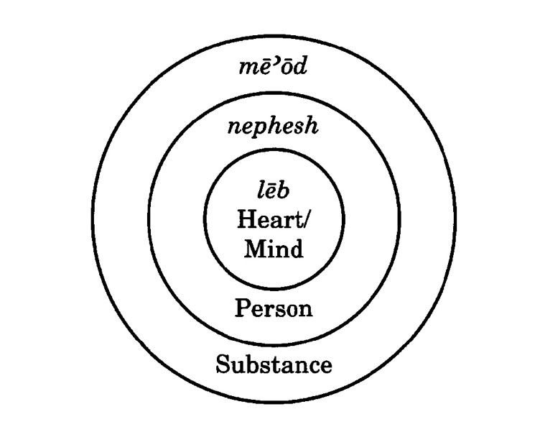
Illustration taken from Block, “How Many Is God?” JETS, 47.2, 203.
Heart—the organ that thinks (mind) and feels
^{ESV}Luke 10:27 Jesus answered, “You shall love the Lord your God with all your heart and with all your soul and with all your strength and with all your mind”
Soul—literally, breath—the things that sustains one’s life (food and air)
Strength—your stuff/possessions

How can “love” be a command?

-Love is an action

-Love is a desire

-Loves can be trained

^{ESV} Prov. 4:23 Keep your heart with all vigilance,
for from it flow the springs of life.

We do the things that we love

What do you love?

Do you love something more than the Lord?

^{ESV} Luke 14:25 Now great crowds accompanied him, and he turned and said to them, ²⁶“If anyone comes to me and does not hate his own father and mother and wife and children and brothers and sisters, yes, and even his own life, he cannot be my disciple. ²⁷Whoever does not bear his own cross and come after me cannot be my disciple.

Teach God’s law (6:7)

^{ESV} Deut. 6:7 You shall teach them diligently to your children, and shall talk of them when you sit in your house, and when you walk by the way, and when you lie down, and when you rise.

Diligently — repetitively, “to recite again and again” (HALOT, 4:1607).

Merism — “A literary device that uses an abbreviated list to suggest the whole. The most common type of merism cites the poles of a list to suggest everything in between” (Longman III, “Merism” in Dictionary of the Old Testament Wisdom, Poetry, & Writing, 464).

Believing parents repetitively teach their children God’s Word through the regular affairs of life

