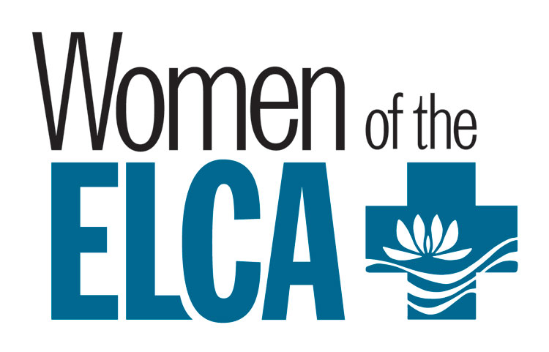**Registration Form**

**Northern Illinois Synod Women of the ELCA**

**36th Annual Convention, September 20, 2025**

**Theme:** *“Rescue, Redeem, Restore”*

**First Lutheran Church**

**225 South 3rd Street, Rockford**

**Article VI – Conventions; Section 2. Representation. Item 1. Voting members of a convention shall be the elected officers of the Synodical women’s organization and one voting member for each unit on the roll of this Synodical women’s organization.**

**Note: Voting member’s duties include attending the business session of the convention.**

**Please check one: VOTING MEMBER__ ALTERNATE ____ PARTICIPANT ____**

**(Deadline is August 20)**

**Please circle your conference:**

**Central East North Northeast Northwest South Southwest West**

***PLEASE PRINT:***

Name ___________________________________________________________________________

Address__________________________________City_________________________

Phone ________________________ E-Mail Address __________________________

Special Meal Request: ____ Vegetarian ____ Gluten Free _____

Name of ELCA Congregation where you are a member ______________________

Address of Church ________________________________________

Pastor’s name and phone ____________________________

Your signature ___________________________________ Date _____________________

***(If you apply for a Scholarship, please include your completed Scholarship Form with this completed Registration Form and send them both to Ruth Anne Hartman.. Her address is on the Scholarship Form. Scholarship requests are due by August 20.)***

**If you are not applying for a Scholarship, please complete this form by August 20, 2025 (indicating if you are a voting member or a participant, with the $50 registration fee) and send to:**

**Convention Registrar: Sandy Swanson, 230 Birch Place, Kewanee, IL 61443**

**Registration Fee: $50.00 (Please do not send cash)** Make **your check or money order payable to: Northern Illinois Synod Women of the ELCA (NIS WELCA)**

**We encourage you to send your individual and/or unit offering with your registration. The convention offering will be divided between the Churchwide WELCA, Our Savior’s Lutheran Church-Rocky Boy, and Rockford Remedies I-Rise Program. Items for physical offering are listed on the invitation.**