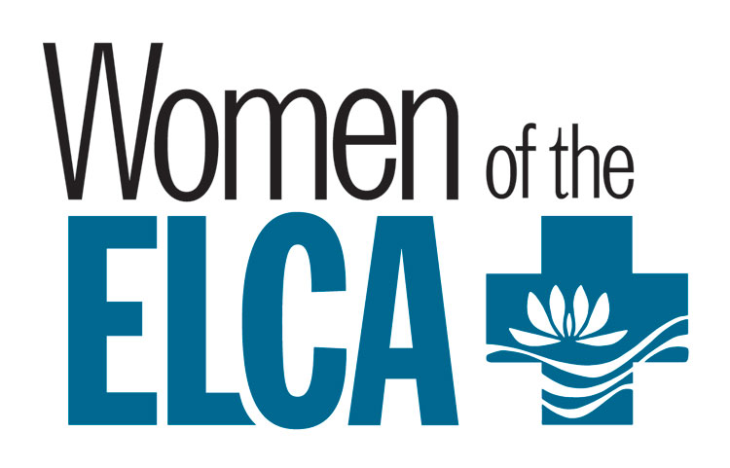**Northern Illinois Synod**

**Women of the Evangelical Lutheran Church in America**

**36th Annual Convention**

**Saturday, September 20, 2025**

**Theme:** *“Rescue, Redeem, Restore”*

**Morning Message:** *Assistant to the Bishop, Reverend Julie Monnard*

**Keynote Speaker:** *Heidi Provo, Anti-Human Trafficking Case Manager and Certified Peer*

*Recovery Specialist for Remedies Renewing Lives I-Rise Program*

**Psalm 82:4** *“Rescue the weak and the needy; deliver them from the hand of the wicked.”*

**Location:**

First Lutheran Church

225 South 3rd Street, Rockford

Coffee & Registration: 8:00 a.m. Registration Fee: $50.00

*Fellowship – Worship– Singing Songs – Exhibits-WELCA business meeting for voting members*

**Convention Offering**

50% Women of the ELCA

25% Our Savior’s Lutheran Church, Rocky Boy

25% Remedies I-Rise Program

**Physical Offering**: Items for Rock House Kids, Rockford:

$5-10 McDonald’s Gift Cards; $10-20 Walmart Gift Cards; Variety Packs of Chips;

Cases of Water, 8 oz or 16.9 oz bottles; Juice Boxes; Peanut Butter Sandwich Crackers; Cheese Sandwich Crackers; 3 or 5 Compartment Disposable Plates or Trays; Disposable Ice Packs

**For overnight reservations, a block of rooms has been reserved**

**at Hilton Garden Inn, 7675 Walton St., Rockford**

**Call (815) 229-3322, press zero (0) and ask for the Lutheran Women’s Convention Rates: 2 Queen, $159 1 King, $154**

**Rooms must be reserved by August 20 to get the group rate.**