You are invited to…
What We Think About God Matters!
Is there another way to think about God?

Thomas Oord Weekend
October 3-5, 2025
Sponsored by St. Luke United Methodist Church (11810 Burke Street, Omaha)
Email: churchoffice@stlukeumc.com

St. Luke United Methodist Church invites believers, seekers, skeptics, questioners, doubters, deconstructors, reconstructors, spiritual wanderers—and anyone curious about a more
loving, relational way to think about God—to a weekend of honest conversation and
hopeful theology with Dr. Thomas Oord.

----------------------------------------

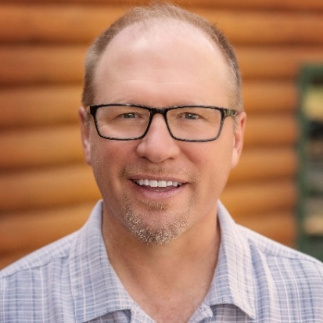
Who is Thomas Oord? Thomas Jay Oord, Ph.D., is a theologian, philosopher and scholar of multi-disciplinary studies. Oord directs the Center for Open and Relational Theology and doctoral students at Northwind Theological Seminary. He is an award-winning author and has written or edited more than thirty books. A gifted speaker, Oord lectures at universities, conferences, churches and institutions. He is known for his contributions to research on love, science and religion, open and relational theology, the problem of suffering and advocacy for the full inclusion of queer people.

Thomas Oord’s website: ThomasJayOord.com

An article you might find helpful:
https://thomasjayoord.com/index.php/blog/archives/god_cant_-_and_the_bible_says_so

----------------------------------------

The schedule for the weekend and details about registering are on the following pages.

Registration for the weekend is required.

Weekend Schedule: Thomas Oord Weekend
October 3-5, 2025
Sponsored by St. Luke United Methodist Church (11810 Burke Street, Omaha)

FRIDAY NIGHT – October 3
🍻 Pub Theology: Rethinking God Over a Pint
Location: Cunningham’s Pub & Grill, 10904 West Dodge Street | 6:00 PM | $20 cover charge at the door (includes food; drinks purchased separately)
Kick off the weekend with good food, big questions and lively conversation as Dr. Thomas Oord invites us to consider a more loving, relational vision of God. This casual pub night is the perfect space to bring your doubts, your curiosity and your open mind.

SATURDAY DAYTIME – October 4
🔍 God, Love and the Problem of Suffering: A Deeper Dive
Location: St. Luke United Methodist Church | 9:00 AM–2:00 PM | Free-will offering to cover light lunch
Spend the day exploring big theological questions: Why does God allow suffering? Can God truly be both loving and powerful? What does Scripture really say? Through engaging teaching and discussion, Dr. Oord will guide us through the heart of “Open and Relational Theology”—where divine love, human freedom and real hope converge.

SATURDAY EVENING – October 4
✨ Faith Outside the Box: A Night for Gen Z & Millennials
Urban Abbey, 1026 Jackson Street | 6:00 PM | Food and drinks purchased individually
This night is for the spiritually curious, the deconstructing, the reconstructing, those unraveling and reweaving—anyone asking tough questions about God, church and belief. Join Dr. Oord for an honest, no-pressure gathering designed especially for younger adults seeking a fresh and freeing faith.

SUNDAY WORSHIP – October 5
❤️ A God Whose Nature and Name Is Love
Location: St. Luke United Methodist Church | 9:00 AM & 10:30 AM
Join us in either of St. Luke’s worship services as Dr. Oord proclaims a hopeful vision of a God who is always loving, always present and always inviting us into deeper relationship. Coffee, donuts and warm community included—just bring your open heart.

Registration info on following page
Registration Info

Registration is required for the weekend, whether you attend one or all of the events.

There is a general registration fee for the weekend, which allows you to attend any or all of the events. Additionally, there are separate costs for some of the events to cover food and other costs.

Registration for the weekend is $25 per person. To register, go to:
https://tithe.ly/event-registration/#/10156144

If preferred, you can register by mailing a check to St. Luke United Methodist Church and indicating your name and that you wish to register for the weekend (include the names of all individuals you are registering). Make the check payable to St. Luke and write “Registration: Oord Weekend” on the memo line. Checks should be mailed to:
Attn: “Oord Weekend”
St. Luke United Methodist Church
11810 Burke Street
Omaha, NE 68154

Questions? Email churchoffice@stlukeumc.com or call 402-333-6886 ext. 300.

