Name of Assembly: United Apostolic Church
Type of service: Bible Study
Date: July 14th, 2025
Series Topic: The Works of the Flesh
Lesson 4: Sins of Hostility – Part 2
Scripture Text: Galatians 5:19-21

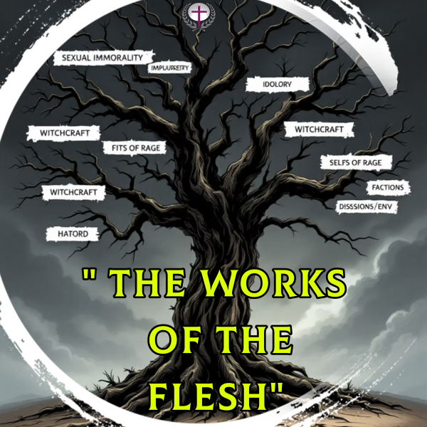

“¹⁹ Now the works of the flesh are manifest, which are these; Adultery, fornication, uncleanness, lasciviousness, ²⁰ Idolatry, witchcraft, hatred, variance, emulations, wrath, strife, seditions, heresies, ²¹ Envyings, murders, drunkenness, revellings, and such like: of the which I tell you before, as I have also told you in time past, that they which do such things shall not inherit the kingdom of God” - Galatians 5:19-21

SINS OF HOSTILITY - Hatred, Variance, Emulations, Wrath, Strife, Seditions, Heresies, Envyings, and Murder

Practical Steps to Overcome Variance
Practice Overlooking Minor Offenses
“A wise man restrains his anger and overlooks insults. This is to his credit” - Proverbs 19:11(TLB).
This verse highlights the virtue of patience and forgiveness, suggesting that wise individuals can control their temper and choose to overlook minor offenses rather than reacting with anger. It emphasizes that a measured and forgiving response is a mark of wisdom and good character.
Address Issues Directly and Lovingly
Follow the Matthew 18 pattern for conflict resolution rather than gossiping.
Step 1: Address Privately and Directly- Initiate the Conversation
“ Moreover if thy brother shall trespass against thee, go and tell him his fault between thee and him alone: if he shall hear thee, thou hast gained thy brother”- Matthew 18:15.
- Choose a private, comfortable setting.
- Pray before approaching the person.
- Focus on specific behaviors, not character.

Approach With Humility
Address the issue with gentleness and respect, recognizing your own imperfections (Galatians 6:1).
- Use “I” statements rather than accusations. “I” statements focus on expressing personal feelings and needs, while “you” statements often sound like blame or criticism.
- Instead of saying, “You never listen to me,” try: “I feel unheard when you interrupt me while I'm talking and I feel like my thoughts are not being valued.”
- Listen carefully to others’ perspectives before defending your position because you are seeking mutual understanding not victory.

Success Criteria
- “if he shall hear thee, thou hast gained thy brother.”
- Reconciliation is the primary goal. This is the process of restoring a broken relationship.
- Private resolution prevents gossip and embarrassment.
- Release grudges and extend the same grace God has shown you.
- Most conflicts should end at this stage.
Step 2: Involve Witnesses
“ But if he will not hear thee, then take with thee one or two more, that in the mouth of two or three witnesses every word may be established”- Matthew 18:16.
- Choose mature, impartial individuals.
- Witnesses provide accountability and clarity.
- Multiple perspectives can reveal blind spots.

Step 3: Church Involvement

“And if he shall neglect to hear them, tell it unto the church: but if he neglect to hear the church, let him be unto thee as an heathen man and a publican” - Matthew 18:17.
- Present the matter to church leadership.
- Provide complete and accurate information.
- Accept the Church’s judgment on the matter.
- Exclusion is only a last resort when all other steps have failed.
- The objectives are bringing about repentance, healing, and restored unity within the community of believers.
This progressive approach ensures that conflicts are addressed at the appropriate level, with wider involvement only when necessary.

WORK # 9: EMULATIONS

Biblical Definition: The Greek word translated as “emulations” is Zelos. It can denote both good and bad qualities. Here in Galatians 5, it refers to a negative form of zeal or passion, often translated as jealousy, envy, or rivalry.

It describes a sinful attitude marked by a desire to surpass or outshine others, often in a malicious or self-serving manner, which leads to conflict and division. The person who lets emulation control their life resents others' success but celebrates when others fall short. They envy others' blessings, compete for attention, and seek to be noticed.

Biblical Examples of Emulations

- Joseph's brothers were “moved with envy” against him. (Genesis 37:1-28; Acts 7:9)
- The religious leaders delivered Jesus out of envy (Matt. 27:18)
- The early church struggled with rivalries between followers of different leaders (1 Cor. 3:3-4)
Overcoming Unhealthy Competition
The spiritual antidote includes:
- Celebrating the success of others as victories for the entire body
- Focusing on Christ's example of servanthood rather than status.
- Recognizing God's sovereign distribution of gifts. “But now hath God set the members every one of them in the body, as it hath pleased him” – 1 Corinthians 12:18. When we recognize that God has sovereignly placed each person in the body according to His wisdom, we can release the need to compete and instead appreciate the unique contributions of every member.

- Embracing Paul's exhortation: “Let nothing be done through strife or vainglory” (Phil. 2:3). Paul's exhortation provides a direct antidote to emulations by calling believers to act from humility rather than competitive pride or empty conceit.

WORK # 10: WRATH

Biblical Definition: The Greek word translated as “wrath” is Thumos. It denotes a sudden, explosive outburst of anger. It is a strong, uncontrolled anger or rage, often manifesting as outbursts or fits of fury.

Manifestations of Wrath

- Sudden Eruptions: Explosive outbursts when circumstances don’t align with expectations, such as when “the car won’t start, or when you can’t find the keys.”

- Physical Expressions: Slamming doors, throwing objects, or physical displays of anger that intimidate others and damage property.

- Verbal Aggression: Harsh words, raised voices, and verbal attacks directed at others or even inanimate objects that fail to cooperate with our desires.

Real-World Examples

- Domestic Contexts: A husband storming out of a room when meals aren't ready on time; parents overreacting to children’s minor mistakes.

- Public Displays: Road rage incidents when cut off in traffic; public confrontations with service workers over perceived slights.

- Workplace Manifestations: Harsh reactions to colleague errors; aggressive responses to technological failures or missed deadlines.

Daily manifestations of wrath often appear in our most intimate relationships and routine interactions.

Spiritual Consequences of Wrath

- Relational Damage: “An angry person stirs up conflict, and a hot-tempered person commits many sins” - Proverbs 29:22. Wrath creates barriers between individuals and destroys the unity Christ intended for His followers.

- Spiritual Bondage: Those manifesting wrath remain “under the grip of the lower nature,” indicating spiritual immaturity and continued bondage to sinful tendencies rather than freedom in Christ.

- Eternal Implications: Paul's warning that those who practice such things “will not inherit the kingdom of God” represents the ultimate spiritual consequence of persistent, unrepentant sin.

Overcoming Wrath: Practical Steps
- Recognition: Acknowledge anger as a work of the flesh rather than justifying or minimizing its expression.

- Surrender: Yield daily to the Holy Spirit, especially in areas where you struggle with triggers and patterns of frustration.
- Practice: Cultivate spiritual disciplines of prayer, Scripture meditation, and accountability relationships.
- Reconciliation: Pursue forgiveness and restoration in relationships damaged by past expressions of wrath.
- Scripture for Meditation: “My dear brothers and sisters, take note of this: Everyone should be quick to listen, slow to speak and slow to become angry, because human anger does not produce the righteousness that God desires” - James 1:19-20. Through consistent application of these principles and dependence on the Spirit's power, believers can experience genuine transformation from patterns of wrath to expressions of Christ-like character, even in life's most frustrating moments.

PERSONAL NOTES
…………………………………...…………………………………………………………………………………………………………………...…………………………………...………………………………………………
…………………………………...…………………………………………………………………………………………………………………...........…………………………………...…………………………………………………………………………………………………………………...…………………………………...………………………………………………

