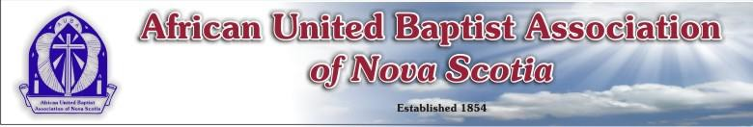

# AFRICAN UNITED BAPTIST ASSOCIATION OF NOVA SCOTIA

**Registration Form (172nd Annual Sessions)**

August 15-17, 2025

Venue – East Preston United Baptist Church

# THEME: “Restore”- (Scripture: Book of Nehemiah)

Name:

Address:

Church/Group

Registration (Please indicate with an **X**)

|  |  |  |
| --- | --- | --- |
| Delegate | Member | Visitor |
| $55 by July 15th  $60 after July 15th | $40 by July 15th  $45 after July 15th | $35 |

Barbeque on Friday, August 15, 2025

Lunch on Saturday, August 16, 2025

Supper on Saturday, August 16, 2025

Lunch on Sunday, August 17, 2025

Registration: ______________

Friday Barbeque Event ______________

Saturday Lunch ($0): ______________

Saturday Supper ($0): ______________

Sunday Lunch ($0): ______________

Total:

Please send form and payment (cheque or money order) to:

**Payable to AUBA**

**c/o Adam Cain (AUBA Treasurer)**

1088 Cole Harbour Road, Cole Harbour, NS B2V 1E7

E-transfers for the AUBA can be sent to [info@aubans.ca](mailto:info@aubans.ca)