Name of Assembly: United Apostolic Church
Type of service: Bible Study
Date: July 8th, 2025
Series Topic: The Works of the Flesh
Lesson 4: Sins of Hostility – Part 1
Scripture Text: Galatians 5:19-21

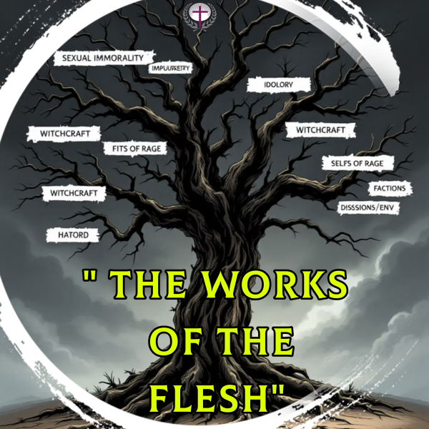
“¹⁹ Now the works of the flesh are manifest, which are these; Adultery, fornication, uncleanness, lasciviousness, ²⁰ Idolatry, witchcraft, hatred, variance, emulations, wrath, strife, seditions, heresies, ²¹ Envyings, murders, drunkenness, revellings, and such like: of the which I tell you before, as I have also told you in time past, that they which do such things shall not inherit the kingdom of God” - Galatians 5:19-21

SINS OF HOSTILITY - Hatred, Variance, Emulations, Wrath, Strife, Seditions, Heresies, Envyings, and Murder

Sins of hostility are especially destructive because they:

- Fracture the unity of the Body of Christ
- Tarnish our testimony before a watching world
- Precipitate spiritual decay and hardness of heart
- Inflict deep, often permanent wounds in relationships.
- Create barriers to effective prayer. “Likewise, ye husbands, dwell with them according to knowledge, giving honour unto the wife, as unto the weaker vessel, and as being heirs together of the grace of life; that your prayers be not hindered” - 1 Peter 3:7.
- Galatians 5:19-21 solemnly warns that those who habitually practice such things “shall not inherit the kingdom of God” — a profound reminder of the eternal consequences of unchecked hostility.
WORK # 7: HATRED

Biblical Definition: The Greek word echthra refers to a settled disposition of hostility, not merely momentary anger, but a hardened heart position that:

- Nurtures persistent animosity that festers over time
- Deliberately rejects opportunities for reconciliation while cultivating bitterness
- Actively undermines another's spiritual and physical well-being
- Creates division within the body of Christ.
Hatred corrupts not only our relationships with others but also severs our vital communion with God, who commands us to extend love even to those who stand against us. “Let all bitterness, and wrath, and anger, and clamour, and evil speaking, be put away from you, with all malice; and be ye kind one to another, tenderhearted, forgiving one another, even as God for Christ's sake hath forgiven you”- Ephesians 4:31-32.

Hatred is the Root of Murder
“Whosoever hateth his brother is a murderer, and ye know that no murderer hath eternal life abiding in him”- 1 John 3:15.

This declaration from the Apostle John establishes a direct equivalence between hatred and murder. Written to early Christian communities facing internal divisions, the passage emphasizes that spiritual life is incompatible with harboring hatred. John doesn't qualify or soften this teaching—the equation is absolute and uncompromising. He uses the same Greek word used for “murderer” that describes literal killers, underscoring the severity of this comparison. It was a core ethical principle in the early church that anyone who hates their brother is a murderer.

Jesus in His teachings also expands the traditional understanding of the commandment against murder, saying, ²¹ “Ye have heard that it was said of them of old time, Thou shalt not kill; and whosoever shall kill shall be in danger of the judgment: ²² But I say unto you, That whosoever is angry with his brother without a cause shall be in danger of the judgment:...” - Matthew 5:21-22.

This teaching forms part of Jesus' pattern of intensifying ethical demands beyond external compliance. He addresses not just physical violence but the emotional states that precede it, establishing a new standard of righteousness.

The phrase “without cause” refers to unjustified anger or anger without a legitimate reason. Jesus is not saying that all anger is sinful, but rather that anger stemming from petty grievances, anger rooted in pride, selfishness, or a lack of self-control, or personal offense can lead to judgment. There are justifiable causes for anger, such as anger that arises from a desire for justice or a zeal for God's will. However, even when our anger is justified, we must remember the exhortation of Paul to the Ephesians: “Be ye angry, and sin not: let not the sun go down upon your wrath” (Ephesians 4:26). Paul acknowledges that experiencing anger is a natural human emotion. Still, he also emphasizes that anger should not lead to sinful behavior. We are called to manage anger in a way that doesn't violate God's commands or cause harm to oneself or others. The verse also includes the instruction “let not the sun go down upon your wrath,” suggesting that anger should be addressed and resolved promptly to prevent it from festering and potentially leading to bitterness or other sins.

The equation of hatred with murder carries profound spiritual consequences. Scripture teaches that harboring hatred creates a spiritual death within the hater, severing their connection with divine love. As 1 John 4:20 states, “If anyone says, ‘I love God,’ and hates his brother, he is a liar.” This teaching demonstrates the radical nature of biblical ethics, demanding not just the absence of violence, but the presence of love. The inward attitude is just as important as outward behavior in assessing spiritual health. Let’s be reminded that Proverbs 23:7 states, “For as he thinketh in his heart, so is he: Eat and drink, saith he to thee; but his heart is not with thee.”

WORK # 8: VARIANCE

Biblical Definition: The Greek word translated as “variance” is Eris. This word generally means strife, discord, quarreling, divisions, and contention.

Variance refers to disputes and quarrels that undermine unity within the body of Christ. These conflicts often arise from:
- Being overly sensitive and easily offended.
- Stubbornness and unwillingness to yield.
- Contrary spirits that resist cooperation.
- Pride that prevents reconciliation.
- Unwillingness to overlook minor offenses.
- Proverbs 6:19 tells us that the Lord hates “one who sows discord among brethren.”
The “Touchy Christian”

The “touchy Christian” exemplifies variance in action—a person whose hypersensitivity becomes a source of continuous discord.

- The touchy Christian is “quick to take offense.”
  - Interprets innocent remarks as personal attacks, creating tension where none was intended.
- The touchy Christian “holds on to grudges.”
  - Maintains detailed mental records of perceived slights, refusing the biblical call to “keep no record of wrongs” – 1 Corinthians 13:5 (NIV).
- The touchy Christian is “stubbornly defensive.”
  - Refuses to consider other perspectives and defends their position regardless of the truth.
- The touchy Christian is “chronically contrary.”
  - Consistently opposes group decisions and creates friction within the fellowship.
- The touchy Christian is “spiritually immature.”
  - Paul connects variance to carnality: “For ye are yet carnal: for whereas there is among you envying, and strife, and divisions, are ye not carnal, and walk as men?” – 1 Corinthians 3:3.
  - Proverbs 18:19 says, “A brother offended is harder to be won than a strong city: and their contentions are like the bars of a castle.” This profound proverb reveals the sobering reality of reconciliation after deep offense, particularly within the intimate bonds of family or church fellowship. When trust is shattered between brothers, the resulting walls of resentment become as impenetrable as a fortress under siege. The metaphor is striking: mending a wounded relationship requires the same persistent effort as conquering a heavily fortified stronghold.

- The touchy Christian becomes enslaved to their own emotions, creating barriers to genuine fellowship and spiritual growth.

The Cost of Variance in the Church

Broken Fellowship | Stunted Spiritual Growth
When variance persists, the body of Christ becomes fragmented, destroying the unity Jesus prayed for in John 17. | Churches consumed with internal conflict cannot focus on their mission of discipleship and evangelism.
Repelled Seekers | Emotional Casualties
Non-believers observe our conflicts and question the authenticity of our faith: “By this shall all men know that ye are my disciples, if ye have love one to another” -John 13:35. | Church conflicts leave deep emotional scars, particularly on new believers who may abandon fellowship altogether when confronted with discord.
Hindered Prayers | Demonic Opportunity
Peter exhorted husbands of the danger of divisions saying, “dwell with them (wife) according to knowledge, giving honour unto the wife, as unto the weaker vessel, and as being heirs together of the grace of life; that your prayers be not hindered” - 1 Peter 3:7.  Unresolved variance blocks our communion with God, creating spiritual drought at both personal and corporate levels. | Paul warns not to “give place to the devil” -Ephesians 4:27. Persistent variance creates spiritual vulnerabilities that demonic forces can exploit to cause harm to the body and impede its mission.

Variance doesn't just damage relationships—it grieves the Holy Spirit and gives Satan a foothold in our congregations. The church that tolerates discord sacrifices its power, testimony, and ultimately its purpose.

PERSONAL NOTES
…………………………………...…………………………………………………………………………...…………………………………………………………………………...…………………………………………………………………………...…………………………………………………………………………...…………………………………………………………………………………………………………………...…………………………………...…………………………………………………………………………………………………………………...
…………………………………...………………………………………

