Name of Assembly: United Apostolic Church
Type of service: Bible Study
Date: June 24th, 2025
Series Topic: The Works of the Flesh
Lesson 3: Sins of Idolatry (Part 1)
Scripture Text: Galatians 5:19-21

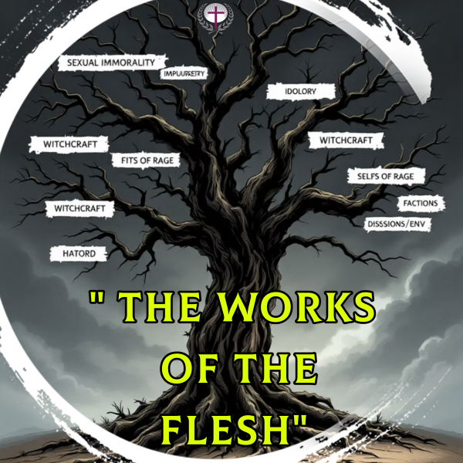
“¹⁹ Now the works of the flesh are manifest, which are these; Adultery, fornication, uncleanness, lasciviousness, ²⁰ Idolatry, witchcraft, hatred, variance, emulations, wrath, strife, seditions, heresies, ²¹ Envyings, murders, drunkenness, revellings, and such like: of the which I tell you before, as I have also told you in time past, that they which do such things shall not inherit the kingdom of God” - Galatians 5:19-21

SINS OF IDOLATRY - Idolatry and Witchcraft

- Idolatry and witchcraft represent profound spiritual transgressions that directly challenge God's rightful authority in our lives. Both practices establish counterfeit systems of worship that corrupt our relationship with God.

- These sins elevate created things above the Creator, fundamentally inverting the divine order established by God. They violate our sacred covenant relationship, replacing authentic worship with hollow substitutes.

- When we practice idolatry or witchcraft, we redirect our devotion and spiritual focus to symbols that promise fulfillment but can never truly satisfy the soul's longing for connection with God.

SINS OF IMPURITY

WORK # 5: IDOLATRY

Biblical Definition: Idolatry occurs when we elevate anything—material possessions, relationships, ambitions, or self-identity—to a position of reverence reserved exclusively for God. It represents the fundamental corruption of worship, where devotion to the Creator is supplanted by allegiance to created things, resulting in spiritual bondage.

God’s Divine Command: The first commandment in Exodus 20:3 emphatically states: "You shall have no other gods before me." This decree establishes the exclusive worship of Jehovah as the cornerstone of covenant faithfulness. As Deuteronomy 6:5 elaborates, we must "love the LORD your God with all your heart, soul, and strength," leaving no room for divided loyalty.

Ancient Forms: Throughout their history, the Israelites repeatedly abandoned Jehovah to worship physical idols, particularly Baal and Asherah.

Neighboring pagan cultures crafted elaborate deities from wood, stone, and precious metals, believing these manufactured gods controlled rainfall, fertility, and the natural world. “³ For the customs of the people are vain: for one cutteth a tree out of the forest, the work of the hands of the workman, with the axe. ⁴ They deck it with silver and with gold; they fasten it with nails and with hammers, that it move not. ⁵ They are upright as the palm tree, but speak not: they must needs be borne, because they cannot go. Be not afraid of them; for they cannot do evil, neither also is it in them to do good” - Jeremiah 10:3-5.

The golden calf incident (Exodus 32) illustrates how quickly God's covenant people can turn to visible, tangible substitutes when faced with uncertainty. Despite witnessing God's miraculous deliverance from Egypt, the Israelites demanded a physical representation to worship when Moses delayed on Mount Sinai.

In the intense showdown on Mount Carmel (1 Kings 18:20-40), Elijah challenged 450 prophets of Baal, revealing the futility of false worship and showcasing Jehovah's supreme power. This pivotal moment highlights the ongoing spiritual battle between genuine devotion to the living God and the seductive influence of idolatry that has troubled Israel throughout their history.

In Colossians 3:5, Paul wrote, “…covetousness, which is idolatry…” By saying this, he demonstrates that covetousness is a kind of idolatry, suggesting that idolatry extends beyond physical statues to encompass any excessive desire that displaces God from His proper place in our hearts.

Ezekiel 14:3 indicates that some Israelites had "set up their idols in their heart," highlighting that idolatry starts as an internal spiritual mindset before it appears in outward behaviors.

When we covet, we raise created things to a position that only the Creator should hold in our hearts. This spiritual displacement occurs when our desires become demands, and our longings turn into obsessions. The sin is not in appreciating God's blessings but in letting those blessings replace God Himself as the source of our ultimate satisfaction and security, much like ancient idol worshipers who made gods from wood and stone. Modern covetousness also crafts idols from ambitions, possessions, and status—all equally unable to fulfill the soul's deepest needs.

Modern Manifestations:

Materialism
In our consumer culture, many worship at altars of possessions and status. Shopping centers have become the cathedrals of our time, where acquisition is celebrated as the highest form of fulfillment.

Multitudes plan and scheme for the future like the man in the parable that Jesus told in Luke 12:16-21, “¹⁶ And he spake a parable unto them, saying, The ground of a certain rich man brought forth plentifully: ¹⁷ And he thought within himself, saying, What shall I do, because I have no room where to bestow my fruits? ¹⁸ And he said, This will I do: I will pull down my barns, and build greater; and there will I bestow all my fruits and my goods. ¹⁹ And I will say to my soul, Soul, thou hast much goods laid up for many years; take thine ease, eat, drink, and be merry. ²⁰ But God said unto him, Thou fool, this night thy soul shall be required of thee: then whose shall those things be, which thou hast provided? ²¹ So is he that layeth up treasure for himself, and is not rich toward God.”

- Material Success
This farmer achieved remarkable prosperity. His barns overflowed with abundance, a testament to his diligence and God’s abundant blessings. Still, his focus remained solely on building wealth, showing a heart fixated on temporary treasures rather than eternal riches.

- Unexpected End
"Thou fool, this night thy soul shall be required of thee; then whose shall those things be which thou hast provided?" (Luke 12:20). These divine words shattered his illusion of security. Death arrived without warning, exposing the emptiness of a life devoted solely to material acquisition rather than spiritual wealth.
Technology as Modern Idolatry

Our devices now demand ritualistic devotion—constant checking, instant responses, and anxious attachment. This digital idolatry divides our attention and diminishes our capacity for authentic spiritual connection.

- Time Consumption: Many spend hours scrolling through social media or consuming digital content, giving technology the best hours of their day instead of dedicating them to God.

- Emotional Attachment: People experience anxiety when separated from their devices, revealing an unhealthy emotional dependence.

- Mental Preoccupation: Even when not actively using technology, many find their thoughts constantly returning to digital interactions and content.

- Financial Priority: The latest devices and upgrades often receive financial priority over kingdom investments and charitable giving.

Careers as Modern Idolatry
Professional success becomes idolatrous when we sacrifice our spiritual well-being on its altar. When our identity becomes inseparable from our occupation, we exchange divine purpose for worldly validation, allowing achievement to define our worth rather than our relationship with God.

- Identity Crisis: When career becomes an idol, people begin to define themselves primarily by their professional achievements rather than their identity as children of God. The question "What do you do?" becomes more significant than "Who do you belong to?" in determining self-worth.

- Misplaced Trust: Career idolatry leads to trusting in professional success for security and provision rather than trusting in God's faithfulness. Promotions, raises, and recognition become the measure of value and success rather than devotion to God's calling.
Family & Health as Modern Idolatry
Even blessings like family, health, and emotional ties can become idols when they take the place of God as our ultimate treasure. Modern idolatry subtly transforms God's gifts into false gods, leading us to pursue in creation what only the Creator can fulfill.

- Family Idolatry: When a family becomes an idol, we may compromise biblical principles to please family members or prioritize family approval over God's commands.

- Health Idolatry: When health becomes an idol, we may become obsessed with physical perfection, spending excessive time and resources on health while neglecting spiritual disciplines.
- Relationship Idolatry: When relationships become idols, we may look to others to fulfill needs that only God can satisfy, leading to codependency and emotional instability.

Today, many people follow this perilous path—accumulating worldly possessions while neglecting their spiritual well-being. Christ's powerful question rings through the ages: "What does it profit a man to gain the whole world, yet forfeit his soul?" The story of the rich fool acts as both a warning and a call to prioritize God's kingdom over temporary treasures.

NOTES

………………………………………………………………………………………………………………………………………………………………………………………………………………………………………………………………………………………………………………………………………………………………………………………………………………………………………………………………………………
……………………………………………………………………………

