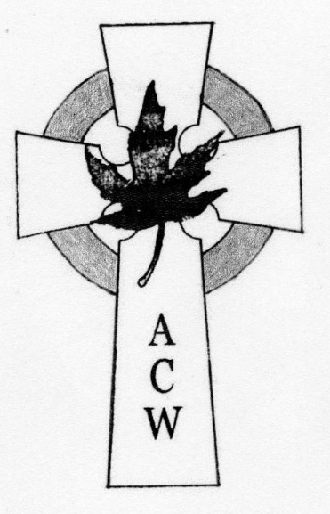
In Touch

Diocese of Edmonton
ACW Quarterly newsletter June 2025
WA
W A

"For we walk by faith, not by
sight." 2 Corinthians 5:7

FAITH

Nicene Creed 1700 years old
Let us confess our faith, as we say,
We believe in one God,
the Father, the Almighty, . . .
We believe in one Lord, Jesus Christ.
the only Son of God. . . .
We believe in the Holy Spirit,
the Lord, the giver of life, . .
We look for the resurrection of the dead,
and the life of the world to come. Amen
The information about the Nicene Creed was brought to us by Bishop Steve as he was visiting Emmanuel. ‘ In 325AD the Church leaders gathered to write the ideas of our FAITH.’ Making this the 1700th year of the Creed. What history we have.

“Faith comes from hearing the message, and the message is heard through the word of Christ.”
(Romans 10:17)

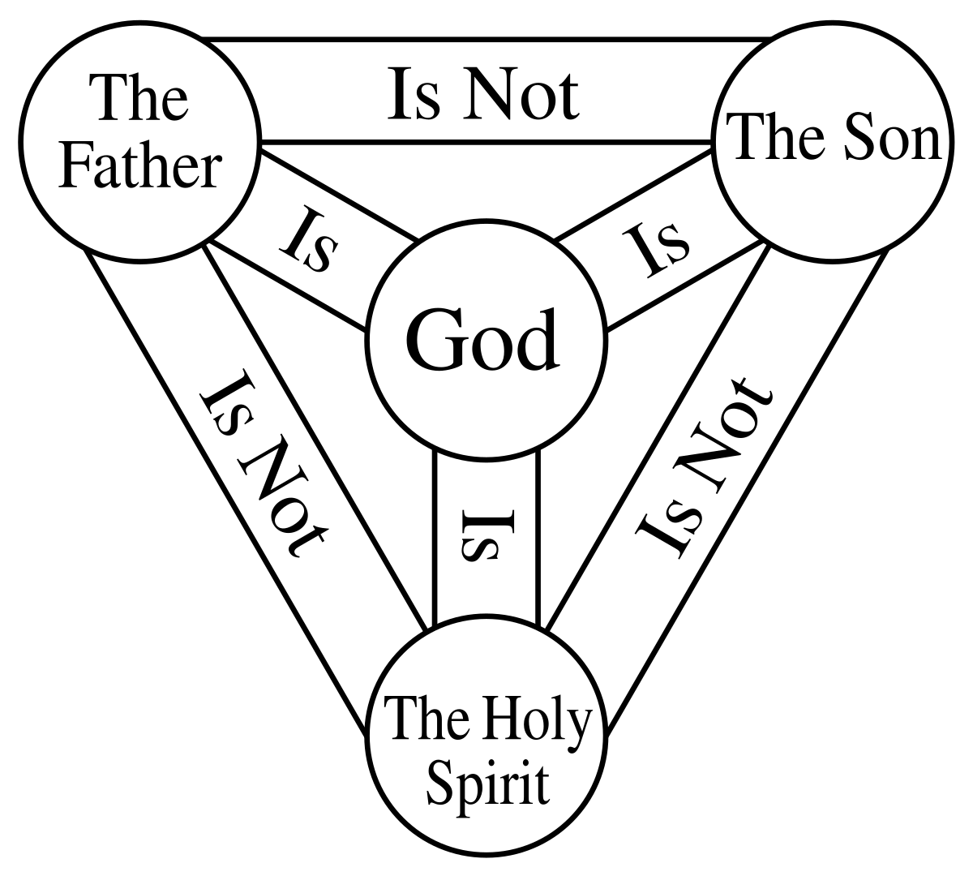

Here are some suggestions to help us grow and mature in our faith:
- Take the time to read about our heroes of faith in the Bible in Heb. 11;
- Pray to God and study His Holy Word; and
- Like Abraham, let us put our faith into action by doing what God has commanded us to do.

We need to keep in mind that a person is justified by both his faith and his actions, and not by his faith alone.
Mother Teresa knew this spiritual truth, and that is why she said, “Faith translated into action becomes love; and love translated into action becomes service to mankind.”
Faith is like a seed that God plants in the soil. The soil is the human heart. Prayer is the water that provides moisture for the seed. Meditation is the heat that helps the seed to germinate. The practice of the Word of God is what provides the nutrients that make our faith grow and bear fruits. The good news is that, in order to make our faith grow and mature, God provides 90% of the effort, and we only have to provide 10%. Therefore faith growth and maturity is a partnership between God and us, with Him doing most of the work.

Diocesan ACW Report

As I write this report it is another sunny spring day, not unlike the beautiful day we enjoyed on May 3 in Camrose at our ACW Annual Meeting. When that day began, trees were bare bark and grass still brown from winter. By the end of that very sunny and warm day everything was turning green and growing – a perfect metaphor for the start of our next year in ACW.
Our “Annual” began with a business meeting on May 2 via Zoom. Thirty-three attended. It was agreed that the ACW Executive will take this next year to refresh the ACW’s constitution and by-laws, to better reflect who we are now from what we were. We were once were a “top-down” organization with directions coming from the Diocesan ACW Board to the parish groups. Over time we have evolved into a collection of parish - ACW groups with the Diocesan Board available to lend support groups in parishes as needed. It is time to rewrite these documents to reflect who we are now. A second, really big change is to have one representative from each parish sit on the ACW Diocesan executive. We are only 12 parishes and we meet mostly via Zoom, so this should be easy to achieve. I will be in touch soon with each parish to meet the representative for your parish.
We had a wonderful laughter-filled day in Camrose on May 3. A huge round of applause to the ladies of St. Andrews for planning and hosting the day in Camrose and to Rev. Christa Eisbrenner for her brilliant sermon on “the ladies of the Bible”, and Lois Wightman who led us on guided us in a Spirt-filled prayer walk around Mirror Lake.(see pg. 5 of In Touch) The love and work put into the day was so evident and welcomed by everyone. Thank you all.
During the church service, Rev. Eisbrenner introduced a prayer for our nation taken from the Book of Alternative Services on page 678. I encourage us all to add this to our regular prayer time. Now, perhaps as never before, we must seek God’s will in these “swiftly changing times”.
Blessings – Elaine

Diocesan
ACW Executive

2022—2023

Patron
The Rt. Rev. Steve London 780-439-7344
Chaplain *

President
Elaine
Past President
Judy
Vice Presidents
First—Vacant
Second—Vacant
Recording Secretary
Margaret
Corresponding Secretary
Elaine
Treasurer
Gen
Prayer Partners

Social Action
Kathy
Life Members
Tracey
Education/Family Life
Ann Marie
*Book of Remembrance Appointed
Melissa
*Lone Members Appointed
Melissa
*In Touch Editor Appointed
Willa

Regional Contacts
West ACW Region
Yellowhead / Edmonton West
St. Timothy’s, Edmonton
Gen
East ACW Region
Whitemud / Battle River/ Cold Lake
St. Mary’s, Ponoka
Deb

Diocesan ACW
c/o Anglican Diocese of Edmonton
10035 – 103 Street NW
Edmonton, AB T5J 0X5

email:
acw.dioceseofedmonton@gmail.com

" For the Nation" (BAS pg. 678)
Almighty God, you have given us this good land as our heritage. May we prove ourselves a people mindful of your generosity and glad to do your will. Bless our land with honest industry, truthful education, and an honourable way of life. Save us from violence, discord, and confusion; from pride and arrogance; and from every evil course of action. Make us who came from many nations with many different languages a united people. Defend our liberties and give those whom we have entrusted with the authority of government the spirit of wisdom, that there may be justice and peace in our land. When times are prosperous, let our hearts be thankful; and, in troubled times, do not let our trust in you fail. We ask this through Jesus Christ our Lord.
Life Members Report
As I write this report, my apple tree in in full bloom. Spring truly lifts the spirits. A prayer for all in school, staff and students, as they finish off their school year and a prayer for the summer months ahead so everyone stays safe and can enjoy some leisure time.
The Annual Meeting by Zoom and the next day’s road trip has come and gone. Ladies from our church who travelled out to Camrose for the road trip had a wonderful time, they really enjoyed all the planned activities. It was good to see so many familiar faces at the Zoom meeting. At the meeting we talked about the Annual Meeting letter and information that was mailed out to Life Members with no e-mail contact. Our executive will be making decisions about future mail outs to life members.
A new life member, Judith Thomas, will be inducted at the West Regional meeting at St. Timothy’s on September 27th. Please check the application for new life members and make sure that an e-mail is provided.
It is always good to hear from life members before the Annual Meeting and those who stay in touch with their life members once they are in care homes. “We stay in touch as she is one of our own”, a touching reminder for all of us to do the same.
Many life members shared where they chose to give this year; P.W.R.D.F. (Alongside Hope) and in their own communities (animal shelter) were just a few examples.
With each Annual Meeting gathering we hear about life members who have passed away and on to higher service. Sadly we have lost:
Shirley French and Anne Greenwall – Immanuel, Wetaskiwin
Shelia Hicks – St. Matthias, Edmonton
Violet Holden and Jacklyn Lillywhite – St. Augustine’s Parkland
Ruth Iverson - St. Thomas, Wainwright “Ruth was a strong A.C.W. member and key in the continuation of the A.C.W. in Wainwright.”
Let us lift up hearts full of thanksgiving for a life well-lived and for work well done.
May they Rest in Peace.

May God Bless
Tracey
Life Member Secretary

Dear God, please help me give thanks even when life is hard.

Dear God, please help me to be an encourage-ment to someone today.

Heavenly Father, please guide me to do Your will.

Education Secretary
I remember years ago, my father telling me about Sir Francis Bacon. According to Bacon, God has written two books. The one is scripture. The other is nature. Both reveal God and neither should be read without the other. I believe we can use the nature around us to open up conversations about the One who created it and us.

For the next few months we will actually get to enjoy sitting outside in nature. We often do this with our families. It is the season of gatherings and BBQs. It may even be the season, if we get a decent amount of rain, for sitting around fires. What wonderful opportunities to have conversations about nature that naturally lead to talk about nature’s Creator.

Maybe we could walk around a garden and talk about the care required to grow one. The same tender care a gardener shows can be likened to the care God shows us. Note the lilies of the field and the sparrows from Jesus in the scripture.

As we watch the business of the ants, the buzzing of the bees, and share the fascination with ladybugs, it is again an opportunity to talk about how interrelated creation is. This leads to how interrelated we are with creation and its Creator.

Rather than teaching, it might be better to point things out and ask, “What do you think … ? Use curiosity to explore the possibilities and open the conversation. Core among the topics is the creation stories and how they show our role in God’s world. We are given dominion. However, that does not mean we lord it over creation. Rather we are to tend it, following God’s example. We were given the animals for companionship. This speaks to us about respecting their lives as ones loved by the Creator rather than seeing them as only for our own purposes.

Anglicanism has its roots in Celtic spirituality. This helps us understand our close connection to nature. This connection to the whole of creation is important for all our interactions. It helps us with all our relationships. When we appreciate, respect, and take care of creation, we are using the same skills we need to use with people. In today’s society, we are losing that sense of connection to each other. Exploring our role in creation can help us explore our role with each other and the work we need to do to further bring in the Kingdom. Even if we don’t explore these things with others, it does not hurt to ask the same questions and have the conversation with ourselves.

Love and Prayers,
Ann Marie +

The Book of
Remembrance

Lynn Susan Frail 1947-2015 St. Augustine Parkland, Spruce Grove
Audrey May Jones Roloff 1934-2016 St. Augustine Parkland, Spruce Grove
Winnifred Mary Coates 1932-2017 St. Augustine Parkland, Spruce Grove

Prayer Walk: Mirror Lake, May 3 2025 - Camrose

C. S. Lewis wrote: “Walking and talking are two very great pleasures, but it is a mistake to combine them. Our own noise blots out the sounds and silences of the outdoor world.” To Lewis, walking in nature was a sensory experience which led to spiritual reflection and joy. His advice: Be fully present and mindful of our surroundings without distractions. Slow down, pay attention and breathe.
The beautiful hymn, This is My Father’s World, can turn our eyes and grateful hearts to God as we walk. Let’s look, listen, and exercise our various senses as we follow along the path. Let’s try to hear God’s voice.
Sound:
Jesus said, “Whoever has ears to hear, let her hear.” A hymn writer once wrote, “This is my Father’s world, and to my listening ears/ All nature sings and round me rings/ The music of the spheres”. He adds, “The birds their carols raise…” and “In the rustling grass I hear Him pass/ He speaks to me everywhere.” Can you hear God’s voice?
Among the loveliest verses in the Bible are the words of the prophet Zephaniah: The Lord your God is with you, He is mighty to save. He will take great delight in you, He will quiet you with His love, He will rejoice over you with singing.” Our Lord sings to us, not just we to Him!
Scent:
Recently we heard again the story of Mary anointing Jesus’s feet with expensive perfume and wiping His feet with her hair. The whole house was filled with the fragrance. Her gift represented her love for Jesus, who understood and appreciated the gift, yet He also saw it as a preparation for His burial: “Sorrow and love flow mingled down”.
The Victorian poet Gerard Manley Hopkins spoke of the world being “charged with the grandeur of God”, and was astounded that people did not see it. Although everything has been smeared by their toil and smudge and smell, Hopkins marveled that “for all this, nature is never spent;/ There lives the dearest freshness deep down things”.
Let us notice the smells – some lovely and some not. Think of the fragrance of incense in Jesus’s time, and what it meant. David asked that his prayer might be set before the Lord like incense. In Paul’s second letter to the Corinthians, he writes, “… thanks be to God, who always leads us in triumphal procession in Christ and through us spreads everywhere the fragrance of the knowledge of Him. For we are to God the aroma of Christ…”; and to the Ephesians he writes, “Live a life of love just as Christ loved us, and gave Himself up for us as a fragrant offering… to God”.
Touch:
We had in our hand a branch of pussywillow. Note the delicate softness, soothing to the touch. Touch something that captures your attention, whether rough or smooth, warm or cool, and so on. Remember too the gifts of God that touch you… the sunshine, the breeze, like the wind of God’s Holy Spirit. He knows us, and knows we need loving, healing touch. Think of the One who “created the heavens and stretched them out, who spread out the earth and gives breath to its people”, and who says to us, “I will take hold of your hand” (Isaiah 42:5, 6). Thank Him for His arms of love as He carries you close to His heart (Isaiah 40:11).
Sight:
The hymn writer says, “This is my Father’s world: I rest me in the thought/Of rocks and trees, of skies and seas;/His hands the wonders wrought”. Look around at the beauty that surrounds us. Look especially at the colours, particularly the fresh green buds and leaves emerging into spring. “Nature is never spent!”
Bashaw author Robert Jacobson writes, “During our few years on this earth, beset by worry, driven by ambition… exhausted by duty, bored to death, we can live out our days in the midst of the most amazing marvels and never see a thing”. But Jesus says, “Consider the lilies of the field!”
“Don’t drive right past them”, says Jacobson. “Don’t take them for granted. Don’t keep ignoring them as useless weeds. Stop! Consider the lilies! And keep on considering them until the wonder of them begins to dawn on you. And until you begin to hear what your Creator is saying to you…”
“This is my Father’s world: why should my heart be sad?/ The Lord is King; let the heavens ring! God reigns; let earth be glad!”
And finally, Taste:
In the 34th Psalm, David urges us: “Taste and see that the Lord is good!”
I trust that we have experienced a taste of God’s goodness.

Puzzle Page & Past Time Pursuits
PREEMIE TO TODDLER KNIT BABY HAT
Red Heart® Super Saver® Ombre™ (10 oz/283 g; 482 yds/440 m) Sizes P Spearmint
SY ABBREVIATIONS Alt = Alternate(ing) Beg = Begin(ning) Cont = Continue(ity)
Dec = Decrease(ing) K = Knit K2tog = Knit next 2 stitches together M1 = Make 1
stitch by picking up horizontal loop lying before next stitch and knitting into back of
loop. P = Purl PM = Place marker Rem = Remain(ing) Rep = Repeat Rnd(s) = Round(s) RS = Right side Ssk = Slip next 2 stitches knitwise one at a time. Pass them back onto left-hand needle, then knit through back loops together St(s) = Stitch(es) WS = Wrong side
SIZES To fit head circumference: Preemie (Newborn-6/12 mos 9½" (18/24 mos 12-16-17½)" [24 (30.5-40.5-44.5) cm] GAUGES 18 sts and 24 rows = 4" [10 cm] with larger needles in stocking st.
INSTRUCTIONS The instructions are written for smallest size Preemie. If changes are necessary for sizes Newborn, 6/12 or 18/24 mos the instructions will be written thus ( ). When only one number is given, it applies to all sizes.
With smaller needles, cast on 46 (58-74-82) sts. 1st row: K2. *P2. K2. Rep from * to end of row. 2nd row: P2. *K2. P2. Rep from * to end of row. Rep last 2 rows of (K2. P2) ribbing 4 (5-6-7) times more. Change to larger needles and proceed in stocking st until work from beg measures 3 (3½-4½-5)" [7.5 (9-11.5-12.5) cm], ending on a purl row and dec 3 (3-1-3) st(s) evenly across last row. 43 (55-73 79) sts. Shape top: 1st rnd: K1. *K2tog. K5 (7-10-11). Rep from * to end of row. 37 (49-67-73) sts. 2nd and alt rows: Purl. 3rd row: K1. *K2tog. K4 (6-9-10). Rep from * to end of row. 31 (43 61-67) sts. 5th row: K1. *K2tog. K3 (5-8-9). Rep from * to end of row. 25 (37 55-61) sts. 7th row: K1. *K2tog. K2 (4-7-8). Rep from * to end of row. 19 (31 49-55) sts. 8th row: As 2nd row. Cont in same manner, dec 6 sts on next and every following alt row until there are 13 sts rem. Break yarn, leaving a long end. Thread end through rem sts and fasten securely. Sew back seam.

I just found this recipe on the computer. Changed it a bit for Preparation and only used 4oz of cream cheese and 2 Tlbs. Of sugar. If you like lots of cream cheese use the full 8oz (250 g.). I wrapped them like I do Sausage rolls. Much easier - roll & cut. Willa
Rhubarb Wraps (2025)
Ingredients
8 oz rhubarb , chopped 1/4 cup granulated sugar
1 tsp cornstarch
8 oz cream cheese , softened 1/4 cup powdered sugar
1 pkg. puff pastry , thawed (long sheets)
1 egg , beaten raw sugar crystals
Instructions:
Preheat your oven to 375°F (190°C). Line a baking sheet with parchment paper.
Prepare the Rhubarb Filling
In a bowl, mix the chopped rhubarb, granulated sugar, and cornstarch until well combined. Set aside to allow the flavors to meld.
In another bowl, beat the softened cream cheese and powdered sugar together until smooth and creamy.
Roll out the thawed puff pastry sheet on a lightly floured surface. Cut each rectangle sheet length ways in half.
Spread a quarter of the sweetened cream cheese along the bottom edge of each half.
Top each row of cream cheese with a quarter of the rhubarb mixture.
Fold the pastry over the filling to create a long roll. Press the edges firmly to seal. Brush the tops with beaten egg for a beautiful golden finish. And sprinkle with Raw Sugar crystals. Cut into bite sized pieces.
Place the assembled wraps on the prepared baking sheet.
Bake for 20–25 minutes, or until the pastry is puffed, golden brown, and crispy.
Serve and Enjoy Let the wraps cool slightly before serving.
Enjoy warm as a sweet treat or pair with a dollop of whipped cream or a scoop of vanilla ice cream for an extra indulgent twist.

Social Action Report

“In the same way, let your light shine before others, that they may see your good deeds and glorify your Father in heaven.” Matthew 5:16

Shine your light in the small places by taking care of our parishes by helping to pay for building upkeep, supporting youth and seniors’ projects, and praying for each other.
Shine your light in our communities meeting the needs we see there through support for foodbanks, thrift shops, knitting & crafting prayer shawls, soup kitchens, Christmas kettles, nursing home visits, summer camps.
Shine your light in our province and country to meet the needs we see there by supporting projects through On Eagle’s Wings, and including prayers and communication with partner parishes.
Shine around the world to take action where we are called by praying for Buye, the Mother’s Union, donating to Alongside Hope projects and action that speaks to our groups.

Prayer for Social Action
Dear God
We ask ourselves what difference we can make in our troubled communities and world. We seek your guidance to show us where you want us to shine our light.
Help us to remember that even our small contributions can make a large impact on your big plan for this world. Help us to remember that all things are possible with your help.
We pray in the name of Jesus our Saviour.
Amen.

Wonder Word Puzzle - FAITH
1 | F | A | M | I | L | Y | T | I | N | U | S | U | S | E | J
2 | O | S | P | I | R | I | T | U | A | L | I | T | Y | D | U
3 | R | E | I | L | R | C | H | A | R | I | T | Y | L | C | S
4 | E | R | O | I | E | A | A | L | U | F | H | T | U | R | T
5 | V | V | S | F | S | R | N | H | C | A | A | I | F | E | I
6 | E | I | C | E | P | E | S | O | N | T | N | L | I | A | F
7 | R | C | R | E | E | D | G | L | E | H | K | A | T | T | I
8 | N | E | E | P | C | I | I | Y | P | E | F | U | U | O | E
9 | O | D | A | R | T | P | V | S | O | R | U | Q | A | R | D
10 | I | N | T | A | T | E | I | P | H | J | L | E | E | P | R
11 | T | I | I | Y | S | A | N | I | O | L | I | R | B | S | O
12 | O | K | O | E | E | C | G | R | N | I | V | E | N | S | W
13 | V | N | N | R | B | E | L | I | E | V | E | S | E | O | E
14 | E | A | C | T | I | O | N | T | S | U | R | T | S | R | H
15 | D | M | I | N | D | F | U | L | T | S | I | R | H | C | T

The answer has 11 letters.

ACTION FOREVER REST
BEAUTIFUL HOLY SPIRIT SERVICE
BELIEVE HONEST SON
BEST HOPE SPIRITUALITY
CARE JESUS THANKFUL
CHARITY JOY THANKSGIVING
CHRIST JUSTIFIED THE WORD
CREATION LIFE TRUST
CREATOR LIVE TRUTHFUL
CREED LOVE UNITY
CROSS MANKIND
DEVOTION MINDFUL
EQUALITY PEACE
FAMILY PRAYER
FATHER RESPECT

From Willa

I did it again – made an error in the March 2025 In Touch. The puzzle on page 7 Row 8 down, row 5 across should be an ‘O’ not a ‘G’. My husband was always my puzzle proof reader so I do miss him. He passed away Oct. 2020. Now thanks to Beth Anne who found my error and even had it corrected when she phoned me. Hope the puzzle is correct this time as I made it. I do appreciate hearing both good and bad things about In Touch. Please send your comments.

Make sure you update your Executive list contacts. I am afraid we are not keeping to our By-Laws 3 year term for Executive positions as we need to fill them with whomever we can. It is very difficult to get new people to join the Executive. We have several positions open - can you assist with one of them.

Please try and imagine the Prayer Walk. For those of us who could not walk they had pictures and followed along. It was very peaceful, enjoyable and interesting.

I couldn’t stop eating the Rhubarb Wraps, Recipe - I found them delicious. Hope you will try them and enjoy. If you have questions do not hesitate to e-mail me. I will get back to you the same day likely.

Dear God, thank You for including me in Your amazing work. Please take what's in my hands and do wonders through it. In Jesus name Amen

Faithfully
Willa
Postage Stamps: please remember to save all the used postage stamps you receive. Do NOT trim them but leave at lease ¼ to ½ inch all around. You can turn them in (at a Regional meeting would be great). We pass them on to the Canadian Bible Society who use them to fund their programs.

In Touch Subscriptions

To subscribe–– Cost is $10 per year––subscribe for up to 3 years. Mail your name, address, phone number and cheque (payable to ACW Diocese of Edmonton ) to:
In Touch Editor,
5808 – 136 Ave NW,
Edmonton T5A 0N5
To renew––Check the date marked on your envelope. If it is highlighted in
YELLOW or RED your subscription has expired––please complete the enclosed renewal form.

F
A
I
T
H

L
O
V
E

H
O
P
E

Deadline Dates for Life Member Applications

Deadlines for applications to be in to have the presentation at:
West Region (Yellowhead/Edmonton West )
(Sept meeting) End of May
East Region (Whitemud / Battle River /Cold Lake)
(Oct meeting) End of May
Diocesan Annual Meeting (May meeting) End of January

Contacts for Life Members &
Book of Remembrance
Life Members: Tracey

Book of Remembrance: Melissa
UP Coming Events

May 29 – Executive Meeting. One Representative from each Branch.
Sept. 6 – Gibbons Pie & Coffee, town wide Garage Sale
Sept. 13 – High Tea – Good Shepherd
Sept.27 – West Regional Meeting – St. Timothy’s
Oct.4 – East Regional Meeting – Ponoka
Nov. 27 – Reunion communion – All Saint’s Cathedral
Puzzle answer - DISIPLINES

Be In Touch
We welcome all submissions. The Editor reserves the right to edit submissions
selected for publication. Send submissions and queries to:

Mailing Address:

Next deadline for submitting articles is August 15/25

