Name of Assembly: United Apostolic Church
Type of service: Bible Study
Date: June 10th & 17th, 2025
Series Topic: The Works of the Flesh
Lesson 2: Sins of Impurity
Scripture Text: Galatians 5:19-21

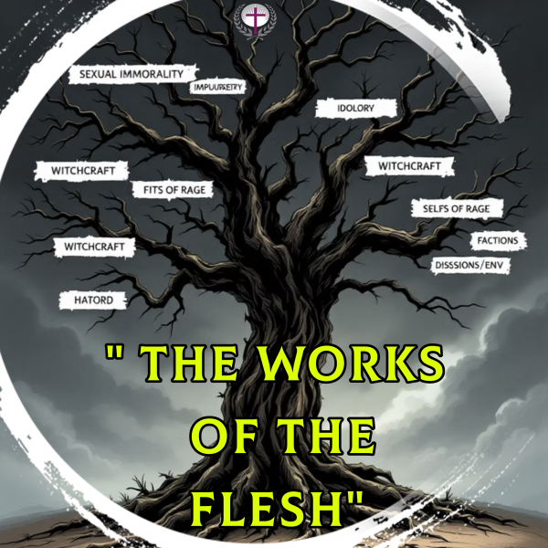

“¹⁹ Now the works of the flesh are manifest, which are these; Adultery, fornication, uncleanness, lasciviousness, ²⁰ Idolatry, witchcraft, hatred, variance, emulations, wrath, strife, seditions, heresies, ²¹ Envyings, murders, drunkenness, revellings, and such like: of the which I tell you before, as I have also told you in time past, that they which do such things shall not inherit the kingdom of God” - Galatians 5:19-21

INTRODUCTION

There are seventeen “works” of the flesh referenced in our text, which can be categorized into four distinct groups that illustrate different areas of human corruption. These categories help us understand the overall impact of sin across all aspects of our lives.

Sins of Impurity – (a) Adultery, (b) fornication, (c) uncleanness (d) lasciviousness.

This Bible study series will help us understand what Paul means by each “work of the flesh.” We'll explore the context, examine each sin mentioned, and discover how to live victoriously through the power of the Spirit.

SINS OF IMPURITY

- Work #2: Fornication

Biblical Definition: The Greek word "Porneia" translates to "fornication" or "sexual immorality." It encompasses a range of behaviors, including prostitution, premarital sex, and all sexual activity outside marriage.

- These practices were widely accepted when Paul wrote this letter to the Galatians, just as they remain commonly accepted today. However, Paul admonishes in 1 Corinthians 6:18-20, “¹⁸ Flee fornication. Every sin that a man doeth is without the body; but he that committeth fornication sinneth against his own body. ¹⁹ What? know ye not that your body is the temple of the Holy Ghost which is in you, which ye have of God, and ye are not your own? ²⁰ For ye are bought with a price: therefore glorify God in your body, and in your spirit, which are God's.” These verses emphasize that fornication is a sin that directly impacts the body. This is because the body is considered a temple of the Holy Spirit, and fornication violates this sacredness.

- Marriage is a divinely ordained institution with various purposes, including reflecting God's relationship, providing companionship, fostering family life, and contributing to societal stability and well-being. In Genesis, we see that it was God who created a wife for Adam. “¹⁸ And the Lord God said, It is not good that the man should be alone; I will make him an help meet for him. ²¹ And the Lord God caused a deep sleep to fall upon Adam, and he slept: and he took one of his ribs, and closed up the flesh instead thereof; ²² And the rib, which the Lord God had taken from man, made he a woman, and brought her unto the man. ²³ And Adam said, This is now bone of my bones, and flesh of my flesh: she shall be called Woman, because she was taken out of Man. ²⁴ Therefore shall a man leave his father and his mother, and shall cleave unto his wife: and they shall be one flesh” – Genesis 2:18; 21 -24.

- “Now concerning the things whereof ye wrote unto me: It is good for a man not to touch a woman. ² Nevertheless, to avoid fornication, let every man have his own wife, and let every woman have her own husband”– 1 Corinthians 7:1-3.

- The Bible views marriage as a sacred union ordained by God, and finding a suitable partner is seen as a divine gift that brings joy and companionship. Every unmarried brother must therefore assess himself and take the necessary steps at the appropriate time.

  - Unmarried brothers who are called to participate in this divine institution known as marriage must recognize that it is their God-given duty to find a wife. “²² Whoso findeth a wife findeth a good thing, and obtaineth favour of the Lord” – Proverbs 18:22.
  - “Whoso findeth a wife findeth a good thing” – this part of the proverb emphasizes the value of marriage and the positive impact a good wife will have on a man's life.

  - “Obtaineth favour of the Lord” - this suggests that finding a good wife is not merely a good choice, but a blessing from God, indicating His favor and approval.

  - Note: If St. Matthew 19:10-12 applies to you, then don’t make the mistake of getting married or giving the impression that you want to be married.

- Work #3: Uncleanness

Biblical Definition: "Akatharsia" (ak-ath-ar-see'-ah) refers to moral impurity, particularly in relation to sexual immorality, while also encompassing other forms of impurity in thoughts, words, and actions. It includes filthiness that extends beyond physical actions to cover impure thoughts and mindsets. This term involves indecency and obscenity in all their forms.

- Uncleanness typically begins in the mind with impure thoughts and gradually leads to outward actions. This progression illustrates how sin operates from the inside out. What starts as seemingly harmless thoughts or entertainment choices can evolve into more serious moral compromise and actual sinful behavior.

- Uncleanness is stimulated by watching sexually explicit videos, viewing obscene pictures, and telling suggestive, smutty stories. This is further aggravated by today’s emphasis on wearing less and exposing more.
- As saints, we are called to holiness and cleanliness, “Having therefore these promises, dearly beloved, let us cleanse ourselves from all filthiness of the flesh and spirit, perfecting holiness in the fear of God” - 2 Corinthians 7:1. Ephesians 5:3 goes further, stating that, “… fornication, and all uncleanness, or covetousness, let it not be once named among you, as becometh saints.” This includes the consumption of immoral content, such as movies, videos, or pictures that expose us to indecency and obscenity.

- THE GENESIS OF A HABIT

Sow a THOUGHT; you reap an ACT
Sow an ACT; reap a HABIT
Sow a HABIT; reap a CHARACTER
Sow a CHARACTER; reap a DESTINY

- Work #4: Lasciviousness

Biblical Definition: The Greek term 'aselgeia' refers to unrestrained sensuality and shameless behavior, characterized by a total absence of moral restraint. It represents a conscious embrace of sensual pleasures, showing a blatant disregard for divine law and societal norms designed to enhance human well-being.

- Uncontrolled Lusts
Lasciviousness manifests through an unbridled, insatiable desire that transcends private sin. Unlike uncleanness, which often remains concealed, lasciviousness represents a profound moral deterioration, as individuals deliberately flout social boundaries and public standards of decency with shocking indifference. Those ensnared by lasciviousness have descended so deeply into impurity that they demonstrate a callous disregard for God's impending righteous judgment and appear utterly indifferent to the moral sensibilities of others around them.

- Behavioral Manifestations
In practical terms, lasciviousness encompasses any sexually explicit, lewd, or indecent expression that violates God's design for sexuality. This includes provocative physical gestures, vulgar speech patterns, immodest attire meant to incite improper desire, and both consuming and creating immoral content that degrades the sacred gift of human intimacy established by God.

- Biblical Example of Lasciviousness

Sodom's Sin

A profound example of lasciviousness is documented in 2 Peter 2:6-8, with the complete account detailed in Genesis 19:1-14, showcasing the depths of moral degradation.

Angels' Arrival
Two divine messengers entered Sodom, and Lot, recognizing the danger of the city streets, urgently insisted they accept his household's protection and hospitality.

Wicked Demand
The men of Sodom, consumed by unbridled lust, surrounded Lot's house and demanded he surrender his visitors for their sexual gratification, revealing their complete abandonment of moral restraint.

Divine Judgment
This flagrant display of lasciviousness represented such an affront to divine law that it provoked God's righteous judgment, destroying Sodom and Gomorrah.

- The Pattern of Sexual Sins
James 1:14-15 describes how sin progresses from temptation to conception to birth to death. Sexual sin follows this same destructive pattern, beginning with lustful thoughts.

- Temptation | - Conception
Sin begins with an enticing thought or temptation that captures our attention and appeals to our desires. | When dwelt upon rather than rejected, the temptation takes root in our heart and develops into intent.
- Birth | - Death
Sin begins with an enticing thought or temptation that captures our attention and appeals to our desires. | If unrepentant, sin ultimately leads to spiritual separation from God and deterioration of one's spiritual vitality.
- The Impact of Sexual Sins
Sexual sin creates waves of destruction, beginning with the individual's relationship with God and then fracturing the sacred marital bond. The resulting pain impacts innocent children and extended family members, ultimately undermining the integrity and witness of the Church.

- Individual | - Marriage
Profound spiritual emptiness and separation from God along with emotional trauma that damages self-worth will result as of sexual sins. | Devastating breach of covenant trust that fractures marital intimacy.
- Family | - Community
Deep wounds inflicted on children and relatives through betrayal and loss. | Far-reaching damage to church unity and testimony in the broader society.

VICTORY THROUGH THE SPIRIT

- Victory doesn't come through human determination or self-discipline alone, but through dependence on the Holy Spirit's power.

- Spirit-led living involves moment-by-moment dependence on God's strength and guidance in every decision and temptation.
- Our identity as children of God motivates holiness, not from
fear, but from love and gratitude for salvation.
PRACTICAL APPLICATION

- Guard Your Heart - Philippians 4:8 instructs believers to focus their minds on things that are true, honorable, just, pure, lovely, commendable, excellent, and praiseworthy. Mental discipline is crucial for sexual purity.

- Accountability - Establishing honest and transparent relationships within the church community provides support, encouragement, and gentle correction when needed to maintain moral purity.

- Digital Boundaries - Setting clear boundaries in digital spaces, entertainment choices, and relationships helps prevent exposure to tempting content and compromising situations.

- Confession and Repentance - When we fall short, immediate confession to God and trusted believers, coupled with genuine repentance, restores fellowship and provides opportunity for growth.

GRACE AND RESTORATION

- No Condemnation - Romans 8:1 assures believers there is no condemnation for those who are in Christ Jesus. Past failures don't disqualify us from God's love and forgiveness.

- Jesus' Forgiveness
Christ offers complete forgiveness to those who genuinely repent, as demonstrated throughout the Gospels with tax collectors, prostitutes, and other sinners who came to Him.

- Church as Hospital
The church should serve as a place of healing and restoration, rather than judgment. Broken people need grace for recovery and growth.

- Restoration Process
Biblical restoration involves confession, repentance, accountability, and gradual rebuilding of trust within the community of faith through demonstrated change.

CONCLUSION

Christian freedom represents the liberty to follow Christ and pursue holiness, rather than a license to indulge one's fleshly desires. When we are led by the Spirit instead of the works of the flesh, sexual purity transforms into both an act of worship and a powerful witness to the world.

God calls us to embrace His vision for sexuality, which is rooted in the covenant of marriage, where intimacy reflects the profound relationship between Christ and His church. This liberation fosters growth, not restriction.

