Order of Worship: Word & Table 06/01/25

Gathering-Lighting the Candles with Light of Christ

Welcome, Greeting, Service Introduction Rev. Warren Lunsford//All

Call to Worship Rev. Warren Lunsford//All

Glorious Things of Thee Are Spoken UMH 731

Opening Prayer of Confession Rev. Warren Lunsford

Silent Personal Confession

Assurance of Forgiveness Rev. Warren Lunsford

Life of the Church Rev. Cindy Lunsford (see bulletin)
Mission Moment – Prayer over donation items…thank you for your love and care!

Psalm Reading Psalm 47 (UMH 781) Gina Elrod

Hymn In the Garden UMH 314

OFFERING OF OURSELVES

Pastoral Prayer Rev. Cindy Lunsford/All

Worship with Our Tithes & Offerings Steve Hawkins instrumental
Dedication & Offertory Rev. Warren Lunsford

Doxology UMH 095

Praise God, from whom all blessings flow;
praise him, all creatures here below;
praise him above, ye heavenly host;
praise Father, Son and Holy Ghost. Amen

Centering Song The Lord’s Prayer Steve Hawkins

PROCLAMATION
Prayer of Illumination Rev. Warren Lunsford/All

Blessed are you, Lord God,
King of all creation:
You have taught us by your Word.
Open our hearts to your Spirit,
and lead us on the paths of Christ, your Son.
All praise and glory be yours forever. Amen.

Scripture Ephesians 1:15-23 Rev. Warren Lunsford

Scripture Acts 1:1-11 Rev. Cindy Lunsford

Message Lifted Up, Set Apart Rev. Cindy Lunsford

WORSHIP AT THE TABLE

Great Thanksgiving & Communion (UMH 9-11) Rev. Cindy Lunsford/All

Prayer After Communion:

God of grace, thank you for this bread and wine,
and for the gift of your Son, Jesus Christ.
Teach us good Lord to serve you as you deserve.
To give and not to count the cost.
To fight and not to heed the wounds.
To toil and not to seek for rest.
To labor and not to ask for any reward,
except that of knowing we do your will.
Through Jesus Christ our risen Lord, Amen

GOING FORTH WITH CHRIST

Closing Hymn All Hail the Power of Jesus’ Name UMH 154

Commissioning & Benediction Rev. Cindy Lunsford

Depart to Serve, caring for others, as we truly serve God

DAILY PRAYER MAIL CHAIN goes out after 5 pm as requests arise.
Send requests to prayer@alexanderchapel.org.
Limited Prayer shawls are also available
Those with cancer | People with falling injuries
Gary Seiler | Those lonely in nursing homes
ACUMC pastoral transition | Gayle Stockton
Steve & Angie-home transition/repairs | Sharon Buchanan
Pam & Russ-home repairs & travels | Marcia Smith and her friend Gary and cousin Sherry
Mary Miller & Sister Pat | Carole Morelock & her friends
Kathy’ shoulder pain and results | Dianne, Scrappy, Patsy, & Judy
Unspoken | Joyceline’s brother John
Brent Sevier | Education staff DOE & local schools, Special Needs kids
Judy Buchannan | Angie’s Shoulder surgery recovery
Walter & Willie Glance | Sabe Hawkins, Steve’s dad
World Peace and Justice | Comfort for grieving family and friends at loss of loved ones
Spread of measles & Bird Flu | Congress and world leaders
Worldwide Anxiety in need of Christ’s Peace | UMCOR Disaster Relief workers and coordinators in WNC
Clay Waldroup | Harriet Burnette
Peggy’s mother | Gallamore Family grief

Jason Brockmeier

CHURCH INFORMATION FOR THIS WEEK
Alexander Chapel Website: alexanderchapel.org
Alexander and Clark’s Chapel Facebook page:
https://www.facebook.com/groups/2425756981049797
Medical Lending Closet Phone Contact: 828-658-1351

June 6, 7:00 pm, A Cappella Alive! Chorus with Bliss and Fireflies,
First Baptist Church, Weaverville, NC

IN THE UPCOMING MONTHS…SPREAD THE WORD!

June 14, 9:30-noon, Bloodmobile Blood Drive, at Christ UMC parking lot
Donors receive $40 e-gift card, walk-in or make appointment call 828-713-6332

June 19, 11:30 am, Ladies Loving the Lord, Twisted Laurel

WORSHIP INFORMATION AT ALEXANDER CHAPEL UMC

Livestream via Zoom
On PC, zoom.us other devices open the app.
Meeting ID is 949 0936 7127, Passcode is 394347
OR use this url link:
https://zoom.us/j/94909367127?pwd=Kml3L9xIfQFJxzW0IGcIiWTg6Nf1vJ.1

The 11am Service will be Posted Online this Afternoon
Direct Link: http://alexanderchapel.org/worship-service-june-01-2025
Or navigate from the church website alexanderchapel.org front page

WELCOME VISITORS and FELLOW SPIRITUAL SEEKERS

To find out more about our church and beliefs, please visit our website
or Contact: revcindy.lunsford@gmail.com OR warrenlunsford@gmail.com


ABCCM FOOD DONATIONS: Donation Basket at Front Door.
We dedicate our gifts on Communion First Sundays.

Canned Items: Chicken, Tuna, Salmon, Fruits, Meats, Hearty Soups, Vegetables

Other Items: Cooking Oil, Fresh Seasonal Fruits, Hot & Cold Cereal, Jelly, Juices, Peanut Butter, Pasta, Pasta Sauce, Self-rising Flour, Sugar

Hygiene: Shampoo, Conditioner, Deodorant, Toothpaste, Toothbrushes, Soap

2025 Annual Conference Opening/Closing Worship Designated Offering



The 2025 Annual Conference Offering will be used to support Scholarships for United Methodist youth and children to attend one of our WNC Camps (Camp Tekoa, Mt. Shepherd and GuilRock) AND provide support for WNC youth to attend the Harambee Youth Conference.

We will do a separate offering in our worship 6/8, Treasurer will give us a check 6/15 to take to the AC.

Alexander Chapel United Methodist

June 01, 2025 ~Ascension C ~

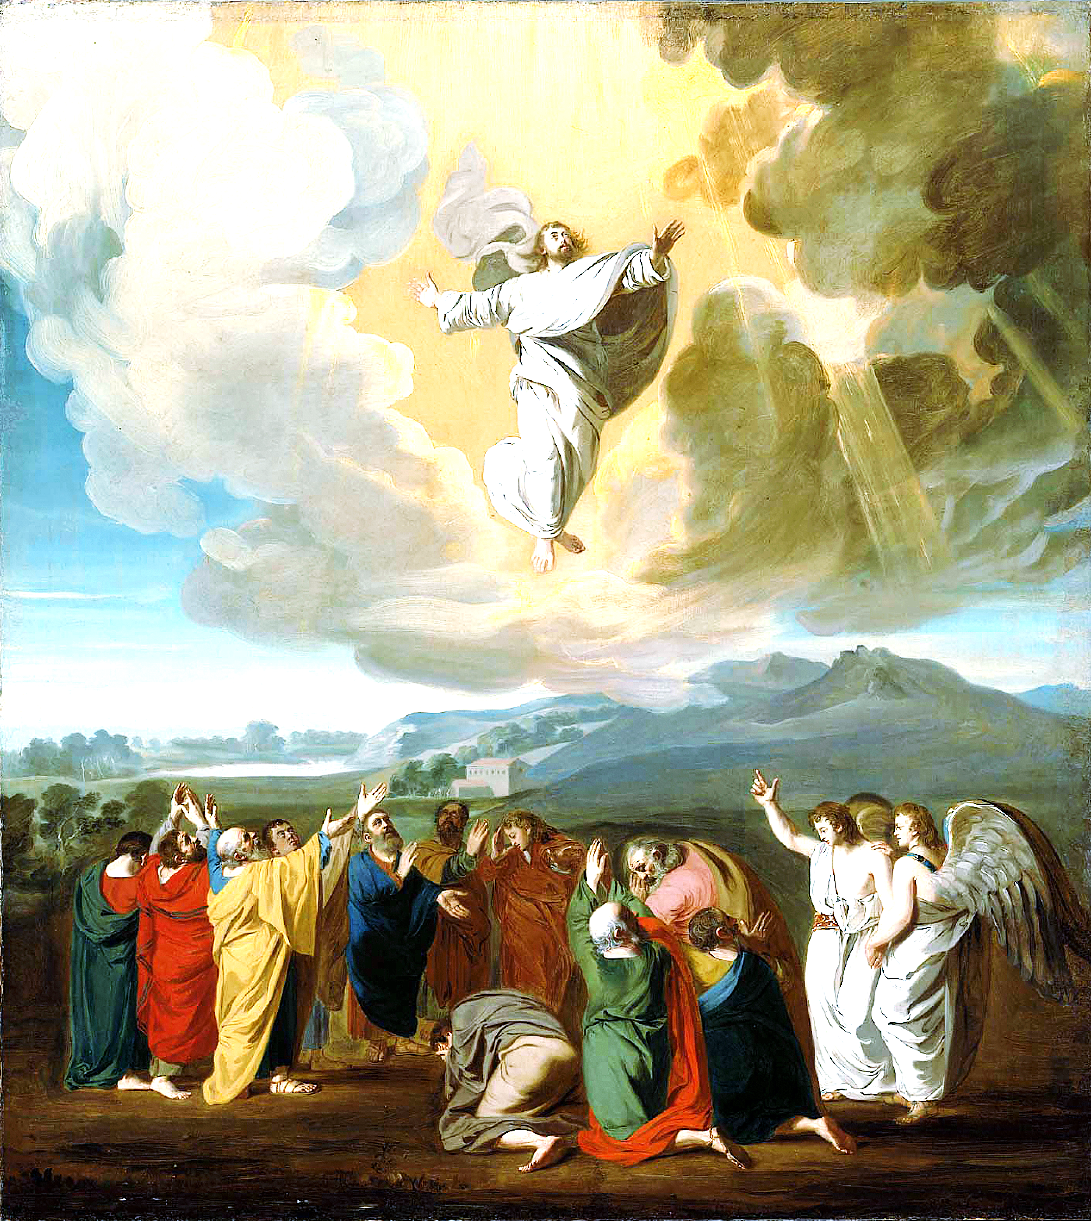

“Worship is the proper response of all moral, sentient beings to God, ascribing all honor and
worth to their Creator-God precisely because he is worthy, delightfully so.”—D.A. Carson

If this is your first time worshipping here, we thank you for making our worship more complete!

~~~~~~~~~~~~~~~~~~~~~~~~~~~
Church Location:
880 Aiken Rd, Asheville, NC 28804
Church Mailing Address:
5 Sawyer Cove Rd, Weaverville, NC 28787
~~~~~~~~~~~~~~~~~~~~~~~~~~~

Pastors: Rev. Warren Lunsford & Rev. Cindy Lunsford

Pastor Contact: revcindy.lunsford@gmail.com, warrenlunsford@gmail.com

Website: alexanderchapel.org

Phones/Text: Cindy 828-891-2753 / Warren 704-288-7378

Pastoral Mailing Address: 431 Pine Ridge Rd, Mars Hill, NC 28754
~~~~~~~~~~~~~~~~~~~~~~~~~~~
Direct bulletin information to Rev. Cindy Lunsford

