Name of Assembly: United Apostolic Church
Type of service: Bible Study
Date: June 3rd, 2025
Series Topic: The Works of the Flesh
Lesson 1: Sins of Impurity
Scripture Text: Galatians 5:19-21; Colossians 3:1-17

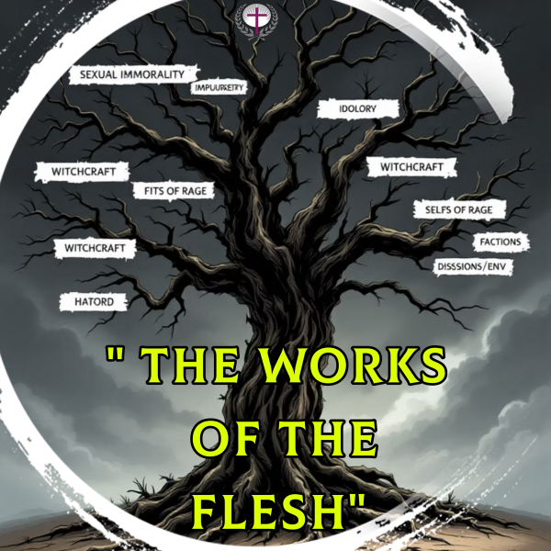
“¹⁹ Now the works of the flesh are manifest, which are these; Adultery, fornication, uncleanness, lasciviousness, ²⁰ Idolatry, witchcraft, hatred, variance, emulations, wrath, strife, seditions, heresies, ²¹ Envyings, murders, drunkenness, revellings, and such like: of the which I tell you before, as I have also told you in time past, that they which do such things shall not inherit the kingdom of God” - Galatians 5:19-21
INTRODUCTION

Galatians 5 illustrates a profound contrast between two distinct paths of living. One path follows the flesh, manifesting in the sinful behaviors listed in verses 19-21. The other path follows the Spirit, yielding the beautiful virtues outlined in verses 22-23.

As descendants of Adam, we inherit a sinful earthly nature; yet as born-again believers, we receive a new divine nature through Christ. This new nature doesn't eliminate the old one—rather, both natures coexist within us, creating an internal battlefield where opposing desires compete for control of our choices and actions.

Our fleshly nature draws us toward the sinful behaviors listed in Galatians 5:19-21, while our spiritual nature leads us toward the fruit of the Spirit. This conflict creates a deeper, more intense spiritual struggle than we experienced before salvation.

Victory does not come through self-effort, but through moment-by-moment surrender to the Holy Spirit's guidance. As we commit to walking in the Spirit, the overwhelming grip of the flesh begins to weaken, as outlined in Galatians 5:16-18: “This I say then: Walk in the Spirit, and ye shall not fulfil the lust of the flesh. For the flesh lusteth against the Spirit, and the Spirit against the flesh; and these are contrary the one to the other: so that ye cannot do the things that ye would. But if ye be led of the Spirit, ye are not under the law.”

To experience victory in Christ, we must deliberately “walk in the Spirit” so that we don’t “fulfill the lust of the flesh.” The word “walk” in the original Greek is in the present tense and means “to conduct ourselves day by day in accord with the directives of the Holy Spirit.

The Holy Spirit has been given to enable us to gain victory over enslavement to sin. Paul describes the struggle more fully in Romans 7:17-25. In Romans 8:5-9, he discusses the victory available to those who are born of the Spirit and follow the Spirit’s leading.

A holy life is never achieved through our own efforts or strength; it is produced as we yield to the guidance of the indwelling Holy Spirit.

There are seventeen “works” of the flesh referenced in our text, which can be organized into four distinct groups that illustrate various areas of human corruption. These categories help us understand the overall impact of sin on all aspects of our lives.

- Sins of Impurity | - Sins of Idolatry
Adultery, fornication,  uncleanness & lasciviousness  - These transgressions distort God's sacred blueprint for  human sexuality.  - They degrade the holy gift of intimate communion.  - Resulting in profound spiritual desolation and shattered relationships that alienate us from our Creator and our fellow beings. | Idolatry and Witchcraft

- Sins of Hostility | - Sins of Intemperance
Hatred, Variance, Emulations, Wrath, Strife, Seditions, Heresies, Envyings and Murder. | Drunkenness and Revellings

This Bible study series will help us understand what Paul means by these terms and how they apply to our daily Christian walk. We'll explore the context, examine each sin mentioned, and discover how to live victoriously through the power of the Spirit.

- A Look at Key Words and Terms:
“¹⁹ Now the works of the flesh are manifest, which are these…;”

- Paul begins with “Now" to draw attention to what follows.

- “Works” suggests active deeds and behavioral patterns, not occasional lapses.

- “The flesh” does not refer to our physical bodies but to our fallen human nature—the part of us that rebel against God and seeks self-gratification rather than His divine will. It is also referred to as the carnal Adamic nature, with its frailties and passions.

- “Are manifest” indicates that these behaviors are obvious and recognizable as sinful, requiring no special spiritual discernment to identify as wrong and destructive.

- “Which are these...” is utilized to present a representative list of carnal behaviors that define unregenerate life and pose a threat to spiritual maturity.

SINS OF IMPURITY

Scripture categorically identifies adultery, fornication, uncleanness, and lasciviousness as works of the flesh, not merely cultural taboos but divine boundaries. The apostle Paul offers no theological ambiguity; these expressions of impurity fundamentally contradict the sanctified life to which believers are called in Christ.

In New Testament times, every conceivable form of immorality was openly practiced by rulers, philosophers, poets, priests, and many ordinary people, without any sense of shame or remorse, as it was an accepted way of life in the ancient world. In this cultural context, believers were encouraged to embrace purity, not as a mere limitation, but as an active testimony to God's redemptive work. This exemplifies God’s eternal holiness and His intended design for human intimacy, offering a transformative witness to a world bound by its passions and desires.

- Work #1: Adultery

Biblical Definition: Sexual relations between a married person and someone other than their spouse.

Leviticus 18:20 says: “Thou shalt not lie carnally with thy neighbor’s wife, to defile thyself with her.” Exodus 20:14 says, “Thou shalt not commit adultery.” Additionally, Hebrews 13:4 declares that God will judge “whoremongers and adulterers.”
- There are various forms of adultery. These include:
  - Physical adultery (described in Leviticus 18:20).

  - Mental adultery (Mental adultery deals with fantasizing or saturating the mind with illicit thoughts about someone else besides your spouse).

    - Jesus expands upon the Old Testament commandment against adultery, stating that lustful thoughts, even before physical action, constitute adultery in the heart. He emphasizes that sin begins with the intention, not just the action (Matthew 5:27-28).

  - Legalized adultery (which consists of the remarriage of a divorced person without cause while the original partner is still living). St. Matthew 19:5-10, St. Mark 10:2-13 and 1 Corinthians 7:10-11;15.

  - Moreover, there exists a concept known as communal adultery, in which married couples participate in a communal living arrangement that permits the men to engage in sexual relations with any woman within the group.

- When God established the home, He designed that one man should live with one woman, and the two should become one flesh. “Therefore, shall a man leave his father and his mother, and shall cleave unto his wife: and they shall be one flesh” – Genesis 2:24.

- The sin of adultery is not a trivial matter, and so married couples must ensure that the Word of God governs all their lives, including sexual intimacy. 1 Corinthians 7:3-5.

Adultery in Scripture

- David's Downfall

The account of David and Bathsheba in 2 Samuel 11-12 illustrates how adultery devastates lives and families. David's lustful weakness results in murder, deception, and lasting consequences.

- Mercy Available

In John 8:1-11, Jesus forgave the woman caught in adultery, urging a change of life. His response shows His grace and the expectation of transformed living after forgiveness.

