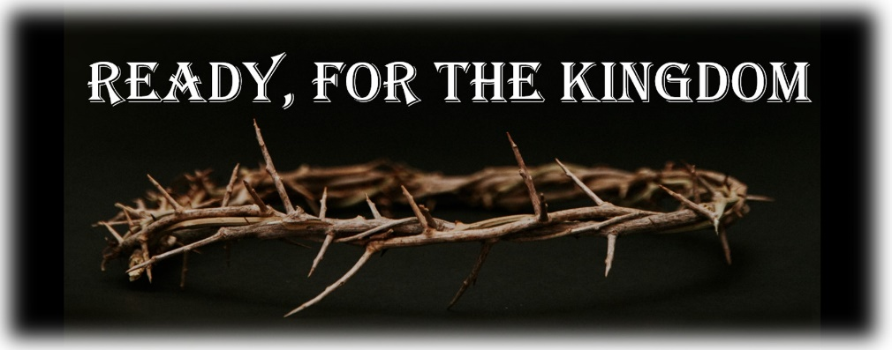

**Scripture: Mark 1:9-15 Date: May 18, 2025**

**Immediately in the Gospel of mark helps us understand ...**

1. The work of God is ______________________.   
   - Jesus acts immediately when the right time comes.
2. The work of God is ______________________.  
   - Jesus is not idle, but is at work to bring about the will of His Father.
3. The work of God is ______________________.  
   - Jesus lived each day to serve and give His life as a ransom for many.
4. We are called to serve God in ____________________.   
   - Jesus lived in perfect obedience to the will of His Father.

**Three questions to reflect on ...**

1. Are we ready to __________________ God’s favor?  
   (Mark 1:9-11)
2. Are we ready to __________________ the struggle?  
   (Mark 1:12-13)
3. Are we ready to __________________ the Gospel?  
   (Mark 1:14-15)

**Scripture to Pray**

"Put on then, as God’s chosen ones, holy and beloved, compassionate hearts, kindness, humility, meekness, and patience, bearing with one another and, if one has a complaint against another, forgiving each other; as the Lord has forgiven you, so you also must forgive."

**Colossians 3:12–13**

**From the Resources**

“What would my Christian life look like is I had the Greek word euthus [immediately] "stamped" on my eyes and heart? Would it make any difference in what I look at this next week, how many hours I spend watching mindless television shows or playing often times godless (even ungodly) video games, surfing the web (even landing in places my eyes should not land), etc? Would it impact how I use my spare time - for temporal tasks or eternal endeavors?”  
- Precept Austin (Online)  
*Commentary on Mark 1*

**Questions to Consider**

1) In what ways do you struggle to receive God’s grace and blessings? What would it look like to depend more on the work of Jesus than on your own righteousness or works?

2) Who, in your life, has endured great struggles and remained faithful to God through them? Do you think you are ready for similar struggles?

3) When was the last time you told someone about the hope we have in Jesus who died for our sins and rose from the grave?