Holy Trinity Lutheran Church

The Resurrection of Our Lord

April 20, 2025, at 10:45 am

Pastor Tina Crog

*Prelude

*Welcome and Announcements worship assistant

*Children’s Moment – Pastor Tina

* Call to Worship – Pastor Tina
Beloved, Christ is risen!
Christ is risen indeed! Alleluia!
Our Savior is risen!
Our Savior is risen indeed! Alleluia!
Steadfast Love is risen!
Steadfast Love is risen indeed! Alleluia!
This is the day that God has made;
Let us rejoice and be glad! Alleluia!

* Opening Hymn “Jesus Christ is Risen Today” ELW 365
Public Domain

1 Jesus Christ is ris'n today, Alleluia!
our triumphant holy day, Alleluia!
who did once upon the cross, Alleluia!
suffer to redeem our loss. Alleluia!

2 Hymns of praise then let us sing, Alleluia!
unto Christ, our heav'nly king, Alleluia!
who endured the cross and grave, Alleluia!
sinners to redeem and save. Alleluia!

3 But the pains which he endured, Alleluia!
our salvation have procured; Alleluia!
now above the sky he's king, Alleluia!
where the angels ever sing. Alleluia!
4 Sing we to our God above, Alleluia!
praise eternal as his love; Alleluia!
praise him, all you heav'nly host, Alleluia!
Father, Son, and Holy Ghost. Alleluia!

Text: Latin carol, 14th cent., sts. 1-3; tr. J. Walsh, Lyra Davidica, 1708, alt.; Charles Wesley, 1707-1788, st. 4

* Confession and Forgiveness Pastor tina
We gather in the name of the Holy One, ✠ who calls us into abundant life, the Risen Christ, who feeds and tends us, and the Spirit, who renews all things. Amen.

Beloved in Christ, we come before God knowing that our faith is not only what we confess with our lips but what we embody in our lives. Let us confess our sins, trusting in God's mercy.

God of all life, in our baptism you call us to feed Christ’s sheep, to walk in the ways of love, and to be witnesses of the new creation. Yet, we fall short. You have shown us the way of love, and we have built barriers instead of tables. You have called us to healing and renewal, and we wound others with our words and ambivalence. Forgive us, O God. Draw us again into your embrace, that we may follow Christ’s command to and to live as signs of your new creation. In the name of Jesus we pray. Amen.

Hear the good news: The One who makes all things new has already made a way for us. Through Christ, the Good Shepherd, who lays down life for the sheep, through the Lamb who gathers a multitude from every nation, through the Living Water that washes away sorrow and shame— your sins are forgiven. You are called and sent to share this love with the world. Amen. Thanks be to God!

* Canticle of Praise “This is the Feast” ELW pg. 149
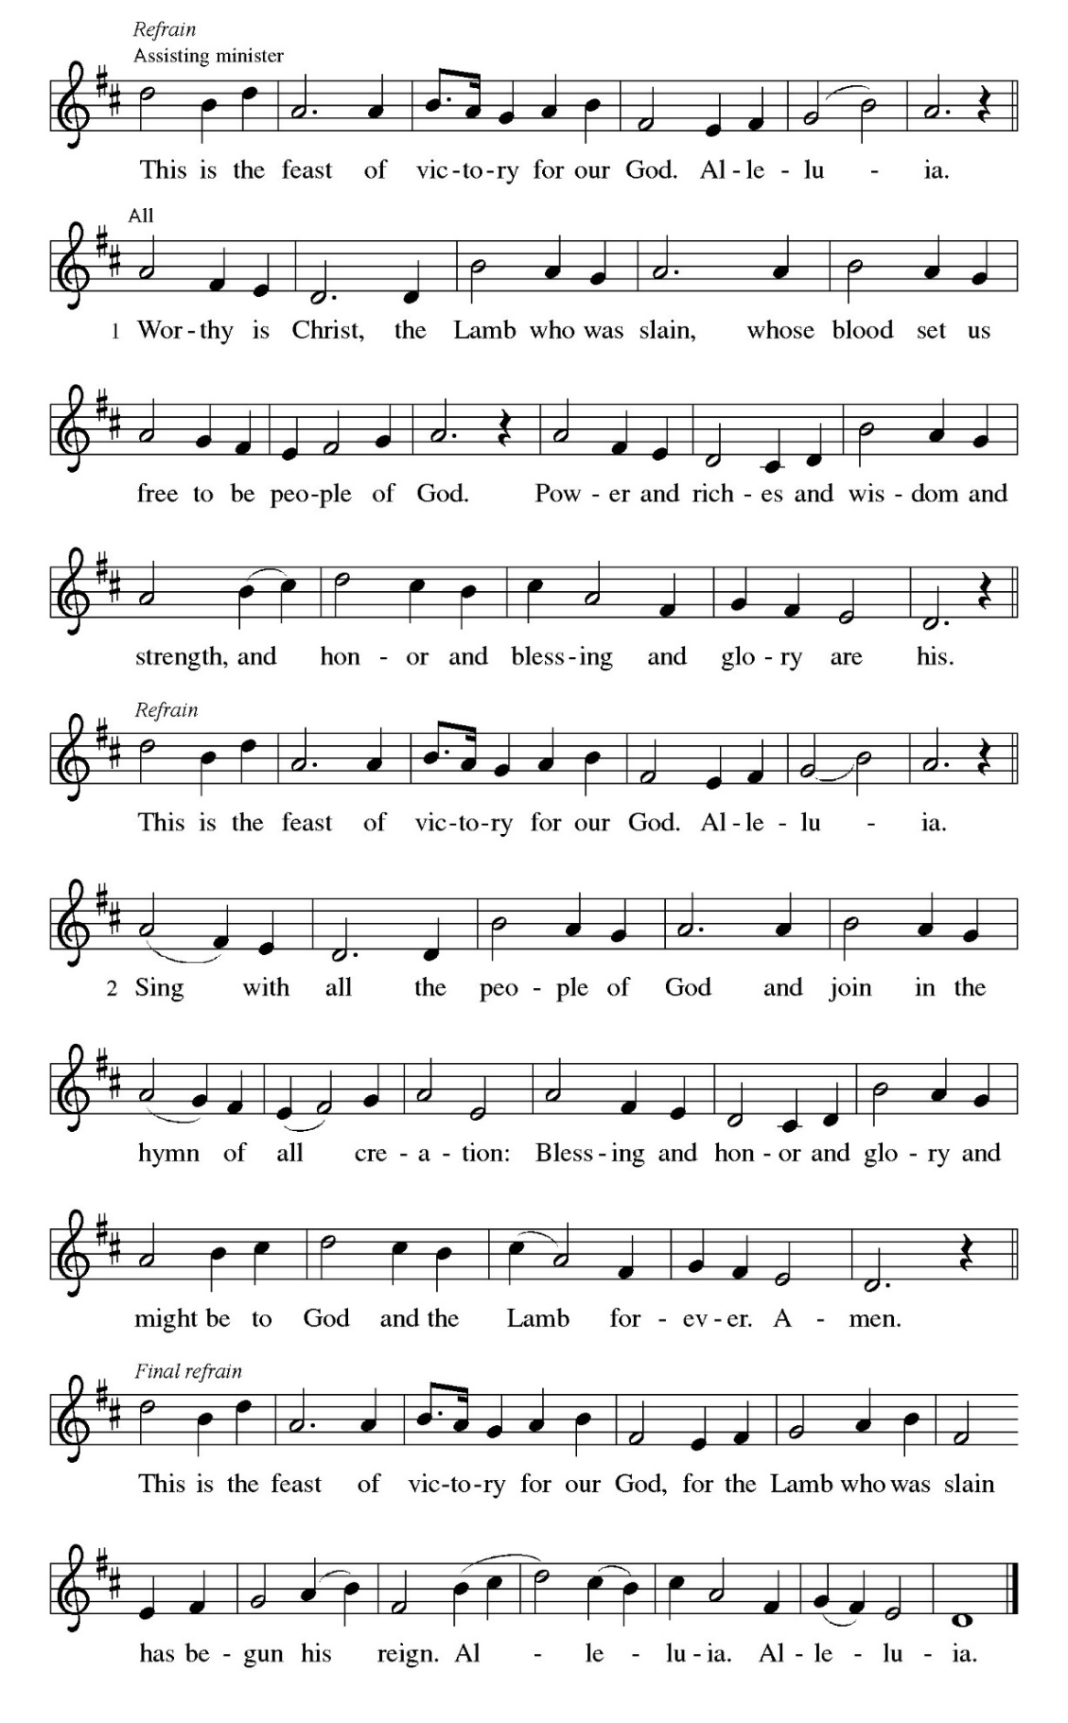
*Greeting pastor tina
Alleluia! Christ has risen.
Christ has risen, indeed! Alleluia!
The grace of our Lord Jesus Christ, the love of God, and the communion of the Holy Spirit be with you all.
And also with you.

*Prayer of the Day worship assistant
God of mercy, we no longer look for Jesus among the dead, for he is alive and has become the Lord of life. Increase in our minds and hearts the risen life we share with Christ, and help us to grow as your people toward the fullness of eternal life with you, through Jesus Christ, our Savior and Lord, who lives and reigns with you and the Holy Spirit, one God, now and forever. Amen.

Passing of the Peace worship assistant
the peace of christ be with you always. and also with you.

Please share a sign of god’s peace with one another.

First Lesson: Acts 10:34-43
³⁴ Peter began to speak to [the people]: “I truly understand that God shows no partiality, ³⁵ but in every nation anyone who fears him and does what is right is acceptable to him. ³⁶ You know the message he sent to the people of Israel, preaching peace by Jesus Christ—he is Lord of all. ³⁷ That message spread throughout Judea, beginning in Galilee after the baptism that John announced: ³⁸ how God anointed Jesus of Nazareth with the Holy Spirit and with power; how he went about doing good and healing all who were oppressed by the devil, for God was with him. ³⁹ We are witnesses to all that he did both in Judea and in Jerusalem. They put him to death by hanging him on a tree; ⁴⁰ but God raised him on the third day and allowed him to appear, ⁴¹ not to all the people but to us who were chosen by God as witnesses, and who ate and drank with him after he rose from the dead. ⁴² He commanded us to preach to the people and to testify that he is the one ordained by God as judge of the living and the dead. ⁴³ All the prophets testify about him that everyone who believes in him receives forgiveness of sins through his name.”

The Word of the Lord. Thanks be to God.

Psalmody
“Come, Praise the Lord, for He Is Good” (Psalm 118:1-2, 14-24)
Sung to the tune: “How Can I Keep from Singing” ELW #763
Public Domain

- Come, praise the Lord, for He is good;
His kindness is forever.
Let Israel say, “For He is good;
His kindness is forever.”
Let all the house of Aaron say,
“His kindness is forever.”
Let those who fear the Lord now say,
“His kindness is forever.”

5. You drove me to the brink of death;
the Lord was there to aid me,
my song and strength with every breath,
to liberate and save me.
I will survive to live and tell
His mighty operation;
with discipline God taught me well,
and freed me from damnation.

7. The stone the builders all denied
is now the one foundation.
This action, by the Lord supplied,
became our inspiration.
This is the day the Lord has made;
we celebrate Your splendor,
so prosper with your mighty aid,
and save us, our Defender.

8. Blessed is the One who comes from God;
from heaven’s court we bless You.
His glory shines with lightning rod,
while worshipers process to
God’s holy place, of stone and wood,
His temple is forever.
Come, praise the Lord, for He is good;
His kindness is forever.
Second Lesson: Philippians 3:17—4:1
¹⁹ If for this life only we have hoped in Christ, we are of all people most to be pitied. ²⁰ But in fact Christ has been raised from the dead, the first fruits of those who have died. ²¹ For since death came through a human being, the resurrection of the dead has also come through a human being; ²² for as all die in Adam, so all will be made alive in Christ. ²³ But each in his own order: Christ the first fruits, then at his coming those who belong to Christ. ²⁴ Then comes the end, when he hands over the kingdom to God the Father, after he has destroyed every ruler and every authority and power. ²⁵ For he must reign until he has put all his enemies under his feet. ²⁶ The last enemy to be destroyed is death.

The Word of the Lord. Thanks be to God.

* Gospel Acclamation “Alleluia” ELW pg. 151
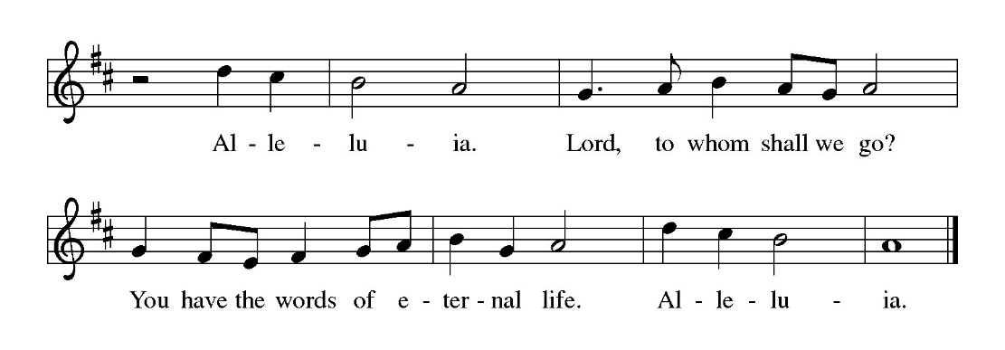
* Gospel: Luke 24:1-12 PASTOR TINA
The Holy Gospel according to Luke the 24th chapter. Glory to you, O Lord.

¹ On the first day of the week, at early dawn, [the women] came to the tomb, taking the spices that they had prepared. ² They found the stone rolled away from the tomb, ³ but when they went in, they did not find the body. ⁴ While they were perplexed about this, suddenly two men in dazzling clothes stood beside them. ⁵ The women were terrified and bowed their faces to the ground, but the men said to them, “Why do you look for the living among the dead? He is not here, but has risen. ⁶ Remember how he told you, while he was still in Galilee, ⁷ that the Son of Man must be handed over to sinners, and be crucified, and on the third day rise again.” ⁸ Then they remembered his words, ⁹ and returning from the tomb, they told all this to the eleven and to all the rest. ¹⁰ Now it was Mary Magdalene, Joanna, Mary the mother of James, and the other women with them who told this to the apostles. ¹¹ But these words seemed to them an idle tale, and they did not believe them. ¹² But Peter got up and ran to the tomb; stooping and looking in, he saw the linen cloths by themselves; then he went home, amazed at what had happened.

The Gospel of the Lord. Praise to you, O Christ.

Sermon pastor tina

* Hymn of the Day
“I Know That My Redeemer Lives!” ELW 619 vs. 1 – 4
Public Domain
1 I know that my Redeemer lives!
What comfort this sweet sentence gives!
He lives, he lives, who once was dead;
he lives, my ever-living head!

2 He lives triumphant from the grave;
he lives eternally to save;
he lives exalted, throned above;
he lives to rule his church in love.

3 He lives to grant me rich supply;
he lives to guide me with his eye;
he lives to comfort me when faint;
he lives to hear my soul's complaint.

4 He lives to silence all my fears;
he lives to wipe away my tears;
he lives to calm my troubled heart;
he lives all blessings to impart.

* Apostle’s Creed WORSHIP ASSISTANT
LET US UNITE OUR VOICES IN SAYING THE APOSTLE’S CREED.

I believe in God, the Father almighty,
creator of heaven and earth.

I believe in Jesus Christ, God's only Son, our Lord,
who was conceived by the power of the Holy Spirit,
born of the Virgin Mary,
suffered under Pontius Pilate,
was crucified, died, and was buried;
he descended to the dead.
On the third day he rose again;
he ascended into heaven,
he is seated at the right hand of the Father,
and he will come to judge the living and the dead.

I believe in the Holy Spirit,
the holy catholic Church,
the communion of saints,
the forgiveness of sins,
the resurrection of the body,
and the life everlasting. Amen.

* Prayers of Intercession PASTOR TINA
God of resurrection and new life, we come before you in prayer for the church, the world, and all who are in need.

A brief silence.
Kindle new life in your church. Encourage all who seek creative ways to share the good news of Christ’s resurrection. Bless mission developers and new ministries that their work plant seeds that flourish. God of grace, hear our prayer.
Nourish new life in all of creation. Shower forests and grasslands, deserts, and mountains with life-giving rains. Grant us delight in your glory that shows forth in all that grows this season. God of grace, hear our prayer.
Empower new life among the nations. As you raised Jesus from the dead, bring new hope for peace and reconciliation in places of war and strife. Raise up leaders who are steadfast in their commitment to justice and transformation. God of grace, hear our prayer.
Bring new hope among all who are in need, especially neighbors without homes or food, and those whose housing or food supply is at risk. Bring healing to all who are fearful, ill, or grieving (especially). God of grace, hear our prayer.
Awaken new life in this place. Open our hearts to ways you are calling us to be at work in the world and our community. Give us courage to boldly share your love for all people beyond our walls. God of grace, hear our prayer.
Trusting in the promises of the resurrection, we remember with thanksgiving our beloved dead. Sustain us with a living hope until we are reunited with them and all the saints at the heavenly banquet. God of grace, hear our prayer.
We commend these and all our prayers to you, O God, trusting that you are always with us; in the name of Jesus Christ, our risen Savior. Amen.

Offering WORSHIP ASSISTANT
the monthly mission for april is for the funeral meal supplies. Let us give to god what he has first given us.

offering Music by jared.

song to be sung while the offering is being returned to the altar.

* Offering Hymn “Come to the Table of Mercy” ELW 481
CCLI #11222261
Come to the table of mercy,
prepared with the wine and the bread.
All who are hungry and thirsty,
come, and your souls will be fed.
Come at the Lord's invitation;
receive from his nail-scarred hand.
Eat of the bread of salvation;
drink of the blood of the Lamb.

* Offering Prayer WORSHIP ASSISTANT AND CONGREGATION IN UNISON
Generous and Abundant God, all that we have comes from your hand—bread from the earth, water that sustains, love that binds us together. Bless these gifts we bring today. May they nourish the hungry, strengthen the weary, and build communities of justice and care, as signs of your new creation. In Christ’s name we pray, Amen.

*The Great Thanksgiving ELW pg. 152
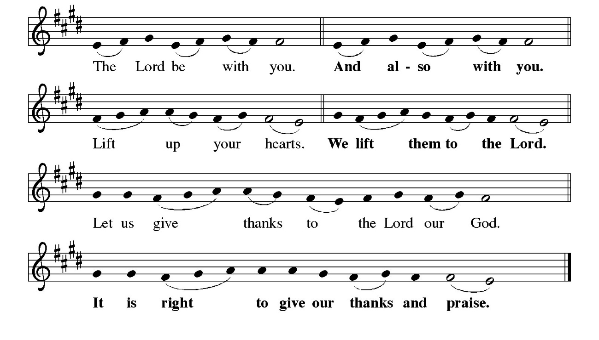
*Preface - Pastor Tina

Change slide when pastor sings “…and join their unending hymn”

*”Holy, Holy, Holy” ELW pg. 153
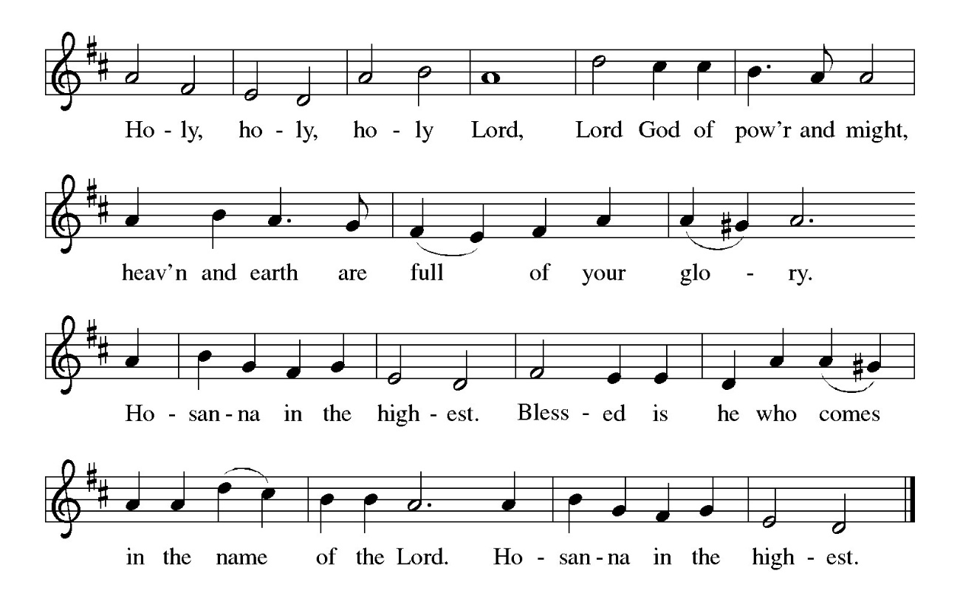

* Liturgy of Holy Communion pastor tina

PLEASE CHANGE SLIDE WHEN PASTOR SAYS “Lord remember us in your kingdom and teach us to pray…”

* Lord’s Prayer pastor tina ELW pg. 154

OUR FATHER, WHO ART IN HEAVEN, HALLOWED BE THY NAME, THY KINGDOM COME, THY WILL BE DONE, ON EARTH AS IT IS IN HEAVEN. GIVE US THIS DAY OUR DAILY BREAD, AND FORGIVE US OUR TRESPASSES AS WE FORGIVE THOSE WHO TRESPASS AGAINST US, AND LEAD US NOT INTO TEMPTATION, BUT DELIVER US FROM EVIL, FOR THINE IS THE KINGDOM, AND THE POWER, AND THE glory, forever and ever. amen.

* Lamb of God ELW pg. 154
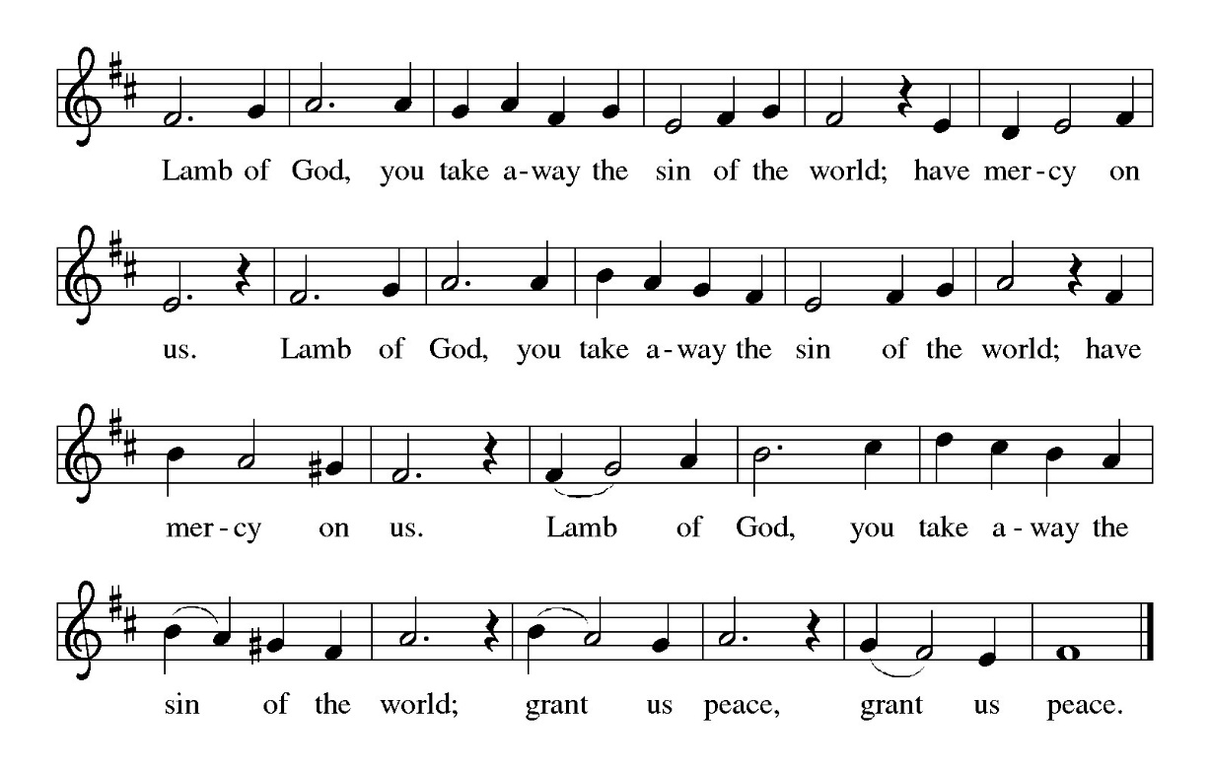
Special Music during Holy Communion BY JARED

*Post Communion Blessing Pastor Tina

* Post Communion Hymn “Be Not Afraid” ELW #388 (sing 2x)
One License A-700000
Pastor sings first time through, congregation joins on repeat
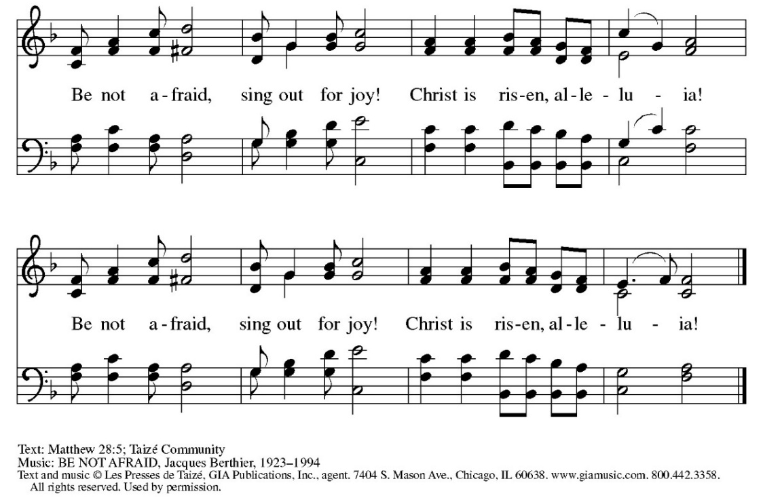

* Prayer After Communion pastor tina and congregation in unison
Holy One, you have fed us with your abundant grace and gathered us into your love. As we have been nourished at this table, send us out to feed, tend, and love as Christ commands. May we be signs of your new creation, where all are welcomed, all are cherished, and all are made whole. Amen.

* Blessing pastor tina
May God’s abiding love and hope give us new life.
May God’s unmerited grace and mercy keep us hope-filled.
And may God’s restorative justice bring to us all, perfect peace.
For alleluia, Christ has risen!
Christ has risen, indeed! Alleluia!

* Closing Hymn “Christ is Risen! Alleluia!” ELW 382
Public Domain

1 Christ is risen! Alleluia!
Risen our victorious head!
Sing his praises! Alleluia!
Christ is risen from the dead!
Gratefully our hearts adore him
as his light once more appears;
bowing down in joy before him,
rising up from griefs and tears.

Refrain
Christ is risen! Alleluia!
Risen our victorious head!
Sing his praises! Alleluia!
Christ is risen from the dead!

2 Christ is risen! All the sadness
of our Lenten fast is o'er;
through the open gates of gladness
he returns to life once more;
death and hell before him bending
see him rise, the victor now,
angels on his steps attending,
glory round his wounded brow. Refrain

3 Christ is risen! All the sorrow
that last evening round him lay
now has found a glorious morrow
in the rising of today.
See the grave its firstfruits giving,
springing up from holy ground;
Christ was dead, but now is living;
he was lost, but he is found. Refrain

4 Christ is risen! Henceforth never
death or hell shall us enthrall.
We are Christ's, in him forever
we have triumphed over all.
All the doubting and dejection
of our trembling hearts have ceased;
hail the day of resurrection!
Let us rise and keep the feast. Refrain

Text: John S. B. Monsell, 1811-1875, alt.
* Dismissal worship assistant
Go in peace, sharing the gifts of Christ! Thanks be to God!

*Postlude

The Call to Worship is by Dr. Lisa Hancock, Discipleship Ministries, September 2024.
The Offering Prayer and Prayer After Communion are by Rev. Kristina N. Crog, 2025
The Final Blessing adapted from Rev. Dr. Sheila Harvey Guillaume on the Worship Ways website at https://www.ucc.org/worship-way/easter-day-april-4/.

