This Week at PPBC


Tuesday, April 8th

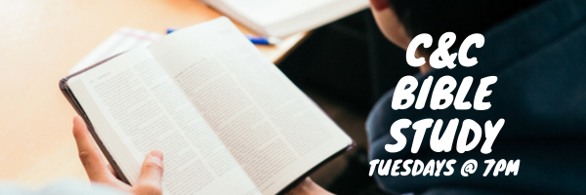

Tuesday, April 8th


Wednesday, April 9th


Thursday, April 10th
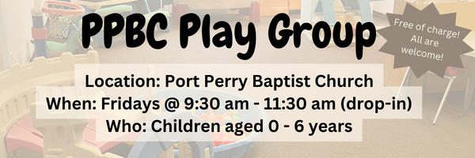
Friday, April 11th, 2025

Friday, April 11th, 2025
Join us Friday nights at the church from 7:30 pm - 9:30 pm for a time of Bible study and games! All youth in grades 7-12 are welcome.


A Prayer request from one of our mission partnerships: Prayer for wisdom at the School in Guatemala as they consider how to budget increases in salaries and wages that have been mandated by the government (10% increases in 2025). Currently, 800 students from JK to Grade 12 attend the school each day, in 2 shifts of 400.

Coming Soon

April 12th 7:30am
Men's Breakfast and Bible Study
7:30 am at the church
The Men will be studying Psalm 119.


Join us at 9am on Sunday April 20th for our traditional Easter Breakfast after our Sunrise Service.
Please RSVP at the Welcome Centre.
Questions? Speak to Kate Anderson

Sunday Ministry Schedules
Below are ministry schedules for Nursery, Jr. Church, Greeters, Ushers, and Sound & Video:
Nursery
April 6: Kathryn denOuden, Audrianna Angrove
April 13: Brenda Clemens, Amber Saunders
Jr. Church; ages 3 to grade 1
April 6: Ellianne McLaren, Grace Brown
April 13: Madeline Werner, TBA
Jr. Church; grade 2-6
April 6: Miriam Bolsonello, Abby Saunders
April 13: Gregg & Karen Anderson, Isabelle Ferguson
Greeters
April 6: Mark & Christine McLaren
April 13: Paul & Helen Jones
Ushers
April 6: Brian Kovack, Roy Wilson
April 13: Paul Sammut, Joe Colwell
Sound & Video
April 6: Sound: Wyatt Werner | Video: Josh Myers
April 13: Sound: Caleb Bolsonello | Video: William Conley

Sunday Morning Service
Welcome
Malawi Team Presentation
Song – O Worship the King
Song – All of Our Tomorrows
Scripture – Acts 2:22-36
Prayer
Message
Song – Jesus Messiah
Song – When I Survey the Wondrous Cross
Communion
Song – I Set My Hope on Jesus
The membership vote on Gregg Anderson as Elder is scheduled for Sunday, April 13. Ballot voting will take place in the gym before and after the morning service. If you have any questions please speak to one of the elders.

Praise & Prayer Highlights
PRAY for Deb Brown, Deb is having treatments for a detached retina. Please PRAY that God provides peace in the waiting.
PRAY for Pastor Jim & Brenda and the family as they mourn the loss of Jim SR. PRAY that God would continue to give them comfort and peace, and that those around them will see the light of the Gospel.
PRAY for Joan Mabley and her ongoing recovery in Port Perry Villa. PRAY for encouragement both spiritually and physically.
PRAY for Alice White and her ongoing health concerns. PRAY for God's provision for Alice and the family as they continue to look for long-term living arrangements with good care for Alice.
PRAY for the Malawi Missions Team; Leno, Paul, Helen, Kathryn, Sara, Lisa & Thea. PRAY for the team as they gear up for immunizations needed for the trip. PRAY for the Jones' as they discuss the program for their trip/service with their Malawi counterparts.
PRAY for Winnie Miller who is recovering from pneumonia. PRAISE that she is out of Hospital and back home at Westshore.
PRAY for John & Joan Mank as they mourn the loss of their son Dean. PRAY that God will give them great comfort in Christ and that the truth of the Gospel will shine through in this moment of loss.
PRAISE that Doug McArthur's sister Sheila has been moved to Rehab from palliative care in Burlington. Please PRAY for God's continued healing for Sheila.
PRAY for the Lamb family as they care for their daughter Cassandra and new granddaughter Amelia. PRAY for strength and recovery.
PRAY for Martin & Tina McCurley. PRAY for Martin and his ongoing health concerns.
Giving

Just as a reminder, there are several ways you can give:

In Person using the offering box located on the back wall of the sanctuary. Donation envelopes are available at the Welcome Centre. Please contact the church office if you would like a box of donation envelopes (office@portperrybaptist.ca)

Through your online banking, you may send electronic transfers to ppbcdonations@gmail.com.

You can also give through Canada Helps. Donation receipts will be provided by Canada Helps, and transaction fees apply.

************************************************************************
Weekly Newsletter

The PPBC Newsletter is emailed to the church family every Friday. If you would like to be added to the weekly email list, please contact the office by phone: 905-985-8681 or by email: office@portperrybaptist.ca.

*****************************************************************
Church Information:

Location:
2210 Hwy 7A
Port Perry, ON
L9L 1B4

Office Hours:
Monday: 8:30am – 4:00pm
Tuesday: 8:30am – 4:00pm
Wednesday: Closed
Thursday: 8:30am – 4:00pm
Friday: 8:30 am - 3:00 pm
Contact:
Phone: 905.985.8681
Email: office@portperrybaptist.ca
Website: www.portperrybaptist.ca

Staff:
Sr. Pastor – Rev. Jim Clemens
Administrative Assistant – Madeline Werner
Children’s Ministry Coordinator – Jenna Anderson

PPBC Newsletter
Sunday, April 6th, 2025



Sunday Starting Point
Sunday, April 6th, 2025 - 9:30 am
“Beginning the day with the Word and prayer”
Adults:
Adults will meet in the sanctuary for a time of study and prayer.
Youth:
Jr & Sr High Girls will meet with Helen Jones in room 24. Jr High Boys will meet with Tracy Ballanger in room 25.
Children Aged 3 – Grade 6:
All children will meet together in Room #26 for a time of singing and Bible lesson
(Please note nursery is unavailable during Starting Point)

*****************************************************************************

Sunday Morning Worship
Sunday, April 6th, 2025 - 10:30 am
We are meeting in the sanctuary and will continue to live-stream for those who are unable to attend.
Message: Isreal Comes to Egypt
Scripture: Genesis 45-48
Pastor Jim Clemens

