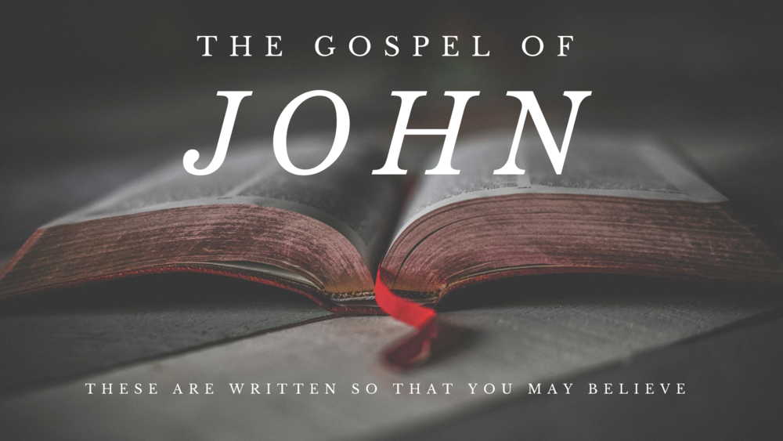
Victory Fellowship Bible Study
273 23rd St. S.W., Barberton, OH 44203
Wednesdays at 7pm
Rev. Roderick D. Grabski (330) 858-0223
WEBPAGE: victoryfellowshipministries.com
arod4God@neo.rr.com FACEBOOK: Roderick Grabski

CLASS NINE: The Promise of the Holy Spirit
- ANNOUNCEMENTS and PRAYER CONCERNS

- Read / Listen to John 7:1-53
  - What are your initial impressions or questions?
Notable translation differences?

- The Unbelief of Jesus’ Brothers (vv. 1-9)
  - About six months have passed between chapters 6 and 7. Chapter 6 was at the time of Passover in April. Chapter 7 is before the Festival of Tabernacles in October.

  - Jesus’ activity during this six month gap is recorded in Matthew chapters 15-18, Mark chapters 7-12, and Luke chapters 9-17.

  - Leviticus 23:33-44; Nehemiah 8:14-16; Zechariah 14:16; Rev. 21:3

  - Jesus’ half-brothers are named in Matthew 13:55 and Mark 6:3. Why do they say these things to Jesus? (See Psalm 69:8)

  - What does Jesus mean by “My time has not yet come?”
2:4; 7:6,8,30; 8:20; 12:23,27; 13:1; 16:32; 17:1; Matt. 26:18,45; Mark 14:35,41

- The Festival of Tabernacles (vv. 10-24)
  - Does Jesus lie to His brothers about going up to the feast?

  - (vv. 11-13) Why did all the people expect to see Jesus there?

  - (vv. 14-15) Compare with Matthew 13:54-57 and Mark 6:2-3.

  - (vv. 16-19) What are the ramifications of Jesus saying He was “sent by God?”

  - (vs. 20) This is one of several instances that Jesus was accused of being demon possessed. (8:48; 10:20; and Matthew12:24)

  - (vs. 21) The one work Jesus is referring to is probably in John 5.

  - (vv. 22-24) The covenant to Abraham: Genesis 17:10-14.

- The Identity of the Messiah (vv. 25-36)
  - (vv. 25-27) What is the contradiction in the mind of the people?

  - (vv. 28-29) What is so unsettling about Jesus words?

  - (vv. 30-32) What was convincing to the crowd about Jesus?

  - (vv. 33-36) In another six months Jesus will be crucified.

- The Promise of the Holy Spirit (vv. 37-39)
  - On the last day of the feast the priests would march seven times around the altar, the choir singing Psalms 113-118. Then, for the last time, they would pour water from the Pool of Siloam over the altar. While this is happening Jesus cries out to the thirsty.
    - Isaiah 12:3; 32:2; 44:3; 58:11; and Zechariah 14:8-9

  - John tells us that Jesus is referring to the Holy Spirit.

  - This would have been on the 21st day of the seventh month. On this date in history the prophet Haggai made a prediction (2:1-9). The book of Hebrews 12:26-29 applies this prediction as the return of the Lord.

- Could this be the Messiah? (vv. 40-44)
  - The “Prophet” is a reference to Deuteronomy 18:15-18. Some Jews thought that the Prophet and the Messiah would be two different persons, but Jesus turned out to be both.

  - What is the mistaken assumption that some in the crowd have?

- Debate Over Jesus’ Claims (vv. 45-53)
  - (vv. 45-49) What quarrel do the chief priests and Pharisees have with the temple police? With the crowd?

  - (vs. 50) Nicodemus is mentioned 3 times in John’s gospel (3:1-2; 7:50; and 19:39). Each time he is identified as the one who came to Jesus by night (or previously).

  - Despite the claims of the Pharisees, prophets did occasionally arise from Galilee. Most notably, Jonah (2Kg 14:25), Nahum (Nah. 1:1), and possibly Elijah (1Kg 17:1).

- Application
  - The Feast of Tabernacles is the seventh and last of the Festivals of the Lord. It is also one of the three pilgrimage festivals that required all Jewish men over the age of 20 to return to Jerusalem and the Holy Temple. The other pilgrimage festivals were Passover and Pentecost. Most scholars agree that the Feast of Tabernacles is symbolic of Christ's Second Coming when He will establish His earthly kingdom. (Revelation 21:1-7)

Final Comments, Questions. Close in Prayer

Next Week: Jesus: Light of the World - Read John 8:1-59 to prepare.

