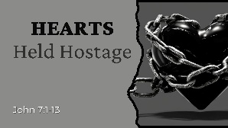
HEARTS HELD HOSTAGE
  - John 7:1-13

The Captive Heart by Sin

Christ’s Clarion Call Our Captivity

The Captive’s Cry is a for Deliverance

HEARTS HELD HOSTAGE
  - John 7:1-13

The Captive Heart by Sin

Christ’s Clarion Call Our Captivity

The Captive’s Cry is a for Deliverance

