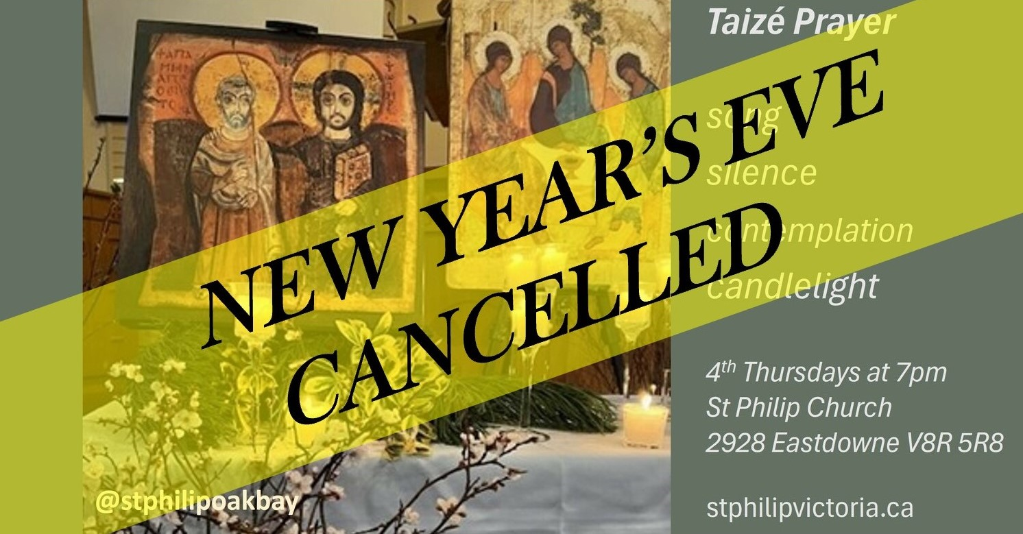
With apologies, the New Year's Eve Prayer in the Style of Taizé at St Philip has been cancelled.
Please join us at St Philip Oak Bay in 2025 for a candlelit service of song, silence and contemplation, in the style of the Taizé Community, on the last Thursdays of the month at 7pm:
30 January 2025
27 February
27 March

