The Parish of the Six Saints
The Twentieth Sunday After Trinity
October 13th, 2024
THE COLLECT.

ALMIGHTY and most merciful God, of your bountiful goodness keep us, we beseech thee, from all things that may hurt us; that we, being ready both in body and soul, may cheerfully accomplish those things that You would have done; through Jesus Christ our Lord. Amen.

Introit Psalm
Everything that thou hast brought upon us, O Lord God, thou hast done in righteousness and judgement: for we have trespassed against thee, and have not obeyed thy commandments; but give glory and honour to thy Name and deal with us according to the multitude of thy tender mercies. Great is the Lord and highly to be praised in the city of our God, even upon his holy hill. Glory be to the Father, and to the Son and to the Holy Ghost…
The Lesson: Isaiah 55:1-3, 10-12
The Epistle: James 3:13-18
The Gradual Psalm: 92:1-4
The Holy Gospel: John 6:27-35

Next Sunday’s Readings
The Lesson: 1 Chronicles 29:9-16
The Epistle: I Peter 2:1-10
The Gradual Psalm: 138: 1-3
The Holy Gospel: Matthew 21:10-16

Daily Bible Readings
A modified schedule from the Prayer Book’s Table of Lessons
Sunday 2 Chronicles 20:1-30 I Peter 4:12-End
Monday 2 Kings1 I Peter 5
Tuesday 2 Kings 2: 1-22 I John 1:1 – 2:6
Wednesday 2 Kings 41:37 I John 2: 7-17
Thursday 2 Kings 5 I John 2: 18 - End
Friday 2 Kings 6:1-23 I John 3: 1-18
Saturday 2 Kings 6:24-7:2 I John 3:19-4:6

Faithful Departed: Marilyn Riel, Bonnie Preston

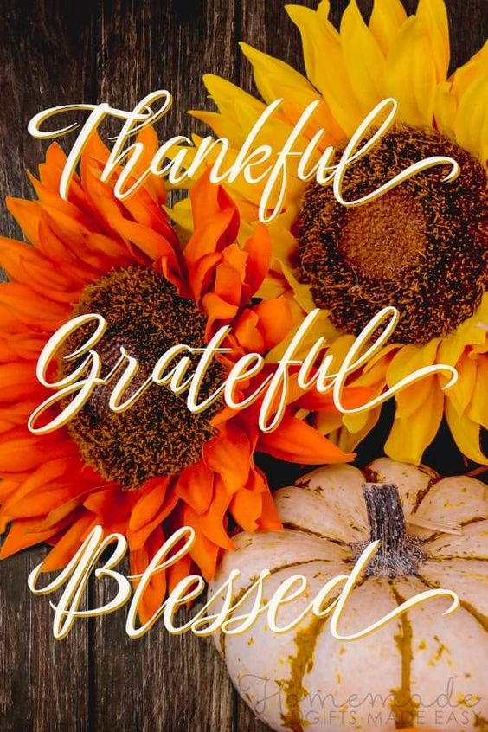

THIS WEEK IN THE PARISH
Daily Morning and Evening Prayer at St. George’s at 8:30 a.m. and 5:00 p.m. Monday – Friday. Please join us in person or by live stream.
IN ADDITION:
Sunday Young Adults’ Dinner (St. George’s) 12:30 p.m.
Community Thanksgiving Dinner (St. George’s) 4:00 p.m.
Monday Discipleship Group at St. George’s 10:30 a.m.
Celebration of Marriage (St. George’s)
Juliana and Michael Hollingsworth 4:00 p.m.
‘To Love as God Loves’ (Zoom) 12:40 p.m.
Discipleship Group at St. James 1:30 p.m.
Beavers (St. George’s) 6:30 p.m.
Tuesday Holy Eucharist at People’s Park Tower 10:00 a.m.
Discipleship Group at Whitmore’s 10:00 a.m.
Wednesday Cubs and Scouts at St. George’s 6:30 p.m.
Thursday The Holy Eucharist at St. George’s 10:00 a.m.
The Willing Workers Fall Sale: Saturday, Oct. 26th. Donations may be dropped off at St. George’s beginning Monday, Oct. 21st (8:00 to 11:30 a.m.). No footwear, encyclopedias or clothing, please.

Please join us when Dr. Elissa Rodkey presents on Sunday: November 3rd at 12:00 p.m. in St. George’s Hall. She will be speaking about; The life and witness of Josephine Butler, a devout Christian woman, wife of an Anglican Priest and mother of four, who fought against the trafficking and prostitution of young girls in Britain in the late 1800s.

Calendars anyone? Orders are being taken for the 2025 Calendar from St. Peter’s Publications in Charlottetown. It features paintings of churches by artists Peter Bresnen and follows the Church Year and readings in our Six Saints’ bulletin. If you are interested in ordering one, please contact the Parish Office no later than Monday, October 21st. The cost is $10.00/each.

Greater Chapter Meeting for Wardens, Synod delegates and Alternates is set for Thursday, Oct. 24th at 7:00 p.m. at St. John the Baptist, Riverview.

Grief Share is set begin on Tuesday, November 5th, at 1:00 p.m. at St. George’s Church. This is a tried and tested program for those who have experienced the loss of a loved one. There is no cost, and everyone is welcome. If you or someone you know would like to receive a visit at home or while in hospital, please contact the Church Office (506-855-5209) or office@stgeorgesmoncton.ca . Thank you very much!
THE RECTOR’S CORNER

In 1995 our Diocese celebrated its Sesquicentennial Anniversary – its 150th -- and parishes were encouraged to do something special; and there were some interesting projects! A hymn was written especially for the occasion, as well as a history of the Diocese called Citizens with the Saints. At least one newborn baby was named after John Medley, our first Bishop; and a little book was compiled to encourage thanksgiving. It was called Grace Before Meals. Graces were submitted from all over the Diocese such that there was one for every day of the year, and for holy days.

For years our family used the same ‘grace’, adding to it as the day or week required, lifting up people and situations before the Lord, according to their need. But when Grace Before Meals came out, it provided helpful variety and structure. Both the Book of Common Prayer and the Book of Alternative Services have a section called ‘Grace at Meals’ on pages 735 and 694 respectively. Here are a couple of examples:

For these and all His many mercies, God’s holy Name be blessed and praised, through Jesus Christ our Lord. Amen. (p. 735, BCP) Come, Lord Jesus, be our Guest, and let these gifts to us be blessed. Amen (p. 694, BAS)

But why do it? I like what Nadia Stefko wrote in her article ‘Why We Say Grace’. “First,” she said “it shows our gratitude for what is present over against our anxiety about what is absent. Second… giving thanks for our food classifies it as a gift we receive, rather than a mere thing we acquire. To call something a gift, is to acknowledge that is has, like all gifts, a story and a source. The source of our food is God – not a supermarket, or a lab, or a factory, or ultimately even a farmer.” (22 November 2016).

Then she adds, “And like the petition from the Lord’s Prayer, ‘give us this day our daily bread,’ our meal-time thanksgiving is part descriptive and part conviction: it says that the food that is here is enough; and it says we believe that God will continue to provide for our needs.” As children of our Heavenly Father and disciples of the Lord Jesus Christ, it is important to give thanks often throughout the day, including mealtimes, wherever we may be, not only for ourselves, but for those who are with us or around us, including this Thanksgiving weekend.
“Praise the Lord, O my soul and forget not all His benefits.” (Psalm 103. 2)

COMING UP
Happy Birthday: Belated wishes to Judy Briggs (Sept 29th) and Christine Stam (Oct. 7th)

Happy 60th Wedding Anniversary to Evelyn and Adrian Smith!

The Willing Workers meet the 2nd, Tuesday of each month, the next meeting will, Tuesday, November 12th, at 2:00 p.m., in the Ladies Parlour.

A big thank you to Nancy Urquhart for her work in preparing the Church for Thanksgiving.

Please join us today, following our 10:00 a.m. service, to wish Juliana Stam and her husband Michael all the best as they prepare to move to their home in Georgia.

The Feast of All Saints (Nov. 1-8) is fast approaching. It is a wonderful opportunity to remember our faithfully departed before God.

Please see the ‘Faithful departed List’ in the main entry and add the names of your loved ones. The list will be included in the Intercession at the Holy Communion on Friday, November 1st, at 5 p.m. and Thursday,
November 8th at 10:00 a.m.

" For I am persuaded that neither death, nor life, nor angels nor principalities, nor powers, nor things present, nor things to come, nor height, nor depth, nor any other creature, shall be able to separate us from the love of God which is in Christ Jesus our Lord". Romans 8. 38,39
HYMNS
Hymns
310 (Monkland)
312 (St. Bees – 106)
307 (St. George)
305 (Nun Danket)

Hymns during Communion:
222 (Agape); 236 (Dolomite Chant); 232 (St. Agnes)

