

***************************************************************************


****************************************************************************


******************************************************************************

We will be meeting at the church for 10:30am



**************************************************************************

************************************************************************


Men's Prayer
Thursday, March 7th, 2024 - 7:30am
The men meet every Thursday @ 7:30am for prayer.
- We will be meeting at Ken Poole’s house

*********************************************************************************
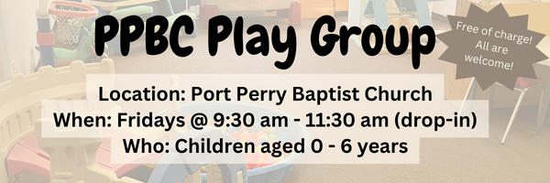


Friday, March 8th at 7:30pm

***************************************************************************



We have put sign-up sheets on the welcome centre with all the roles that we need filled in order to run this ministry. Please stop by the welcome centre and check out where you can help this year!
Please note, all volunteers are required to attend the Plan to Protect training session that will be offered before the soccer season starts
If you have any questions, please speak to Jenna Bryant
****************************************************************************************************************


Sunday Ministry Schedules

Nursery
March 3: Jan Gerrow, Grace Brown
March 10: Emilie Smith, TBA
Jr. Church; ages 3 to grade 1
March 3: Deb Brown, Lena Sammut
March 10: Gregg & Karen Anderson, Abby Saunders
Jr. Church; grade 2-6
March 3: Miriam Bolsonello, Jen Owens
March 10: Janine Kovack, Elise Anderson
Greeters
March 3: Kim & Fern St-Onge
March 10: April & Les Saunders
Ushers
March 3: Joe Colwell, Matt Saunders
March 10: Mark McLaren, Paul Sammut
Sound & Video
March 3: Sound: Brian Kovack | Video: Amin Persis
March 10: Sound: Caleb Bolsonello | Video: Charlotte Clemens
***************************************************************************

Missions Update

To our PPBC Family from Ebi and Carolyn Meraji:
"Thank you for praying for us and your support as we dig deep into ministry this year. We are making plans and preparations for our busy season here. March is an extremely important ministry time as it is Persian New Year (Norouz). Prayers are needed. Pray for us as we head into our Persian New Year celebrations this March. We will be gathering gift baskets together for our Iranian friends to help them celebrate, feel loved and to share the Gospel message. Pray for the 5 baskets we will prepare and the hearts and minds that will receive them." Ebi and Carolyn

Praise & Prayer Highlights

Sunday, March 3rd, 2024
- PRAY for Martin & Tammy Lamb. Martin has been experiencing problems with his eyes where his eyes are very dry. It has been quite debilitating for him. Please PRAY for healing and strength for each day.
- PRAY for Carolyn & Ebi. Pray for them as they head into our Persian New Year celebrations this March. They will be gathering gift baskets together for their Iranian friends to help them celebrate, feel loved and to share the Gospel message. PRAY for the 5 baskets they will prepare and the hearts and minds that will receive them.
- PRAY for Pastor Jim and Brenda as they are away, that God will help them redeem this time for their good and His glory.
- PRAY for Josh Anderson as he prepares to preach the word to us this Sunday.
- PRAY for Joan and John Mank and their son Dean. PRAY for God's provision and care physically and spiritually. PRAY for John Mank who had surgery for his heart on Tuesday.
- PRAY for Donna Jones, Paul, Helen and the entire Jones family as they mourn the loss of David Jones. PRAY for God’s gracious provision of gospel comfort and peace.
- PRAY for Martin & Tina McCurley as they respond to physical and financial challenges.
- PRAY for Ken & Jeannine Poole. PRAY that God would give physical recovery and spiritual comfort and strength.
- PRAY for those who suffer from chronic illness and pain. PRAY they will know God’s sustaining grace, peace, and comfort daily.
- Remember to PRAY for our seniors and shut-ins; Jim Bolsonello, Bev Agnew, Alice White, Winnie Miller, Donna Jones, and Joan Mabley.
- PRAY for Grace McGeehan. PRAY for healing and that physio will go well.
- PRAY for Jakob & Amy, Josh & Jenna, Josh & Chelsea, Davey & Larissa, and Mack & Tiffany as they prepare for marriage this year.
- PRAY for Dan Bouwma who is on Military deployment to South Carolina until August. PRAY for his physical and spiritual health while he is away.


Small Groups at Port Perry Baptist Church

C&C - Tuesdays evenings at the church

Clemens/Araujos - Wednesday mornings at the church

McLarens - Wednesday evenings during Dugout at the church

Ballangers - Thursday evenings at their house

Werners - Thursday evenings at the church

Metcalfes – Thursday evenings at the church

Kovacks – Every other Thursday evening at their house

Andersons/Angroves - Saturday evenings at the Church

*Interested in joining a small group? Contact the office or speak to Tracy Ballanger

***********************************************************************



Giving

Just as a reminder, there are a number of ways you can give:

In Person using the offering box located on the back wall of the sanctuary. Donation envelopes are available at the Welcome Centre. Please contact the church office if you would like a box of donation envelopes (office@portperrybaptist.ca)

Through your online banking, you may send electronic transfers to ppbcdonations@gmail.com.

You can also give through Canada Helps. Donation receipts will be provided by Canada Helps, and transaction fees apply.

**************************************************************************
Weekly Newsletter
The PPBC Newsletter is emailed to the church family every Friday. If you would like to be added to the weekly email list, please contact the office by phone: 905-985-8681 or by email: office@portperrybaptist.ca. Hard copies are available on
Sundays at the Welcome Centre.

*****************************************************************

Church Information:

Location:
2210 Hwy 7A
Port Perry, ON
L9L 1B4

Office Hours:
Monday: 8:30am – 4:00pm
Tuesday: 8:30am – 4:00pm
Wednesday: Closed
Thursday: 8:30am – 4:00pm
Friday: 8:30 am - 3:00 pm
Contact:
Phone: 905.985.8681
Email:office@portperrybaptist.ca
Website: www.portperrybaptist.ca

Staff:
Sr. Pastor – Rev. Jim Clemens
Administrative Assistant – Madeline Werner
Children’s Ministry Coordinator – Jenna Bryant

PPBC Newsletter
Sunday, March 3rd, 2024

Weekly Newsletter
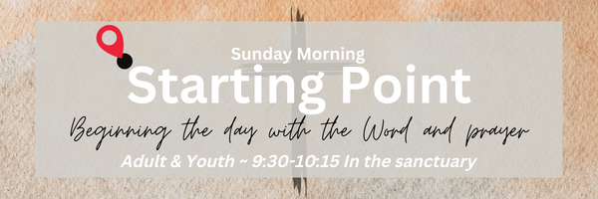

Sunday Starting Point
Sunday, March 3rd, 2024 - 9:30 am
“Beginning the day with the Word and prayer”

Adults:
Adults and youth will meet in the sanctuary for a time of study and prayer.
Youth:
Jr & Sr High Girls will meet Helen Jones in room 24. Jr High Boys will meet Tracy Ballanger in room 25
Jr Church:
All children will meet together in room 26 for a time of singing and Bible lesson.

(Please note nursery is unavailable during Sunday School)
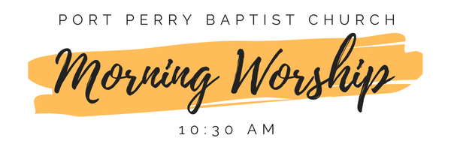
*****************************************************************************

Morning Worship & Live-Stream
Sunday, March 3rd, 2024 - 10:30 am
We are meeting in the sanctuary and will continue to live-stream for those who are unable to attend.
Josh Anderson
1 Timothy 1:12-17

