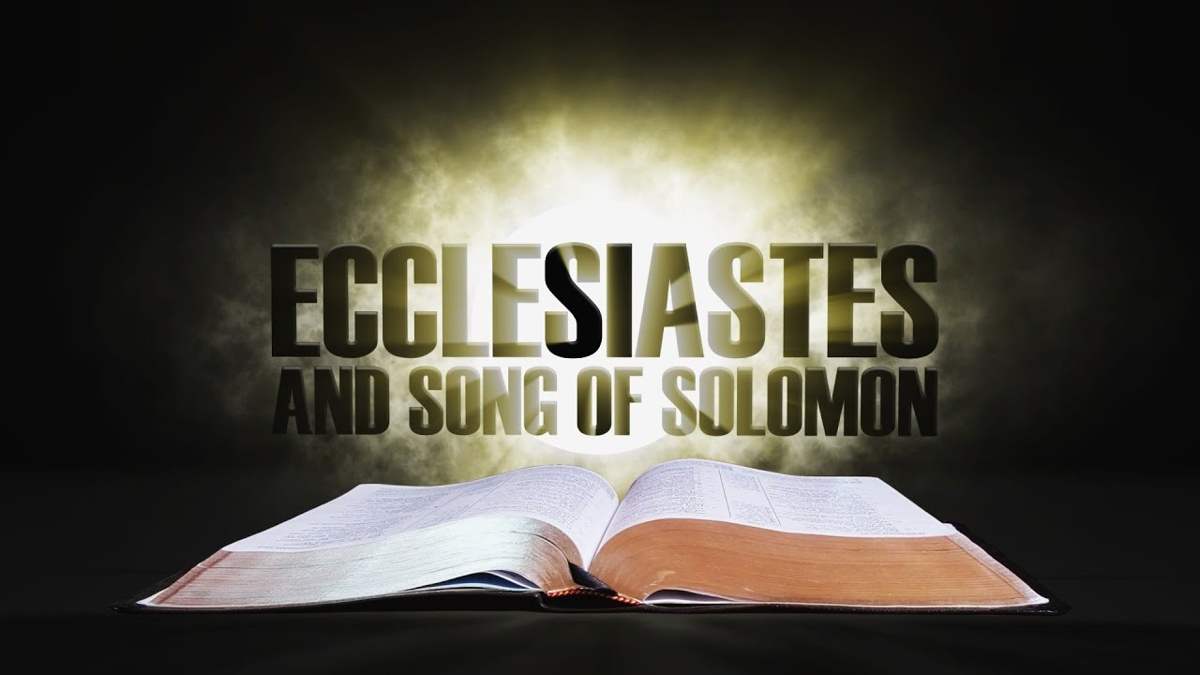
Victory Fellowship Bible Study
273 23rd St. S.W., Barberton, OH 44203
Wednesdays at 7pm
Rev. Roderick D. Grabski (330) 858-0223
arod4God@neo.rr.com FACEBOOK: Roderick Grabski

CLASS SEVEN: Ambition & Desire Frustrated / Word to the Wise

- ANNOUNCEMENTS and PRAYER CONCERNS

- Read / Listen to Ecclesiastes 6:1-12
  - What are your initial impressions or questions? Notable translation differences?

- Without God, Life is Futile (6:1-6)
  - (vv. 1-2) How might a rich man not enjoy his riches?

  - (vv. 3-6) In biblical times it was a sign of God’s blessing to have many children (Psalm 127:3-5). Solomon suggests that if a person has everything but not God, it is better for them to not have been born. (Job 3:1-16; Matthew 26:24)

- Without God, Ambition is Frustrated (6:7-9)
  - Discuss the three proverbs listed here:
    - Appetite drives us but is never satisfied
    - Wisdom cannot save us from our appetite or from poverty
    - It is important to be satisfied with what we have.

- Without God, the Future is Hopeless (6:10-12)
  - (vs. 10) This verse recalls the attempt of Adam and Eve to be as smart as God. (Genesis 3:4-6)

  - (vs. 11) We cannot change the fundamental truths of life so it is futile to babble on about supposed new insights. There is nothing new under the sun.

  - (vs. 12) Only God knows the future and it is better to trust Him. Turning away from God only leads to futility and destruction. (Matthew 7:13-14; Romans 1:18-32)

- Read / Listen to Ecclesiastes 7:1-14
  - What are your initial impressions or questions? Notable translation differences?

- Word to the Wise (7:1-10)
  - (vv. 1-4) Discuss in these four proverbs why it is wise to give attention to death.

  - (vv. 5-6) What is the “song of fools?” What is the smirking laughter of fools compared to?

  - (vv. 7-9) How do these 3 maxims help the wise person confront political reality?

  - (vs. 10) Why is it unwise to ask this question?

- God is Sovereign (7:11-14)
  - (vv. 11-12) What do these verse say about wisdom and money?

  - (vv. 13-14) What do these verse say about God’s sovereignty?

- Application
  - Our confidence should not be in our riches, strength, or wisdom - but in our knowledge of, and trust in, God. (Jeremiah 9:23-24)

  - Only God has control of the future. We are wise to trust it to Him. (Proverbs 3:5-8)

  - Some of the most painful experiences in life can provide great opportunities for gaining wisdom. (2 Corinthians 7:10)

- Final Comments, Questions. Close in Prayer

Next Week: Prudence in a Sin-Corrupted World / Respect Your Authorities
- Read Ecclesiastes 7:15 – 8:17 to prepare.

