
For more information about this
Our mailing address is Oasis Youth Ministries PO Box 445, Holbrook AZ 86025
ministry or to join our prayer
and support team,
you can go online to
www.oasisyouthministries.com
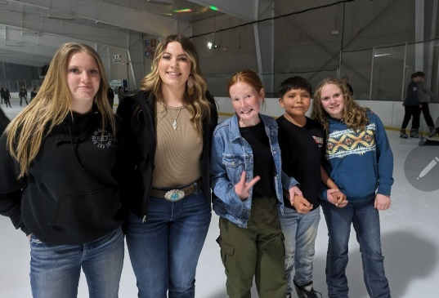
Dear Friends and Family, March 2024

Howdy from Holbrook! We pray you are well. Spring is here early, apparently, in northeastern Arizona. We have had a few flurries, but overall a very mild winter; lately it’s been much warmer.

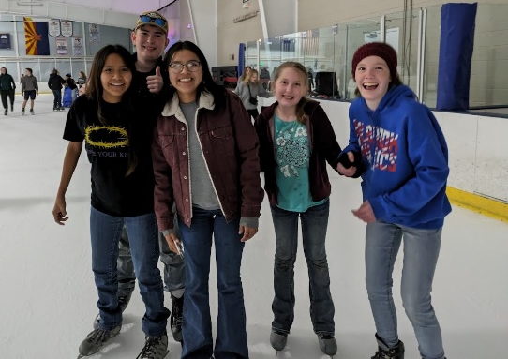
We recently took a group of 19 teens to Flagstaff to ice skate. While it was icy cold in the mountain town of Flagstaff, the ice rink is indoors. Much pizza was consumed in between skating around in the cold arena. There were, of course, many hard falls and slams into the wall, but overall it looked as though everyone had fun. Jerad gave a talk on Jesus healing a woman on the Sabbath from Luke 13:10-17, and used it as a springboard for presenting the Gospel.

The Well, which is for teaching and discipling Christian teens, is continuing on a weekly basis. The jr high group recently finished their study of Ephesians and have now begun a study of the book of Esther. The high school group is now looking at and discussing the last few chapters of Revelation (we’ve finally made it to the new heavens and new earth!).

Our Thursday night meeting with young adults, the Next Chapter, is still taking its time reading through The Screwtape Letters by C.S. Lewis. The discussions about our modern world that have come from reading this older book together have been fantastic. Lewis was a man of rare insight.

We are preparing to send (hopefully) 10 teens to a worldveiw conference at Arizona Christian University this summer. Our group that went last year had a great time of fun and learning in the Phoenix sunshine. Those going, like last year, will be taking part in various fundraisers to earn the money needed to attend. We will be kicking that off this month.

Prayer Requests:
- Please be in prayer for our students who will be attending the Worldview Academy this summer. Pray for their hearts to be prepared and for God to provide financially for them to come. If you are interested in helping scholarship a teen to go, please contact Carrie Burgess at oasisym22@gmail.com or 812-391-5262. The cost is $850/person. This is a small price compared to the large amount of preparation it gives our students in a culture that is becoming increasingly hostile to followers of Jesus.
- Pray for one of our leaders, Shivanna, as she will be heading to Bethany Global University for training in missions. We will miss her but are excited for her “next chapter” in life!

Thank you so very much for making it possible for Oasis to serve God here in northeastern Arizona; we could not do what God has called us to here without you! Your prayers and support make you truly part of the ministry here. May God richly bless you!

Grace and Peace,
Jerad and Carrie Burgess

