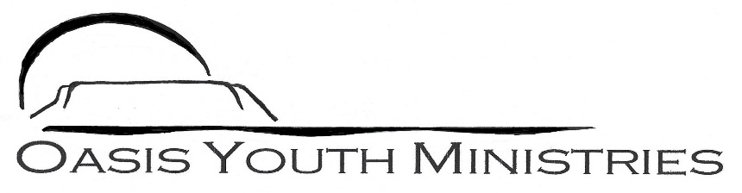
For more information about this
Our mailing address is Oasis Youth Ministries PO Box 445, Holbrook AZ 86025
ministry or to join our prayer
and support team,
you can go online to
www.oasisyouthministries.com

Dear Friends and Family, January/Feb 2024

Hello and blessings from Holbrook, Arizona! We hope you are well and that you had a wonderful Christmas and New Year. Happy 2024! How crazy it seems to me, having been born in 1975, that we are almost a quarter of a century into the 2000’s. We are looking forward to what God has in store for this new year. With local schools back in session we are finally fully back in the swing of things here.

The Well is going again, seeking to teach jr high and high school students to have a deeper understanding of their faith. The jr high group is currently doing a video-based study on Ephesians. It is structured for teenagers, and looks at different themes found in the book. Tonight looked at unity in the church. The jr high kids seem to really be enjoying it. The high schoolers are nearing the completion of their study of the book of Revelation. It has been, as you might expect, an interesting, strange, glorious, and (at times) difficult journey. It has been immensely rewarding. We finally just got to chapter 19 which tells of Christ’s victorious return.

We recently took 16 teens to Flagstaff to bowl. Shivanna gave a great talk with the youth on our need to find our identity in Christ rather than looking towards our culture and friends for acceptance and purpose.

In the Next Chapter, which is a one night a week book study for young adults, we are back reading through C.S. Lewis’s classic The Screwtape Letters. It has served as a springboard for several excellent discussions; it is amazing how much Lewis speaks to our current society in a book that was written during the early part of World War II (1941). It is so true that the human heart and human nature do not change.

Thank you so very much for making it possible for Oasis to serve God here in northeastern Arizona. Your prayers and support make you truly a part of what God is doing here.
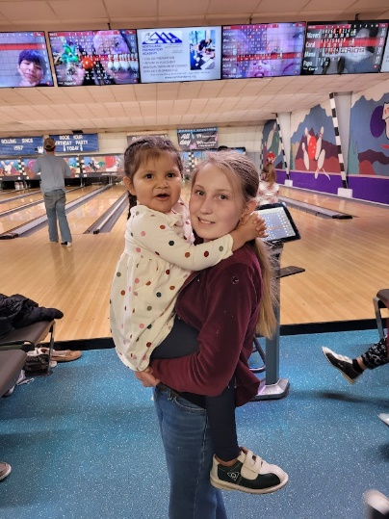
Grace and Peace,
Jerad and Carrie Burgess
