

**May 09. 2023**

**Facebook:** **https://www.facebook.com/groups/101542159983749**

**Website:** **https://www.nspeidiocese.ca/ministries/diocesan-environment-network**

##### **Email:** **endionspei@gmail.com**

**Our Mission:** “To strive to safeguard the integrity of creation and sustain and renew the life of the earth”.



Join the Diocesan Environment Network (DEN) at Synod and test drive an electric vehicle!  Spots are limited so register here: https://outlook.office365.com/owa/calendar/NextRideDalhousie@cleanfoundation.ca/bookings/?fbclid=IwAR04u9scGPCtuqmWw5XkYdnBE_v6CRBe2kzFtjCtzo4u_OjfVsmaCqX6HHc

 “Next Ride is the provincial electric vehicle education and engagement program for Nova Scotia. They are offering free test drives where you can experience the thrill of driving electric and receive answers to all of your questions about making the switch to an EV.”

Date: Friday, May 26  Time: 930 am - 1230 pm Location: Outside the Student Union Building on the Dal campus.

**Come see our DEN display at Synod**

.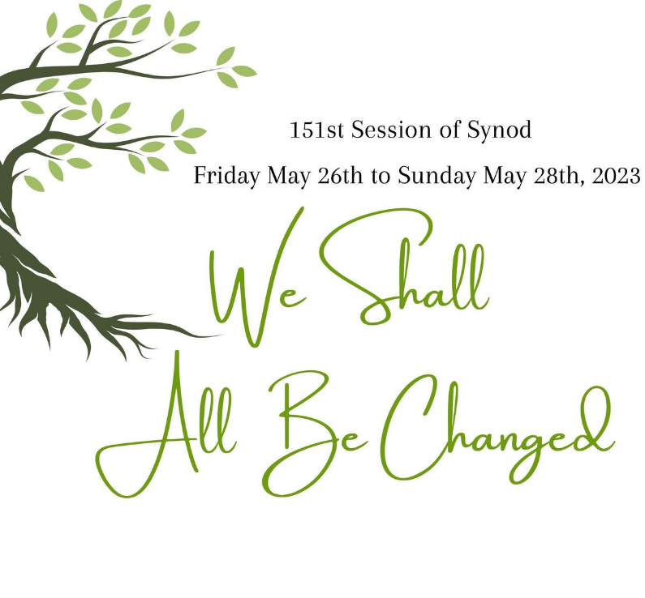



|  |  |
| --- | --- |
| F:\0.DEN Enews\tree planting St, Luke's.jpg | Congratulations to St. Luke’s Anglican Church in Dartmouth as they celebrate 75 years and for the successful tree planting held last weekend to commemorate the coronation of King Charles III.  What are your plans for the Communion Forest? Having a tree planting? Please share with us. We would love to feature your photos! |





B﻿ird Week is our new annual celebration where we hope to profile local species and encourage citizens and decision makers to take actions that benefit birds and their habitats. We have a series of guided bird walks planned and will be releasing HRM's bird friendly score-card this week, so citizens can understand exactly where Halifax is doing well and where more work is needed to protect our feathered neighbours.

https://www.eventbrite.ca/e/halifax-bird-week-tickets-619815463737?fbclid=IwAR3-z1cJGUj5vXRuMuNagmv2BSgW46z2ErXTfGsbQoncX_ux2gLmihhNewA



NEXT WEEKEND! Join us at Hartlen Point for a morning of birding on World Migratory Bird Day 🪶

Dress according to the weather as we will be heading out rain or shine. Bring water and binoculars, if you have them. We hope to see you there!

Hartlen Point is Canada's 10th most popular birding site (and the only one that isn't a protected area.)

  ·



I am writing here to a few students and people involved in environmental issues and interested in conservation in St. Margarets Bay.

We have a 9-week student position available from late June through August, leading a team (2 high school students) to work on trail building in a woodland in St. Margaret's Bay.  Outdoors all summer... Physical work ... Ideally for someone with experience working on trails.  Know anyone?  $21-23/hr.  Could be done 4 days/week.  Let me know!  (Must be returning to school or just graduated, 30 yrs of age or under for this funding).  Thanks in advance for any leads you may have. Louisa_Horne@hotmail.com



**Kairos Petition to Senate on Bill C-226**

For decades, polluting industries and landfill sites have ended up in racialized communities in Canada, resulting in higher-than-normal rates of cancer, respiratory illnesses, and other chronic health problems. Current mechanisms and channels fail to effectively address this systemic problem of environmental racism. With Bill C-226, Canada can begin to redress the problem.  Please tell senators to support swift passage of Bill C-226. If Bill C-226, becomes law, it will be an effective tool for addressing environmental racism in Indigenous, Black, and other racialized communities across Canada. It will require the government to examine the links between racialization, socio-economic status and environmental risk, and develop Canada’s first national strategy on environmental racism and environmental justice.

**Sierra Club email to your MP requesting a Strong Cap on Emissions from Oil and Gas**

|  |
| --- |
| In just a few weeks, the federal government is expected to release a draft outlining new regulations for a cap on oil and gas sector emissions. The oil and gas industry is the largest emitter of greenhouse gases in Canada—and the industry’s lobbyists are doing everything they can to keep it that way. Canada has setnational goals and targetsfor reducing greenhouse gas emissions, including for the oil and gas sector. But these targets aren’t working. Without stronger regulations, including accountability and tougher penalties, the oil and gas industry simply isn’t going to forego its massive profits—even for the health and well-being of humanity. In fact,oil and gas sector emissions have risen more than emissions in any other sector of the economy:88% since 1990. A strong emissions cap will among other things: create new jobsin the renewable energy sector (outstripping job losses in oil and gas) and free up billions in tax dollars that are currently propping up the fossil fuel industry. |

**Petition to Protect Nova Scotia's Provincial Parks**

On Thursday, April 20, 2023, Natural Resources Minister Tory Rushton said that the government would not entertain a proposal to turn part of West Mabou Beach Provincial Park into a golf course. This is great news for the community in Mabou, for the 18 rare and endangered species in the park and for all who spoke up to say that our parks and protected areas must remain protected! Despite this win, our protected areas are still vulnerable to private interests. It is critical that the Provincial Parks Act is strengthened to make it clear that our protected areas are not available for sale, lease, barter or trade. Nova Scotia has a goal of protecting 20 per cent of our lands and water by 2030. Allowing the development of already protected areas will make reaching these targets impossible, and threatens the legitimacy and effectiveness of the entire system of land conservation. Protected should mean protected.

**Tell Citibank: Stop Financing Fossil Fuels! - Stop the Money Pipeline**

Citibank is one of the top banks financing fossil fuels. At a recent shareholder meeting, the CEO had difficulty grasping the basics of how fossil fuel financing works. They stated that they didn’t need to stop financing fossil fuel companies in order to stop financing fossil fuels. Currently, only 4% of their bank’s financing for fossil fuels comes through direct project-level loans, while 96% comes from general corporate loans. This shows their climate goals can not be met through project-financing targets alone. Add your name to help clear up the confusion and encourage Citibank to take their impact more seriously.

**Tell Canada to issue an emergency protection order for caribou! - David Suzuki Foundation**

Ontario is not effectively protecting the critical habitat of boreal woodland caribou. There have been years of recommendations made to intervene in the provincial jurisdiction in order to protect the habitat that boreal caribou need to survive and recover. The loss of nature cannot be halted or reversed when status quo industrial operations just continue to destroy and degrade habitat. Action and change is needed. Ontario’s forest management protocol doesn’t protect caribou habitat and federal leadership is needed. This petition is going to the Minister of Environment and Climate Change and the Minister of Natural Resources, asking the federal government to step in and protect this species at risk.

**petition: Red Wolves Are on the Brink of Extinction (thepetitionsite.com)**

Red Wolves are the rarest canine in the world! Sadly, they are nearly extinct. Estimates say there are fewer than 20 left in the wild. In order to save this unique species, we should be doubling down on conservation efforts and improvements in reintroduction programs. Hunting is also a serious issue for these creatures. Despite hundreds of deaths from illegal shootings over the past 25 years, authorities have not prosecuted a single individual for red wolf poaching. The solutions needed to protect the red wolves involve better public education and committing more time, money, research, and resources. This petition is for the United States Fish and Wildlife Service, asking for more efforts to be made to save the red wolf.

|  |
| --- |
| F:\0.DEN Enews\Banners\banners Grandmas Going Green.jpg  **Big Empty Buildings.**  I’m retired now and feel I have all this time and can do ever so much. Not quite. It is amazing how quickly a day fills up. Equally amazing is how many projects I can think about starting.  I promised myself a summer just to heal, garden, and maybe keep a house as clean as I remember I use to do. That doesn’t stop me from starting a list of “IDEAS”  *Ideas* can become social movements.  Do you know it was mainly Rev. Marian Lucas Jefferies *ideas* that started DEN. She had some like-minded people around her, but it was Rev. Marian that was called to Bishop Sue’s office. She was the one that got the idea of environment work to be turned into the Diocesan Environment Network.  I don’t feel I can do anything that great, however, there is one thing that has been troubling me.  I could have (with little more than submitting a request) the use of three LARGE buildings. The type with steeples on their roofs.  They sit empty 6 days a week. That alone is a waste. We rotate services here in the Parish of Blandford, so really any one of the buildings is used once every 21 days. Like most parishes, we are frugal, perhaps even a tightwad. Keeping the price of heating those big, tall buildings as low as we can from September to June is a collective goal.  I always argue that once the building is heated for service, it takes little to keep it warm for the afternoon. Why not use that time in winter?  The entire months of summer allows the doors to open (front and back) and give a half-cool interior.  If we were businesspeople that owned large buildings and seldom used them, well, there would be plenty to tell us of the error of our ways.  I know! I know! We need volunteers to make anything happen.  Volunteers run for the hills because they feel if they do something ONCE, they are committed to every event for LIFE. Burnout doesn’t just happen in hospitals.  I have a few ideas. Children’s activities come to mind first but don’t stop there.  Images of quilts over the back of pews come to mind but finding quilters may not be easy. So, why not a crafter’s display or sale? Our community centre does a Christmas Craft Show but maybe that doesn’t happen elsewhere. Give, if not rent, every second pew for a crafter’s wares.  Is there a music group that either just sings or uses instruments that could use a place to practice? Maybe they would donate a show.  Is there an Art Group or even one solitary artist that might like to put on a show?  Asking for a donation gives you more than a definite price and allows everyone the dignity of paying their way.  The more people that come through our church doors to do any event, is that many more people who get comfortable inside the church building. So often I hear, “If I ever went to church the roof would fall in.” Oddly enough, it hasn’t happened yet.  This may not be an answer to low attendance at service. One thing our parish has learned is that although people may not come to service if the church needs help, be it a work party or financial help, the community comes running to our aid. Maybe it is time to open the doors wider and show them what they are supporting.  My goal is set for ONE event inside the church building before the New Year. Let’s see what I can do.  Got any ideas? Send them to claudiaazinck@gmail.com  **Garden Ideas**  Do you ever have problems spacing seeds? This would only work for bigger seeds like beets. Using the heavy garden rake, make holes or indents with the tines of the rake, down your row, and then put a seed in each hole, with a couple of seeds at the end to use as transplants if a hole doesn’t produce a plant.  Many of you know the trick to take a water or pop bottle, punch holes in it and plant it in your garden. Unscrew the top and fill it with water. The water goes out into the ground slowly. One step more. Do you have any orphaned socks that the matching sock hasn’t turned up this last year? Stuff a sock in the water bottle before burying it. Fill the bottle again but the water comes out slower, keeping plants fresh  I have heard of people using two sizes of pots for their plants. The larger pots go into the ground and stay there. Flowers are started or repotted in smaller pots that are set in the bigger pots. Come fall, pull out the smaller pots to keep plants over winter, or dump them out and start again the next year.  **Here is a rainy-day craft. Weaving a Potholder**  A cereal box or piece of heavier cardboard makes a good loom to male a pot holder or cloth trivet to hold a hot pot.  Cut your cardboard a bit bigger than what you want for a finished project. Cut slits into the cardboard an equal distance apart. Cut equal slits on the opposite side.  Using yarn or t-shirt material, start at the outermost slit in the cardboard and wrap the yarn around and around the long side of the cardboard loom.  Using either yarn on a darning needle or heavier material hand weave between the upright strands, weave one over and one under.  When the loom is full carefully cut the upright yarn and tie it with a square knot.  If this is enjoyable try weaving two over and two under or one under and two over making up new patterns for each hot mat.    **Cabbage Roll Casserole**  1 pack of ground beef  1 onion  1 can tomato sauce (I use spaghetti sauce)  1 cup of rice  2 cups beef broth  Preheat oven to 350F.  Cook the hamburger in a frying pan, drain, and put in a large bowl with all the ingredients except broth.  Add to a small roaster or a 10 x 13 pan. Add broth to top  Cover with foil and put in 350 F oven for 30-40 minutes  On the first day, we use this as a casserole with a salad. On the second day, we make wraps to put the leftovers in for lunch. Either way, Yumm!    This prayer is based on Jesus’ words from Matthew 6:25-34:  Holy God of Abundance, As we sow and reap and gather into barns; As we work and earn and calculate our net worth, Let us consider the birds of the air; Let us consider the lilies of the field. Let us notice and look and give thanks for the food that feeds us and the food that feeds the birds; for the clothes that cover and warm us and the colors and textures that clothe the flowers and fields. May we dwell in gratitude– not gratitude as a denial of today’s problems, a refusal to admit that tomorrow will bring troubles of its own, but a gratitude that is deep trust, a choice to embrace the grace. Holy God of abundance, ease us away from worry and point us on the path toward your Kingdom. Amen  https://spaciousfaith.com/2014/02/04/consider-the-birds-a-prayer/ |
|  |
|  |