May 7, 2023
Welcome, Welcome, Welcome!
At BAC, our goal is to LIVE & LOVE like JESUS.

Key Principles to keep in mind…
“A biblical epistle is at once two seemingly contradictory things. It is a letter from a man to a group of people in a particular time and place, and it is a message from the spirit of God to all Christians in every generation. Just as Christ was fully human in fully divine, so is the letter to the Colossians.” (Life Change Series by Navigators; Colossians & Philemon p. 15)
It is Jesus/HS in us & Jesus/HS flowing thru us (resting in Jesus), that makes the abundant life even possible !
Incarnation of Christ NOT Imitation of Christ
CONTEXT (“Nothing has meaning without CONTEXT”)
Understanding Context is extremely important and very, very challenging.
Exegesis is also critically important.
The goal of good Biblical exegesis is to bridge the two cultures so that today’s recipients experience the same impact as the 1st recipients. (E.g., The Good Samaritan) New Horizons in Hermeneutics by A. Thiselton
A visual Representation might look like…
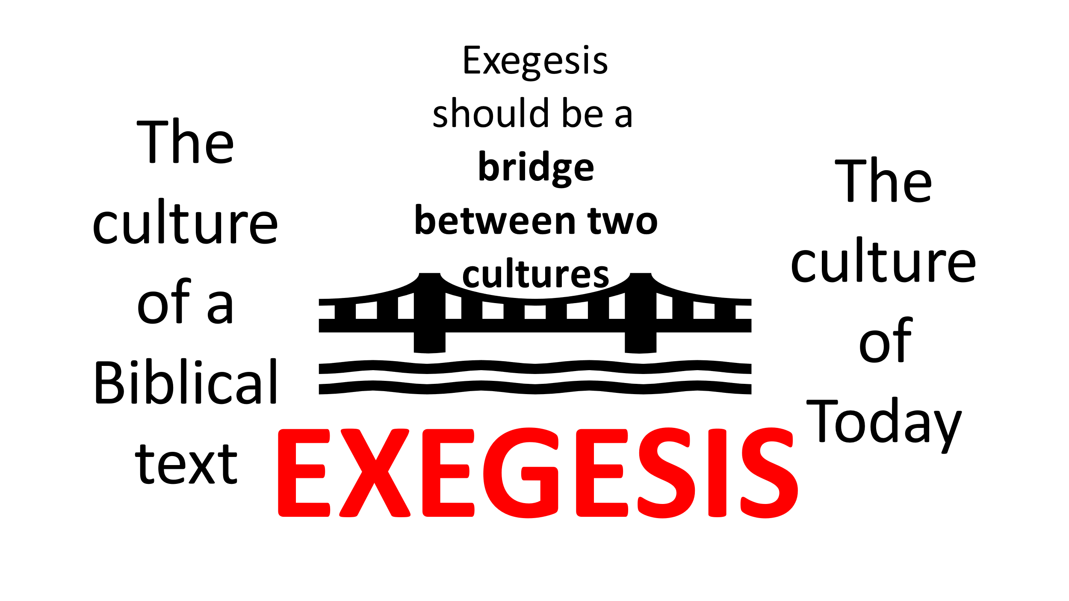
When it comes to understanding the true meaning of a Scripture or in the hearing of a word from the Lord, typically, a person could be mistaken in at least three ways.
1. Reading or hearing what God said.
2. Interpreting what he/she read or heard
3. Applying the truth to one’s life
Theological Humility
Theological Humility is critical! A person may only have a partial understanding or even be totally wrong! Let us remember 1 Peter 4:8 “love covers a multitude of sins.”
Many Evangelical scholars interpret Colossians 3:22-4:1 through the lens of a type of Functional Equivalent. Hence, they apply its truths to modern day employers and employees. To Illustrate the concept of Functional Equivalent: Believers are commanded to “greet one another with a holy kiss”
in most Western Cultures a Functional Equivalent is a simple greeting, like a handshake. Fortunately, God has not left us helpless & alone, rather He has given us the Holy Spirit & some principles in the Bible concerning relationships
Work Relations & Colossians 3:22 - 4:1
Please turn to Colossians 3:22 – 4:1 “Slaves, obey your earthly masters in everything; and do it, not only when their eye is on you and to win their favor, but with sincerity of heart and reverence for the Lord. Whatever you do, work at it with all your heart, as working for the Lord, not for men, since you know that you will receive an inheritance from the Lord as a reward. It is the Lord Christ you are serving. Anyone who does wrong will be repaid for his wrong, and there is no favoritism. Masters, provide your slaves with what is right and fair, because you know that you also have a Master in heaven.”
This morning we will look at several of Paul’s commands. (Please always remember to practice Theological Humility)
First observation – The chapter and verse divisions are manmade.
Second observation – Paul is writing to followers of Jesus; therefore, it seems safe to assume that Paul is NOT commanding us to obey an immoral, inappropriate command or request.
This morning’s passage raises many questions
The 1st command seems to me to be very counter-cultural. “Slaves, obey your earthly masters in everything; and do it, not only when their eye is on you and to win their favor, but with sincerity of heart and reverence for the Lord. “…OBEY…”
Food for Thought –
What might have been going on at Colosse that led Paul to address this issue? Not just when your boss(es) is/are looking!
What if we are asked to do something that we think, or feel is unfair?
The 2nd command has to do with one’s attitude.
Question: What do you think Paul means when he says “…with sincerity of heart and reverence for the Lord.”?
Some believers have memorized Hebrew 13:17 to assist them in having a positive attitude even during difficult or unfair circumstances.
The 3rd command has to do with one’s work habits as well as one’s attitude. Therefore, “…Whatever you do, work at it with all your heart m as working for the Lord, not for men, since you know that you will receive an inheritance form the Lord as a reward. It is the Lord Christ you are serving.”
The Shakers were a sect of the Quakers that lived in the 1700’s. Who can tell me why the Shakers furniture making techniques might be considered an example of this passage in action?
More Penetrating Questions: What might it look like for a Believer to do something as unto the Lord? Who is Paul speaking to? Only to the Colossian Believers or to us as well? Is our motive to receive a reward (selfish) or do we d things out of love for God and love for others? What are some of the motives that you have noticed in others at work? Is it possible that the Protestant Work Ethic came out of verses like these?
More instruction from Paul “Anyone who does wrong will be repaid for his wrong, and there is not favoritism.”
Scripture “…It is mine to avenge, I will repay – says the Lord.” (Romans 12:19b)
More Questions: In verse 25, what do you think “anyone” implies? According to verse 25, is there any advantage in being a Believer?
The 4th command primarily deals with one’s actions towards others. “Masters, provide your slaves what is right and fair, because you know that you also have a master in heaven.” “…provide…”
Question: What is Paul’s rationale for “providing”? Paul’s Answer: “…because you know that you also have a master in heaven.” What are potential implications of “…what is right and fair…”? How do you know when you are providing “…what is right and fair…”?
Critical Reflective Question: What does this passage teach you about God’s character? Since we will ultimately answer to God, let’s spend some time in Silent Prayer giving Him opportunity to speak! During our time of Silent Prayer, let us focus on three questions:
1. Is there anything that has put a distance between me & God or me & others?
2. Have I treated God or others less than a true/good friend?
3. Is there anything that I need to repent of?

Prayer for Communion
Communion (1 Corinthians 11:23-34)
Sing a song unto the Lord.
Benediction

Table Talk (Discussion Points)
Please Consider Sharing: Please share your thoughts on the following: The Abundant Life is ONLY attainable via GOD accomplishing it IN us and THROUGH us?
- What are your thoughts of the idea of EXEGESIS being the bridge between a culture of the Bible and our current day culture?
- How do you think THEOLOGICAL HUMILITY helps with the command to LOVE one another?
- In your understanding, is it appropriate that Colossians 3:22-4:1 is applied to employers and employees today? Why or Why Not?
- Are you aware of a situation where an employee was asked to do something wrong or unfair? What happened?
- What rationale does Paul give for being kind to others? What do you think about Paul’s rationale?
- In all of this, what do we learn about God’s character?
- (OVERALL) Share what the Holy Spirit impressed upon you personally, during our time together.

B.A.C. ANNOUNCEMENTS

- Welcome to the gathering of the Buckhannon Alliance Church where we desire to Live & Love Like Jesus & invite others to do the same!
- Join us weekly to pray! See app or website for dates & times!
- Women’s Prayer gathering for IWs will be Monday, May 8th from 6-7 in the prayer room. Contact Beth Bohman for more information.
- May 14th @ 9 am: Ladies breakfast to honor all the women of the BAC. The men will be hosting and serving. Gals of all ages are welcome!
- May 21st - German Fund-Raising Feast immediately following the morning service. Stick around for good food, fellowship, and help the Berlin Partnership Team with a donation! (See our website for the menu.)
- Please see our website or app for other announcements or opportunities coming up!

B.A.C. ANNOUNCEMENTS

- Welcome to the gathering of the Buckhannon Alliance Church where we desire to Live & Love Like Jesus & invite others to do the same!
- Join us weekly to pray! See app or website for dates & times!
- Women’s Prayer gathering for IWs will be Monday, May 8th from 6-7 in the prayer room. Contact Beth Bohman for more information.
- May 14th @ 9 am: Ladies breakfast to honor all the women of the BAC. The men will be hosting and serving. Gals of all ages are welcome!
- May 21st - German Fund-Raising Feast immediately following the morning service. Stick around for good food, fellowship, and help the Berlin Partnership Team with a donation! (See our website for the menu.)
- Please see our website or app for other announcements or opportunities coming up!

