St. John the Divine Anglican Church

Sunday March 19th, 2023
Fourth Sunday in Lent
We gather on the unceded territory of the Squamish Nation

www.squamishanglicanchurch.ca
info@squamishanglicanchurch.ca
1930 Diamond Road, Squamish
Phone number: 604-898-5100

WELCOME AND ANNOUNCEMENTS

THE GATHERING OF THE COMMUNITY

PENITENTIAL RITE
Leader If any want to become my followers, let them deny themselves and take up their cross and follow me. Mark 8.34

Let us confess our sins against God and our neighbour.
Silent prayer.

God of all mercy,
All we confess that we have sinned against you, opposing your will in our lives. We have denied your goodness in each other, in ourselves and in the world you have created. We repent of the evil that enslaves us, the evil we have done and the evil done on our behalf. Forgive, restore and strengthen us through our Saviour Jesus Christ, so that we may abide in your love and serve only your will. Amen.

Leader May the God of love and power forgive you and free you from your sins, heal and strengthen you by the Holy Spirit and raise you to new life in Jesus Christ.
All Amen.

KYRIE ELEISON
Kyrie eleison (Kyrie eleison)
Christe eleison (Christe eleison)
Kyrie eleison (Kyrie eleison)

INTRODUCTORY RESPONSES
Leader We cast our burdens upon you, O Lord, All and you will sustain us.
Leader Create in us clean hearts, O God,
All and renew a right spirit within us.
Leader Cast us not away from your presence
All and take not your Holy Spirit from us.
Leader Give us the joy of your saving help again
All and sustain us by your bountiful Spirit.
Leader Blessed are you, O Holy One,
All the God of our salvation who bears our burdens.

ACT OF PRAISE: Singing Songs of Expectation CP (Blue Book) #536

THE COLLECT OF THE DAY Prayers for an Inclusive Church (2009) alt. Leader Let us pray.
(Silence)
Creator and Healer,
People you work your Sabbath will in the chaos of our life: teach us the insight that gives true judgement and praises you wherever you are found, making miracles from spit and mud; through Jesus Christ, the Son of earth. Amen.

CHILDREN’S TIME

THE PROCLAMATION OF THE WORD
We sit to listen for the word of God

1ST READING: 1 SAMUEL 16:1-13
Reader Hear what the Spirit is saying to the Church. People Thanks be to God.
PSALM 23 BAS ( Green Book ) p.#
2ND READING: Ephesians 5: 8-14
Reader Hear what the Spirit is saying to the Church. People Thanks be to God.

GRADUAL HYMN: I Want Jesus to Walk with Me CP( Blue Book ) #512

HOLY GOSPEL: JOHN 9: 1-41 (as you are able, please stand) Reader The Lord be with you. People And also with you.
Reader The Gospel of our Lord Jesus Christ according to John. People Glory to you, Lord Jesus Christ.
(At the conclusion…)
Reader The Gospel of Christ! People Praise to you, Lord Jesus Christ.

HOMILY

APOSTLE’S CREED
I believe in God, the Father almighty,
creator of heaven and earth.
I believe in Jesus Christ, his only Son, our Lord.
He was conceived by the power of the Holy Spirit
and born of the Virgin Mary. He suffered under Pontius Pilate, was crucified, died, and was buried.
He descended to the dead. On the third day he rose again.
He ascended into heaven,
and is seated at the right hand of the Father.
He will come again to judge the living and the dead.
I believe in the Holy Spirit,
the holy catholic Church, the communion of saints,
the forgiveness of sins, the resurrection of the body,
and the life everlasting. Amen.

PRAYERS OF THE PEOPLE Standing, sitting or kneeling, we offer prayer as a community for the Church, for the world, for those in need and for those who have died.
THE PEACE
Leader The peace of the Lord be always with you.
All And also with you.

OFFERTORY HYMN: The Lord’s My Shepherd CP (Blue Book) #519
To make a gift to the life and ministry of St. John’s you can leave a cheque
or cash in the plate by the entrance of the sanctuary, send an e-transfer to give@squamishanglicanchurch.ca Or make a donation through our
online portal (Tithely), which can be accessed through our website,
or by scanning the QR code.

THE PRAYER OVER THE GIFTS
Leader Let us pray,

(Silence)
God of light,

All your Word brings to us a new vision of your glory. Accept our offering of praise and thanksgiving, through Jesus Christ our Lord. Amen.

Eucharistic Prayer #5 Sung
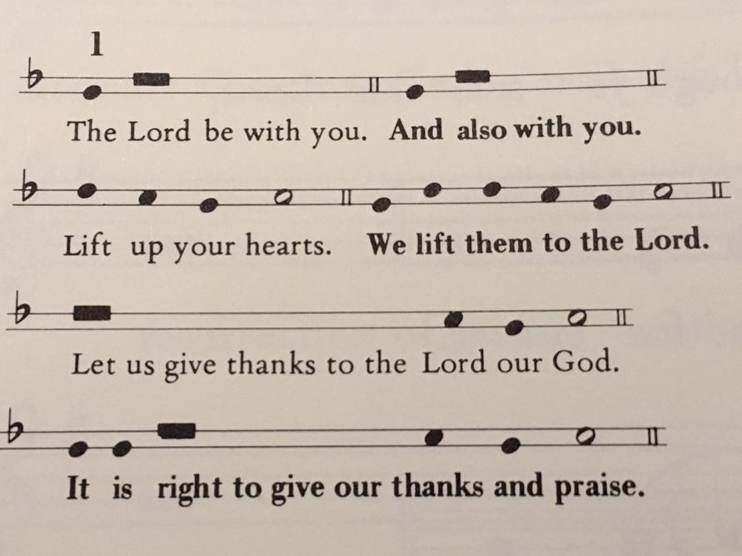

Celebrant We give you thanks and praise, almighty God, for the gift of a world full of wonder, and for our life which comes from you. By your power you sustain the
universe.

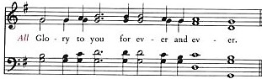
People

Celebrant You created us to love you with all our heart, and to love each other as ourselves, but we rebel against you by the evil that we do. In Jesus, your Son, you bring healing to our world and gather us into one great family. Therefore, with all who serve you on earth and in heaven, we praise your wonderful name, as we sing,
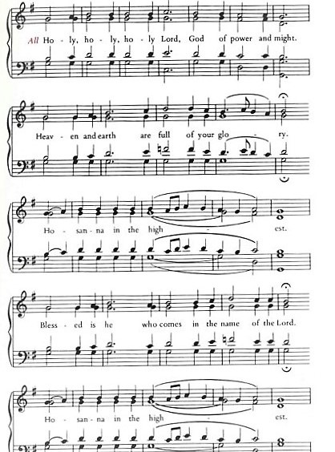

Celebrant We give you thanks and praise, loving Father, because in sending Jesus, your Son, to us you showed us how much you love us. He cares for the poor and the hungry. He suffers with the sick and the rejected.

Betrayed and forsaken, he did not strike back but overcame hatred with love. On the cross he defeated the power of sin and death. By raising him from the dead you show us the power of your love to bring new life to all your people.

Celebrant On the night before he gave up his life for us, Jesus, at supper with his friends, took bread, gave thanks to you, broke it, and gave it to them, saying, “Take this, all of you, and eat it: this is my body which is given for you.”

After supper, Jesus took the cup of wine, said the blessing, gave it to his friends, and said, “Drink this, all of you: this is the cup of my blood, the blood of the new and eternal covenant, which is shed for you and for many, so that sins may be forgiven. Do this in memory of me.”

People

Celebrant Gracious God, with this bread and wine we celebrate the death and resurrection of Jesus, and we offer ourselves to you in him. Send your Holy Spirit on us and on these gifts, that we may know the presence of Jesus in the breaking of bread, and share in the life of the family of your children.
People

Celebrant Father, you call us to be your servants; fill us with the courage and love of Jesus, that all the world may gather in joy at the table of your kingdom.

We sing your praise, almighty Father, through Jesus, our Lord, in the power of the Holy Spirit, now and for ever.
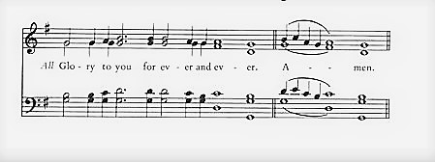
People

THE LORD’S PRAYER
Leader As our Saviour taught us, let us pray,
All Our Father in heaven, hallowed be your name, your kingdom come, your will be done, on earth as in heaven. Give us today our daily bread. Forgive us our sins as we forgive those who sin against us. Save us from the time of trial, and deliver us from evil. For the kingdom, the power, and the glory are yours, now and forever. Amen.

FRACTION SENTENCE #7 Green Book (BAS) p.#213
Leader We break this bread,
All Communion in Christ’s body once broken.
Leader Let your Church be the wheat which bears its fruit in dying.
All If we have died with him, we shall live with him; if we hold firm, we shall reign with him.

Leader The gift’s of God for the people of God.
All Thanks be to God.

If you wish to receive a blessing rather than the bread, place your hand over your heart. If you wish to receive a wafer, extend two hands. Gluten free wafers are available upon request. Please refrain from intincting (dipping) the bread in the chalice.

PRAYER AFTER COMMUNION
Leader Let us pray, (Silence)
Father,
All through your goodness we receive your Son in word and sacrament. May we always have faith in him, Jesus Christ the Lord. Amen.
DOXOLOGY Glory to God whose power, working in us, can do infinitely more than we can ask or imagine. Glory to God from generation to generation, in the Church and in Christ Jesus, forever and ever. Amen.
BLESSING

CLOSING HYMN: Praise the One Who Breaks the Darkness CP (Blue Book) #397

DISMISSAL
Leader Go in peace to love and serve the Lord. All Thanks be to God!

