March 5, 2023
Keepers of The Flame– The Deeper Meanings of Missions Giving
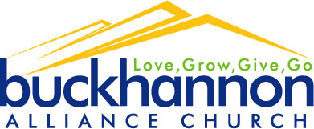
Welcome

PHILIPPIANS 4:14-19

- INVOLVEMENT – 14-16. Missions giving makes us a partner with missionaries.

- PLEASING – “it was good of you”

- PERSONAL - “it was good of you to share in my”

- PRACTICAL – “to share in my troubles”

- PERSISTENT - “more than once”

- INVESTMENT – 17, 18. Missions giving pays spiritual dividends.

- INVITATION – 19. Missions giving encourages us to trust God and see how he provides.

- God meets our needs personally ("my God").

- God meets our needs perfectly ("all your needs").

- God meets our needs permanently ("according to his glorious riches in Christ Jesus").

B.A.C. ANNOUNCEMENTS
- Welcome to the gathering of the Buckhannon Alliance Church where we desire to Live & Love Like Jesus.
- There are several opportunities for corporate prayer times for anyone interested. Those dates & times are posted on our church app.
- Next week we will have a spaghetti dinner after the service to help raise funds for the mission’s trip to Berlin! Please prayerfully consider a donation to help out!
Our Berlin 2023 team is: Jerry & Vickey Casto, Thomas & Lauren Wood, Trevor, Emily, Wyatt, & Magen Morris, Barry Fletcher, and Pastor Jeff Norris.
- Men’s Prayer Breakfast on Saturday, March 18th from 7-9 am in the Fellowship Hall. Join us for fellowship, a hearty breakfast, and discussion about men’s ministry opportunities in the weeks and months to come!
- Alliance Women’s WV Spring event, March 18th 9:30-1:30 @ the Morgantown Alliance Church. See Emily Morris for details.
- See website or app for other opportunities coming up!

