St. John the Divine Anglican Church

Sunday March 5th, 2023
Second Sunday in Lent
We gather on the unceded territory of the Squamish Nation

www.squamishanglicanchurch.ca
info@squamishanglicanchurch.ca
1930 Diamond Road, Squamish
Phone number: 604-898-5100

WELCOME AND ANNOUNCEMENTS

THE GATHERING OF THE COMMUNITY

PENITENTIAL RITE
Leader If any want to become my followers, let them deny themselves and take up their cross and follow me. Mark 8.34

Let us confess our sins against God and our neighbour.
Silent prayer.

God of all mercy,
All we confess that we have sinned against you, opposing your will in our lives. We have denied your goodness in each other, in ourselves and in the world you have created. We repent of the evil that enslaves us, the evil we have done and the evil done on our behalf. Forgive, restore and strengthen us through our Saviour Jesus Christ, so that we may abide in your love and serve only your will. Amen.

Leader May the God of love and power forgive you and free you from your sins, heal and strengthen you by the Holy Spirit and raise you to new life in Jesus Christ.
All Amen.

KYRIE ELEISON
Kyrie eleison (Kyrie eleison)
Christe eleison (Christe eleison)
Kyrie eleison (Kyrie eleison)

INTRODUCTORY RESPONSES
Leader We cast our burdens upon you, O Lord, All and you will sustain us.
Leader Create in us clean hearts, O God,
All and renew a right spirit within us.
Leader Cast us not away from your presence
All and take not your Holy Spirit from us.
Leader Give us the joy of your saving help again
All and sustain us by your bountiful Spirit.
Leader Blessed are you, O Holy One,
All the God of our salvation who bears our burdens.

ACT OF PRAISE: He Comes to Us As One Unknown CP (Blue Book) #456

THE COLLECT OF THE DAY Prayers for an Inclusive Church (2009) alt.
Leader Let us pray.
(Silence)
God of mercy,
People you are full of tenderness and compassion, slow to anger, rich in mercy, and always ready to forgive: grant us grace to renounce all evil and to cling to Christ, so that in every way we may prove to be your loving children; through Jesus Christ our Lord, who lives and reigns with you and the Holy Spirit, one God, for ever and ever. Amen.

CHILDREN’S TIME

THE PROCLAMATION OF THE WORD
We sit to listen for the word of God

1ST READING: GENESIS 12: 1-4A
Reader Hear what the Spirit is saying to the Church. People Thanks be to God.
PSALM 121 BAS ( Green Book ) p.# 882
I lift up my eyes to the hills; from where is my help to come?
My help comes from the Lord, the maker of heaven and earth.
He will not let your foot be moved and he who watches over you will not fall asleep.
Behold, he who keeps watch over Israel shall neither slumber nor sleep;
The Lord himself watches over you; the Lord is your shade at your right hand,
So that the sun shall not strike you by day, nor the moon by night.
The Lord shall preserve you from all evil; it is he who shall keep you safe.
The Lord shall watch over your going out and your coming in, from this time forth for evermore.

2ND READING: ROMANS 4: 1-5, 13-17 Reader Hear what the Spirit is saying to the Church. People Thanks be to God.

GRADUAL HYMN: I Want Jesus to Walk With Me CP( Blue Book ) #512

HOLY GOSPEL: JOHN 3: 1-17
(as you are able, please stand)
Reader The Lord be with you. People And also with you. Reader The Gospel of our Lord Jesus Christ according to John. People Glory to you, Lord Jesus Christ.
(At the conclusion…)
Reader The Gospel of Christ! People Praise to you, Lord Jesus Christ.

HOMILY
APOSTLE’S CREED
I believe in God, the Father almighty,
creator of heaven and earth.
I believe in Jesus Christ, his only Son, our Lord.
He was conceived by the power of the Holy Spirit
and born of the Virgin Mary.
He suffered under Pontius Pilate,
was crucified, died, and was buried.
He descended to the dead.
On the third day he rose again.
He ascended into heaven,
and is seated at the right hand of the Father.
He will come again to judge the living and the dead.
I believe in the Holy Spirit,
the holy catholic Church, the communion of saints,
the forgiveness of sins, the resurrection of the body,
and the life everlasting. Amen.

PRAYERS OF THE PEOPLE Standing, sitting or kneeling, we offer prayer as a community for the Church, for the world, for those in need and for those who have died.
THE PEACE
Leader The peace of the Lord be always with you.
All And also with you.

OFFERTORY HYMN: Come Now, O Prince of Peace CP (Blue Book) #588

To make a gift to the life and ministry of St. John’s you can leave a cheque
or cash in the plate by the entrance of the sanctuary, send an e-transfer to give@squamishanglicanchurch.ca Or make a donation through our
online portal (Tithely), which can be accessed through our website,
or by scanning the QR code.

THE PRAYER OVER THE GIFTS
Leader Let us pray,

(Silence)
God of wisdom,
All may the light of the eternal Word, our Lord and Saviour Jesus Christ, guide us to your glory. We ask this in his name. Amen.
Eucharistic Prayer #5 Sung
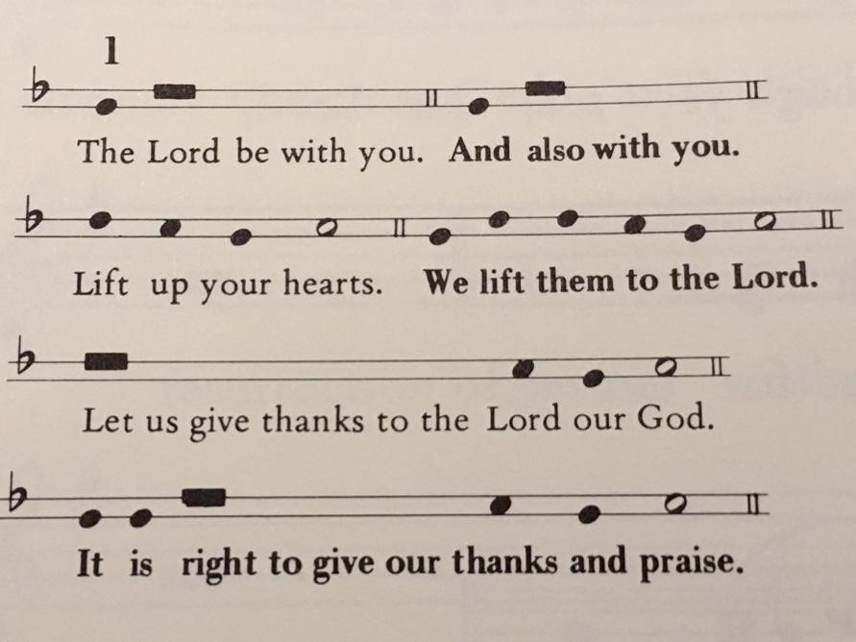

Celebrant We give you thanks and praise, almighty God, for the gift of a world full of wonder, and for our life which comes from you. By your power you sustain the
universe.
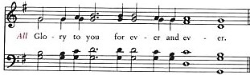
People

Celebrant You created us to love you with all our heart, and to love each other as ourselves, but we rebel against you by the evil that we do. In Jesus, your Son, you bring healing to our world and gather us into one great family. Therefore, with all who serve you on earth and in heaven, we praise your wonderful name, as we sing,
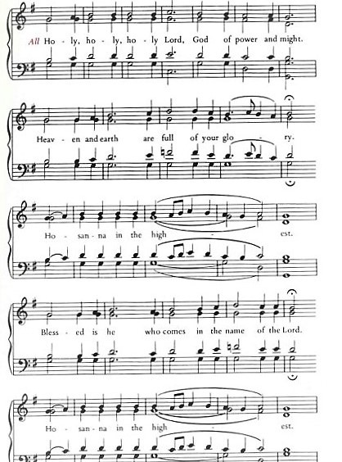

Celebrant We give you thanks and praise, loving Father, because in sending Jesus, your Son, to us you showed us how much you love us. He cares for the poor and the hungry. He suffers with the sick and the rejected.

Betrayed and forsaken, he did not strike back but overcame hatred with love. On the cross he defeated the power of sin and death. By raising him from the dead you show us the power of your love to bring new life to all your people.

People

Celebrant On the night before he gave up his life for us, Jesus, at supper with his friends, took bread, gave thanks to you, broke it, and gave it to them, saying, “Take this, all of you, and eat it: this is my body which is given for you.”

After supper, Jesus took the cup of wine, said the blessing, gave it to his friends, and said, “Drink this, all of you: this is the cup of my blood, the blood of the new and eternal covenant, which is shed for you and for many, so that sins may be forgiven. Do this in memory of me.”

People

Celebrant Gracious God, with this bread and wine we celebrate the death and resurrection of Jesus, and we offer ourselves to you in him. Send your Holy Spirit on us and on these gifts, that we may know the presence of Jesus in the breaking of bread, and share in the life of the family of your children.
People

Celebrant Father, you call us to be your servants; fill us with the courage and love of Jesus, that all the world may gather in joy at the table of your kingdom.

We sing your praise, almighty Father, through Jesus, our Lord, in the power of the Holy Spirit, now and for ever.
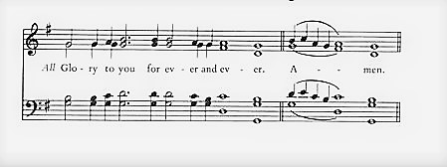

People

THE LORD’S PRAYER
Leader As our Saviour taught us, let us pray,
All Our Father in heaven, hallowed be your name, your kingdom come, your will be done, on earth as in heaven. Give us today our daily bread. Forgive us our sins as we forgive those who sin against us. Save us from the time of trial, and deliver us from evil. For the kingdom, the power, and the glory are yours, now and forever. Amen.

FRACTION SENTENCE #7 Green Book (BAS) p.#213
Leader We break this bread,
All Communion in Christ’s body once broken.
Leader Let your Church be the wheat which bears its fruit in dying.
All If we have died with him, we shall live with him; if we hold firm, we shall reign with him.

Leader The gift’s of God for the people of God.
All Thanks be to God.

If you wish to receive a blessing rather than the bread, place your hand over your heart. If you wish to receive a wafer, extend two hands. Gluten free wafers are available upon request. Please refrain from intincting (dipping) the bread in the chalice.

PRAYER AFTER COMMUNION
Leader Let us pray, (Silence)
Creator of heaven and earth,
All we thank you for these holy mysteries, which bring us now a share in the life to come, through Jesus Christ our Lord. Amen.
DOXOLOGY Glory to God whose power, working in us, can do infinitely more than we can ask or imagine. Glory to God from generation to generation, in the Church and in Christ Jesus, forever and ever. Amen.
BLESSING

CLOSING HYMN: Come and Journey with a Saviour CP (Blue Book) #482

DISMISSAL
Leader Go in peace to love and serve the Lord.
All Thanks be to God!

The flowers in the sanctuary this morning
are given with thanksgiving and love
for the joy-filled lives of Edie and Christine.
David and family.

PRAYER REQUESTS

The Church
The Archdeaconry of Westminster –The Venerable Richard Leggett, Regional Archdeacon
Mother’s Union – Diocese of New Westminster Chapter
Our companion diocese, the Episcopal Diocese of the Northern Philippines and our companion parish, St. John the Divine Mission, Lacmaan.
St. John the Divine, Squamish - The Reverend Cameron Gutjahr, Rector, Canon Donald J. Lawton, Honorary Assistant.

Immediate Prayer Requests

Rana, Cate, Kathy, Lillian and Michael Moore, Kayla Mak, John, Dorothy, Marilyn, Jen, Sandra, Rob, Mari, Brian and Carol, The Howe Sound Women’s Centre, the residents of Hilltop House, the residents of Shannon Falls, the Elders of the Squamish Nation, the patients of Squamish General Hospital and the patients of the Sea to Sky Hospice.
We pray for the repose of the soul of Roy Shephard. We hold Muriel, Sarah and Rachel and family in prayer.

Announcements
THIS WEEK St. John will be host and sponsor for the Squamish Music Festival being held this week!
Tuesday Tot Time from 10 am-noon (in the hall) Lenten Study 4 pm at St. John
Thursday Office hours 9 am – noon Lenten Study 7 pm online
Friday Office hours 9 am –noon
Sunday Third Sunday in Lent 10 am
Lenten Study Five week study of Emma Ineson’s book Ambition: What Jesus Said about Power, Success and Counting Stuff. There will be two opportunities a week to participate: Tuesdays at 4 pm at St. John’s(beginning Feb 28th)Thursdays at 7pm online(beginning March 2nd) Please register for this study through the office.
Trivia Night Friday March 24th @ 7:00PM $20.00 per person, up to 6 per team Snacks and Refreshments Included. Register at info@squamishanglicanchurch.ca
Giving The ministry of St. John’s is made possible from the gifts of the community. If you would like to make a financial donation to St. John’s, there are a variety of ways outlined on our website.
Rector’s Reflection This Lent, Jessica and I decided to go down to one car between us. A different sort of fast than usual.
This particular decision was made for various reasons: to fast for the earth by hopefully using the car less, perhaps to enjoy some cost-savings, to set some boundaries, to slow down and be more intentional about travel, to not take for granted this convenience, and reflect on where I have become dependent on this form of personal transportation. It won’t be easy, but I think it will be good. I hope that it will give me more opportunities to practice patience, prayer, surrender, flexibility, and good humour.
However, there has been another unintentional and surprising opportunity that has already come out of it. The fast has already born fruit! Just a few days after Ash Wednesday, we heard that our good friends’ car had broken down and that it would take them a few weeks to arrange to get a replacement. Because of this fast, we were able to unreservedly say, “please, use this care for the next month.”

Sharing this story is not meant to pat myself on the back. Instead, it is to make the point that the benefits and opportunities from fasting and other spiritual disciplines can sometimes surprise us.

It is also to say that the point of fasts and Lenten practices is not to punish ourselves or make us miserable. Rather, these disciplines should, ideally, lead us to greater love for God and neighbour; lead us to greater generosity, peace, and justice in our lives and in the world.

I pray that we may all be surprised along our Lenten journeys this year. I pray that in all our spiritual practices that we may grow in our abilities to both give and receive God’s abundant grace.
Thanks be to God!
CG+

