Gloria Dei (Old Swedes’) Church

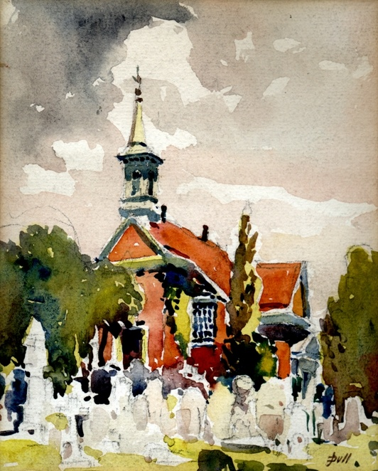

Christian Street and Columbus Boulevard
Philadelphia, PA 19147
215-389-1513 www.old-swedes.org

We, the congregation of Gloria Dei (Old Swedes), existing by and for the glory of God, knowing that God, through this congregation, helps us find our way and to use our gifts, gather together, to honor and celebrate the acceptance of our differences and uniqueness, to be an inviting, welcoming, sustaining and loving community, to respond to the needs of others, to preserve and build upon the beauty, tradition and heritage of this sacred place.

February 26, 2023
First Sunday in Lent
Ministry Assistants Today:
Lector: Christine Pickup
Intercessor: Eric Michael Sanchez
Usher: Nils vanAmmers
Altar Guild: Jeanette Woehr
Celebrant: Rev. Canon Gordon Reid

Opening Hymn # 590 O Jesus Christ, May Grateful Hymns Hymnal 1982
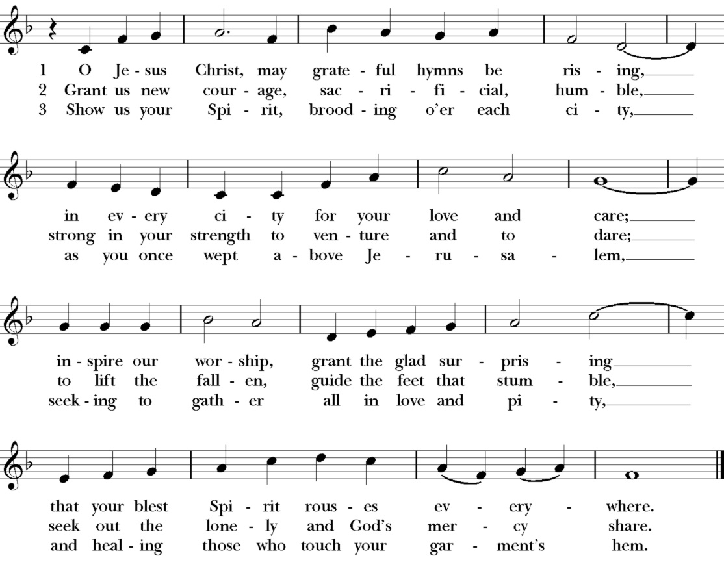

Celebrant Bless the Lord, who forgives all our sins.
All His mercy endures forever.
Celebrant Hear the commandments of God to his people: I am the Lord your God, who brought you out of bondage. You shall have no other gods but me.
All Amen. Lord have mercy.
Celebrant You shall not make for yourself any idol.
All Amen. Lord have mercy.
Celebrant You shall not invoke with malice the Name of the Lord your God.
All Amen. Lord have mercy.
Celebrant Remember the Sabbath day to keep it holy.
All Amen. Lord have mercy.
Celebrant Honor your father and your mother.
All Amen. Lord have mercy.
Celebrant You shall not commit murder.
All Amen. Lord have mercy.
Celebrant You shall not commit adultery.
All Amen. Lord have mercy.
Celebrant You shall not steal.
All Amen. Lord have mercy.
Celebrant You shall not be a false witness.
All Amen. Lord have mercy.
Celebrant You shall not covet anything that belongs to your neighbor.
All Amen. Lord have mercy.

Celebrant If we say that we have no sin, we deceive ourselves, and the truth is not in us. But if we confess our sins, God, who is faithful and just, will forgive our sins and cleanse us from all unrighteousness.
Let us confess our sins against God and our neighbor.
(Silence)

Celebrant Let us pray.
All Most merciful God, we confess that we have sinned against you in thought, word, and deed, by what we have done, and by what we have left undone. We have not loved you with our whole heart; we have not loved our neighbors as ourselves. We are truly sorry and we humbly repent. For the sake of your Son Jesus Christ, have mercy on us and forgive us; that we may delight in your will, and walk in your ways, to the glory of your Name. Amen.
Celebrant Almighty God have mercy on you, forgive you all your sins through our Lord Jesus Christ, strengthen you in all goodness, and by the power of the Holy Spirit keep you in eternal life.
All Amen.
(all stand, as they are able)

Kyrie Have Mercy on Us Lord
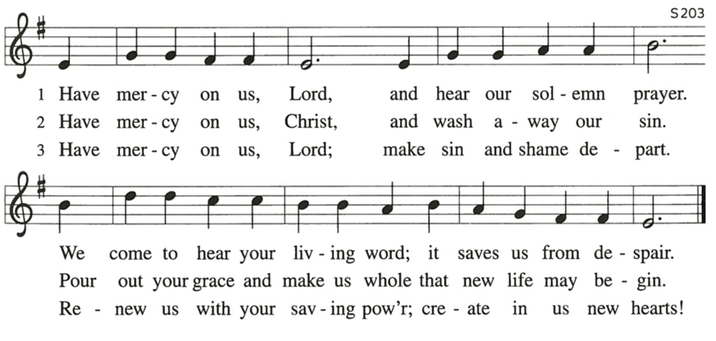

Celebrant Let us pray together.
People Almighty God, whose blessed Son was led by the Spirit to be tempted by Satan: Come quickly to help us who are assaulted by many temptations; and, as you know the weaknesses of each of us, let each one find you mighty to save; through Jesus Christ your Son our Lord, who lives and reigns with you and the Holy Spirit, one God, now and forever. Amen.

First Reading Genesis 2:15-17; 3:1-7 Christine Pickup
The Lord God took the man and put him in the garden of Eden to till it and keep it. And the Lord God commanded the man, “You may freely eat of every tree of the garden; but of the tree of the knowledge of good and evil you shall not eat, for in the day that you eat of it you shall die.”
Now the serpent was more crafty than any other wild animal that the Lord God had made. He said to the woman, “Did God say, ‘You shall not eat from any tree in the garden’?” The woman said to the serpent, “We may eat of the fruit of the trees in the garden; but God said, ‘You shall not eat of the fruit of the tree that is in the middle of the garden, nor shall you touch it, or you shall die.’“ But the serpent said to the woman, “You will not die; for God knows that when you eat of it your eyes will be opened, and you will be like God, knowing good and evil.” So when the woman saw that the tree was good for food, and that it was a delight to the eyes, and that the tree was to be desired to make one wise, she took of its fruit and ate; and she also gave some to her husband, who was with her, and he ate. Then the eyes of both were opened, and they knew that they were naked; and they sewed fig leaves together and made loincloths for themselves.

Reader Hear what the Spirit is saying to God’s people.
People Thanks be to God

Psalm 32
1 Happy are they whose transgressions are forgiven, *
and whose sin is put away!
2 Happy are they to whom the Lord imputes no guilt, *
and in whose spirit there is no guile!
3 While I held my tongue, my bones withered away, *
because of my groaning all day long.
4 For your hand was heavy upon me day and night; *
my moisture was dried up as in the heat of summer.
5 Then I acknowledged my sin to you, *
and did not conceal my guilt.
6 I said," I will confess my transgressions to the Lord." *
Then you forgave me the guilt of my sin.
7 Therefore all the faithful will make their prayers to you in time of trouble; *
when the great waters overflow, they shall not reach them.
8 You are my hiding-place; you preserve me from trouble; *
you surround me with shouts of deliverance.
9 "I will instruct you and teach you in the way that you should go; *
I will guide you with my eye.
10 Do not be like horse or mule, which have no understanding; *
who must be fitted with bit and bridle, or else they will not stay near you."
11 Great are the tribulations of the wicked; *
but mercy embraces those who trust in the Lord.
12 Be glad, you righteous, and rejoice in the Lord; *
shout for joy, all who are true of heart.

Second Reading Romans 5:12-19

As sin came into the world through one man, and death came through sin, and so death spread to all because all have sinned-- sin was indeed in the world before the law, but sin is not reckoned when there is no law. Yet death exercised dominion from Adam to Moses, even over those whose sins were not like the transgression of Adam, who is a type of the one who was to come.
But the free gift is not like the trespass. For if the many died through the one man's trespass, much more surely have the grace of God and the free gift in the grace of the one man, Jesus Christ, abounded for the many. And the free gift is not like the effect of the one man's sin. For the judgment following one trespass brought condemnation, but the free gift following many trespasses brings justification. If, because of the one man's trespass, death exercised dominion through that one, much more surely will those who receive the abundance of grace and the free gift of righteousness exercise dominion in life through the one man, Jesus Christ.
Therefore just as one man's trespass led to condemnation for all, so one man's act of righteousness leads to justification and life for all. For just as by the one man's disobedience the many were made sinners, so by the one man's obedience the many will be made righteous.

Reader Hear what the Spirit is saying to God’s people.
People Thanks be to God

Gradual Hymn # 147 Now Let Us All With One Accord Hymnal 1982
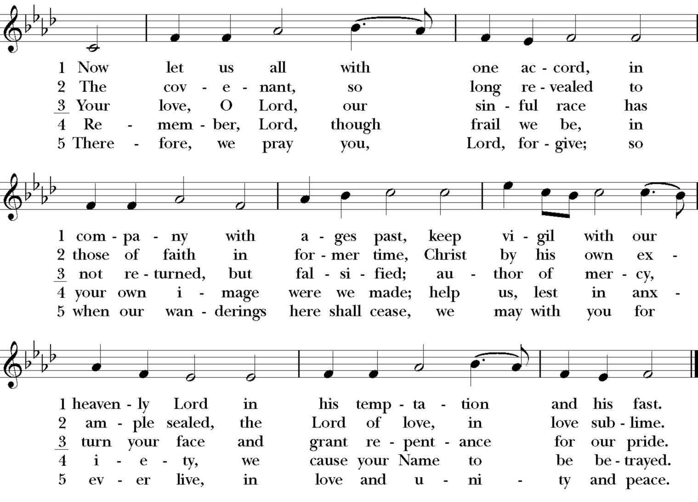

Celebrant The Holy Gospel of our Lord Jesus Christ according to Matthew (4:1-11)
People Glory to you, Lord Christ

Jesus was led up by the Spirit into the wilderness to be tempted by the devil. He fasted forty days and forty nights, and afterwards he was famished. The tempter came and said to him, “If you are the Son of God, command these stones to become loaves of bread.” But he answered, “It is written,
‘One does not live by bread alone,
but by every word that comes from the mouth of God.’”
Then the devil took him to the holy city and placed him on the pinnacle of the temple, saying to him, “If you are the Son of God, throw yourself down; for it is written,
‘He will command his angels concerning you,’
and ‘On their hands they will bear you up,
so that you will not dash your foot against a stone.’”
Jesus said to him, “Again it is written, ‘Do not put the Lord your God to the test.’”
Again, the devil took him to a very high mountain and showed him all the kingdoms of the world and their splendor; and he said to him, “All these I will give you, if you will fall down and worship me.” Jesus said to him, “Away with you, Satan! for it is written,
‘Worship the Lord your God,
and serve only him.’”
Then the devil left him, and suddenly angels came and waited on him.

Celebrant The Gospel of the Lord
People Praise to you, Lord Christ
Sermon Rev. Canon Gordon Reid

The Nicene Creed

We believe in one God,
the Father, the Almighty,
maker of heaven and earth,
of all that is, seen and unseen.
We believe in one Lord, Jesus Christ,
the only Son of God,
eternally begotten of the Father,
God from God, Light from Light,
true God from true God,
begotten, not made,
of one Being with the Father.
Through him all things were made.
For us and for our salvation
he came down from heaven:
by the power of the Holy Spirit
he became incarnate from the Virgin Mary,
and was made man.
For our sake he was crucified under Pontius
Pilate; he suffered death and was buried.
On the third day he rose again
in accordance with the Scriptures;
he ascended into heaven and is seated at the right hand of the Father.
He will come again in glory to judge the living and the dead,
and his kingdom will have no end.
We believe in the Holy Spirit, the Lord, the giver of life, who proceeds from the Father and the Son. With the Father and the Son he is worshiped and glorified.
He has spoken through the Prophets.
We believe in one holy catholic and apostolic Church. We acknowledge one baptism for the forgiveness of sins.
We look for the resurrection of the dead,
and the life of the world to come. Amen.

Prayers of the People - Form III Eric Michael Sanchez
Father, we pray for your holy Catholic Church;
That we all may be one.

Grant that every member of the Church may truly and humbly serve you;
That your Name may be glorified by all people.

We pray for all bishops, priests, and deacons, especially: Justin, Archbishop of Canterbury; Michael, our Presiding Bishop; Daniel, our Bishop; the Vestry, staff, and congregation of our church.
That they may be faithful ministers of your Word and Sacraments.

We pray for all who govern and hold authority in the nations of the world;
That there may be justice and peace on the earth.

Give us grace to do your will in all that we undertake;
That our works may find favor in your sight.

Have compassion on those who suffer from any grief or trouble; We remember especially those who are connected to our church family: Connie, Re, Christian, Thomas, Margie, Wayne, Marissa, Marylou, Emilymarie, Jeanie, Pat, Francis, Bob, Bonnie, Roland, Bill, Ed, Rene, John, Geoff, Connie, and Jack.
(You may add other names either silently or aloud.)
Let us pray.
That they may be delivered from their distress.
Give to the departed eternal rest.
(You may add names of departed people either silently or aloud.)
We also pray for the souls of all who have died in the earthquake in Turkey and Syria, from gun violence, and the pandemic.
Let light perpetual shine upon them.

We praise you for your saints who have entered into joy;
May we also come to share in your heavenly kingdom.

Let us pray for our own needs and those of others. Grant us the guidance of your Holy Spirit as we seek a new Rector for our parish. We also ask for your blessings on anyone celebrating a birthday or anniversary this week.
Grant that we may continue to experience your love and guidance in the years to come.

Celebrant Almighty and eternal God, ruler of all things in heaven and earth; mercifully accept the prayers of your people, and strengthen us to do your will, through Jesus Christ Our Lord. Amen.

The Peace

Celebrant The Peace of the Lord be always with you.
People And also with you

Announcements

Celebrant Walk in love as Christ loved us and gave himself for us, an offering and sacrifice to God.

Offertory
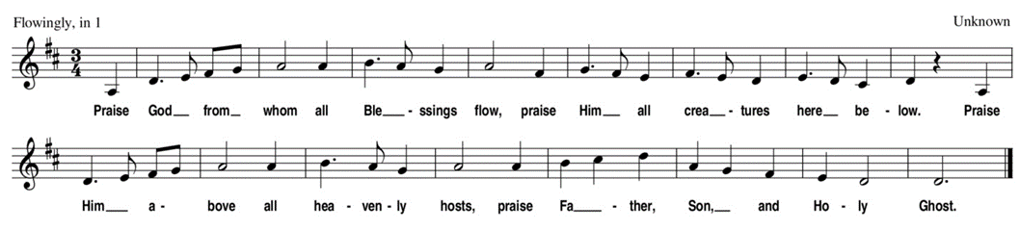

The Holy Communion – Eucharistic Prayer B

+Celebrant The Lord be with you.
People And also with you.
Celebrant Lift up your hearts.
People We lift them to the Lord.
Celebrant Let us give thanks to the Lord our God.
People It is right to give our thanks and praise

Celebrant It is right, and a good and joyful thing, always and everywhere to give thanks to you, Father Almighty, Creator of heaven and earth.
Through Jesus Christ our Lord, who was tempted in every way as we are, yet did not sin. By his grace we are able to triumph over every evil, and to live no longer for ourselves alone, but for him who died for us and rose again.
Therefore, we praise you, joining our voices with Angels and Archangels and with all the company of heaven, who forever sing this hymn to proclaim the glory of your Name:

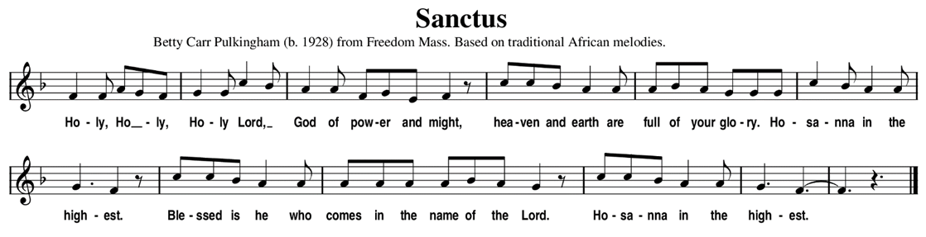

Celebrant We give thanks to you, O God, for the goodness and love which you have made known to us in creation; in the calling of Israel to be your people; in your Word spoken through the prophets; and above all in the Word made flesh, Jesus, your Son. For in these last days you sent him to be incarnate from the Virgin Mary, to be the Savior and Redeemer of the world. In him, you have delivered us from evil, and made us worthy to stand before you. In him, you have brought us out of error into truth, out of sin into righteousness, out of death into life. On the night before he died for us, our Lord Jesus Christ took bread; and when he had given thanks to you, he broke it, and gave it to his disciples, and said, “Take, eat: This is my Body, which is given for you. Do this for the remembrance of me.” After supper he took the cup of wine; and when he had given thanks, he gave it to them, and said, “Drink this, all of you: This is my Blood of the new Covenant, which is shed for you and for many for the forgiveness of sins. Whenever you drink it, do this for the remembrance of me.” Therefore, according to his command, O Father,
People We remember his death, We proclaim his resurrection, We await his coming in glory.
Celebrant And we offer our sacrifice of praise and thanksgiving to you, O Lord of all; presenting to you, from your creation, this bread and this wine. We pray you, gracious God, to send your Holy Spirit upon these gifts that they may be the Sacrament of the Body of Christ and his Blood of the new Covenant. Unite us to your Son in his sacrifice, that we may be acceptable through him, being sanctified by the Holy Spirit. In the fullness of time, put all things in subjection under your Christ, and bring us to that heavenly country where with all your saints, we may enter the everlasting heritage of your sons and daughters; through Jesus Christ our Lord, the firstborn of all creation, the head of the Church, and the author of our salvation. By him, and with him, and in him, in the unity of the Holy Spirit all honor and glory is yours, Almighty Father, now and forever.
People Amen.

Celebrant And now, as our Savior Christ has taught us, we are bold to say,

People Our Father, who art in heaven,
Hallowed be thy name;
Thy kingdom come;
Thy will be done;
On earth as it is in heaven.
Give us this day our daily bread.
And forgive us our trespasses,
As we forgive those who trespass against us.
And lead us not into temptation;
But deliver us from evil.
For thine is the kingdom,
And the power and the glory,
For ever and ever. Amen.

The Breaking of the Bread

Celebrant Christ our Passover is sacrificed for us;
People Therefore let us keep the feast.
Celebrant The Gifts of God for the People of God. Take them in remembrance that Christ died for you, and feed on him in your hearts by faith with thanksgiving.

(All persons are invited to the Lord’s supper.)

The Post-Communion Prayer

Celebrant Let us pray
People Eternal God, heavenly Father, you have graciously accepted us as living
members of your Son our Savior Jesus Christ, and you have fed us with spiritual
food in the Sacrament of his Body and Blood. Send us now into the world in peace,
and grant us strength and courage to love and serve you with gladness and
singleness of heart; through Christ our Lord. Amen.

The Blessing

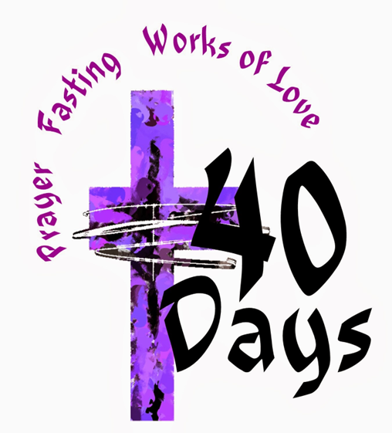

Closing Hymn # 559 Lead Us, Heavenly Father Hymnal 1982
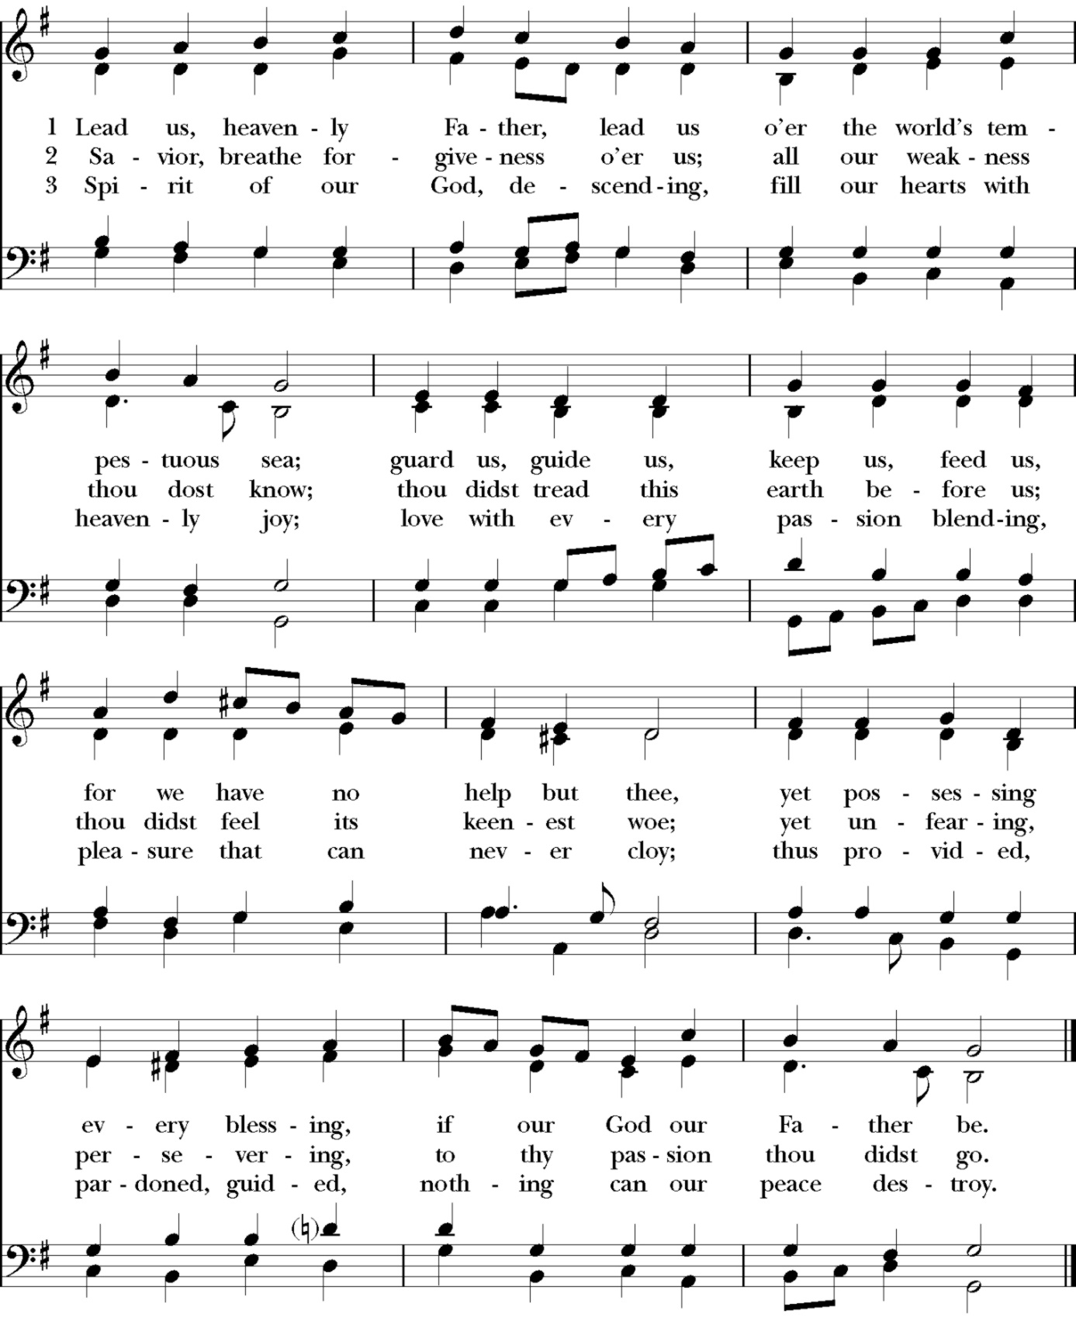

Dismissal

Celebrant Worship has ended and our service begins. Let us go forth into the world rejoicing in the power of the Holy Spirit!
People Thanks be to God.
Postlude

Evensong
Evensong: Tuesday Musical Meditation, every Tuesday at 6:30pm in the Sanctuary.
Join us for a refreshed version of our popular service. Don't worry, it isn't entirely different! Paul Fejko will still be performing on our beautiful Hook & Hastings organ. Keep an eye out for some interesting guest guitarists, a drum circle, poems, and discussions that we hope will inspire you throughout the rest of the week. The program will be led by our sextons, Jim & Paula Minacci, who want to create a welcoming and relaxed atmosphere that everyone will enjoy.

Join us for 10 Minutes of Prayer
Every Monday at 9:00am on Zoom.
Megan Bartlett will lead a ten-minute prayer, following the Morning Devotion service in the Book of Common Prayer. We lift up to God our personal and parish needs, as we search for a new Rector.
Meeting ID: 909 012 0129
Passcode: 1U029q
If you have the BCP, turn to page 137.

Dates to Remember
March 12 – Daylight Savings ends
April 2 – Palm Sunday
April 6 – Maundy Thursday
April 7 – Good Friday
April 9 – Easter Sunday

Thank you to Jaime Konowal for supplying the baked goods for fellowship this Sunday.

Gloria Dei Staff
Paul Fejko – Music Director
Jim and Paula Minacci – Sextons
Christine McBride – Parish Administrator
Amy Liberi – Wedding and Event Coordinator

Gloria Dei Vestry
Megan Bartlett – 267-581-9357 megan77777@yahoo.com
Julie Daye - 215-520-7097 jultag22@yahoo.com
Jill Duink – 215-290-9668 jillddd@hotmail.com
Amy Grant – 267-216-6518 amy@southwarkhistory.org
Bob Jenkins - 215-779-5751 tazjenkins13@gmail.com
Jaime Konowal – Rector’s Warden - 215-847-7665 jaimelkonowal@gmail.com
Candace Roberts – Accounting Warden (w) 215-592-6590 croberts@quantum-think.com
Nils van Ammers - 610-216-4431 vanammers.nils@gmail.com
Jeanette Woehr – Secretary – 856-264-3551 jeanettew164@verizon.net

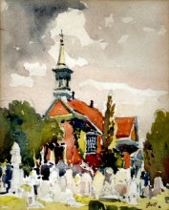
Gloria Dei (Old Swedes’ Church)
Columbus Blvd and Christian Street - Philadelphia, PA 19147
215-389-1513 - www.old-swedes.org
Find us on Facebook Gloria Dei (Old Swedes’) Episcopal Church

