THE ELDER’S PRIORITIES (ACTS 20:28-31)
Elder Covenant # 1: As Elders we will shepherd the flock of this local body so as to model the love of Jesus through disciple making discipleship.

Elders have three priorities:
- SELF – 28a. 4 questions
- Who is the “self”?
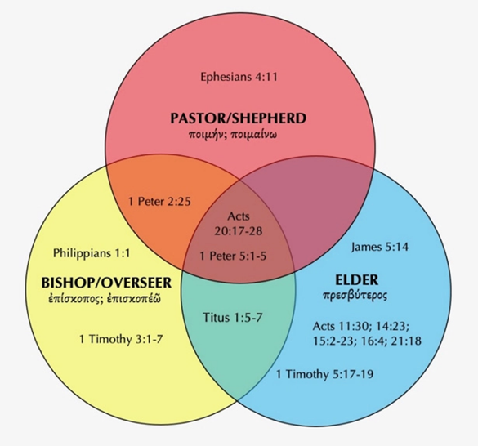
- How did the “self” get this position?

- How many “selves” are there in a church?

- How does one “keep watch over self”?

II. SHEEP – 28b. 3 questions
- Who are the sheep?

- How do elders keep watch over the people of God?

- How valuable are the sheep?

III. SCAMS – 29-31.

