Name of Assembly: United Apostolic Church Type of service: Bible Study
Date: January 31st, 2023
Topic: “The Effectual Fervent Prayer”
Scripture Text: James 5:16-18

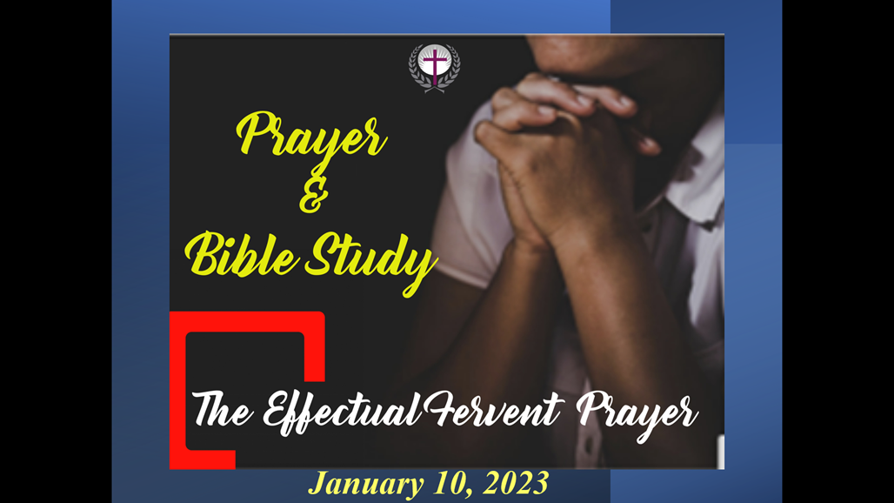
“Confess your faults one to another, and pray one for another, that ye may be healed. The effectual fervent prayer of a righteous man availeth much. Elias was a man subject to like passions as we are, and he prayed earnestly that it might not rain: and it rained not on the earth by the space of three years and six months. And he prayed again, and the heaven gave rain, and the earth brought forth her fruit” – James 5:16-18.

“^{1 Kings 17:1}And Elijah the Tishbite, who was of the inhabitants of Gilead, said unto Ahab, As the Lord God of Israel liveth, before whom I stand, there shall not be dew nor rain these years, but according to my word….” – ^{1 Kings 18:41-45} ⁴¹ And Elijah said unto Ahab, Get thee up, eat and drink; for there is a sound of abundance of rain. ⁴² So Ahab went up to eat and to drink. And Elijah went up to the top of Carmel; and he cast himself down upon the earth, and put his face between his knees, ⁴³ And said to his servant, Go up now, look toward the sea. And he went up, and looked, and said, There is nothing. And he said, Go again seven times. ⁴⁴ And it came to pass at the seventh time, that he said, Behold, there ariseth a little cloud out of the sea, like a man's hand. And he said, Go up, say unto Ahab, Prepare thy chariot, and get thee down that the rain stop thee not. ⁴⁵ And it came to pass in the mean while, that the heaven was black with clouds and wind, and there was a great rain. And Ahab rode, and went to Jezreel.”

“Therefore also now, saith the Lord, turn ye even to me with all your heart, and with fasting, and with weeping, and with mourning: And rend your heart, and not your garments, and turn unto the Lord your God: for he is gracious and merciful, slow to anger, and of great kindness, and repenteth him of the evil. Who knoweth if he will return and repent, and leave a blessing behind him; even a meat offering and a drink offering unto the Lord your God? Blow the trumpet in Zion, sanctify a fast, call a solemn assembly: Joel 2:28 And it shall come to pass afterward, that I will pour out my spirit upon all flesh; and your sons and your daughters shall prophesy, your old men shall dream dreams, your young men shall see visions:” – Joel 2:12-15; 28

THE EFFECTUAL FERVENT PRAYER REQUIRES DISCIPLINE

“Disciplined” & “Prayer” don’t often go together – but they should!

PRAYER SHOULDN’T JUST BE RANDOM! It is not an accident that followers of Jesus are called DISCIPLES, which comes from the same root word as DISCIPLINE. Prayer is certainly “a training regimen that has cumulative benefits over time” – PRAYER IS A DISCIPLINE!

Today we will look at the Bible’s most familiar passage about prayer:

- “And seeing the multitudes, he went up into a mountain: and when he was set, his disciples came unto him” - Matthew 5:1.

- “When Jesus saw his ministry drawing huge crowds, he climbed a hillside. Those who were apprenticed to him, the committed, climbed with him. Arriving at a quiet place, he sat down and taught his climbing companions” - Matthew 5:1 (MSG)

In the Sermon on the Mount, Jesus is teaching His DISCIPLES, not preaching to sinners. In fact, The Message introduces this passage to show us that Jesus always expects more from His disciples than He does from the crowd. As He “climbs higher” with His disciples, instead of Jesus telling us what HE wants to do for US (salvation), He now tells us what He wants US to do for HIM (discipleship). The Sermon on the Mount is all about becoming a “climbing companion” of Jesus!

- “Take heed that ye do not your alms before men, to be seen of them: otherwise ye have no reward of your Father which is in heaven” - Matthew 6:1.

- “Be especially careful when you are trying to be good so that you don't make a performance out of it. It might be good theater, but the God who made you won't be applauding” - Matthew 6:1 (MSG).

The Message Bible is very accurate in paraphrasing this verse, because Jesus uses the Greek word “theaomai” which is the original root of our English word “theater.” Jesus is identifying the most common temptation in spiritual disciplines, that is the temptation to craft a public image that is vastly different than our private reality.

WHY ARE SPIRITUAL DISCIPLINES IMPORTANT? Because they help us conquer our old nature and let our new nature gain supremacy in our three basic areas of spiritual struggle: “For all that is in the world, the lust of the flesh, and the lust of the eyes, and the pride of life, is not of the Father, but is of the world” - 1 John 2:16.

Matthew 6 introduces 3 areas of spiritual discipline:

- “² Therefore when thou doest thine alms, do not sound a trumpet before thee, as the hypocrites do in the synagogues and in the streets, that they may have glory of men. Verily I say unto you, They have their reward. ⁵ And when thou prayest, thou shalt not be as the hypocrites are: for they love to pray standing in the synagogues and in the corners of the streets, that they may be seen of men. Verily I say unto you, They have their reward. ¹⁶ Moreover when ye fast, be not, as the hypocrites, of a sad countenance: for they disfigure their faces, that they may appear unto men to fast. Verily I say unto you, They have their reward.”

When we are “talking” more than we are “walking” we have entered the realm of being hypocrites, (actors wearing masks) who already have their reward (“wages for work done). Jesus is NOT saying that you always have to do your giving, praying and fasting in SECRET. He is simply teaching that giving, praying or fasting that is only motivated by a desire to impress others will NOT be rewarded by God. Because you have chosen to receive the “public” reward, you have eliminated the better “private” reward.

When You Give

“When you do something for someone else, don't call attention to yourself. You've seen them in action, I'm sure — 'playactors' I call them — treating prayer meeting and street corner alike as a stage, acting compassionate as long as someone is watching, playing to the crowds. They get applause, true, but that's all they get. When you help someone out, don't think about how it looks. Just do it — quietly and unobtrusively. That is the way your God, who conceived you in love, working behind the scenes, helps you out” - Matthew 6:3-4 (MSG)

Giving is an important discipline because it helps us conquer the LUST OF THE EYES. (The lust of the eyes says “I want”)

When You Fast

- “When you practice some appetite-denying discipline to better concentrate on God, don't make a production out of it. It might turn you into a small-time celebrity but it won't make you a saint. If you 'go into training' inwardly, act normal outwardly. Shampoo and comb your hair, brush your teeth, wash your face. God doesn't require attention-getting devices. He won't overlook what you are doing; he'll reward you well” - Matthew 6:16-18 (MSG).

Fasting is an important discipline because it helps us conquer the LUST OF THE FLESH. (The lust of the flesh says “I need”). Fasting is negative for the flesh but positive for the spirit. It intensifies your prayer life like nothing else can.

“And he said unto them, This kind can come forth by nothing, but by prayer and fasting” - Mark 9:29.

Your fast is between you and God, not to impress anyone else with how spiritual you are. You are not denying your flesh at all when your flesh gets public credit for all the denial it is enduring! This is why CORPORATE FASTING is good – everyone is doing the same thing.

When You Pray

“And when you come before God, don't turn that into a theatrical production either. All these people making a regular show out of their prayers, hoping for stardom! Do you think God sits in a box seat? Here's what I want you to do: Find a quiet, secluded place so you won't be tempted to role-play before God. Just be there as simply and honestly as you can manage. The focus will shift from you to God, and you will begin to sense his grace. The world is full of so-called prayer warriors who are prayer-ignorant. They're full of formulas and programs and advice, peddling techniques for getting what you want from God. Don't fall for that nonsense. This is your Father you are dealing with, and he knows better than you what you need. With a God like this loving you, you can pray very simply. Like this:” - Matthew 6:5-9a (MSG)
Prayer is an important discipline because it helps us conquer the PRIDE OF LIFE. (The pride of life says “I’m in charge”)
Notice two things about Jesus’ instructions:
  - We are taught how NOT to pray before we are taught how to pray! (We need to have the right ATTITUDE in prayer, and then we also need to have the right APPROACH in prayer).

  - Jesus is NOT condemning repeated requests (He told us to “ask, seek and knock” in Matthew 7:7-8, “⁷ Ask, and it shall be given you; seek, and ye shall find; knock, and it shall be opened unto you: ⁸ For every one that asketh receiveth; and he that seeketh findeth; and to him that knocketh it shall be opened.”

  - He made the same request – “let this cup pass from me” – several times in Matthew 26), “³⁹ And he went a little farther, and fell on his face, and prayed, saying, O my Father, if it be possible, let this cup pass from me: nevertheless not as I will, but as thou wilt. ⁴⁰ And he cometh unto the disciples, and findeth them asleep, and saith unto Peter, What, could ye not watch with me one hour? ⁴¹ Watch and pray, that ye enter not into temptation: the spirit indeed is willing, but the flesh is weak. ⁴² He went away again the second time, and prayed, saying, O my Father, if this cup may not pass away from me, except I drink it, thy will be done. ⁴³ And he came and found them asleep again: for their eyes were heavy. ⁴⁴ And he left them, and went away again, and prayed the third time, saying the same words” – Matthew 26:39-44.
When the KJV refers to “vain repetitions” the Greek wording means “to speak without thinking” (modern equivalent: “a broken record”). The Lord’s Prayer (really the “Disciple’s Prayer”) is not given to be repeated, but to help us AVOID meaningless repetition!
This is a PRAYER OUTLINE – six topics to bathe in prayer daily. And as we make this discipline a ROUTINE part of our day, what we are really doing is cleaning out our heart, which is the conduit for communication from God (much like regular exercise keeps your physical heart healthy).
Matthew 6:9-13 (KJV) After this manner, therefore, pray ye:
- PRAISE: Our Father which art in heaven, Hallowed be thy name.
- PURPOSE: Thy kingdom come. Thy will be done in earth, as it is in heaven. PROVISION: Give us this day our daily bread.
- PARDON: And forgive us our debts,
- PEOPLE: As we forgive our debtors.
- PROTECTION: And lead us not into temptation, but deliver us from evil:
- PRAISE: For thine is the kingdom, and the power, and the glory, for ever.
Amen.
After He concludes His “PRAYER OUTLINE” Jesus adds one more critical reminder that this “disciplined prayer” is really about our hearts being a CLEAN CONDUIT for God to do what only He can do in us …
“In prayer there is a connection between what God does and what you do. You can't get forgiveness from God, for instance, without also forgiving others. If you refuse to do your part, you cut yourself off from God's part” - Matthew 6:14-15 (MSG).
THIS WON’T HAPPEN IN A DAY, BUT IT WILL HAPPEN DAILY!

Personal Notes
………………………………………………………………………………………………………………………………………………………………………………………………………………………………………………………………………………………………………………………………………………………………………………………………………………………………………………………………………………………………………………………………………………………………………………………………………………………………………………………………………………………………………………………………………………………………………………………………………………………………………………………………………………………………………………………………………………………………………………………………

