January 22, 2023
Corporate Covenant Statement #5
Welcome, Welcome, Welcome
I am on a journey with God!
We are all on a journey!

So, why not journey together!
Thank goodness the Bible does not leave us hanging, but rather it teaches us about who we are and how we can seek the Lord.
Today…. we are going to look primarily at Corporate Covenant Statement #5.
We will regularly humble ourselves individually and corporately before God as part of our process in sanctification; and will agree to submit to the decisions mad by the Elder Board and Leadership Teams under the authority of the Christian & Missionary Alliance.
Micah 6:8 “He has showed you, O man, what is good. And what does the LORD require of you? To act justly and the love mercy and to walk humbly with your God.”
Again, why not humbly walk together?
John 15:5 “I am the vine; you are the branches. If a man remains in me and I in him, he will bear much fruit; apart from me you can do nothing.”
It is in me & Jesus flowing thru me (Resting in Jesus)
Process of Sanctification (Becoming like Jesus)
1 John 1:5-10 “This is the message we have heard from him and declare to you: God is light; in him there is no darkness at all. If we claim to have fellowship with him yet walk in the darkness, we lie and do not live by the truth. But if we walk in the light, as he is in the light, we have fellowship with one another, and the blood of Jesus, his Son, purifies us from all sin. If we claim to be without sin, we deceive ourselves and the truth is not in us. If we confess our sins, he is faithful and just and will forgive us our sins and purify us from all unrighteousness. If we claim we have not sinned, we make him out to be a liar and his word has no place in our lives.”
Solution: “If we confess our sins, he is faithful and just and will forgive us our sins and purify us from all unrighteousness (Humbly walking with our GOD”)

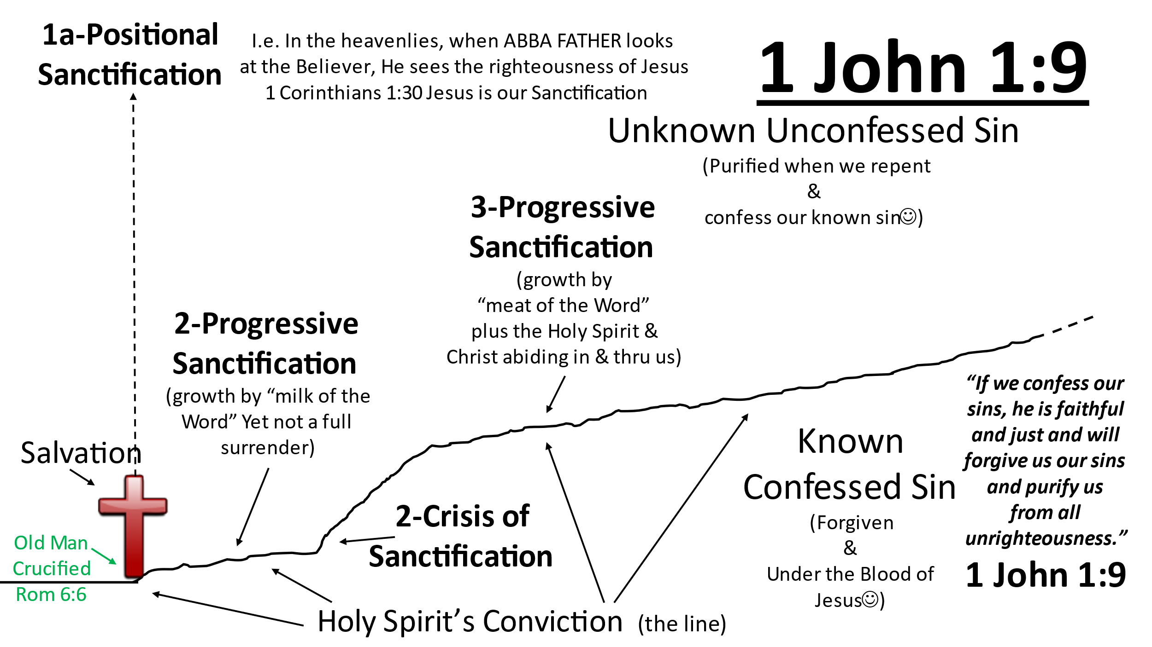
and will agree to submit to the decisions made by the Elder Board and Leadership Teams under the authority of the Christian Missionary Alliance.”

Submission: Romans 13:1-7 “Everyone must submit himself to the governing authorities, for there is no authority except that which God has established. The authorities that exist have been established by God. Consequently, he who rebels against the authority is rebelling against what God has instituted, and those who do so will bring judgment on themselves. For rulers hold no terror for those who do right, but for those who do wrong. Do you want to be free from fear of the one in authority? Then do what is right and he will commend you. For he is God's servant to do you good. But if you do wrong, be afraid, for he does not bear the sword for nothing. He is God's servant, an agent of wrath to bring punishment on the wrongdoer. Therefore, it is necessary to submit to the authorities, not only because of possible punishment but also because of conscience. This is also why you pay taxes, for the authorities are God's servants, who give their full time to governing. Give everyone what you owe him: If you owe taxes, pay taxes; if revenue, then revenue; if respect, then respect; if honor, then honor.”
Hebrews 13:17 “Obey your leaders and submit to their authority. They keep watch over you as men who must give an account. Obey them so that their work will be a joy, not a burden, for that would be of no advantage to you.”
Apostle’s Civil Disobedience
Acts 5:27ff “They left the presence of the council-rejoicing that they were counted worthy to suffer dishonor for the Name.”
New Testament Principle with King David’s Humble Attitude
Matthew 18:15-17 - Go in private, go with a witness, take it to the Elders, treat them as Jesus treated “Sinners”, 1 Samuel – Humility
Theological Humility (C&MA President John Stumbo)
I know what I believe, I strive to live by my convictions, BUT I realize that could be wrong!!!
Therefore, rather than judging others, I strive to practice Matthew 18:15-17 (PCA)
Back to my earlier question: Since we are all on a journey, why not journey together? (The 1st & 2nd Great Commandments) (John 17, Jesus’ High Priestly Prayer-Unity) (Submitting to Jesus and to one another)

Prayer
Sing a song unto the Lord
Benediction

Table Talk (Discussion Points)
Please Consider Sharing:
- What are our thoughts on John 15:5? What does Jesus say we can do apart from Him?
- What are your thoughts on Jeff’s assessment of people’s typical response to not being able to live up to the 10 Commandments?
- What are your thoughts on 1 John 1:5-10? What does John say is our only out/hope?
- What are your thoughts on Jeff’s question: “Why not journey together?”
- (OVERALL) Sharing what the Holy Spirit impressed upon you personally, during our time together.

B.A.C. ANNOUNCEMENTS
- Welcome to the gathering place of Buckhannon Alliance Church. Our desire is to Love, Grow, Give, and Go with/for Jesus Christ.
- There are several opportunities for corporate prayer times for anyone interested. Those dates & times are posted on our church app.
- Our next Annual meeting for annual reports will be held on January 29, 2023. At this annual meeting we will also be discussing the Elder Board’s decision to designate approximately 40% of the church’s giving to the Great Commission Fund of the C&MA to BAC’s two C&MA adopted International Worker families (The 40% is currently being equally divided between the Carters and the Chinchilla families).
- Ladies, this announcement is for you! There is going to be a ladies night taking place Tuesday February 7th at 6pm! There will be a charcuterie board, worship, testimony, and a time of prayer! You’re not going to want to miss this opportunity to fellowship and encounter our God! So, mark your calendar for Tuesday February 7th, 6pm!
- SDI2.0 training workshop will be Saturday, February 11th from 8:30-3:30. See Pastor Trevor for more information and to sign up.
- The next Anniversary and Birthday celebration at Pastor Jeff’s house will be on February 25th. Everyone who had a birthday or anniversary in November, December, January, or February is invited!
- Feb 4 BAC family fun day 3-7pm in gym.
- See website or app for other opportunities coming up.

