Fir-Conway Lutheran Church
18101 Fir-Island Rd, Mount Vernon, WA 98273
www.firconwaylutheran.org
A Congregation of the ELCA
Baptism of our Lord
January 8th, 2023
A few notes of welcome…
Presider: Pastor Kristi Lambing
Acolyte:
Lector:
Accompanist: Judy Bekker
Communion Assistant:
Communion Set up:
Bread:
Ushers:
Coffee Hour:
Offering Counters:

All are invited to receive the bread and wine of communion. The white juice is grape juice. There are gluten free wafers available.

The indicates when to stand, as you are able. The bold lettering is when the assembly participates.

We are very thankful that you joined us today!

Welcome
Thanksgiving for baptism
All may make the sign of the cross, the sign that is marked at baptism, as the presiding minister begins.
Blessed be the holy Trinity, ☩ one God,
The fountain of living water, the rock who gave us birth, our light and our salvation.
Amen.
Joined to Christ in the waters of baptism, we are clothed with God’s mercy and forgiveness. Let us give thanks for the gift of baptism.
Silence is kept for reflection.
We give you thanks, O God, for in the beginning your Spirit moved over the waters and by your Word you created the world, calling forth life in which you took delight.

Through the waters of the flood you delivered Noah and his family. Through the sea you led your people Israel from slavery into freedom. At the river your Son was baptized by John and anointed with the Holy Spirit. By water and your Word you claim us as children, making us heirs of your promise and servants of all.

We praise you for the gift of water that sustains life, and above all we praise you for the gift of new life in Jesus Christ. Shower us with your Spirit, and renew our lives with your forgiveness, grace and love.
To you be given all honor and praise through Jesus Christ our Lord in the unity of the Holy Spirit, now and forever.
Amen.

Greeting
The grace of our Lord Jesus Christ, the love of God, and the communion of the Holy Spirit be with you all.
And also with you.
Gathering Song
ELW #673 “God, Whose Almighty Word” all verses
Prayer of the Day
O God our Father, at the baptism of Jesus you proclaimed him your beloved Son and anointed him with the Holy Spirit. Make all who are baptized into Christ faithful to their calling to be your daughters and sons, and empower us all with your Spirit, through Jesus Christ, our Savior and Lord, who lives and reigns with you and the Holy Spirit, one God, now and forever. Amen

1st Reading: Isaiah 42:1-9
¹Here is my servant, whom I uphold, my chosen, in whom my soul delights; I have put my spirit upon him; he will bring forth justice to the nations. ²He will not cry or lift up his voice, or make it heard in the street; ³a bruised reed he will not break, and a dimly burning wick he will not quench; he will faithfully bring forth justice. ⁴He will not grow faint or be crushed until he has established justice in the earth; and the coastlands wait for his teaching. ⁵Thus says God, the Lord, who created the heavens and stretched them out, who spread out the earth and what comes from it, who gives breath to the people upon it and spirit to those who walk in it: ⁶I am the Lord, I have called you in righteousness, I have taken you by the hand and kept you; I have given you as a covenant to the people, a light to the nations, ⁷to open the eyes that are blind, to bring out the prisoners from the dungeon, from the prison those who sit in darkness. ⁸I am the Lord, that is my name; my glory I give to no other, nor my praise to idols. ⁹See, the former things have come to pass, and new things I now declare; before they spring forth, I tell you of them.
Word of God, word of life.
Thanks be to God.

Psalm 29
¹Ascribe to the Lord, you gods, ascribe to the Lord glory and strength.
²Ascribe to the Lord the glory due God’s name; worship the Lord in the beauty of holiness.
³The voice of the Lord is upon the waters; the God of glory thunders;
the Lord is upon the mighty waters.
⁴The voice of the Lord is a powerful voice; the voice of the Lord is a voice of splendor.
⁵The voice of the Lord breaks the cedar trees; the Lord breaks the cedars of Lebanon;
⁶the Lord makes Lebanon skip like a calf, and Mount Hermon like a young wild ox.
⁷The voice of the Lord bursts forth in lightning flashes.
⁸The voice of the Lord shakes the wilderness; the Lord shakes the wilderness of Kadesh.
⁹The voice of the Lord makes the oak trees writhe and strips the forests bare. And in the temple of the Lord all are crying, “Glory!”
¹⁰The Lord sits enthroned above the flood; the Lord sits enthroned as king forevermore.
¹¹O Lord, give strength to your people;
give them, O Lord, the blessings of peace.
Second Reading: Acts 10:34-43
A reading from Acts
³⁴Peter began to speak to [Cornelius and his household]: “I truly understand that God shows no partiality, ³⁵but in every nation anyone who fears him and does what is right is acceptable to him. ³⁶You know the message he sent to the people of Israel, preaching peace by Jesus Christ—he is Lord of all. ³⁷That message spread throughout Judea, beginning in Galilee after the baptism that John announced: ³⁸how God anointed Jesus of Nazareth with the Holy Spirit and with power; how he went about doing good and healing all who were oppressed by the devil, for God was with him. ³⁹We are witnesses to all that he did both in Judea and in Jerusalem. They put him to death by hanging him on a tree; ⁴⁰but God raised him on the third day and allowed him to appear, ⁴¹not to all the people but to us who were chosen by God as witnesses, and who ate and drank with him after he rose from the dead. ⁴²He commanded us to preach to the people and to testify that he is the one ordained by God as judge of the living and the dead. ⁴³All the prophets testify about him that everyone who believes in him receives forgiveness of sins through his name.”
Word of God, word of life.
Thanks be to God.
Gospel Acclimation

Gospel: 3:13-17
The Holy Gospel according to Matthew
Glory to you O’Christ.
¹³Then Jesus came from Galilee to John at the Jordan, to be baptized by him. ¹⁴John would have prevented him, saying, “I need to be baptized by you, and do you come to me?” ¹⁵But Jesus answered him, “Let it be so now; for it is proper for us in this way to fulfill all righteousness.” Then he consented. ¹⁶And when Jesus had been baptized, just as he came up from the water, suddenly the heavens were opened to him and he saw the Spirit of God descending like a dove and alighting on him. ¹⁷And a voice from heaven said, “This is my Son, the Beloved, with whom I am well pleased.”
Word of God, word of life.
Thanks be to God.

Time with Children
Sermon:
Recordings of the sermons can be found at https://www.firconwaylutheran.org/podcasts/media ; each Monday the latest sermon will be posted onto our website.

Hymn of the Day
ELW # 304 “Christ, When for Us You Were Baptized” all verses

Apostles Creed
We believe in God, the Father almighty,
creator of heaven and earth.
We believe in Jesus Christ, God’s only Son, our Lord,
who was conceived by the Holy Spirit,
born of the virgin Mary,
suffered under Pontius Pilate,
was crucified, died, and was buried;
he descended to the dead.
On the third day he rose again;
he ascended into heaven,
he is seated at the right hand of the Father,
and he will come to judge the living and the dead.
We believe in the Holy Spirit,
the holy catholic church,
the communion of saints,
the forgiveness of sins,
the resurrection of the body,
and the life everlasting.
Amen

Prayers of the People
Called together to follow Jesus, we pray for the church, the world, and all in need.
A brief silence.
Calling God, you speak with power to your church. Open our hearts and minds to the new things you are declaring. Strengthen bishops, pastors, deacons, lay leaders, and teachers of the faith. Equip the baptized for your reconciling and redeeming work.
God, in your mercy, hear our prayer.

Abiding God, your mercy is steadfast. Give sanctuary to people who flee from oppression, war, poverty, and famine. Sustain health care workers, caregivers, first responders, counselors, and all who help and heal. Comfort those who are grieving or experiencing crisis, we pray for the loved ones of Genevieve Johnson.
God, in your mercy, hear our prayer.

Blessing God, in Christ you gather the beloved community. Kindle the gifts of your Spirit in your people. Accompany the newly baptized, those recently ordained, and any beginning a new ministry. Inspire synodical leaders and congregational councils to serve with imagination and wisdom.
God, in your mercy, hear our prayer.

What other prayers do we lift up today?

Promising God, your faithfulness endures throughout all generations. We lift up Riley, Kate, & Henry, Mary, John & Julie. Our students, as they return to school in all the locations. Let your presence be felt and our love for them received. God, in your mercy, hear our prayer.

We bring to you our needs and hopes, O God, trusting your wisdom and power revealed in Christ crucified.
Amen.

Peace
The peace of Christ be with you always. And also with you.

Choral Group
Offering (At this time we will pass our offering baskets, if you are new or it’s your first time joining us, please do not feel obligated to give. Please fill out a “Thank you for joining us today” in the pew in front of you. If you would like to give an offering electronically, please go to our website at https://www.firconwaylutheran.org/give where an online donation can be given.)

Offering Hymn

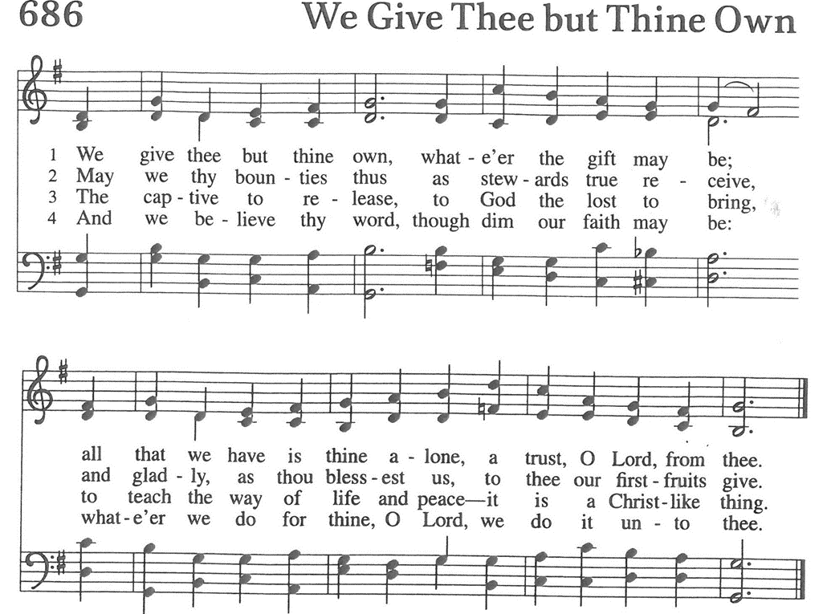
Offering Prayer
Liberating God, you break the bonds of injustice and let the oppressed go free. Receive these offerings in thanksgiving for all your works of merciful power and shape us as people of your justice and freedom. You we magnify and adore, through Jesus our Savior.
Amen

Communion
Great Thanksgiving
The Lord be with you.
And also with you.

Lift up your hearts.
We lift them to the Lord.

Let us give thanks to the Lord our God.
It is right to give our thanks and praise.

Preface
It is indeed right, our duty and our joy, that we should at all times and in all places give thanks and praise to you, almighty and merciful God, through our Savior Jesus Christ. By the leading of a star he was shown forth to all nations; in the waters of the Jordan you proclaimed him your beloved Son, and in the miracle of water turned to wine he revealed your glory. And so, with all the choirs of angels, with the church on earth and the host of heaven, we praise your name and join their unending hymn:

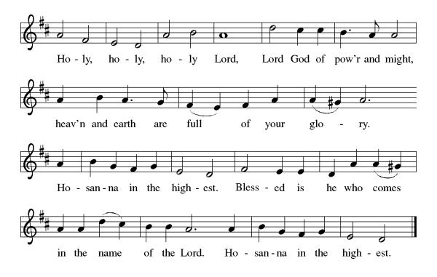
Words of Institution
Holy One, the beginning and the end, the giver of life:
Blessed are you for the birth of creation.
Blessed are you in the darkness and in the light.
Blessed are you for your promise to your people.
Blessed are you in the prophets’ hopes and dreams.
Blessed are you for Mary’s openness to your will.
Blessed are you for your Son Jesus,
the Word made flesh.

In the night in which he was betrayed,
our Lord Jesus took bread, and gave thanks;
broke it, and gave it to his disciples, saying:
Take and eat; this is my body, given for you.
Do this for the remembrance of me.

Again, after supper, he took the cup, gave thanks,
and gave it for all to drink, saying:
This cup is the new covenant in my blood,
shed for you and for all people for the forgiveness of sin.
Do this for the remembrance of me.

Let us proclaim the mystery of faith:
Christ has died.
Christ is risen.
Christ will come again.

With this bread and cup
we remember your Word dwelling among us,
full of grace and truth.
We remember our new birth in his death and resurrection.
We look with hope for his coming.
Come, Lord Jesus.

Holy God, we long for your Spirit.
Come among us.
Bless this meal.
May your Word take flesh in us.
Awaken your people.
Fill us with your light.
Bring the gift of peace on earth.
Come, Holy Spirit.

All praise and glory are yours,
Holy One of Israel,
Word of God incarnate,
Power of the Most High,
one God, now and forever.
Amen.

Lord’s Prayer
Gathered into one by the Holy Spirit, let us pray as Jesus taught us.
Our Father, who art in heaven,
hallowed be thy name,
thy kingdom come,
thy will be done,
on earth as it is in heaven.
Give us this day our daily bread;
and forgive us our trespasses,
as we forgive those
who trespass against us;
and lead us not into temptation,
but deliver us from evil.
For thine is the kingdom,
and the power, and the glory, forever and ever. Amen.

Communion Invitation
All are welcome to join us for Holy Communion. Please indicate if you need a gluten free cracker.

Communion Blessing
God the eternal Word,
who dwells with us in Jesus,
and who holds us in the grace of the Holy Spirit,
☩ bless you now and forever.
Amen.

Communion Prayer
Holy One, we thank you for the healing that springs forth abundantly from this table. Renew our strength to do justice, love kindness, and journey humbly with you.
Amen.

Announcements
Lefse for sale $9.00 per package
Our online directory can now be accessed through our website; please checkout https://www.firconwaylutheran.org/pages/current-members if you have difficulties accessing please contact Pastor.
January 10th at 1 p.m. Bunko in the Fellowship Hall
January 14th at 1 p.m. Genevieve Johnsons Memorial service
January 16th Martin Luther King Jr. Day, Front office will be closed
January 21st A.A. at 4 p.m.
*January 22nd Annual Meeting after Church

Ringing of the bell
Blessing
God bless you and keep you, ☩ Jesus grant you grace and truth, and the Spirit send peace upon your hearts, now and forever.
Amen
Sending Hymn
ELW# 301 “Bright and Glorious is the Sky” verses 1-4

Dismissal
Go in peace. Follow the way of Jesus.
Thanks be to God.

Looking Forward:
GoFundMe is live, you can find the link on the website or by going to https://www.gofundme.com/f/historical-church-sanctuary-restoration
Here's how to sign up for AmazonSmile
1. Visit smile.amazon.com.
2. Sign in with your Amazon.com credentials.
3. Choose Fir Conway Lutheran Church as your charitable organization
Here is the link - https://smile.amazon.com/ch/91-6051936
If you do any shopping with Amazon, sign up for Amazon Smiles and designate Fir-Conway Lutheran Church as your charity. 0.5% of all eligible Amazon Smiles purchases go towards your designated charitable organization. Set up is easy and is remembered each time you shop on Amazon.

Stewardship Schedule for January

Calling all Stewards
The following positions are open, if you are interested in any of these positions, please let Harvey Wolden, Kristina Kortlever, or Matt Mathison know. If you need more information about a position, please ask a current council member.

Stewardship and Finance (2-year term) - attends monthly council meeting
Congregational Liaison (1-year term) - attends monthly council meeting
Christian Education (2-year term) - attends monthly council meeting
Nominating Committee (1-year term) - 3 positions
Synod Assembly Representative (1-year term) - need three people - preferably one female, one male and one youth - Attend Synod meeting on May 13, 2023
Cemetery Committee (4-year term) - one position
Lutherwood Representative (1-year term) - one position
Audit Committee (3-year term) - one position
Youth Ministry (1-year term) - one position

Thank you for considering filling one of these positions.

