Welcome to Newsletter #26 (Jan 2023)
Happy New Year!
As part of the plan to focus more on “Stewardship proper” rather than fundraising, I welcome all suggestions.
This newsletter will introduce an issue important to all of us “Stewardship of Relationships”. You will be hearing more about this from Reverend Laurel over the next few weeks, but to start us off, I am reproducing an article which she passed along.
******
Stewardship of Relationships
Healthy Boundaries in Families
I have a theory about the man who invented the household electrical outlet: he did not parent a small child. If he did, outlets would not be placed at the perfect height for inquisitive little fingers! One of the first things new crawlers want to do is explore their environment and touch everything. One rarely moves as fast as when one notices curious fingers heading for those little slots on an outlet.
The first boundaries we learn about are the ones that impact our safety. Electrical outlets, household chemicals and cleaners, hot things, and breakables are among the many items we teach our little ones to handle with the greatest care and respect. We learn about healthy boundaries with things, but sometimes overlook healthy boundaries with people.
Healthy relationships with members of our families are vital to our overall health and well-being and should be attended to with the same care and respect we give household things. We know the “golden rule” is to treat others as we would like them to treat us, but do we know the “platinum rule?” The golden rule centers on us – the people giving in a relationship. The platinum rule centers on the people receiving what we have to give in a relationship. The platinum rule says, “treat others as they would like to be treated.”
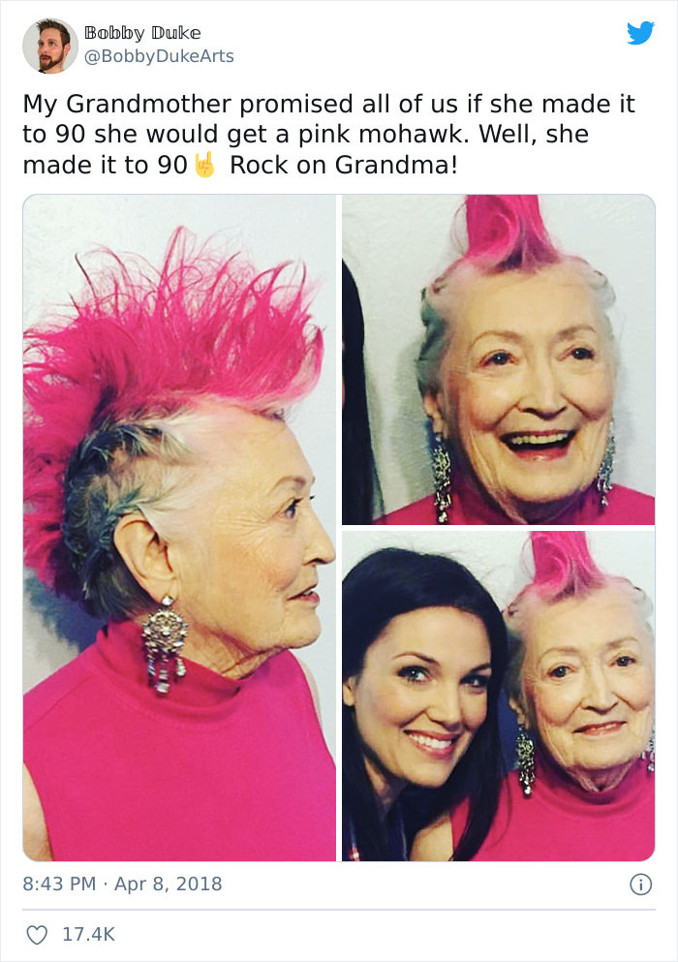
There was a family with a daughter who wanted to shave off half her hair and dye the other half bright pink. The daughter was of the age when young people are trying to discover who they are, and experiment with looks to find their personal style. One afternoon Mom and daughter bought the right shade of bright pink and brought out the clippers. By supper the daughter had styled the new look just so and strode into the dining room. Dad was unaware that this transformation had taken place and was displeased, to say the least. The daughter argued back, “It’s not the ‘family hair.’”
We’re all on a path to becoming who God dreams us to be. Making space for that discernment – in whatever form it takes - is a powerful way to offer support and encouragement. Knowing what’s ours to manage and what’s not is an important boundary to keep. Likewise, understanding and being able to articulate to others how we’d like to be treated will help strengthen the bonds of affection in a relationship.
When personal boundaries aren’t respected, the results can be as painful as an electric shock. Unlike a quick zap before the circuit-breaker engages, hurts from personal boundary crossings can last a lifetime. As we grow and change in the course of our lives, we must learn new ways to interact with one another with the greatest care and respect. Being good stewards of our family relationships, in the ways we practice good stewardship with things, allows us to strengthen family affections and build lasting bonds.

RESOURCES:
https://positivepsychology.com/great-self-care-setting-healthy-boundaries/
https://ur.life/article/self-care-101-how-to-set-boundaries-on-social-media
https://www.masterclass.com/articles/boundaries-at-work
If you find the article interesting, the resources listed here are a great way to follow up.
Here is more about what a boundary is and is not from Olivia Vizachero:
“It’s a particular course of action YOU take to take care of yourself when a particular set of circumstances arises.
That’s it.
It’s about what YOU do.
Not about what THEY do.
Ever.”
And….
“Boundaries are not mandates for other people to follow.
Boundaries are not demands.
Boundaries are not expectations.
Boundaries are not ultimatums.
Boundaries are not idle threats.
There is plenty of food for thought here. Relationships are often something we take for granted, but instead of always reacting to situations in the same way, it is refreshing to realize that we can change our behaviour in positive ways if we are prepared to think it through and try something different.

Meanwhile, back at St. John’s………
The Holly Tea was a great success! We made about $2000 in total after deducting expenses and taking into account the craft sales over the following few weeks. Well done everyone!
Thanks to all the volunteers who helped make it a memorable occasion.
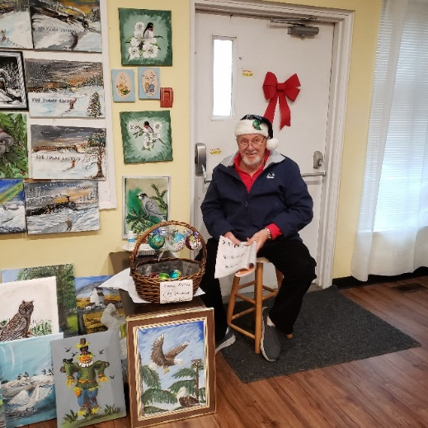
Lawrence with his paintings. He generously donated all his profits.
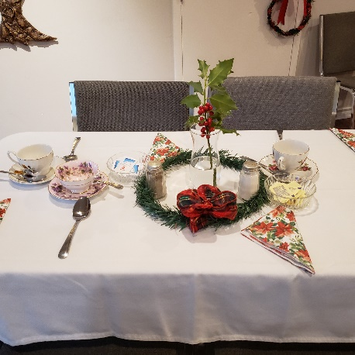
A table set for the delicious tea! (Photos by Trudy Perry)
We also had a wonderful Intergenerational service and potluck on December 11th (Advent 3), which was rounded off by a surprise visit from Santa and Mrs. Claus! Did anyone finish making their coloured Advent ornaments?
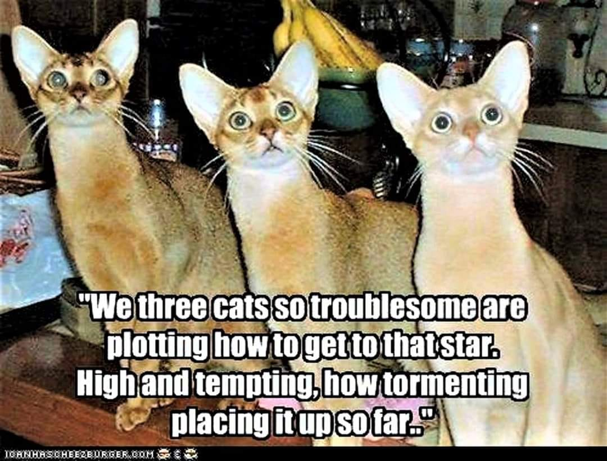

At the Dawn of a New Year

At the dawn of a new year,
we come to welcome hope for a new world.

Let the darkness lift,
to welcome a dawn of plenty,
with enough for everyone
and people ready to share.

Let the day begin,
with new energy for the struggle
to protect our children
and to care for the vulnerable.

Let the light shine,
to open a path to safety
for all who are seeking home
and longing for life.

Let the sun rise
on new talks and new resolve
to end the bombing and the terror
and to find solutions that will last.

At the dawn of a new year
we come to declare our hope
and to welcome a new world.

~ written by Susan Durber, and posted on the Monthly Prayers page of the Christian Aid website. http://www.christianaid.org.uk/

