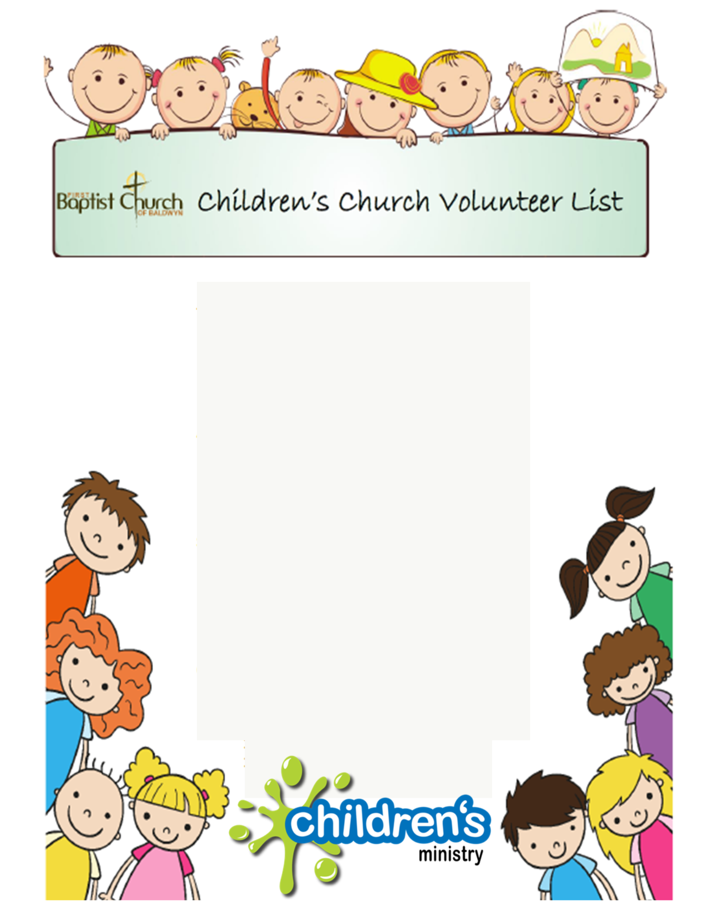

January

01/01/23 – Family New Year Service

(No Children’s Church)

01/08/23 – Holly Nelson and Deanna Arnold

01/15/23 – Brittany and Michael Covington

01/22/23 – Angela and Kevin Crump

01/29/23 – Lisa Hathcock and Amy Bratton

February

02/05/23 – Kelly and Brandon Moss

02/12/23 – Sherri and Emma Kate Buse

02/19/23 – Kelly and Gaston Griffin

02/26/23 – Brittany Tutor and Leah Beth Letson

March

03/05/23 – Courtney and Lee Roberts

03/12/23 – Holly Nelson and Deanna Arnold

03/19/23 – Brittany and Michael Covington

03/26/23 – Angela and Kevin Crump

April

04/02/23 – Lisa Hathcock and Amy Bratton