Sunday, Dec. 11, 2022 Advent 3 Joy
Myrtle Capling Memorial will be part of the service.
Greeters: Bev Agur
Coffee: Sonja van Sickle, Mae Pagdin
Service Leader: Rev. Ingrid Brown
Reflection:
Power Point: Merrilee Cameron
Scripture Reader: Elaine Brown
Isaiah 35:1-7
To read the scripture follow the link below then
type in the scripture verse http://bible.oremus.org

Comox United Church worship services are available in three ways.
1) Attend worship in-person at the church on Sundays at 10:00 am.
2) Watch live on-line by going to our YouTube channel. Just click on this link at 10:00 am on Sunday morning:
https://www.youtube.com/@comoxunitedchurch3917/streams
3) Watch the service at another time from the "Virtual Services" page on our website:
https://www.comoxunitedchurch.com/pages/online-sunday-services

Life and Work of the Church
Mondays 1:30 Knitting Group
Tuesdays 10:00 Coffee and Conversation
Fridays 9:00 Men’s Shed
Sat. Dec. 17 2:00 Carol Sing
Sun. Dec. 18 10:00 Lessons and Carols Service
Sat. Dec. 24 8:00 pm Candle Light Service
Sun. Dec. 25 no service at Comox United –
shared service at St. George’s United Church 10:30 worship time
Sun. Jan. 1 no service at Comox United –
shared service at CV Presbyterian Church
10:30 worship time

The congregation of Comox United extends its heartfelt condolences to our minister Wayne Hughes and his wife Carol Bye on the death of Wayne’s mother, Gwynne Hughes, on November 26 in Edmonton. Wayne and Carol were able to get to Edmonton and spend a few hours with her before she died. Her Celebration of Life will be held next week. We wish Wayne, Carol, and their family peace, comfort and strength during this time of grief.
Wayne plans to be back in the church office on Tuesday, December 13.

THANK YOU !
The UCW would like to thank the women of the church who gave so generously of items for the Transition Society. The potluck and fellowship of eating and sharing time together is heartwarming. The gift of music shared by Gloria set a joyful tone to our time together. We also enjoyed Isobel’s story about the “season for mercy” and the singing of Christmas Carols. A special thank you to the members of the UCW and friends who worked for many hours to make it happen from set up, to clean up to dishwashing.

Belonging

“We all long to belong.
How do you know where you belong?
Well, it's usually a place "where everybody knows your name, and
they're always glad you came".*
Have you ever noticed someone sitting by themselves on Sunday morning?
This person might be a regular attender
or a newcomer.
Go and sit with the person.
If you know their name, use it.
If you don't, introduce yourself and ask "what's your name?"
If you don't recognize them, say
"I don't believe we've met" and then introduce yourself.
A welcoming church doesn’t leave someone sitting alone, even if you recognize them.
Each Sunday take the opportunity to let someone know that you're glad they came.

*From Cheers Theme by Gary Portnoy and
Judy Hart-Angelo

DEEPENING YOUR ADVENT EXPERIENCE

Advent began November 27. One way to move through this season is to receive online a daily meditation and images built around a specific word to inspire reflection and prayer. The word is taken from the daily lectionary readings. This resource is provided by AdventWord and is available by going to their webpage adventword.org. It is free. You can sign up to receive this daily message, in English and Spanish, by email or by following AdventWord on social media.
Thanks, Peggy

CHRISTMAS SINGALONG
with Gloria Herauf
Comox United Church
Saturday, December 17th at 2 PM
Good Will Offering
Come and sing your favourite carols and Christmas songs in a good old fashioned sing-song! [Words will be provided]

Comox Valley Presbyterian Church
CRECHES OF THE WORLD

725 Aspen Road, Comox
Friday, December 16, 1 - 3pm
(for seniors & those with mobility issues)
Friday, December 16, 3 - 6:30pm
Saturday, December 17, 10am - 3:30pm

FREE ADMISSION
CHRISTMAS MUSIC
CHILDREN’S AREA

VISIT WWW.CVPC.CA FOR MORE INFO

+++++++++++++++++++++++++++++
St. George’s United Church
Fundraising for
Habitat for Humanity

Cookie Walk - Dec. 18, 2022 2:00 – 3:30

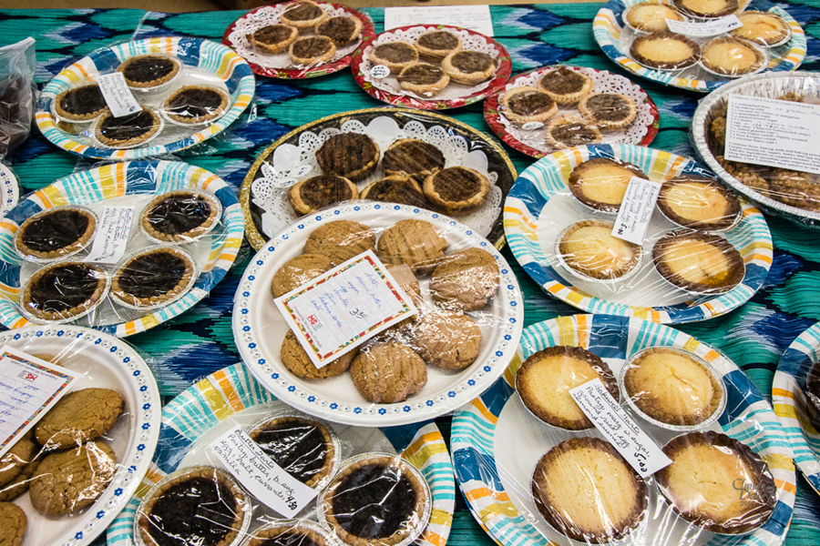
What is a cookie walk?
1) purchase a box for $15.00
2) take a ‘walk’ around the
tables fill the box with a
‘bakers dozen’ festive cookies of your choice.
+++++++++++++++++++++++++++++++++

Message from the
Envelope Secretary

- Any gifts that you wish to have receipted in the 2022 calendar year must be received before December 29th (the date of the last 2022 deposit).
- Please ensure that the church has your current mailing address for tax receipting purposes.
- Please contact me if you would like church envelopes or wish to have monthly debits to your bank account through the United Church’s Pre-Authorized Remittance Program.
Thank you - Cheryl McMahon envelopesecretary@comoxunitedchurch.com
Please be on the lookout for housing!
Our new minister and her husband
will need housing when they arrive
in Comox in January.
Needed: either a house or apartment
ideally over 900 sq. Ft.
minimum 2 bedrooms
okay with dogs (38 lb. border collie)
$2000 - $2400 monthly rent
Ideas? Contact Joyce ajwagland@hotmail.com

Plants in the Narthex (entrance)
Free to a good home.

Free Books
They are a number of books on a table
in the hall.
Please help yourself.

First Aid Kit
There used to be a first aid kit in the kitchen. This sat on top of the fridge. Has someone taken this home to replenish it?
We do need a first aid kit in the kitchen.
If someone has one to donate this would be gratefully accepted.

Comox UC Website – How To
This week’s Tip:

1. To learn about this year’s Blue Christmas Service, go to the church website by googling
Comox United Church.
2. From the menu at the top of the page, click on Events.
3. Scroll down to Blue Christmas Service.
4. Consider attending this comforting service.

Please email Joyce Wagland at websiteadmin@comoxunitedchurch.com or phone 250-207-5650.

Ukraine Refugees- Christmas
Should you hear of anyone with a spare real or artificial Christmas tree (or ornaments) please let me know as I have Ukrainian families wanting trees.

Thank you!
Alexandra Griffith
Member of the CV Ukrainian Cultural Society
Ukrainian Community Support Volunteer
250-207-1107
adlgriffith@gmail.com

Learning towards Reconciliation
“Reconciliation” was one of the recurring themes during our recent Visioning Process. A starting point for reconciliation is to learn and understand as much as possible about Indigenous values and views. With that in mind, here is an opportunity for you to learn more.

Building Bridges Through Understanding the Village© is an experiential workshop where participants explore their own, personal role in supporting the revival of the values that worked so beautifully in Indigenous villages for thousands of years. This workshop will be held on Thursday, March 9, 2023 from 8:30am - 4:30pm in the Bighouse on the traditional territory of the K’ómoks First Nation.

Register here: http://ca.apm.activecommunities.com/courtenayrecreation/Activity_Search/5607

Space is limited to 30 people.
Another workshop may be added in the spring if there is sufficient interest.

COMING in February, 2023!
Beach Street Players and
Director, Gloria Herauf
are thrilled to announce their upcoming Musical,
SOUNDTRACK
OF OUR LIVES

Performance Dates are
February 9, 10, 11 and
February 17, 18 at Comox United Church.

Filled with fun, laughter, and great music, Beach Street Players will put a smile on your face and a song in your heart!
Be sure to mark your calendars!
Tickets are $25 and will be available at Blue Heron Books and Benjamin Moore House of Color beginning January 6th. Tickets will also be on sale in the hall after church beginning January 8th.
“INDIGENOUS CANADA” WORKSHOP
Beginning in the New Year a cooperative learning opportunity is being jointly offered by Comox United and Comox Valley Unitarian Fellowship. Using the free online open access course from U of Alberta through Coursera, "Indigenous Canada" is presented in 12 modules. Participants will independently listen to two online modules of 45-70 minutes in length sometime over a 2 week period. Then participants will meet via Zoom for a facilitated discussion about the content of the two modules. The Zoom discussions will be 7 p.m. to approximately 8:30 p.m. every second and fourth Monday of the month beginning January 23, 2023 and ending April 24, 2023. There will be no Zoom discussion April 10, 2023, Easter Monday.
“Indigenous Canada is a 12-lesson Massive Open Online Course (MOOC) from the Faculty of Native Studies, U of Alberta, that explores the different histories and contemporary perspectives of Indigenous peoples living in Canada. From an Indigenous perspective, this course explores complex experiences Indigenous peoples face today from a historical and critical perspective highlighting national and local Indigenous-settler relations. Topics for the 12 lessons include the fur trade and other exchange relationships, land claims and environmental impacts, legal systems and rights, political conflicts and alliances, Indigenous political activism, and contemporary Indigenous life, art and its expressions.” https://www.coursera.org/learn/indigenous-canada
Join us in exploring the history and background of Indigenous peoples in Canada. To sign up or ask questions about this joint program between CU and CVUF please contact Christy Faraher-Amidon at: christyfa@gmail com
“Indigenous Canada” Working Group
Wayne Wilson Comox United
Wanda Harssema CVUF
Christy Faraher-Amidon CVUF
Barbara Huhn CVUF

Moderator’s Christmas Message 2022

(Transcript of Videotaped Message)

My church family,

Christmas greetings to you in the name of the one who came to us as the Word made flesh―in the form of a baby born into lowly and humble beginnings.

We recite through the Gospel of John, “In the Beginning was the Word, and the Word was with God, and the Word was God….” It’s cryptic at best, but there is a reason we read the gospels alongside the Hebrew scriptures. Listen to the words of the Prophet Isaiah [52:7─10]:

How beautiful upon the mountains are the feet of the messenger who announces peace, who brings good news, who announces salvation, who says to Zion, “Your God reigns.”
Listen! Your sentinels lift up their voices, together they shout for joy; for in plain sight they see the return of the Lord to Zion.
Break forth, shout together for joy, you ruins of Jerusalem; for the Lord has comforted his people; he has redeemed Jerusalem.
The Lord has bared his holy arm before the eyes of all the nations, and all the ends of the earth shall see the salvation of our God.

We often associate the prophetic texts with dire warnings against our human fallibility and worst individual and corporate character defects.
But in this case, Isaiah is preaching a good news story. One of beauty, peace, good news, salvation, joy, comfort, redemption, vulnerability, and salvation.

What could be a better news story in the arrival of the Christ child than remembering all that good news promised to us through our faith? Not that we get to those things because of our faith, just that our faith reminds us―every year in the remembering of the coming of the Christ child―that all things are made new or possible again. That God wishes us to have life and to have it in abundance.

Sometimes it’s hard to remember with the constant assault of bad news stories meant to keep us in a state of perpetual stress and believing the worst in each other. In fact, all empirical evidence points to the opposite: Humans are generally decent, and committed to the fabric of our societies and our social contracts with each other. That we are capable of great feats of innovation, kindness, overcoming obstacles, and achieving the impossible. We were born to achieve the impossible. And not only in the absence of crisis, but even more strongly in times of crisis.

So this year, when so much seems uncertain and the news amplifies all the hard news stories, remember that when the Word is made flesh, there is One who came to show us that all the ends of the earth should see the salvation of God―and that through that One, we are capable of coming together to achieve the impossible.

From the Office of the Moderator and on behalf of The United Church of Canada, I wish you the very merriest and most inspirational of Christmases. May you be the good news and see the good news and share the good news this Christmas season.

Moderator Carmen Lansdowne

