Faith Evangelical Lutheran Church, Washington, IL
Second Sunday of Advent
December 4, 2022

Welcome

Lighting of the Advent Candles Red Book #242

Text: Marty Haugen, b. 1950
Music: REJOICE, REJOICE, Marty Haugen
Text and music © 1983 GIA Publications, Inc., 7404 S. Mason Ave., Chicago, IL 60638. www.giamusic.com.800.442.3358. All rights reserved. Used by permission. Reprinted under OneLicense #A-711151

Please pray with me as we light our Second Advent Candle.
Praise to you, O God, who gives us courage to start again.
You fasten righteousness around your waist
and baptize with the Holy Spirit’s fire.
Bless us as we mirror your mighty fire in these simple flames,
and teach us to mirror your justice in the paths we prepare.
We ask that peace abound,
until none hurt or destroy over all the earth.
Amen.

Confession and Forgiveness

P: In the name of the Father, and of the + Son, and of the Holy Spirit.
C: Amen.
You may make the sign of the cross as a reminder of your baptism.
P: Blessed be the Lord, the God of Israel, who alone does wondrous things.
C: Blessed be God’s name forever. Amen.
P: Beloved, now is the time to wake from sleep.
Let us confront our sins, and confess them to the one who is merciful and just.
Please keep silence for reflection
P: God of new beginnings,
C: we confess that we have not welcomed your holy reign.
We have strayed from your paths.
We prepare for war instead of peace.
We dishonor one another and your creation.
Purify us with your refining fire
and set us again on your way of love,
that we may bear fruit worthy of repentance,
and welcome your coming among us.
Amen.
P: People of God, a new thing is growing in our midst,
a tender branch, a living sign.
By water and the Spirit you are joined to this wonder.
You have put on ☩ Christ, and your sins have been washed away.
Rejoice in the way of the Lord.
C: Amen.
Peace: As forgiven children of God, we have peace
Faith Lutheran Church
2206 Washington Rd,
Washington, IL 61571
Website and online worship:
www.shareourfaith.org
Church: 309-745-9306
faithlth@shareourfaith.org
Pastor John Rothfusz
Home: 309-745-9282
pastor@shareourfaith.org
with God, and peace with one another.
P The peace of the Lord be with you always.
C And also with you.
P Let us share that peace with one another.

*Hymn: “All Earth Is Hopeful” Red Book #266

Text: Alberto Taulé, b. 1932; tr. Madeleine Forell Marshall, b. 1946
Music: TODA LA TIERRA, Alberto Taulé, b. 1932
Spanish text and tune © 1993 Centro de Pastoral Liturgica, admin. OCP Publications Tr. © 1995 Madeleine Forell Marshall, admin. Augsburg Fortress
Reprinted under OneLicense.net#A-711151

P The grace of our Lord Jesus Christ, the love of God,
and the communion of the Holy Spirit be with you all.
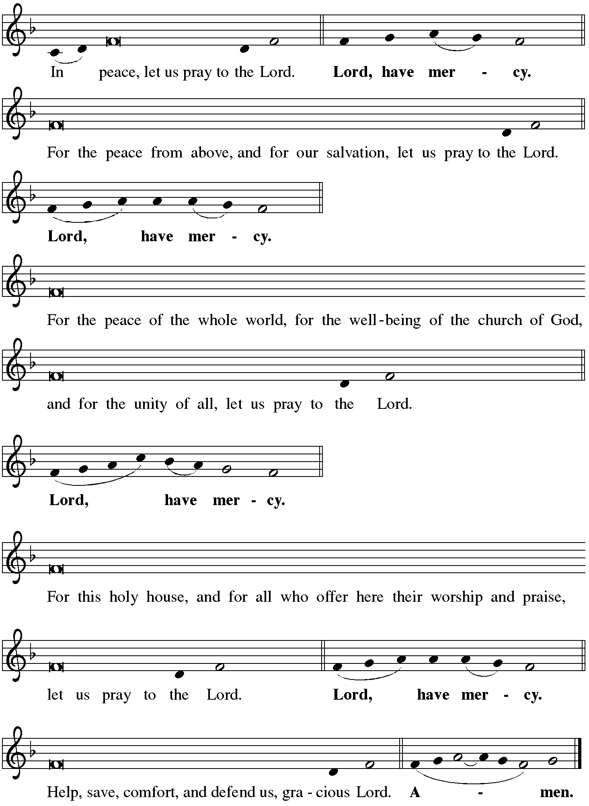
C And also with you.
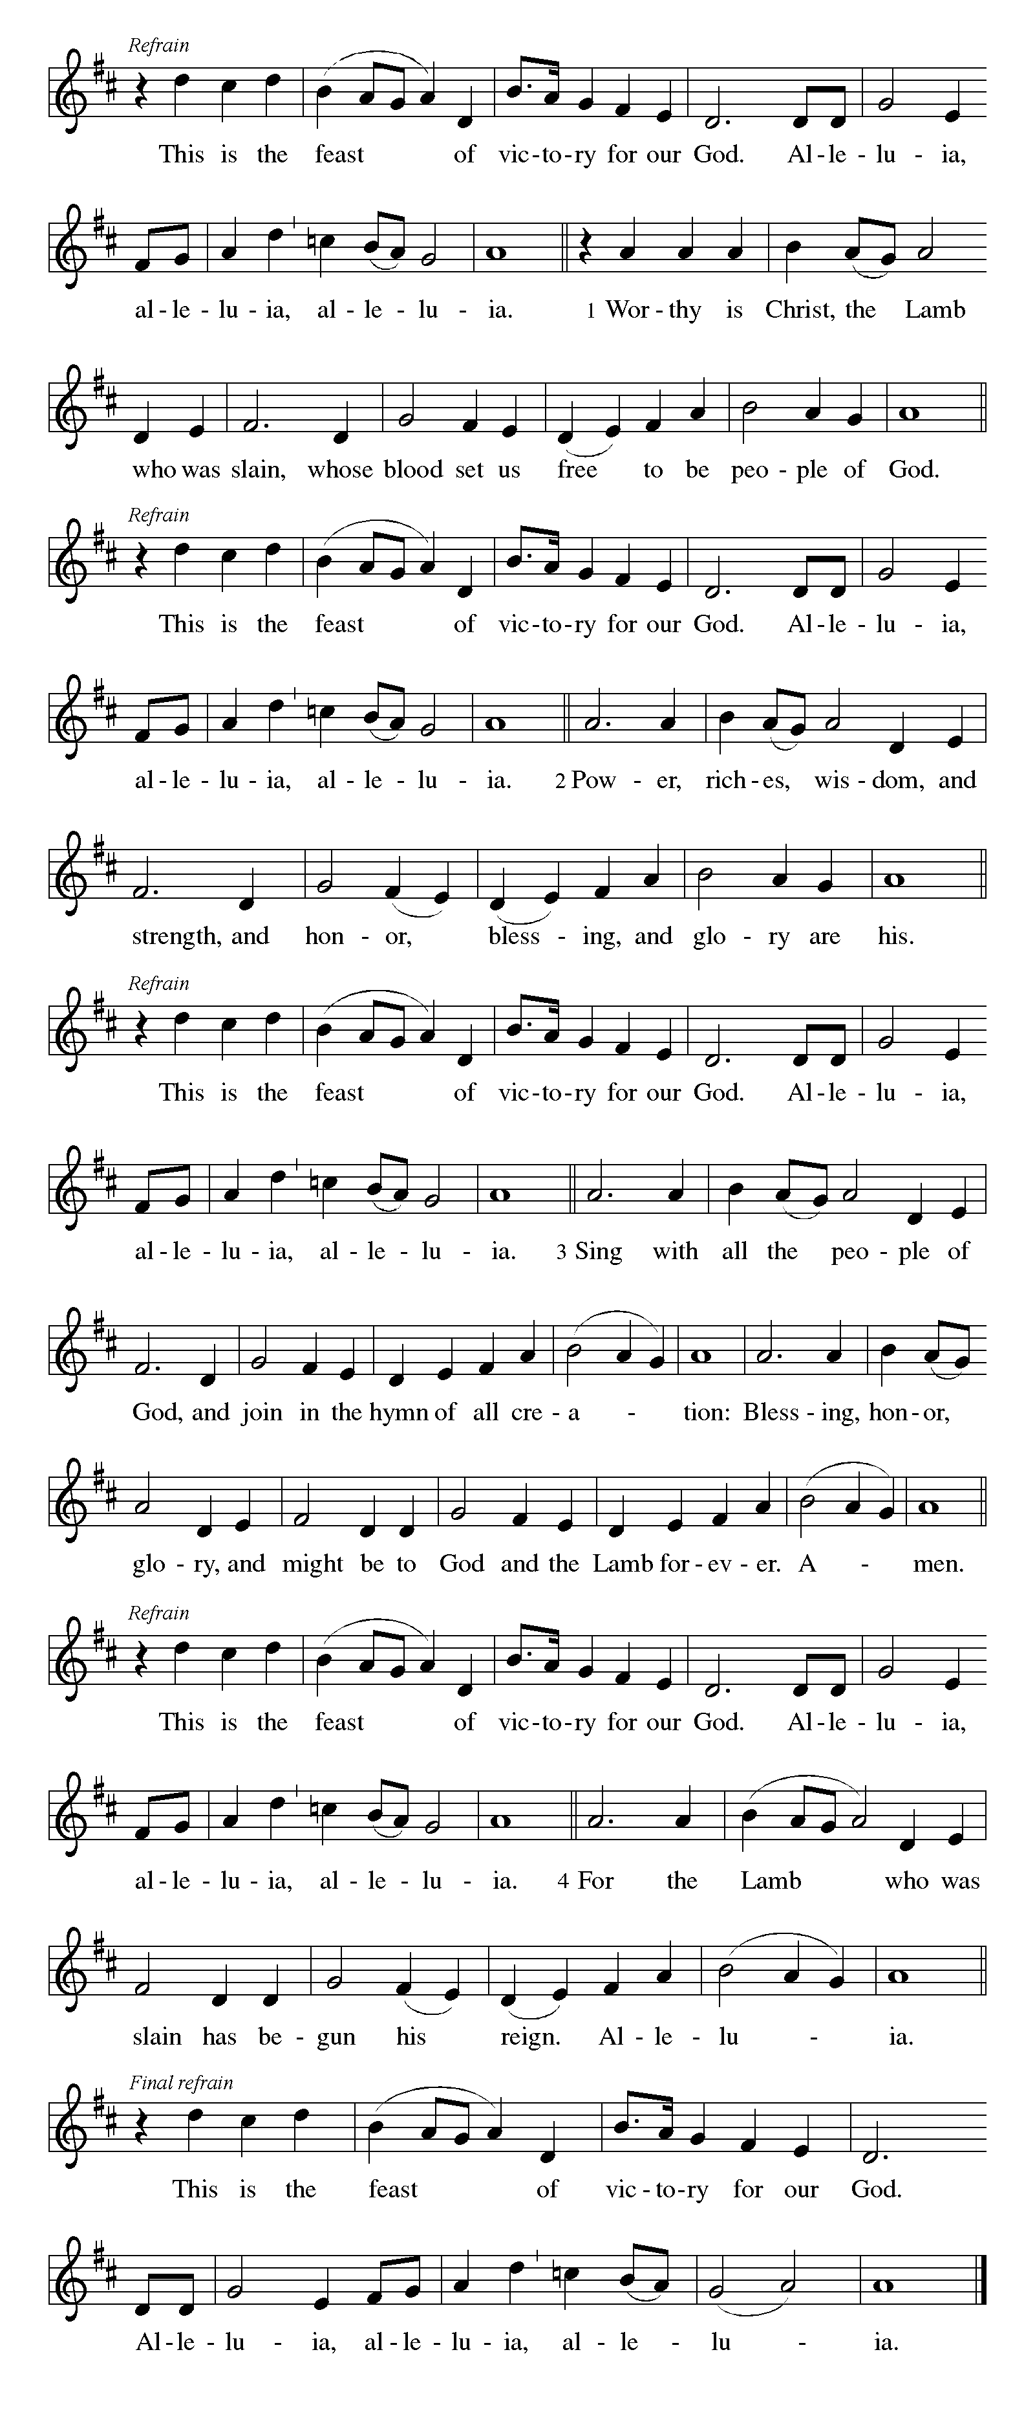

P The Lord be with you
C And also with you.
Let us pray together the Prayer of the Day.
Stir up our hearts, Lord God, to prepare the way of your only Son. By his coming nurture our growth as people of repentance and peace; through Jesus Christ, our Savior and Lord, who lives and reigns with you and the Holy Spirit, one God, now and forever. Amen.

Children’s Message

First Reading: Isaiah 11:1-10 Pew Bible Page #555
¹A shoot shall come out from the stump of Jesse, and a branch shall grow out of his roots. ²The spirit of the Lord shall rest on him, the spirit of wisdom and understanding, the spirit of counsel and might, the spirit of knowledge and the fear of the Lord. ³His delight shall be in the fear of the Lord. He shall not judge by what his eyes see, or decide by what his ears hear; ⁴but with righteousness he shall judge the poor, and decide with equity for the meek of the earth; he shall strike the earth with the rod of his mouth, and with the breath of his lips he shall kill the wicked.
⁵Righteousness shall be the belt around his waist, and faithfulness the belt around his loins.
⁶The wolf shall live with the lamb, the leopard shall lie down with the kid, the calf and the lion and the fatling together, and a little child shall lead them. ⁷The cow and the bear shall graze, their young shall lie down together; and the lion shall eat straw like the ox. ⁸The nursing child shall play over the hole of the asp, and the weaned child shall put its hand on the adder’s den. ⁹They will not hurt or destroy on all my holy mountain; for the earth will be full of the knowledge of the Lord
as the waters cover the sea. ¹⁰On that day the root of Jesse shall stand as a signal to the peoples; the nations shall inquire of him, and his dwelling shall be glorious.

R The Word of the Lord
C Thanks be to God

Psalm 72:1-7, 18-19 Read responsively by whole verse
¹Give the king your justice, O God,
and your righteousness to the king’s son;
²that he may rule your people righteously
and the poor with justice;
³that the mountains may bring prosperity to the people,
and the hills, in righteousness.
⁴Let him defend the needy among the people,
rescue the poor, and crush the oppressor.
⁵May he live as long as the sun and moon endure,
from one generation to another.
⁶Let him come down like rain upon the mown field,
like showers that water the earth
⁷In his time may the righteous flourish;
and let there be an abundance of peace till the moon shall be no more.
¹⁸Blessed are you, Lord God, the God of Israel;
you alone do wondrous deeds!
¹⁹And blessed be your glorious name forever,
and may all the earth be filled with your glory. Amen. Amen.

Second Reading: Romans 15:4-13 Pew Bible Page #920
⁴Whatever was written in former days was written for our instruction, so that by steadfastness and by the encouragement of the scriptures we might have hope. ⁵May the God of steadfastness and encouragement grant you to live in harmony with one another, in accordance with Christ Jesus, ⁶so that together you may with one voice glorify the God and Father of our Lord Jesus Christ.
⁷Welcome one another, therefore, just as Christ has welcomed you, for the glory of God. ⁸For I tell you that Christ has become a servant of the circumcised on behalf of the truth of God in order that he might confirm the promises given to the patriarchs, ⁹and in order that the Gentiles might glorify God for his mercy. As it is written, “Therefore I will confess you among the Gentiles, and sing praises to your name”; ¹⁰and again he says, “Rejoice, O Gentiles, with his people”; ¹¹and again,
“Praise the Lord, all you Gentiles, and let all the peoples praise him”; ¹²and again Isaiah says, “The root of Jesse shall come, the one who rises to rule the Gentiles; in him the Gentiles shall hope.” ¹³May the God of hope fill you with all joy and peace in believing, so that you ma

R The Word of the Lord
C Thanks be to God
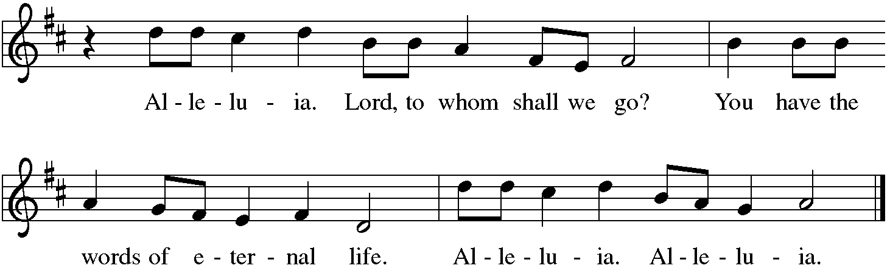

Gospel Reading: Matthew 3:1-12 Pew Bible Page #778

C Glory to you, O Lord
¹In those days John the Baptist appeared in the wilderness of Judea, proclaiming, ²“Repent, for the kingdom of heaven has come near.” ³This is the one of whom the prophet Isaiah spoke when he said,
“The voice of one crying out in the wilderness: ‘Prepare the way of the Lord,
make his paths straight.’ ”
⁴Now John wore clothing of camel’s hair with a leather belt around his waist, and his food was locusts and wild honey. ⁵Then the people of Jerusalem and all Judea were going out to him, and all the region along the Jordan, ⁶and they were baptized by him in the river Jordan, confessing their sins.
⁷But when he saw many Pharisees and Sadducees coming for baptism, he said to them, “You brood of vipers! Who warned you to flee from the wrath to come? ⁸Bear fruit worthy of repentance. ⁹Do not presume to say to yourselves, ‘We have Abraham as our ancestor’; for I tell you, God is able from these stones to raise up children to Abraham. ¹⁰Even now the ax is lying at the root of the trees; every tree therefore that does not bear good fruit is cut down and thrown into the fire.
¹¹“I baptize you with water for repentance, but one who is more powerful than I is coming after me; I am not worthy to carry his sandals. He will baptize you with the Holy Spirit and fire. ¹²His winnowing fork is in his hand, and he will clear his threshing floor and will gather his wheat into the granary; but the chaff he will burn with unquenchable fire.”
The Gospel of the Lord C Praise to you, O Christ
Sermon by Pastor John Rothfusz
Sermon Hymn: “On Jordan’s Bank the Baptist Cry” Red Book #249

Text: Charles Coffin, 1676-1749; tr. Composite
Music: PUER NOBIS, European tune, adapt. Michael Practorius, 1571-1621
Apostles’ Creed
C: I believe in God, the Father almighty,
creator of heaven and earth.
I believe in Jesus Christ, God's only Son, our Lord,
who was conceived by the Holy Spirit,
born of the virgin Mary,
suffered under Pontius Pilate,
was crucified, died, and was buried;
he descended to the dead.
On the third day he rose again;
he ascended into heaven,
he is seated at the right hand of the Father,
and he will come to judge the living and the dead.
I believe in the Holy Spirit,
the holy catholic church, the communion of saints,
the forgiveness of sins, the resurrection of the body,
and the life everlasting. Amen.
Prayers: After each portion of the prayers finishes with “Lord in your mercy,” please respond, “Hear our prayer.”

Offering: Jesus is Lord, and leads us in the ways of life and salvation. Let us offer ourselves to the Lord and joyfully lift our tithes and offerings to God.

Please take a moment now to make an electronic offering to the church on the website, with the Tithe.ly app on your phone, or drop an envelope in the plate at communion time.
Faith Lutheran website link www.shareourfaith.org

Offering Prayer

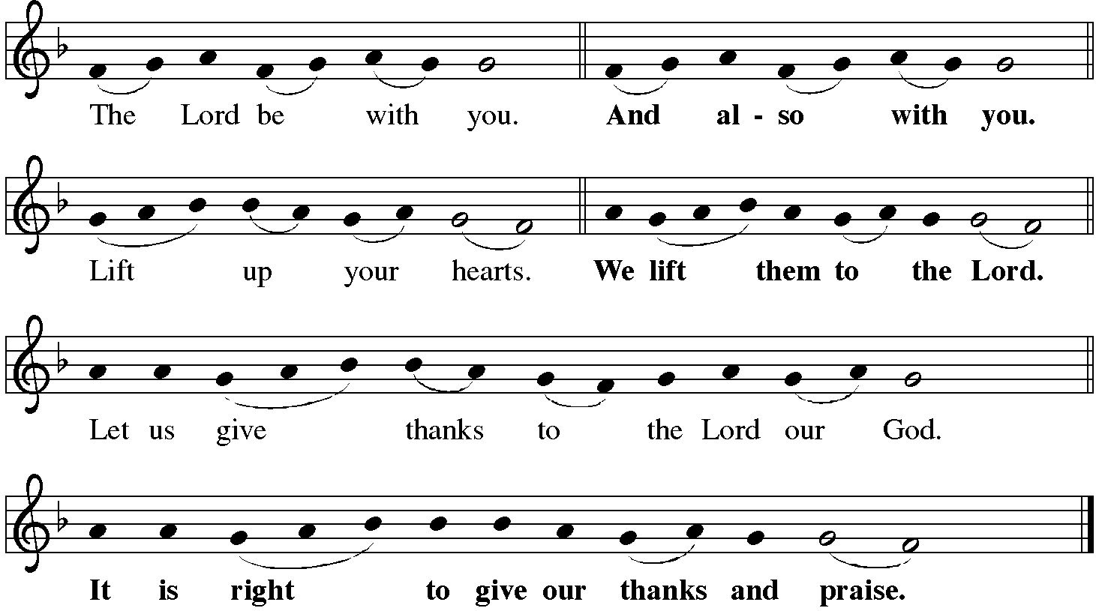

P It is indeed right, our duty and our joy… with the church on earth and the hosts of heaven, we praise your name and join their unending hymn:
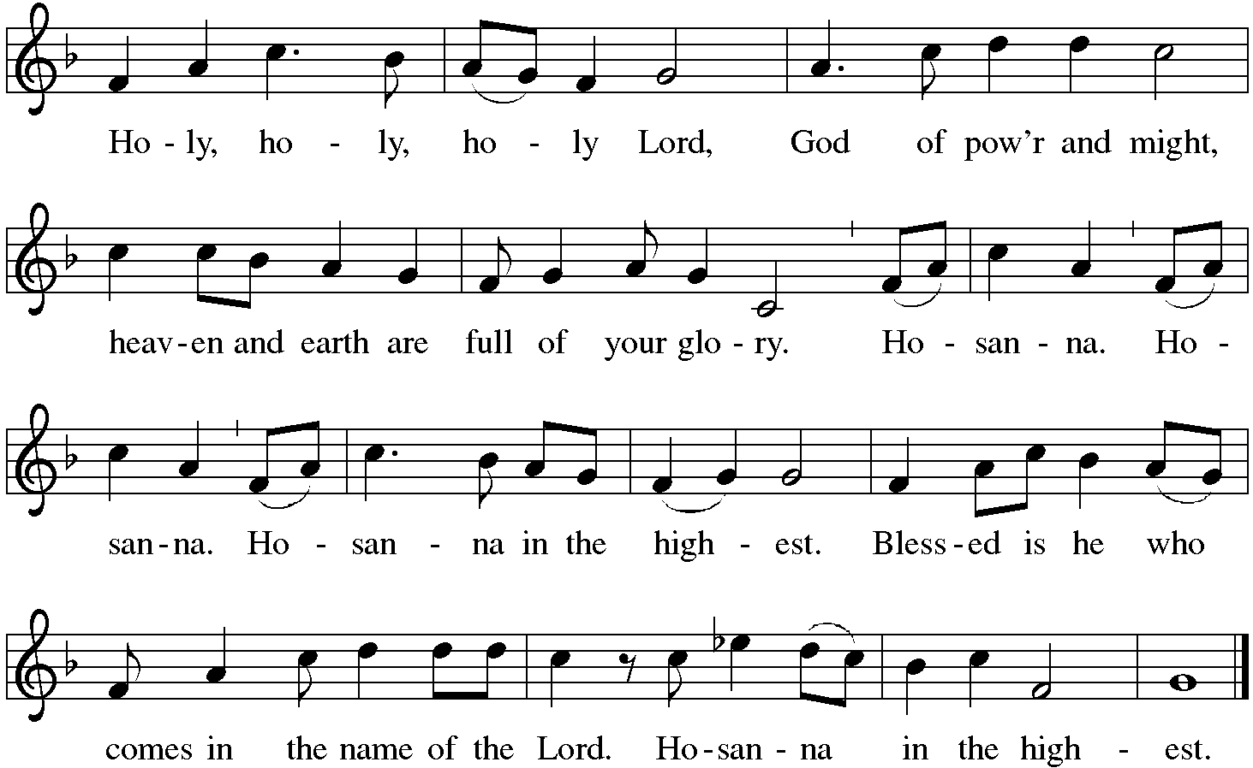

Holy Communion Preface pp. 108-111 or other Eucharistic prayer
In the night in which he was betrayed,
our Lord Jesus took bread, and gave thanks;
broke it, and gave it to his disciples, saying:
Take and eat; this is my body, given for you.
Do this for the remembrance of me.
Again, after supper, he took the cup, gave thanks,
and gave it for all to drink, saying:
This cup is the new covenant in my blood,
shed for you and for all people for the forgiveness of sin.
Do this for the remembrance of me.

C The Lord's Prayer
Our Father, who art in heaven, hallowed be thy name,
thy kingdom come, thy will be done, on earth as it is in heaven.
Give us this day our daily bread; and forgive us our trespasses,
as we forgive those who trespass against us;
and lead us not into temptation, but deliver us from evil.
For thine is the kingdom, and the power, and the glory,
forever and ever. Amen
Communion Distribution

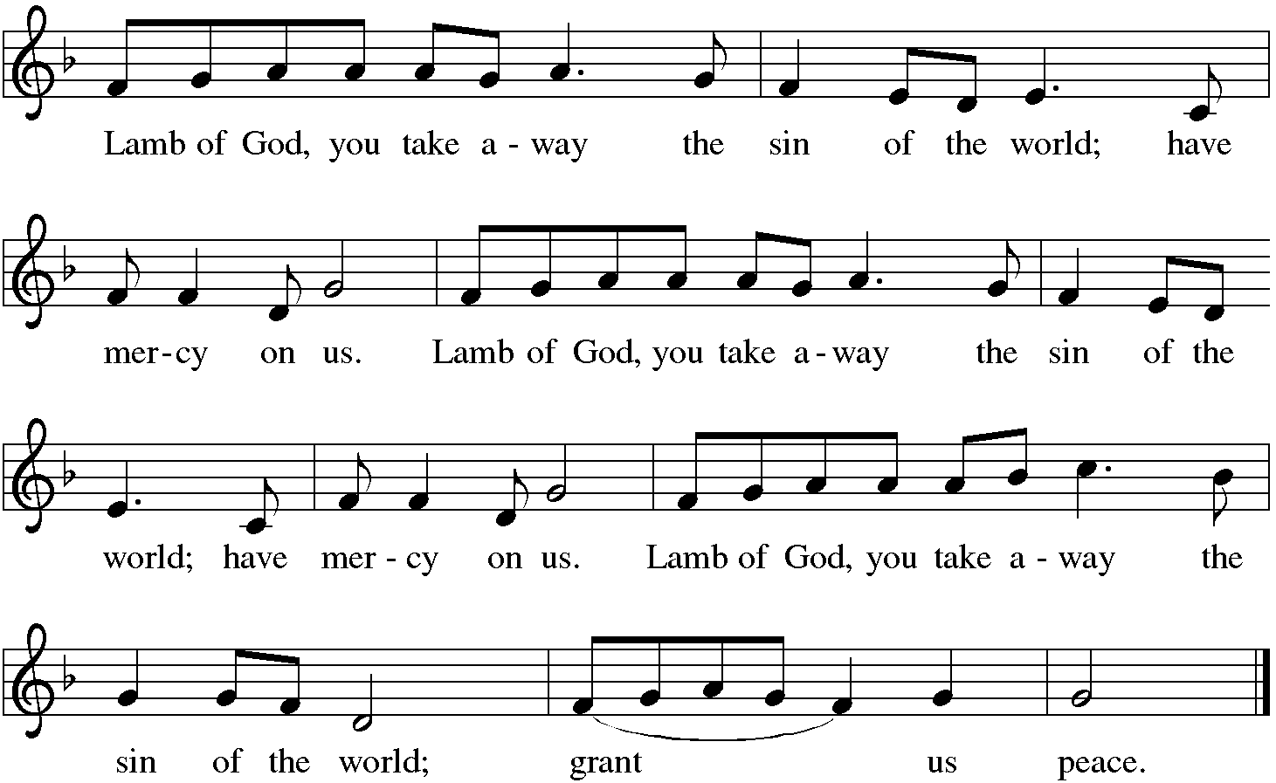

Communion Hymn: “Lo, How a Rose E’er Blooming” Red Book #272

Text: German, 15th cent.; tr. Theodore Baker, 1851-1934, sts. 1-2; Harriet R. Krauth, 1845-1925, st. 3; John Casper Mattes, 1876-1948, st. 4
Music: ES IST EIN ROS, Alta Catholische Geistliche Kirchengesäng, Köln, 1599

Communion Prayer

Announcements

Blessing
P The Lord bless you and keep you. The Lord make his face shine on you and be gracious to you. The Lord look upon you with favor and + give you peace. In the name of the Father, and of the Son and of the Holy Spirit.
C Amen

Hymn: “Prepare the Royal Highway” Red Book # 264

Text: Frans Mikael Franzén, 1772-1847; tr. Lutheran Book of Worship, 1978
Music: BEREDEN VÄG FÖR HERRAN, Swedish folk tune, 17th cent. Reprinted under OneLicense.net#A-711151

Dismissal
A Go in peace. Serve the Lord.
C Thanks be to God!

Postlude

Liturgy and texts from Sundays and Seasons.com. Copyright 2022 Augsburg Fortress. All rights reserved.
Reprinted by permission under Augsburg Fortress Liturgies Annual License #23628.

