Sunday, Nov. 27, 2022 Advent 1
Greeters: Merrilee Cameron
Coffee: Heather Flint, Margie van Binsbergen
Service Leader: Rev. Deb. Bowman
Sermon:
Power Point: Sue Newman
Scripture Reader: Joan Gillies
Luke 1:46-56
To read the scripture follow the link below then
type in the scripture verse http://bible.oremus.org

Comox United Church worship services are available in three ways.
1) Attend worship in-person at the church on Sundays at 10:00 am.
2) Watch live on-line by going to our YouTube channel. Just click on this link at 10:00 am on Sunday morning:
https://www.youtube.com/channel/UCJIaxG_quMwagK5WeiQwXPA
3) Watch the service at another time from the "Virtual Services" page on our website:
https://www.comoxunitedchurch.com/pages/online-sunday-services

On Friday November 25th at 5:30 pm, please join us for
The Hanging of the Greens
Potluck & Service
as we celebrate the arrival of Advent! Let’s enjoy having dinner together, followed by a short service and chance to decorate the sanctuary.
Please bring mitts, toques, scarves etc. to decorate the tree. These will be donated to Care-A-Van.
A signup sheet will be in the hall during coffee time for volunteers to help setup and cleanup for this event.
Hope to see you there!
Questions? Speak with Fiona Curry (fmmcurry@gmail.com)

November 27 is the First Sunday of Advent and Rev Debra Bowman will be our
minister that day.
After worship come and join us for
Soup and Buns hosted by the Knitting Group.
Donations received will be split between Comox United Church and the Care A Van.
Deb led us in our visioning process this past year. On May 29, 2022 the results of our visioning were presented to the congregation during worship. So many great ideas!
Four guiding values!
During our lunch on November 27, 2022 we will hear from 6 or 7 teams about how they are implementing some of the ideas that emerged.
Bring your appetite on November 27 and be prepared to be inspired once again.

Please be on the lookout for housing!
Our new minister and her husband
will need housing when they arrive
in Comox in January.
Needed: either a house or apartment
ideally over 900 sq. Ft.
minimum 2 bedrooms
okay with dogs (38 lb. border collie)
$2000 - $2400 monthly rent
Ideas? Contact Joyce ajwagland@hotmail.com

DEEPENING YOUR ADVENT EXPERIENCE
Advent begins this Sunday. One way to move through this season is to receive online a daily meditation and images built around a specific word to inspire reflection and prayer. The word is taken from the daily lectionary readings. This resource is provided by AdventWord and is available by going to their webpage adventword.org. It is free. You can sign up to receive this daily message, in English and Spanish, by email or by following AdventWord on social media.
Thanks,
Peggy

The Cat in the Hat, Sherlock Holmes and Red Green

Thanks to those 15 people who signed up in November to get more involved at Comox United.
Our three mascots are very grateful to everyone.
Heather Flint, Ruth Giles, Sonja Van Sickle, Ruth Gibson, Amy Yakimyshyn, Joyce Relyea, Sue Sutherland-Justice, Carolyn Halcrow, Fiona Curry, Laurel Dow, Barb Craig-White, Julie Waller, Loraleigh Fitzgerald, Amy Lewis, Janet Bjarnson.
Meanwhile, if you needed to spend more time thinking, and missed the Involvement Drive, No Fear!
You can email NoVA at nova@comoxunitedchurch.com , and we will answer any questions you might have, and supply you with the written job description for any position of interest.
Or, just talk to Howard, Merrilee, Mike, Laurel or Scott Curry at coffee for some inside info!

Happy Advent Everyone, from the NoVA Team

Plants in the Narthex (entrance)
“Free to good home” help yourself

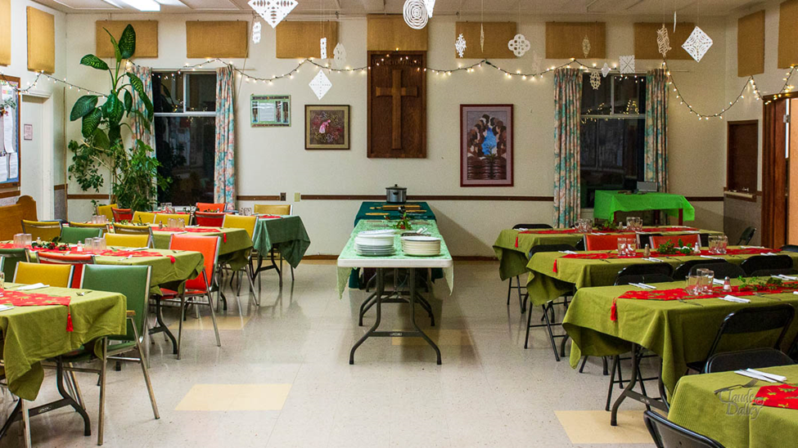

Comox United Church UCW, the Louisa Catchpole unit, invites you to our Ladies
Christmas Potluck Luncheon
on Monday, December 5th,
at 12.15 pm in the church Hall.
Potluck - meats, buns and butter
will be provided by the UCW;
salads, vegetable dishes and
desserts would be welcomed.

At this luncheon we traditionally collect donations for the Transition House - they would appreciate any of the following: deodorant, razors, body wash, tooth brushes and full-size toothpaste, hair brushes and combs, socks, gloves and underwear (varied sizes), also lightly-used single sheets and towels.

Comox UC Website – How To
This week’s Tip:

1. For a snapshot of the church services over Christmas, go to the church website by
googling Comox United Church.
2. From the menu at the top of the page, click on Events.
3. Scroll down to Christmas at Comox United Church.
4. Enjoy!

Belonging

We all long to belong.
How do you know where you belong?
Well, it's usually a place "where everybody knows your name, and
they're always glad you came".
Have you ever noticed someone sitting by themselves on Sunday morning?
This person might be a regular attender
or a newcomer.
Go and sit with the person.
If you know their name, use it.
If you don't, introduce yourself and ask "what's your name?"
If you don't recognize them, say
"I don't believe we've met" and then introduce yourself.
A welcoming church doesn’t leave someone sitting alone, even if you recognize them.
Each Sunday take the opportunity to let someone know that you're glad they came.

Free Books
They are a number of books on a table in the hall.
Please help yourself.

COMING in February, 2023!
Beach Street Players and
Director, Gloria Herauf
are thrilled to announce their upcoming Musical,
SOUNDTRACK OF OUR LIVES
Performance Dates are February 9, 10,11, 12 and February 17, 18 at Comox United Church. Filled with fun, laughter, and great music, Beach Street Players will put a smile on your face and a song in your heart! Be sure to mark your calendars!

St. George’s United Church
Fundraising for
Habitat for Humanity

Cookie Walk - Dec. 18, 2022 2:00 – 3:30

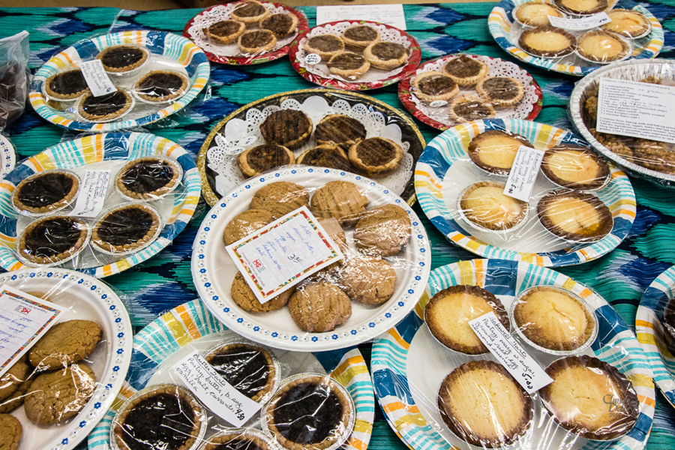
What is a cookie walk?
1) purchase a box for $15.00
2) take a ‘walk’ around the
tables fill the box with a
‘bakers dozen’ festive cookies of your choice.

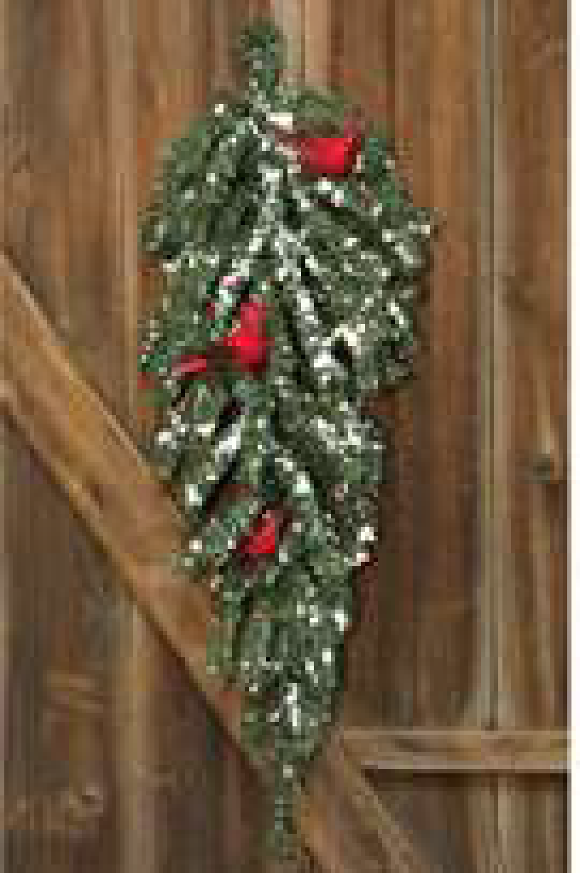
Once again, the Comox Valley Glacier Grannies will be selling beautiful Christmas swags for your front door. We also have wreaths in two sizes and festive pots. All are made with fresh greenery.
Swags $25. Pots $15.Small Wreaths $25.Large Wreaths $35.

Orders must be placed by Sunday, November 27.
Items will be available for pickup at the church on Sunday, December 4 at 11:15 am outside the front door.
Payment can be made by cash or cheque or e-transfer.
Please make cheque out to: Glacier Grannies.
E-transfer to cvglaciergrannies@gmail.com with your order and phone number clearly identified in the “Message” box.

